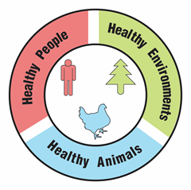
An Outbreak of Antibiotic-Resistant Bacteria

Teacher Guide

Lesson Summary:
Follow the story of a young man who has a life-threatening case of food poisoning caused by antibiotic- resistant Salmonella bacteria. How did the bacteria become multidrug-resistant? How could the bacteria spread to humans, animals, plants, and the environment?

Core Concepts:
- Antibiotic use (for people, animals, or crops) can lead to bacteria that are resistant to multiple antibiotics.
- Illnesses caused by antibiotic-resistant bacteria are dangerous because they are difficult to treat.
- Bacteria can acquire new antibiotic resistance genes through mutations or through gene transfer from the environment, from other bacteria, and from viruses.
- Natural selection occurs when bacteria with genes for antibiotic resistance survive and become more common within a population
- A One Health approach identifies and seeks solutions to the spread of antibiotic-resistant bacteria between people, animals, and the environment (e.g., water, soil, and plants).

Suggested Grade Levels: Grades 9 – 12

Class Time Required (approximate):
- Part 1: A dangerous Salmonella infection 15 minutes
- Part 2: The source of the outbreak 15 minutes
- Part 3: How do bacteria become resistant to multiple antibiotics? 20 minutes
- Part 4: Natural selection and antibiotic-resistant bacteria 20 minutes
- Part 5: The spread of antibiotic-resistant bacteria 30 minutes
- Part 6: One Health and antibiotic-resistant bacteria 40 minutes

Copyright © 2022 by University of Rochester. All rights reserved. May be copied for classroom use. This lesson was developed with support from the National Institutes of Health under Award Number R25GM132758. The content is solely the responsibility of the authors and does not necessarily represent the official views of the National Institutes of Health.
Teacher Preparation:

Part(s) | Materials needed for each student
1 - 6 | - Copy of student handout An Outbreak of Antibiotic-Resistant Bacteria  - Access to internet and computer  - Optional: poster paper and markers for the class sharing of answers as described in suggested class procedure
3 - 4 | - One dice. Dice can be purchased at local craft stores. Students can also use a dice roll program such as the one at https://www.online-stopwatch.com/chance-games/roll-a-dice/.  - 1 color copy of Key for Dice Roll. May be laminated or inserted into a sheet protector for use with multiple classes. Two students may share one Key for Dice Roll. See page vii.  - Clear plastic 3 oz. cup containing one black bead. Label the cup Salmonella Bacteria Cell in Chicken Intestine. Make one cup for each student. Use tribeads (https://www.beadkraft.com/tri-beads) or pony beads (https://www.beadkraft.com/pony-beads). You may substitute small squares of colored paper for the beads.  - Sandwich or snack bag containing at least 3 of each color of bead (red, green, blue, and pink). Label bag Antibiotic Resistance Genes from Other Kinds of Bacteria.
5 | - 1 copy of How Antibiotic-Resistant Bacteria Spread. See page vii. Print in color. Do not laminate. Students will need to draw arrows and write labels on this illustration. See page viii.  - Optional: Pencils with erasers so that students can make changes in their work if needed.
6 | - Access to Google, PowerPoint or similar digital program for making slides, or poster paper and markers.

Suggested Class Procedure:

General
- Distribute 1 copy of An Outbreak of Antibiotic-Resistant Bacteria to each student.
- It is suggested that students work in pairs. However, each student should have their own beads and cup for Parts 3 and 4.
- The topic of antibiotic-resistant bacteria is rich enough to trigger conversations and questions that go beyond the immediate content in this lesson. Teachers may set up a “Parking Lot” for collecting student questions or ideas for additional connections/research.
Parking Lot Strategy
- Make a large poster paper or bulletin board area in the classroom as your Parking Lot.
- When students have a question or additional connection, have them write it on a sticky note and hand it to you or put it in the Parking Lot.
- Only answer questions immediately if they are essential for completing the lesson.
- Put sticky notes with other questions or connections in the Parking Lot.
- At the end of the lesson, review the Parking Lot questions.
- Remove questions that were answered by the lesson.
- Ask students which remaining questions and connections they would like to discuss.

Part 1: A dangerous Salmonella infection (20 minutes)
- Read the information in the text box aloud to the class.
- Students work individually or with their partner to complete Part 1.

Part 2: The source of the outbreak (20 minutes)
- Ask students to read the information in the text box.
- Read question 1 and tell students that they will need to use the information in the news article to complete the remaining questions in Part 2.
- Students work individually or with their partner to complete Part 2.
- Optional: Show a video that summarizes a similar case - https://www.cdc.gov/foodsafety/patient-stories/AJ-salmonella.html There are other patient story videos at https://www.cdc.gov/foodsafety/patient-stories.html

Part 3: How do bacteria become resistant to multiple antibiotics? (20 minutes)
Note: The focus of this part should be on the concept that mutation is not the only way bacteria can become resistant to antibiotics. Bacteria can acquire antibiotic resistance genes from their environment, from viruses, and from gene exchange with other bacteria.
- Read the information in the text box aloud to the class.
- Emphasize that the purpose of the modeling activity in Part 3 is to show how bacteria could become resistant to many types of antibiotics.
- Distribute a bag or basket containing the following materials to each student:
- 1 copy of Key for Dice Toss
- 1 dice (die)
- Clear plastic cup labeled Salmonella Bacteria Cell in Chicken Intestine that contains one black bead. Note: For advanced students you can increase the complexity of the activity by using different colored beads or no beads in the cup.
- Bag of beads labeled Antibiotic Resistance Genes from Other Kinds of Bacteria Cells that contains at least 3 of each color of bead (red, green, blue, and pink).
- Explain that the beads represent genes that make bacteria resistant to specific antibiotics.
- Students work individually or with a partner to complete Part 3. The current instructions call for 4 dice rolls. If time permits, students could do additional dice rolls to increase the diversity of antibiotic resistant bacteria.
- If students are working in a class, ask the class to select the model that represents the most dangerous Salmonella bacteria. They should explain their selection.
- Discuss the model. Do you think this model is an accurate way to represent what happens in the intestines of chickens, other animals, and humans? Why or why not? What questions do you have about the model?
- IMPORTANT: Students should save their cup containing beads for use in Part 4. If keeping the cups with beads is not feasible, have students write down the colors of the beads that were in the cup and what antibiotic resistance genes this represents.

Part 4: Natural Selection and Antibiotic Resistant Bacteria (20 minutes)
- Students will use the cup with beads that they saved from Part 3. They need to know to what antibiotics their bead model is resistant.
- Read the information in the text box aloud to the class.
- Emphasize that the purpose of the model in Part 4 is to show how the use of antibiotics can lead to natural selection bacteria that are resistant to many types of antibiotics.
- To make Part 4 more active, have all students hold their cups with beads and stand up. As the questions describe the introduction of antibiotics, students whose model would not survive exposure to that antibiotic should sit down.
- Students work individually or with a partner to complete Part 4.
- If students are working in a class, ask the class to select the model that represents the Salmonella bacteria that will become most common if additional antibiotics are used on the farm. They should explain their selection.
- Discuss the model. Do you think the model is an accurate way to represent what happens when antibiotics are used in chickens, other animals, and humans? What questions do you have about the model?

Part 5: The spread of antibiotic-resistant bacteria (30 minutes)
- If possible, provide pencils with erasers for students to use to draw the arrows in this activity.
- Ask students to read the information in the first text box and use it to answer question 1.
- Ask several students to read their answer to question 1.
- Distribute the How Antibiotic-Resistant Bacteria Spread illustration to each student. Suggestion: Laminate this illustration or put in a sheet protector. Students could use dry erase markers to draw and label the arrows.
- Read the instructions for question 2. Read statement A. Ask students to look at the sample of the arrow and label on the illustration.
- Encourage students to draw their arrows and labels in pencil so that they can erase if they want to change their arrows or labels.
- Students work individually or with their partner to complete Part 5. Encourage them to call you over to check their work if they are not sure what they have done is correct.
- Call on several students to share their answers to questions 2 through 4. To facilitate providing answers to question 2, it is helpful to project the How Antibiotic-Resistant Bacteria Spread illustration and draw the arrows and labels on the projected image.
- Optional: Have students do more in-depth research on ways to stop the spread of antibiotic resistant bacteria.

Part 6: One Health and antibiotic-resistant bacteria (40 minutes)
- Read the information in the first text box aloud to the class.
- Students work with their partner to complete question 1.
- Have several students share their answer to question 1. It is important for students to have this correct before moving on to question 2.
- Display the following video from the CDC to add to student understanding of One Health. https://www.youtube.com/watch?app=desktop&v=TG0pduAYESA
- Read the information in the second text box aloud to the class.
- Students work with their partner to complete question 2 – their digital slide. Note: Students without access to digital slide programs like Google or PowerPoint can produce a paper version.
- Suggestion – Collect the digital slides into one slide deck. Share this slide deck with the class. If you have ample class time, you may consider having students present and explain their slides.
- Students receive full credit if their slide links tick-borne diseases to the health of humans, animals and the environment.
- Optional extension: Have students identify another example of a One Health problem. Have students use their idea to create a similar slide/poster that explains why their example is a One Health problem. Students can use examples from their community or from the One Health CDC website.

Teacher Resources:

- This lesson is based on a CDC investigation: Outbreak of Multidrug-Resistant Salmonella Infections Linked to Raw Chicken Products https://www.cdc.gov/salmonella/infantis-10-18/index.html

- Centers for Disease Control and Prevention (CDC): One Health video used in Part 6
Scan the QR code with your smartphone or tablet camera app to link to a file with all the websites.

https://www.youtube.com/watch?app=desktop&v=TG0pduAYESA

- Centers for Disease Control and Prevention (CDC): One Health
https://www.cdc.gov/onehealth/index.html

- Centers for Disease Control and Prevention (CDC): Antibiotic Resistance
https://www.cdc.gov/drugresistance/index.html

- Centers for Disease Control and Prevention (CDC): Salmonella
https://www.cdc.gov/salmonella/index.html

- Centers for Disease Control and Prevention (CDC): Food Safety Videos
https://www.cdc.gov/foodsafety/communication/food-safety-videos.html#patient-stories

- Antimicrobial Resistance & Multidrug Resistant Salmonella
https://cahfs.umn.edu/antimicrobial-resistance-multidrug-resistant-salmonella

- Scientific American: How Drug-Resistant Bacteria Travel from the Farm to Your Table
https://www.scientificamerican.com/article/how-drug-resistant-bacteria-travel-from-the-farm-to-your-table/

- New York Times: Deadly Germs, Lost Cures
https://www.nytimes.com/series/deadly-germs-lost-cures

- FRONTLINE: The Trouble with Antibiotics
Consider showing these videos after students have completed this lesson.
https://www.pbs.org/wgbh/frontline/film/trouble-with-antibiotics/

- About AMR (Antimicrobial Resistance)
https://amr.biomerieux.com/en/about-amr/

- Report: Antibiotic Resistance Threats in the United States 2019
https://www.cdc.gov/drugresistance/pdf/threats-report/2019-ar-threats-report-508.pdf

Key for Dice Roll: How Bacteria Get New Antibiotic Resistance Genes

 | Your Salmonella does not gain any new antibiotic resistance genes.  Do not add any new antibiotic genes to your Salmonella.
 | During transformation, bacteria take up "free floating" genes that have been released from dead bacteria in their environment. Your Salmonella takes up a “free floating” cephalosporin resistance gene from the contents of the chicken’s intestine. Add a red cephalosporin antibiotic resistance gene to your Salmonella. | 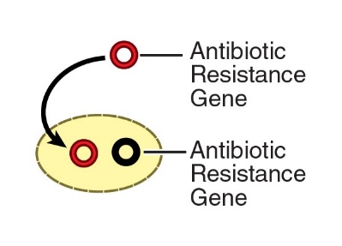
 | During a simple mating process called conjugation, antibiotic resistance genes can be transferred from one bacterium to another. Your Salmonella mates with another bacteria that is living in the intestine of the chicken. That bacteria cell gives your Salmonella a ciprofloxacin resistance gene. Add a green ciprofloxacin resistance gene to your Salmonella. | 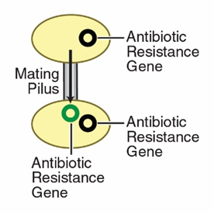
 | During transduction, antibiotic resistance genes are transferred from one bacterium to another by a virus. A virus picks up an antibiotic resistance gene from bacteria that contain a tetracycline resistance gene. The virus then injects the gene into your Salmonella. Add a blue tetracycline resistance gene to your Salmonella. | 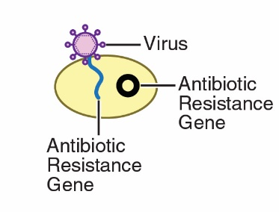
 | Mutations that create new antibiotic resistance genes are extremely rare.  If you roll a 5 on the dice, roll the dice three more times. If you roll 5’s on all four rolls of the dice, add a pink penicillin resistance gene to your Salmonella. | Mutations are random changes in genes. Mutations are not caused by exposure to antibiotics. They rarely lead to antibiotic resistance genes.
 | Your Salmonella does not gain any new antibiotic resistance genes.  Do not add any new antibiotic genes to your Salmonella.

How Antibiotic-Resistant Bacteria Spread

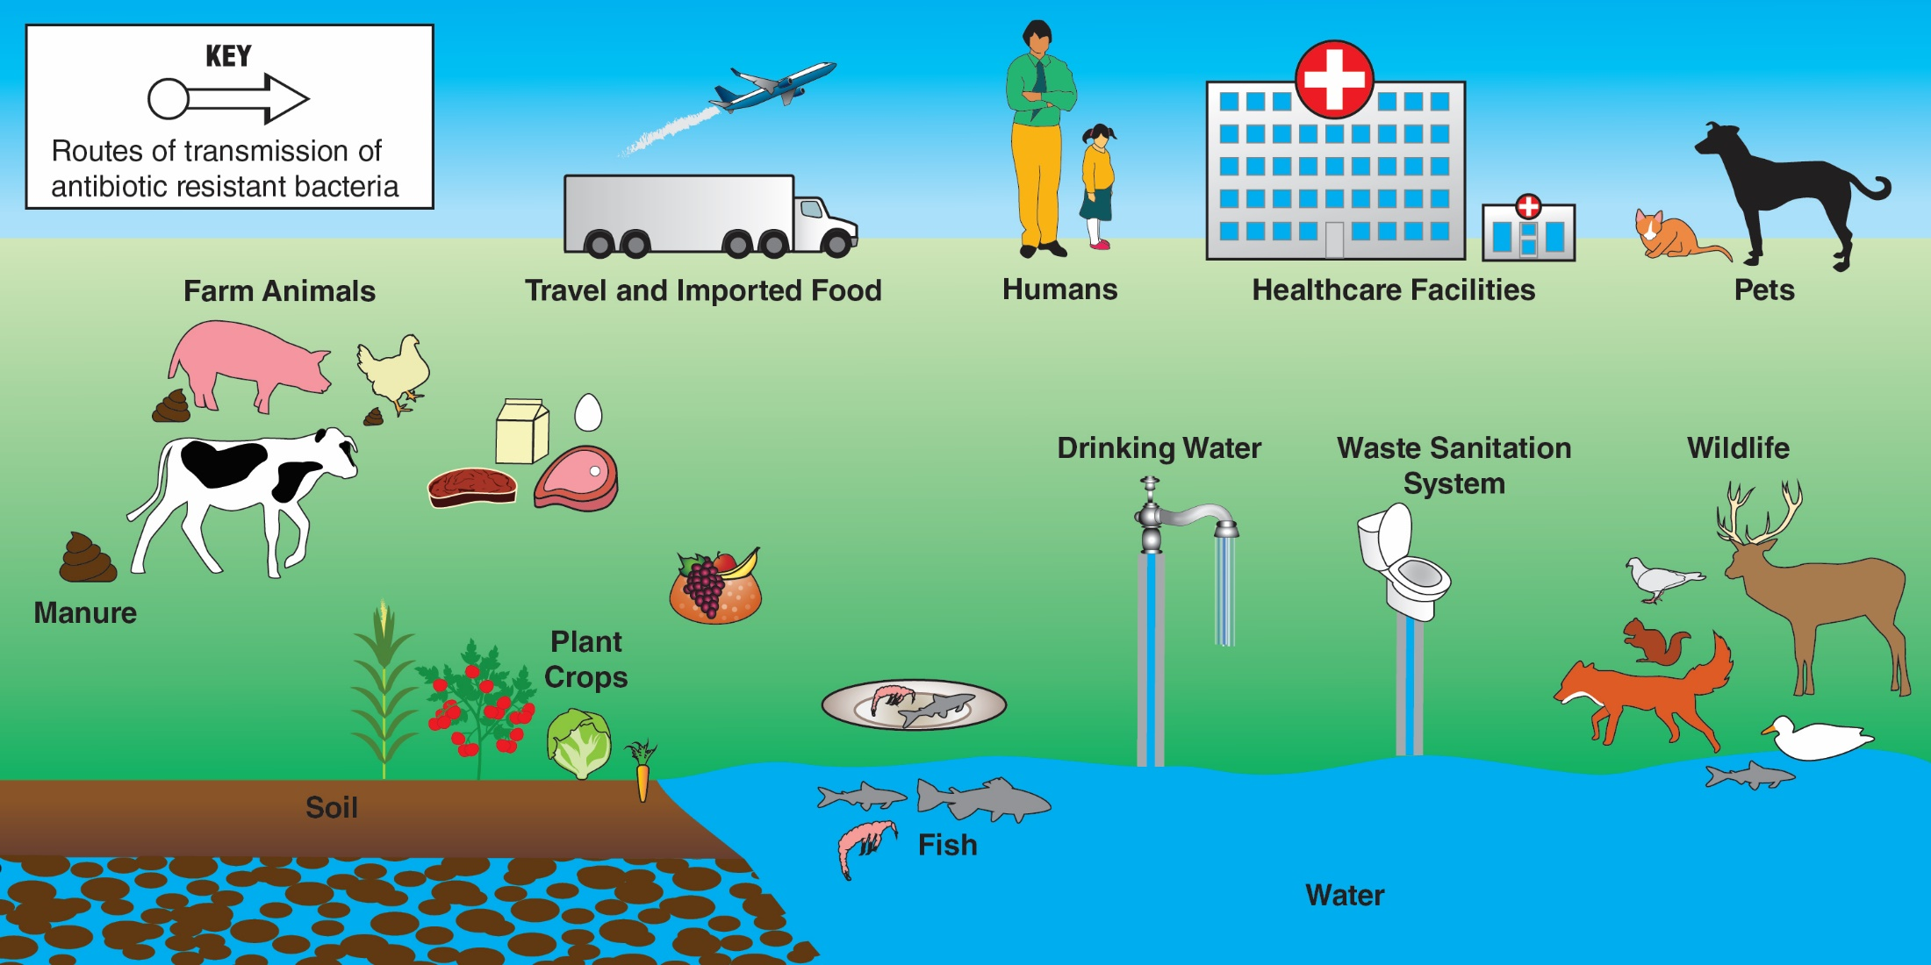
A
Teacher KEY for Part 5 Question 2

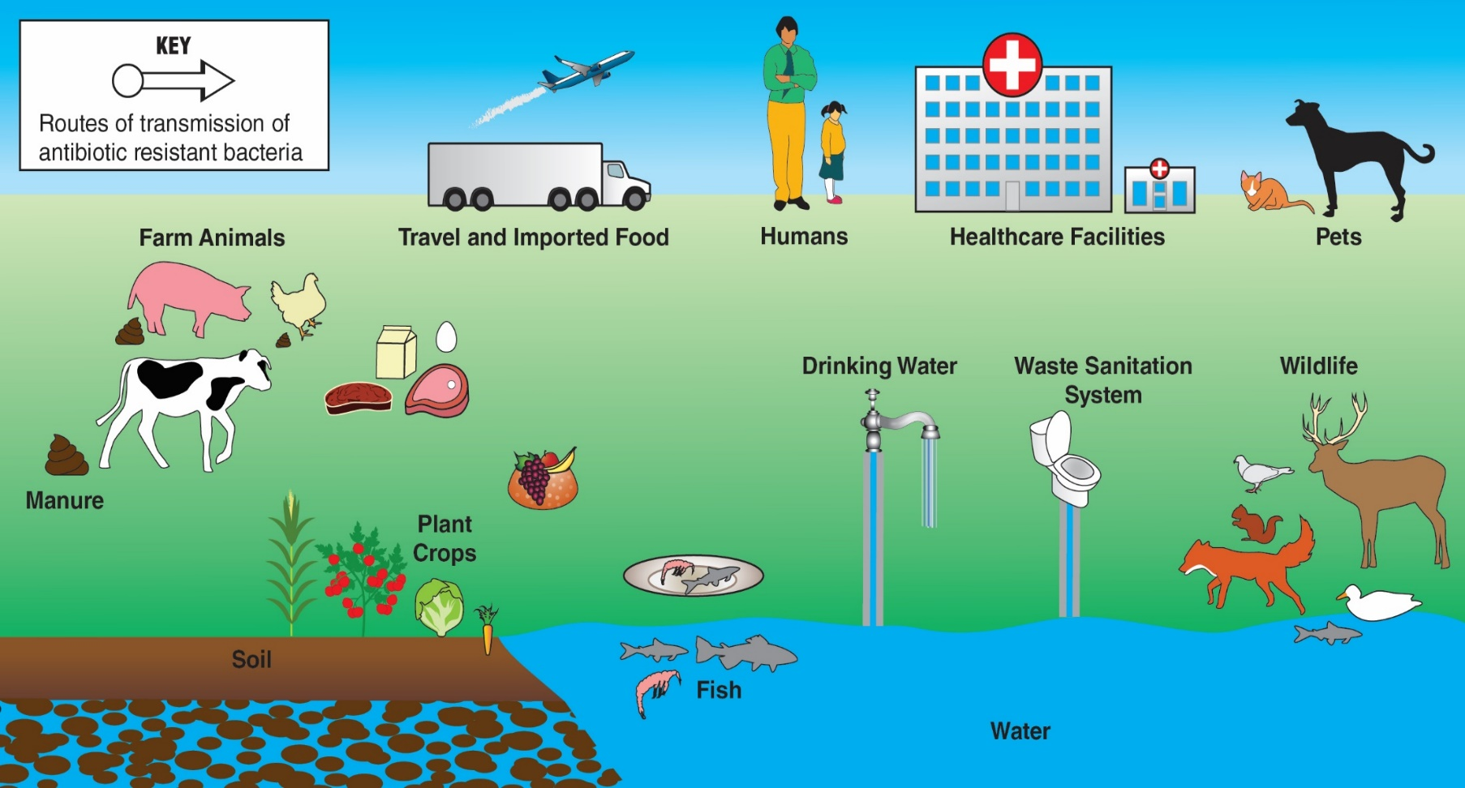
F
A
B
C=
D=
E=

NGSS Correlation:

Working Towards Performance Expectations
HS-LS4-3. Apply concepts of statistics and probability to support explanations that organisms with an advantageous heritable trait tend to increase in proportion to organisms lacking this trait. [Clarification Statement: Emphasis is on analyzing shifts in numerical distribution of traits and using these shifts as evidence to support explanations.] [Assessment Boundary: Assessment is limited to basic statistical and graphical analysis. Assessment does not include allele frequency calculations.]
Science and Engineering Practices  - Apply concepts of statistics and probability (including determining function fits to data, slope, intercept, and correlation coefficient for linear fits) to scientific and engineering questions and problems, using digital tools when feasible. | Disciplinary Core Ideas  - Natural selection occurs only if there is variation in the genes and traits between organisms in a population. Traits that positively affect survival can become more common in a population.  - Natural selection leads to adaptation, that is, to a population dominated by organisms that are anatomically, behaviorally, and physiologically well suited to survive and reproduce in a specific environment. That is, the differential survival and reproduction of organisms in a population that have an advantageous heritable trait leads to an increase in the proportion of individuals in future generations that have the trait and to a decrease in the proportion of individuals that do not.  - Adaptation also means that the distribution of traits in a population can change when conditions change. | Crosscutting Concepts  - Students observe patterns in systems at different scales and cite patterns as empirical evidence for causality in supporting their explanations of phenomena. They recognize classifications or explanations used at one scale may not be useful or need revision using a different scale; thus requiring improved investigations and experiments. They use mathematical representations to identify certain patterns and analyze patterns of performance in order to reengineer and improve a designed system.

An Outbreak of Antibiotic-Resistant Bacteria

Answer Key

Part 1: A dangerous Salmonella infection

Base your answers to questions 1 through 4 on the information in the text box below.

For 14-year-old Ajay, a case of food poisoning caused by Salmonella bacteria became life threatening. Some of the Salmonella bacteria escaped from his intestine and caused a serious infection in his circulatory and urinary systems. Ajay was treated with azithromycin, a type of antibiotic that doctors usually prescribe for Salmonella infections. Unfortunately, that antibiotic did not work, and Ajay kept getting sicker.

Ajay’s doctors ordered laboratory tests to determine which type of antibiotics might be effective in treating his bacterial infection. For these tests, disks with different antibiotics were placed on a growth medium in a lab dish. Then, a sample of Salmonella bacteria from Ajay was grown on the growth medium. The results of the tests are shown in the diagram below.
- If the Salmonella bacteria are killed by the antibiotic on the disk, a clear ring, called a zone of inhibition, will appear around the disk.
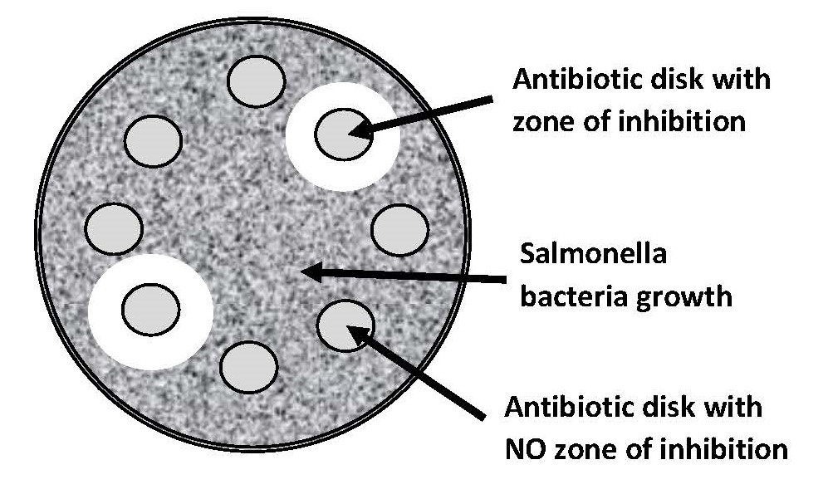
- If the Salmonella bacteria are resistant to (not killed by) the antibiotic on a disk, there is not a zone of inhibition around the disk.

- Each disk contains a different type of antibiotic. Why do six of the antibiotic disks not have a zone of inhibition around them?

Those disks have antibiotics that do not kill the bacteria.

- How many of the antibiotics tested would be effective in treating Ajay’s Salmonella infection? Support your answer with information from the diagram above.

Only two of the antibiotic disks have zones of inhibition around them and could be used to treat Ajay’s infection.

- How can you tell that the Salmonella that infected Ajay are antibiotic-resistant Salmonella?

Antibiotic resistant bacteria are bacteria that are not killed by one or more antibiotics. Most of the antibiotic disks had no zone of inhibition indicating that the bacteria are not killed by those antibiotics.

- Explain why the lab report from Ajay’s tests described the Salmonella that affected him as “multidrug-resistant” bacteria.

There were only two antibiotic disks with zones of inhibition. That means that the bacteria are multidrug-resistant because they are resistant to the antibiotics in all of the other disks.

Part 2: The source of the outbreak

Luckily, doctors found two antibiotics that were effective in killing the Salmonella bacteria that made Ajay so sick. After Ajay was treated with these antibiotics, he slowly recovered and was released from the hospital. Ajay asked his doctors if they knew how he was exposed to the Salmonella that made him so sick. The doctors said that epidemiologists were working to identify the source of the outbreak. About a month after Ajay recovered, his father noticed a news article about a Salmonella outbreak.

- Read the news article below. As you read, underline information that would help Ajay understand how he was exposed to the Salmonella that made him sick.

Salmonella Outbreak Linked to Contaminated Chicken

An outbreak of food poisoning caused by antibiotic resistant Salmonella bacteria has sickened at least 129 people. The Salmonella outbreak is a serious health threat because the antibiotics usually used to treat Salmonella infections are not effective for treating this outbreak.

Epidemiologists from the CDC (Centers for Disease Control and Prevention) conducted interviews with ill people. Most remembered eating different types and brands of chicken products purchased from many different locations.

CDC laboratory scientists conducted tests that identified the multidrug-resistant Salmonella in samples taken from affected humans, affected pets, some live chickens, some raw chicken products, and some raw pet food that contains chicken.

The CDC provided advice to physicians who are selecting antibiotic treatment for suspected cases of Salmonella infection. The CDC also shared this information with veterinarians, farmers, and food processors from the chicken industry. The CDC requested that they take steps to reduce Salmonella contamination.

Because not all chicken was contaminated, the CDC did not advise consumers to avoid eating chicken. They also have not recalled chicken products or advised stores to stop selling or recall chicken products. The CDC recommended that consumers avoid exposure to Salmonella bacteria by handling raw chicken carefully.

Base your answers to questions 2 through 5 on the information in the news article on the previous page.

- Explain why “multidrug-resistant” bacteria are dangerous.

They cause illnesses that are difficult to treat because only some antibiotics will kill the bacteria.

- The news article claims that chickens were the source of Salmonella that caused the outbreak. State two pieces of evidence to support this claim.

- Ill people who reported eating different types and brands of chicken products purchased from many different locations.
- Tests identified the multi-drug resistant Salmonella in samples taken from affected humans, affected pets, live chickens, raw chicken products, and raw pet food that contains chicken.

- The CDC did not recommend that people stop selling or buying chicken. State two pieces of evidence that support this decision by the CDC.

- Not all chicken was contaminated.
- There are things that people can do to protect themselves from exposure to Salmonella bacteria.

- Explain why the CDC provided information about the Salmonella outbreak to veterinarians, farmers, and food processors.

These people could take actions to prevent Salmonella contamination of animals and foods.

Part 3: How do bacteria become resistant to multiple antibiotics?

Ajay knows that mutations could cause new traits to appear. However, he also knows that mutations are rare and random events. He asked his biology teacher “How could Salmonella bacteria become resistant to many different antibiotics?”
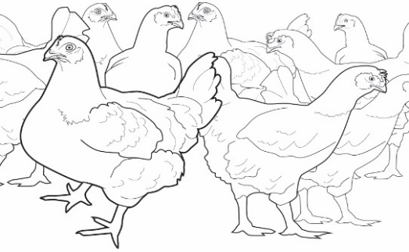
You and your classmates will model how Salmonella living in the intestines of a chicken may acquire antibiotic resistance genes from other bacteria around it.

The intestines of a chicken are crowded with millions of bacteria that may contain different antibiotic resistance genes—genes that enable them to survive exposure to specific antibiotics.

Key for Beads
Blue bead = Tetracycline resistance gene
Black bead = Erythromycin resistance gene
Green bead = Ciprofloxacin resistance gene
Pink bead = Penicillin resistance gene
Red bead = Cephalosporin resistance gene

- The cup provided by your teacher represents a Salmonella bacteria cell living in the intestine of a chicken. Use the Key for Beads on the right. Circle the name of antibiotic resistance gene that is present in your bacteria model?

- You will use dice rolls and beads to model how bacteria can become resistant to multiple antibiotics. The bag labeled Antibiotic Resistance Genes from Other Kinds of Bacteria contains beads that represent antibiotic resistance genes from other bacteria that live in the chicken’s intestines.

- Roll the dice. Follow the instructions on the Key for Dice Roll to determine what happens to the Salmonella bacteria. Did the Salmonella bacteria get a new antibiotic resistance gene?
If NO - Go to question 4.
If YES - Complete the next three bullets:

- Using the Key for Beads, circle the name of the new antibiotic resistant gene that is now present in your model bacteria.

- Using the Key for Dice Roll, name and describe the process by which the bacteria obtained the new gene.
Answers will vary
- Go to question 4.
- Roll the dice again. Follow the instructions on the Key for Dice Roll to determine what happens to the Salmonella bacteria. Did the Salmonella bacteria get a new antibiotic resistance gene?

If NO - Go to question 5.
If YES - Complete the next three bullets:
- On the Key for Beads, circle the name of the new antibiotic resistance gene that is now present in your model bacteria.

- Using the Key for Dice Roll, name and describe the process by which the bacteria obtained the new gene.

Answers will vary
- Go to question 5.

- Roll the dice again. Follow the instructions on the Key for Dice Roll to determine what happens to the Salmonella bacteria. Did the Salmonella bacteria get a new antibiotic resistance gene?

If NO - Go to question 6.
If YES - Complete the next three bullets:

- On the Key for Beads above, circle the name of the new antibiotic resistance gene that is now present in your model bacteria.

- Using the Key for Dice Roll, name and describe the process by which the bacteria obtained the new gene.
Answers will vary

- Go to question 6.

- Roll the dice again. Follow the instructions on the Key for Dice Roll to determine what happens to the Salmonella bacteria. Did the Salmonella bacteria get a new antibiotic resistance gene?

If NO - Go to question 7.
If YES - Complete the next three bullets:

- On the Key for Beads above, circle the name of the antibiotic resistance gene that is now present in your model bacteria.

- Using the Key for Dice Roll, name and describe the process by which the bacteria obtained the new gene.
Answers will vary

- Go to question 7.

- Multidrug-resistant bacteria are resistant to more than one antibiotic. Is your Salmonella bacteria model multidrug-resistant? If so, list the antibiotics that it is resistant to.

Student answers will vary depending on the antibiotic resistance genes in their bacteria.

- If a person becomes infected with Salmonella bacteria like the one that you modelled, what kinds of antibiotics would be effective for treating the infection? Explain how you can tell. Note: Refer to the Key for Beads.

Student answers will vary depending on the antibiotic resistance genes in their bacteria. Their explanation should include the idea that their model did not contain a bead or beads to represent the antibiotics in their answer.

- Observe the bacteria models made by other students in your class. Explain how you would identify the Salmonella bacteria model that would be most likely to survive and reproduce in an environment where multiple antibiotics are present.

The bacteria cell with the most different types of antibiotic resistance genes would be most likely to survive and reproduce.

- Ajay wanted to know how Salmonella bacteria could become resistant to many different antibiotics. Explain how bacteria could acquire resistance to multiple antibiotics without relying on the rare and random process of mutations.

Bacteria can get antibiotic resistance genes from other bacteria, from viruses, or from their environment.
Students may list the processes of transformation, transduction, or conjugation.

Part 4: Natural selection and antibiotic-resistant bacteria

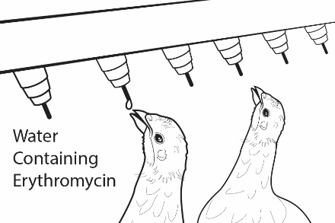
To prevent respiratory diseases in young chickens on his farm, a farmer adds an antibiotic called erythromycin to the water that the chickens drink. When the antibiotic erythromycin is used, only bacteria that have erythromycin resistance genes will survive.

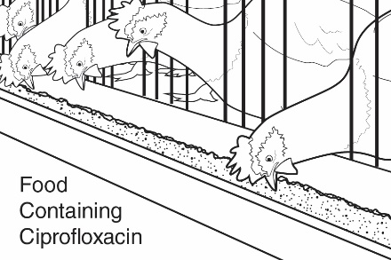
To prevent intestinal diseases in young chickens on the farm, the farmer uses chicken feed that contains an antibiotic called ciprofloxacin. When ciprofloxacin is used, only bacteria that have ciprofloxacin resistance genes will survive.

- What antibiotic resistance genes need to be present in Salmonella bacteria to enable them to survive and reproduce in the chickens that live on this farm?

Erythromycin and ciprofloxacin resistance genes

- Could the Salmonella bacteria that you modeled survive and reproduce in the intestines of chickens that live on this farm? Look at the cup with beads and the key from Part 3. Explain why or why not.

Student answers will vary depending on what antibiotic resistance genes are present in their model. The Salmonella bacteria will only survive if they have erythromycin and ciprofloxacin resistance genes.

- Did the use of antibiotics on the farm cause your Salmonella bacteria to become antibiotic resistant OR was your Salmonella bacteria resistant to antibiotics before the antibiotics were used on the farm? Support your answer with evidence from the model.

No, my bacteria had antibiotic resistance genes before it was exposed to the antibiotic.

- Natural selection occurs when genes for antibiotic resistance become more common in a population because they increase the organisms’ abilities to survive and reproduce. What genes are likely to become more common in the population of Salmonella bacteria that live on the chicken farm?

Resistance to erythromycin and ciprofloxacin

- The statements below describe events in the natural selection of bacteria that are resistant to the antibiotic penicillin. Indicate the order in which the events occurred by writing numbers (2, 3 or 4) in front of the statements.

___1___ Bacteria in the chickens’ intestines naturally have a variety of antibiotic resistance genes.

___2___ The bacteria are exposed to erythromycin when chickens drink their water.

___4___ Erythromycin-resistant bacteria become more common on the chicken farm.

___3___ Bacteria that are resistant to erythromycin survive and reproduce.

Animals in large industrial farms produce large quantities of manure - liquid (urine) and solid (feces) wastes. These wastes contain many different kinds of bacteria and viruses. Animal manure is often stored in open pits called “manure lagoons.”

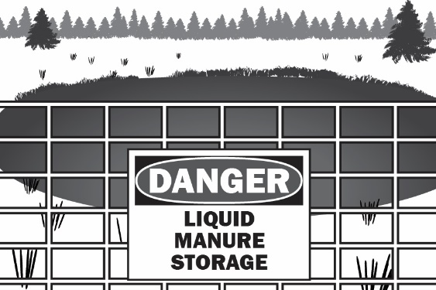
Manure lagoons are ideal places for bacteria reproduction. As the bacteria reproduce, they are exposed to low levels of antibiotics from the feces of animals that were treated with antibiotics. They are also surrounded by sources of antibiotic resistance genes such as viruses, free-floating antibiotic resistance genes, and other types of bacteria that are antibiotic resistant. This can result in new bacteria that are resistant to many different kinds of antibiotics. Wastes from manure lagoons may be used to fertilize fields or may be accidentally released into nearby water sources.

- Describe what conditions in a manure lagoon are likely to result in the evolution (natural selection) of new antibiotic-resistant bacteria.

There are many bacteria mixed with many sources of antibiotic resistance genes.
There are low levels of antibiotics that allow resistant bacteria to survive and reproduce more rapidly that non-resistant bacteria.

- Describe two ways that people might be exposed to antibiotic-resistant bacteria from manure lagoons.

By walking through fields fertilized with wastes. By eating plants grown in fields fertilized with wastes. By drinking water contaminated by wastes.

Part 5: The spread of antibiotic-resistant bacteria

Ajay claims that banning the sale of animal products from large farms is the best way to prevent outbreaks of diseases caused by antibiotic-resistant Salmonella. One of Ajay’s friends whose parents own a large dairy farm asked him to consider the chart below and rethink his claim.

Some Sources of Salmonella Outbreaks
Animal Products | Pets and Pet Products | Plant Products
Poultry  Beef  Pork  Fish  Milk  Cheese  Eggs  Ice cream | Birds  Reptiles such as turtles  Amphibians such as frogs  Dogs  Cats  Hedgehogs  Pet food  Pet treats | Bean sprouts  Melons  Lettuce  Onions  Tomatoes  Peppers  Spinach  Cucumbers  Cereal  Rice  Nuts  Spices

Modified from:
https://www.researchgate.net/figure/Some-sources-of-Salmonella-outbreaks_tbl1_278793722

- Does the information on the chart support Ajay’s claim that outbreaks of Salmonella could be prevented by banning the sale of animal products from farms that use antibiotics? Support your answer with information from the chart.

No because people could be exposed to antibiotic resistant Salmonella by eating plant products or coming in contact with pets or pet foods.

There are many ways that Salmonella can spread between humans, animals, and the environment. The six statements (A-F) listed below describe some of the ways that antibiotic-resistant bacteria such as Salmonella can spread between humans, animals, and the environment.

- Antibiotic-resistant bacteria from humans can enter waterways if they are not completely removed by waste sanitation systems.
- Farm animal manure applied to fields spreads antibiotic-resistant bacteria to soil and water.
- Crops can be contaminated by antibiotic-resistant bacteria in soil and water.
- Foodborne transmission of antibiotic-resistant bacteria to humans is a common route the spread to humans.
- Antibiotic-resistant bacteria enter humans when they drink contaminated water.
- Contact with pets and wildlife can transmit antibiotic-resistant bacteria to humans.

- Draw arrows on the How Antibiotic-Resistant Bacteria Spread picture to represent each of the six statements (A-F). Label the arrow with the letter of the statement that it represents. Note: As an example, the first statement has been shown on the picture using a red arrow and red “A”.

- Look at the arrows you drew on the How Antibiotic-Resistant Bacteria Spread picture. These arrows represent processes/routes that spread antibiotic-resistant bacteria. Suggest one way to block a process/route and prevent the spread of antibiotic-resistant bacteria to each of the following:

- Humans:

- Animals (pets or wildlife):

- The environment (soil, water, plants, or air):

Student answers will vary. Allow time for students to share their answers.

Part 6: One Health and antibiotic-resistant bacteria

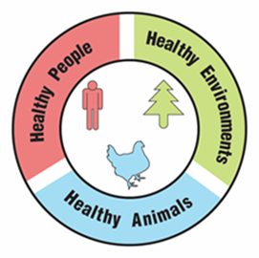
One Health

A university is suggesting that the local government take a One Health approach to solving complex local problems, such as antibiotic-resistant bacteria. A One Health approach uses the idea that complex problems often involve the health of people, animals, and the environment. Therefore, solutions to One Health problems must be designed to protect the health of people, animals, and the environment.

- Use the information in the text box above to explain what must be involved in a complex problem for it to be considered a One Health problem.

It must involve humans, animals, and the environment.

To support adoption of a One Health approach, the university officials want to create a series of slides to provide examples of One Health problems in the community. Your team has been hired to create a slide to answer the question, “Why are antibiotic-resistant bacteria a One Health problem?”

Remember how the CDC video used images with captions to help people understand what One Health problems and solutions involve. Using pictures and captions will help people understand and remember what the One Health approach involves.

- Use the information in the text box above and what you learned about antibiotic-resistant bacteria to develop your slide. Use the following template to organize your slide:

Why are antibiotic-resistant bacteria a One Health problem?
Picture and a caption to explain how animals are involved in the problem | Picture and a caption to explain how humans are involved in the problem | Picture and a caption to explain how the environment is involved in the problem

