

A Case of Unintentional Overdose

Core Concepts:
- Acetaminophen is a pain medicine found in many over-the-the counter medications and some prescription medications.
- Acetaminophen overdose can cause liver damage.
- Liver damage can lead to serious illness or death because the liver carries out many functions critical for maintaining homeostasis.
- Acetaminophen overdose can result from taking too much of one medicine.
- Acetaminophen overdose can result from taking two or more medicines that contain acetaminophen.

Class Time Required:
2-3 forty minute class periods

Teacher Provides:
For each student
- Copy of student handout entitled A Case of an Unintentional Overdose
- Copy of General Safety Precautions. See page vii. Each student only needs a half sheet.

For each team of students
- Color copies of the three medicine labels. See pages viii through x.
- Laboratory Test Sheet—printed on plastic transparency. Each team only needs a half sheet. See page xi. Alternatively, you can print it on paper and place the paper strip into a plastic sheet protector.
- Color Charts for Laboratory Tests—printed in color. Each team only needs a half sheet. See page xii.
- 3 labeled droppers:
- Luis Cordera Blood Plasma
- Bilirubin Test Solution
- Albumin Test Solution
- Small tube labeled Luis Cordera Blood Plasma containing at least 2 ml of pH 10 buffer solution. Purchase pH 10 buffer from a science supplier such as Ward’s Science. https://www.wardsci.com/store/catalog/product.jsp?product_id=8868691
Copyright © 2017 by University of Rochester. All rights reserved. May be copied for classroom use. This lesson was developed with support from the National Institutes of Health under Award Number R25OD010494. The content is solely the responsibility of the authors and does not necessarily represent the official views of the National Institutes of Health.
- Small tube labeled Bilirubin Test Solution containing at least 1 ml of 0.1% methyl red solution. Purchase methyl red from a science supplier such as Ward’s Science. https://www.wardsci.com/store/catalog/product.jsp?product_id=8880637
- Small tube labeled Albumin Test Solution containing at least 1 ml of 0.1% bromothymol blue. Purchase bromothymol blue from science supplier such as Ward’s Science. https://www.wardsci.com/store/catalog/product.jsp?product_id=8868613
- Small bag labeled ALT Enzyme Test Paper containing ½ strip of 1-12 pH paper. Purchase from Carolina Biological Supply. http://www.carolina.com/ph-test-papers/hydrion-jumbo-ph-strips-wide-range-ph-1-12-100-strips-per-vial-pack-5-vials/895280.pr

Teacher Resources:

- Your Guide to Over-the-Counter Pain Relief slideshow discusses what to consider when taking OTC pain relievers.
http://www.webmd.com/drug-medication/otc-pain-relief-10/slideshow-pain-relievers

- KnowYourDose.org from the Acetaminophen Awareness Coalition provides a variety of resources including a report and an infographic on acetaminophen use.
http://www.knowyourdose.org/

- Acetaminophen-Savvy resource guide: tools for teen influencers provides resources for teachers on the safe use of acetaminophen.
http://www.talkaboutrx.org/acetaminophen/teen-influencers-landing.jsp

- Taking Acetaminophen Safely is a YouTube video (approximately 2 minutes). It provides background about acetaminophen, a common over-the-counter pain reliever and fever reducer, and the many different types of medications that might contain acetaminophen; the danger of taking more acetaminophen than directed; how to learn if acetaminophen is in a medicine by looking at the Drug Facts label; and how to take acetaminophen safely https://www.youtube.com/watch?v=cBDOx85Ywck

- Ten Tips to Prevent an Accidental Overdose provides information on the importance of using the appropriate dosing devices when taking liquid medicine. http://www.fda.gov/ForConsumers/ConsumerUpdates/ucm253338.htm

Suggested Class Procedure:
- Distribute a copy of A Case of Unintentional Overdose student instructions to each student.
Warning: It is essential that you maintain families’ legal rights to privacy related to health and medicine use. Do not allow students to provide or discuss examples of medicines or dietary supplements used by their family members.

Note: The everyday use of the words “drugs”, “medicines”, and “dietary supplements” is different from the definitions used by the FDA (Food and Drug Administration). However, to help students relate the activity to their lives, we have used the words “drug” and “medicine” interchangeably.

- Assign students to work in pairs to complete Part 1: Completing a Patient Record for Luis Cordera.
- Several students read their answers to Part 1.
- Distribute and review General Safety Precautions.
- Assign students to work in pairs students to complete Part 2: Laboratory Tests for Luis Cordera.
- Read the first two paragraphs of Part 2 aloud to class.
- Distribute laboratory materials for Part 2 to each pair of students.
- Students work with their partner and follow the instructions to complete Part 2.
- Select students to read their answers to questions 19 and 20 in Part 2.
- Distribute 3 medicine labels for Part 3.
- Students work with their partner to complete Part 3: What Caused Luis Cordera’s Liver Damage?
- Select students to share their answers to question 7 in Part 3.
- Students work with their partner or individually to complete Part 4: Why is a Healthy Liver Important? Note that Part 4 may be done for homework.
- Several students share their answers to questions 1 and 2 in Part 4.
- Display student labels created in Part 4. Consider having students use post it notes to “vote” for the poster was most effective. For the poster they chose, they should write one feature of the poster that made it effective.
- Optional: The multiple choice questions on pages iv-vi may be used for homework or as a quiz.

Multiple Choice Questions – A Case of Unintentional Overdose

Base your answers to questions 1 through 4 on the information in the box below.

Acetaminophen is the most commonly used drug ingredient in America. It is found in over 600 over-the-counter (OTC) and prescription drugs. Many people don’t realize that acetaminophen found in a variety of their prescription and over-the-counter medicines, including pain relievers, fever reducers, and many cough and cold medicines.

When taken as directed, acetaminophen is safe and effective pain reliever and fever reducer. Like any medicine, however, there is a limit to how much should be taken in one day. The U.S. Food and Drug Administration (FDA) recommends a maximum daily dose of no more than 3,000 milligrams (mg) of acetaminophen.

Taking more acetaminophen than directed is an overdose and can lead to liver damage or death. An overdose occurs when a person takes too much acetaminophen at one time or takes a second dose before they are supposed to in an effort to help manage pain. Using multiple medications that contain acetaminophen can also result in an overdose. If a person takes an overdose of acetaminophen, they should seek prompt medical treatment by immediately contacting a doctor or a Poison Control Center.

- Acetaminophen may be found in
- Over-the-counter medicines only.
- Prescription medicines only.
- Both over-the-counter and prescription medicines.

- Taking more than the recommended amount of acetaminophen may result in
- Alcoholism.
- Liver damage.
- Fever and muscle aches.

- An acetaminophen overdose may result when a person takes
- More than one medicine that contains acetaminophen.
- A medicine prescribed for another person.
- 2000 mg of acetaminophen per day.

- If you suspect that someone has taken an acetaminophen overdose,
- It is a problem for children, but not for adults.
- Contact a doctor or a Poison Control Center immediately.
- Wait to see if you notice any unusual signs or symptoms.

Base your answers to questions 5 through 12 on the Adult Strength Acetaminophen Drug Facts label shown below.
Adult Strength Acetaminophen
DRUG FACTS LABEL
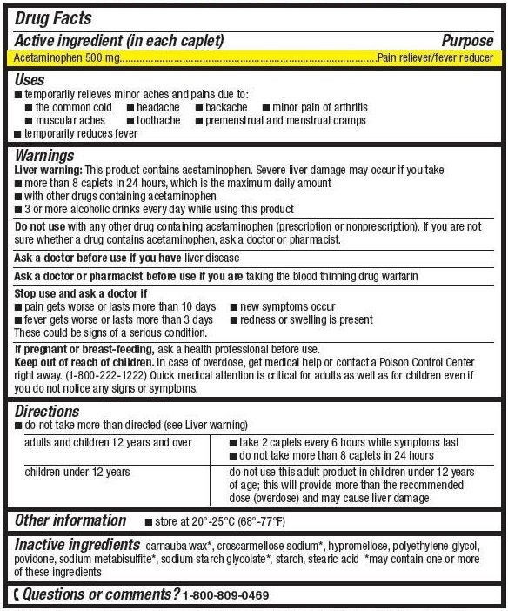

- According to the information on the label, acetaminophen is
- An antihistamine.
- A muscle relaxant.
- A pain reliever and fever reducer.

- How much acetaminophen is in one Adult Strength Acetaminophen caplet?
- 500 mg
- 1000 mg
- 5000 mg

- What is considered a safe dose of Adult Strength Acetaminophen that an adult could safely take at one time?
- 1 caplet
- 2 caplets
- 8 caplets

- How long should an adult wait before taking additional Adult Strength Acetaminophen caplets?
- 4 hours
- 6 hours
- 8 hours

- What is the largest number of Adult Strength Acetaminophen caplets that an adult can safely take in a 24 hour period?
- 4 caplets
- 6 caplets
- 8 caplets

- A person should consult a doctor before taking Adult Strength Acetaminophen if they
- Consume three or more alcoholic beverages every day.
- Are 12 years old and over.
- Have been diagnosed with kidney disease.

- A person should not take Adult Strength Acetaminophen if they take
- Dietary supplements
- Herbal supplements
- Other medicines that contain acetaminophen

- A person should stop taking Adult Strength Acetaminophen and contact their doctor if they experience
- A fever that gets worse or lasts for more than 3 days
- Pain that lasts for more than twenty four hours.
- Nervousness and excitability

- When the liver stops functioning, it is a medical emergency that requires immediate treatment because
- Treatment with albumin and alcohol can prevent liver damage.
- A healthy liver is essential for maintaining homeostasis.
- Patients with liver damage can only survive if they get an immediate liver transplant.

- Liver damage caused by acetaminophen is usually diagnosed by
- Treating the patient with a medicine that destroys acetaminophen.
- Taking X-rays of the patient’s liver.
- Testing a patient’s blood plasma for high levels of bilirubin and liver enzymes.

- Albumin is a plasma protein made by the liver. Albumin is a protein needed to keep the correct amount of water in the blood and body tissues. Liver damage would result in
- An increase in protein in the diet.
- A decrease in albumin in the blood.
- Dehydration due to high albumin levels.
General Safety Precautions
- Work in a clean, uncluttered area. Cover the work area to protect the work surface.
- Read and follow all instructions carefully.
- Pay particular attention to following the specific safety precautions included in the instructions.
- Wear safety goggles while performing experiments using chemicals.
- Do not use droppers as “squirt guns”.
- Never taste or ingest any chemicals used for this activity - they may be toxic.
- Do not eat, drink, or apply make-up or contact lenses while performing experiments.
- Wash your hands before and after performing experiments.
- Chemicals used in experiments may stain or damage skin, clothing or work surfaces. If spills occur, wash the area immediately and thoroughly.
- Follow your teacher’s instructions for end-of-experiment clean-up.

General Safety Precautions
- Work in a clean, uncluttered area. Cover the work area to protect the work surface.
- Read and follow all instructions carefully.
- Pay particular attention to following the specific safety precautions included in the instructions.
- Wear safety goggles while performing experiments using chemicals.
- Do not use droppers as “squirt guns”.
- Never taste or ingest any chemicals used for this activity - they may be toxic.
- Do not eat, drink, or apply make-up or contact lenses while performing experiments.
- Wash your hands before and after performing experiments.
- Chemicals used in experiments may stain or damage skin, clothing or work surfaces. If spills occur, wash the area immediately and thoroughly.
- Follow your teacher’s instructions for end-of-experiment clean-up.

Medicine Labels for “A Case of Unintentional Overdose”

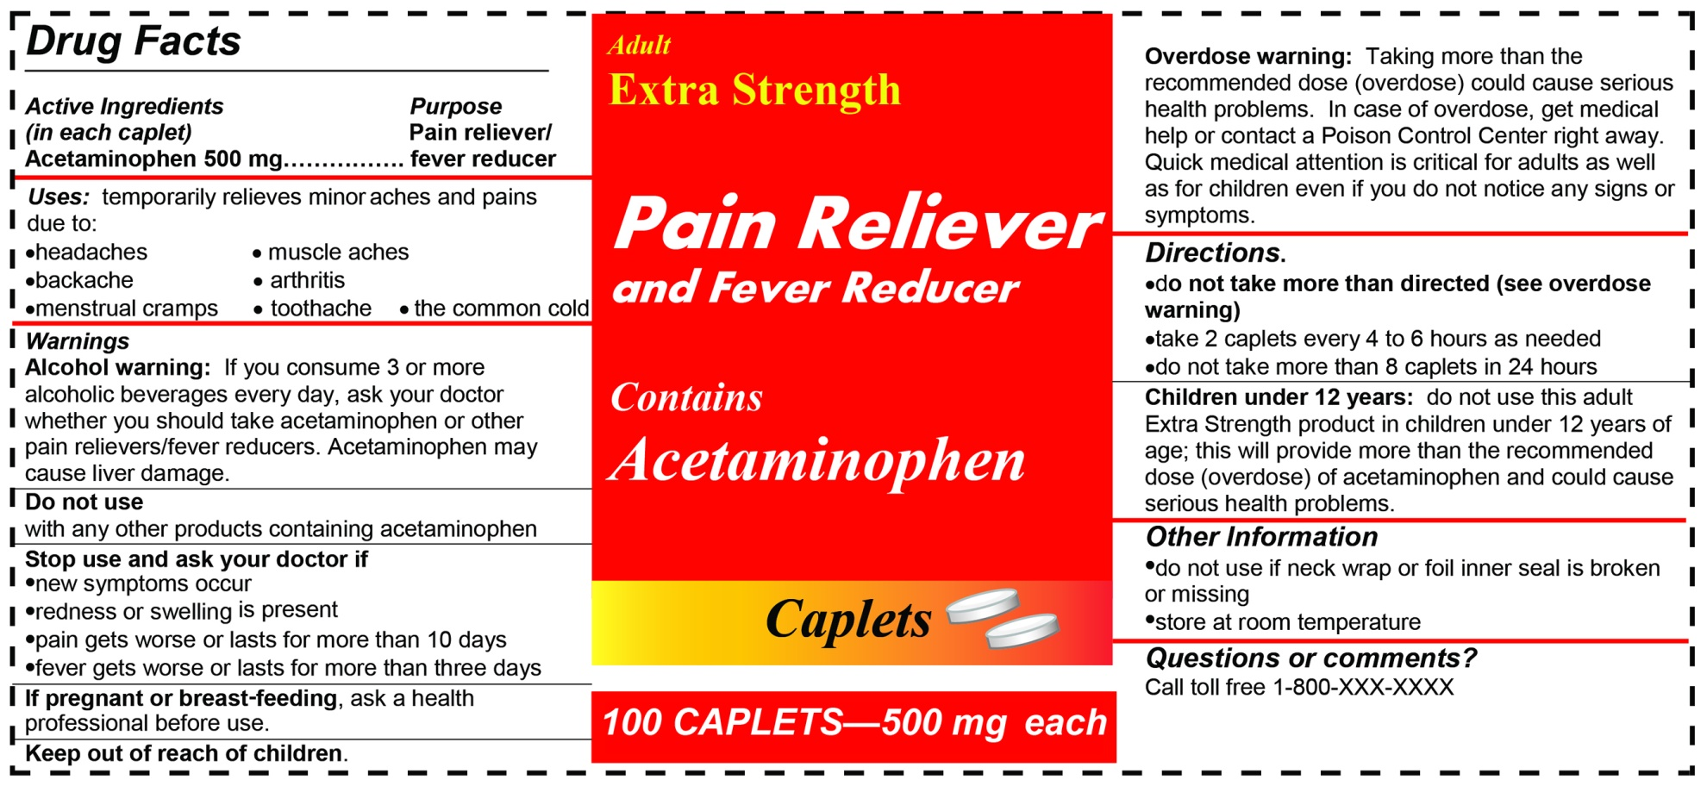

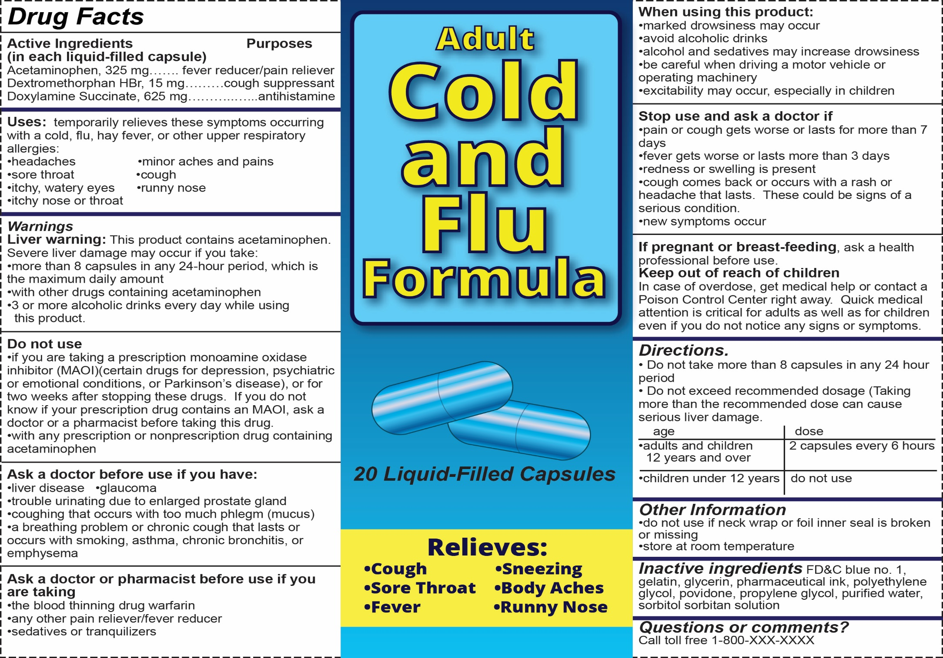
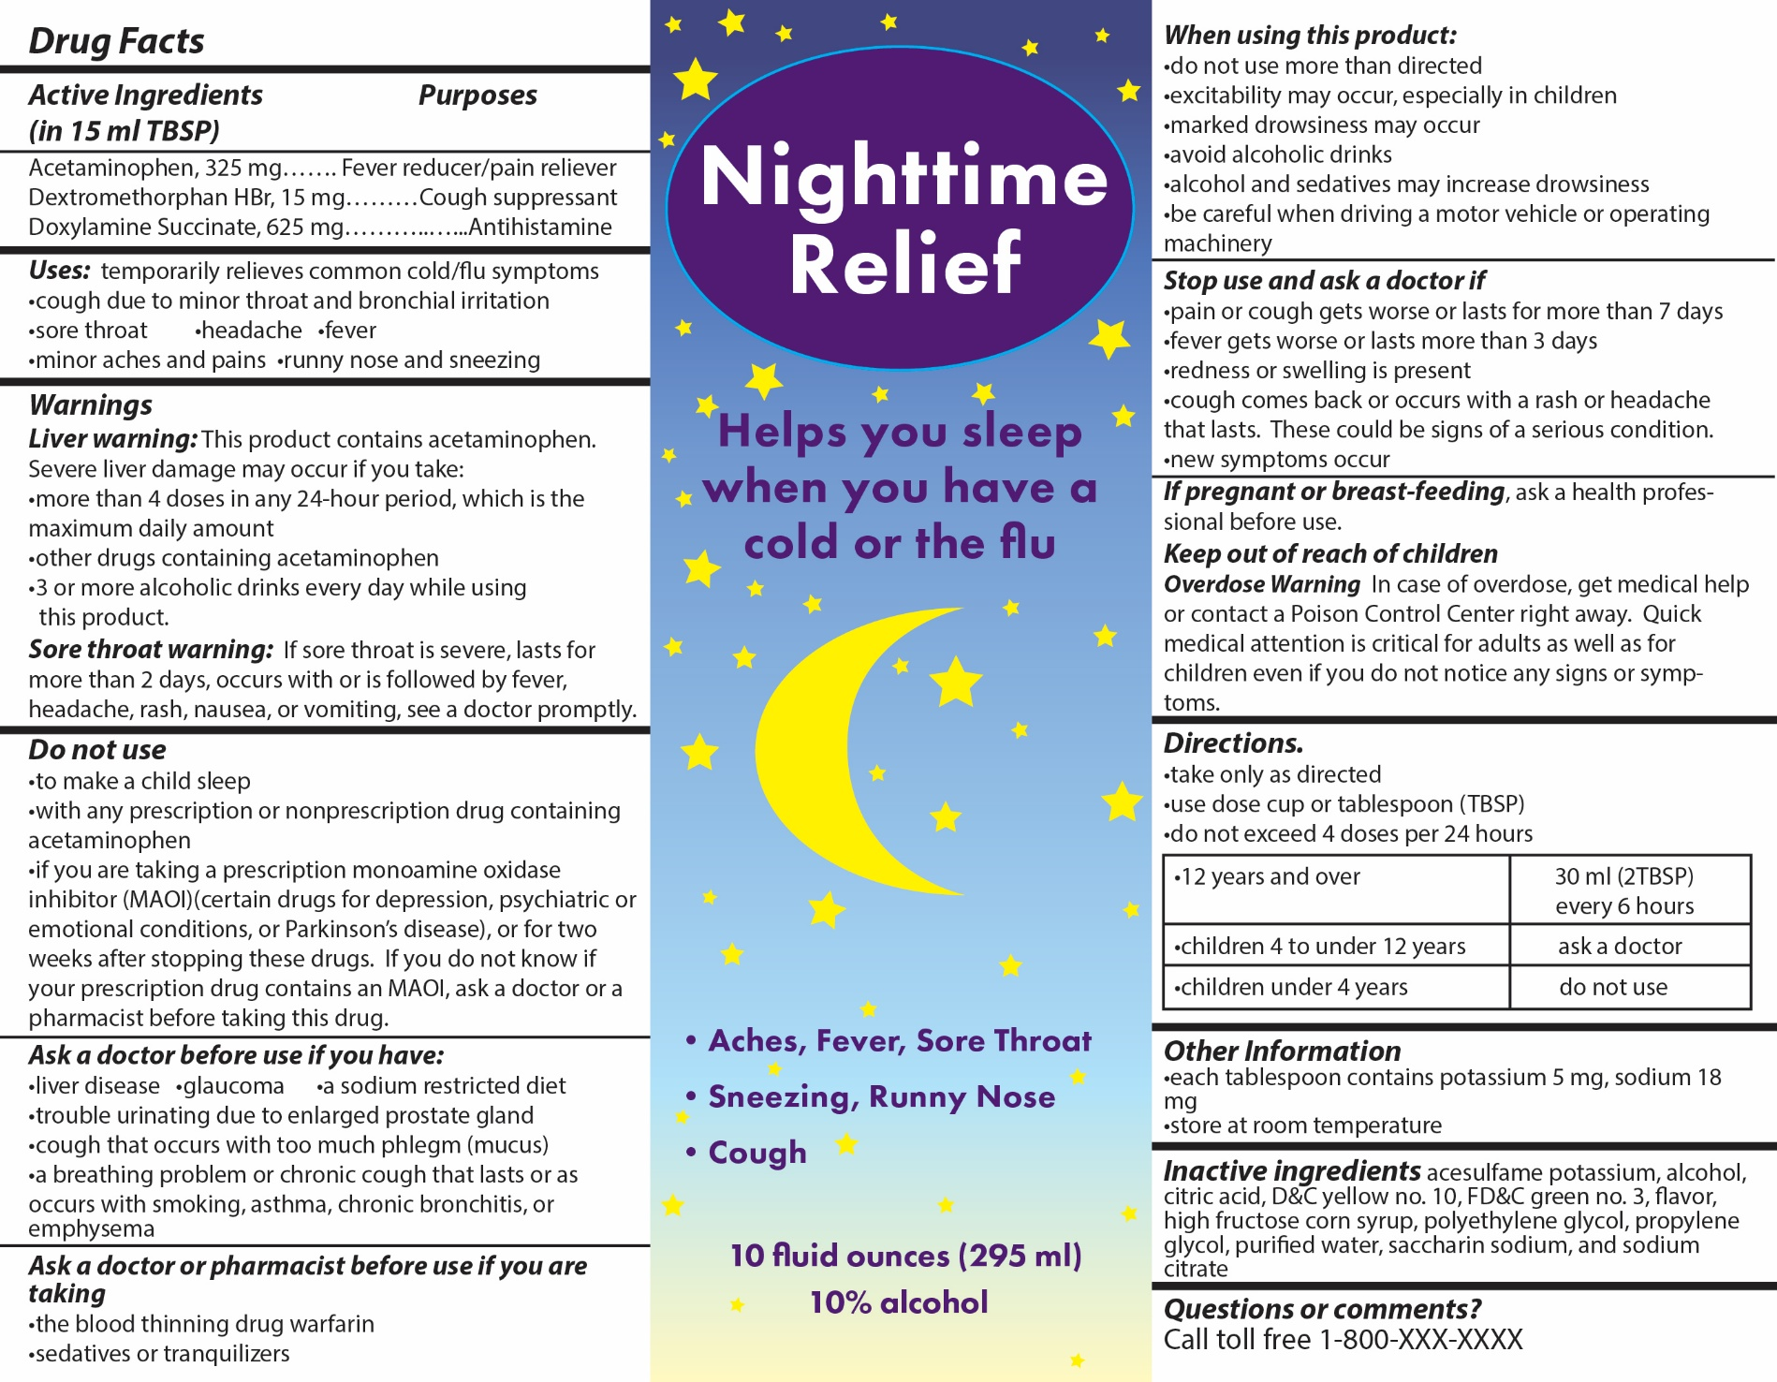

Laboratory Test Sheet
Laboratory Tests | Add 2 drops of  Luis Cordera Blood Plasma to each circle.
Plasma Bilirubin Test

Add 1 drop of
Bilirubin Test Solution to this circle.
Plasma Albumin Test

Add 1 drop of
Albumin Test Solution to this circle.
ALT Enzyme Test
Add one strip of
ALT Test Paper
to this circle.

Laboratory Test Sheet
Laboratory Tests | Add 2 drops of  Luis Cordera Blood Plasma to each circle.
Plasma Bilirubin Test

Add 1 drop of
Bilirubin Test Solution to this circle.
Plasma Albumin Test

Add 1 drop of
Albumin Test Solution to this circle.
ALT Enzyme Test
Add one strip of
ALT Test Paper
to this circle.

Color Charts for Laboratory Tests

Plasma Bilirubin Test
Low | Normal | High

Plasma Albumin Test
Low | Normal | High

ALT Enzyme Test
Low | Normal | High
Color Charts for Laboratory Tests

Plasma Bilirubin Test
Low | Normal | High

Plasma Albumin Test
Low | Normal | High

ALT Enzyme Test
Low | Normal | High

A Case of Unintentional Overdose

The Case

Two days ago, fourteen year-old Luis Cordera felt like he was coming down with the flu and had trouble sleeping. He took some over-the-counter medicines for his headache, cold symptoms, and insomnia (difficulty sleeping). Over-the-counter medicines are legal drugs that can be purchased without a prescription from a doctor. They can be purchased at pharmacies, grocery stores, or convenience stores.

Today at school, Luis began feeling nauseous and started vomiting. His stomach hurt, he was sweating excessively, and his heart felt like it was racing. Luis’s science teacher noticed that the whites of his eyes and his skin were yellowish, and he insisted that Luis go to the school nurse. The nurse called Luis’s parents and told them he should be taken immediately to the emergency room at a nearby hospital.

Part 1: Completing a Patient Record for Luis Cordera

- Use The Case information above to complete a patient record for Luis Cordera. List at least 5 symptoms that Luis is experiencing at school.

General Hospital - Patient Record

Date of Admission: 2/12/2017 Time of Admission: 2:50 pm
Patient Name: Luis Cordera Gender: Male Age: 14 years
Height: 65 inches (165 cm) Weight: 115 pounds (52.2 kilograms)
Temperature: 99 ºF (37 ºC) Heart Rate: 100 beats per minute

Symptoms:

- Do you think that Luis has the “stomach flu” or some other health problem? Support your answer with evidence from the patient record.
_________________________________________________________________________
_________________________________________________________________________

Part 2: Laboratory Tests for Luis Cordera

The emergency room doctor noticed that Luis had a medical condition called jaundice. Jaundice results when too much bilirubin (pronounced BIL-ee-roo-bin), a yellow pigment, accumulates in the body. This causes the skin and the whites of the eyes to turn yellow. Bilirubin is processed by the liver so that it can be eliminated from the body.
Jaundice can happen for many reasons, such as blood diseases, liver diseases, digestive diseases, infections, and medicines. The doctor ordered laboratory tests on Luis’s blood to help determine what was causing Luis’s jaundice.
- What is the name of the yellow pigment that builds up in the blood when a person has jaundice?
_________________________________

- List at least four things that can cause jaundice.
- ______________________________________________________________________
- ______________________________________________________________________
- ______________________________________________________________________
- ______________________________________________________________________

- Why might the doctor want to conduct laboratory tests on Luis Cordera’s blood?
_________________________________________________________________________
_________________________________________________________________________

Follow the instructions on pages 3 and 4 to conduct each of the three laboratory tests that the doctor ordered. Record the results of the laboratory tests on the Data Table: Laboratory Test Results sheet on the last page of this handout. Note: You may tear the Data Table page off to make it easier for you to record the results.

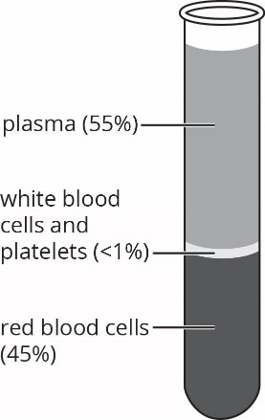

Blood Plasma

Plasma is a pale yellow liquid that makes up 55% of the blood. It is composed of water with dissolved salts, proteins, and enzymes. The primary purpose of plasma is to transport nutrients, hormones, and proteins to the parts of the body that need them. Cells also deposit their waste products into the plasma, and the plasma in turn helps remove this waste from the body.

Plasma Bilirubin Test

- Place two drops of Luis Cordera’s blood plasma sample onto the circle labeled “Plasma Bilirubin Test” on the Laboratory Test Sheet.
Bilirubin testing checks for levels of bilirubin in blood plasma. Bilirubin, a yellow pigment, is a waste product of the normal breakdown of red blood cells. Higher than normal levels of bilirubin may indicate different types of liver problems. Occasionally, higher bilirubin levels may indicate an increased rate of red blood cell breakdown.

- Add 1 drop of Bilirubin Test Solution to the plasma in the circle.
- Use the Plasma Bilirubin Test color chart to determine the level of bilirubin in the plasma sample.
- Record the results of the bilirubin test on the Data Table: Laboratory Test Results sheet.
- What does the result of the plasma bilirubin test indicate about Luis Cordera’s health? Record the answer to this question in the last column of the Data Table: Laboratory Test Results sheet.

Plasma Albumin Test
- Place two drops of Luis Cordera’s blood plasma sample onto the circle labeled “Plasma Albumin Test” on the Laboratory Test Sheet.
Albumin is a plasma protein made by the liver. Albumin is a protein needed to keep the correct amount of water in the blood and body tissues. Albumin testing measures the amount of this protein in the plasma. Low levels of plasma albumin may be a sign of kidney disease or liver disease. High levels of plasma albumin may be a sign of dehydration or a high protein diet.

- Add 1 drop of Albumin Test Solution to the plasma in the circle.
- Use the Plasma Albumin Test color chart to determine the albumin level.
- Record the results of the albumin test on the Data Table: Laboratory Test Results sheet.
- What does the result of the plasma albumin test indicate about Luis Cordera’s health? Record the answer to this question in the last column of the Data Table: Laboratory Test Results sheet.

ALT Enzyme Test
- Place two drops of Luis Cordera’s blood plasma sample onto the circle labeled “ALT Enzyme Test” on the Laboratory Test Sheet.
The ALT enzyme test measures the level of ALT enzyme in blood plasma. ALT is an enzyme that helps the liver break down proteins that can be used as a source of energy. ALT is normally found inside liver cells. If liver cells are damaged, they may release ALT enzyme into blood plasma. Therefore, ALT enzyme in blood plasma indicates liver damage.

- Add 1 strip of ALT Enzyme Test Paper to the plasma in the circle.
- Use the ALT Enzyme Test color chart to determine the ALT enzyme level.
- Record the results of the ALT enzyme test on Data Table: Laboratory Test Results sheet.
- What does the result of the ALT enzyme test indicate about Luis Cordera’s health? Record the answer to this question in the last column of the Data Table: Laboratory Test Results sheet.

Conclusions
- Based on all of the test results, what can you conclude is causing Luis Cordera’s jaundice? Support your conclusions with at least three pieces of evidence from the Data Table: Laboratory Test Results sheet.
_________________________________________________________________________
_________________________________________________________________________
_________________________________________________________________________
_________________________________________________________________________
_________________________________________________________________________

- Which of the three tests provides the best evidence that Luis has liver damage? Support your answer with information provided from the test.
_________________________________________________________________________
_________________________________________________________________________
_________________________________________________________________________

Part 3: What Caused Luis Cordera’s Liver Damage?

The doctor explained that knowing what caused Luis’s liver damage would help him select the best treatment for Luis. The doctor asked Luis and his parents whether Luis had used alcohol, prescription medicines, over-the-counter medicines or illegal drugs during the last few days. Luis explained that he had only used over-the-counter medicines that were in his family’s medicine cabinet. All he had taken in the last few days were medicines for his headache, fever, flu symptoms, and some medicine to help him sleep. Luis also explained that he had been careful to read the directions and take only the dose that the label indicated.

Extra Strength Pain Reliever

Luis said that he took two Extra Strength Pain Reliever caplets when he woke up, two caplets at lunch time, two caplets at dinner time, and two caplets at bedtime.

- Look at the Extra Strength Pain Reliever label. How many mg (milligrams) of acetaminophen were in all of the Extra Strength Pain Reliever caplets that Luis took? _____________
Show your calculations in the space below.

- Did Luis follow the dosage instructions on the Extra Strength Pain Reliever label? _____________
Support your answer with information from the label.
_________________________________________________________________________
_________________________________________________________________________

Adult Cold and Flu Formula

Luis said he took two Adult Cold and Flu Formula capsules when he woke up, two capsules at lunch time, two capsules at dinner time, and two capsules at bedtime.

- Look at the Adult Cold and Flu Formula label. How many mg (milligrams) of acetaminophen were in all of the Adult Cold and Flu Formula capsules that Luis took? _____________
Show your calculations in the space below.

- Did Luis follow the dosage instructions on the Adult Cold and Flu Formula label? _____________
Support your answer with information from the label.
_________________________________________________________________________
_________________________________________________________________________
Nighttime Relief

Luis said he had been having trouble getting to sleep so he took 2 tablespoons (30 mL) of Nighttime Relief at 10:00 pm. When he was still awake at 11:00 pm, he took another 2 tablespoons.

- Look at the Nighttime Relief label. How many mg (milligrams) of acetaminophen were in all of the Nighttime Relief liquid that Luis took? _____________ milligrams
Show your calculations in the space below.

- Did Luis follow the instructions on the Nighttime Relief label? _____________
Support your answer with information from the label.
_________________________________________________________________________
_________________________________________________________________________

The doctor explained that many people don’t realize that acetaminophen is found in many over-the-counter medicines, including pain relievers, fever reducers, and cough and cold medicines. While acetaminophen is safe and effective when used as directed, there is a limit to how much you should take in one day. Adults weighing over 50 kg (110 pounds) can take a maximum dose of 4,000 milligrams per day. Taking more acetaminophen than directed is an overdose that can lead to liver damage.
- Luis weighs 115 pounds. Did Luis take an overdose of acetaminophen? _____________
Support your answer by calculating the total amount of acetaminophen Luis took. Show your work in the space below.
- Extra Strength Pain Reliever
- Adult Cold and Flu Formula
- Nighttime Relief
- TOTAL =

Some people do not realize that prescription medicines may also contain acetaminophen. Before taking over-the-counter pain medicines, it is important to read prescription labels or ask a doctor or a pharmacist to be sure the prescription medicine you are taking does not contain acetaminophen. On prescription medicine labels, acetaminophen is often listed as APAP.

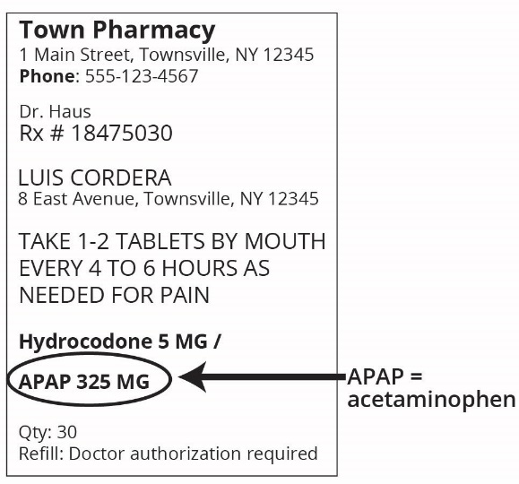
- Would it be safe for Luis to take Adult Cold and Flu Formula and the prescription medicine shown on the right? Explain why or why not.
________________________________________________________________________________
________________________________________________________________________________
________________________________________
________________________________________

- A new report from the Acetaminophen Awareness Coalition highlights common mistakes that patients often make when using acetaminophen:
- Taking more than the recommended dose for any of the medicines at a single time.
Did Luis do this for any of the medicines? Support your answer with specific information.
____________________________________________________________________________________________________________________________________________
______________________________________________________________________

- Taking the next dose too soon.
Did Luis do this? Support your answer with specific information.
____________________________________________________________________________________________________________________________________________
______________________________________________________________________

- Using multiple products with acetaminophen at the same time.
Did Luis do this? Support your answer with specific information.
____________________________________________________________________________________________________________________________________________
______________________________________________________________________

Part 4: Why is a Healthy Liver Important?

The doctor told Luis’s parents that Luis’s condition was extremely serious. The results of Luis’s laboratory tests indicated that his liver was severely damaged. The doctor explained that when the liver stops functioning, it is a medical emergency that requires immediate treatment.

The liver is a large reddish brown organ that sits on the right side of the belly. A healthy liver is essential for maintaining homeostasis because it:
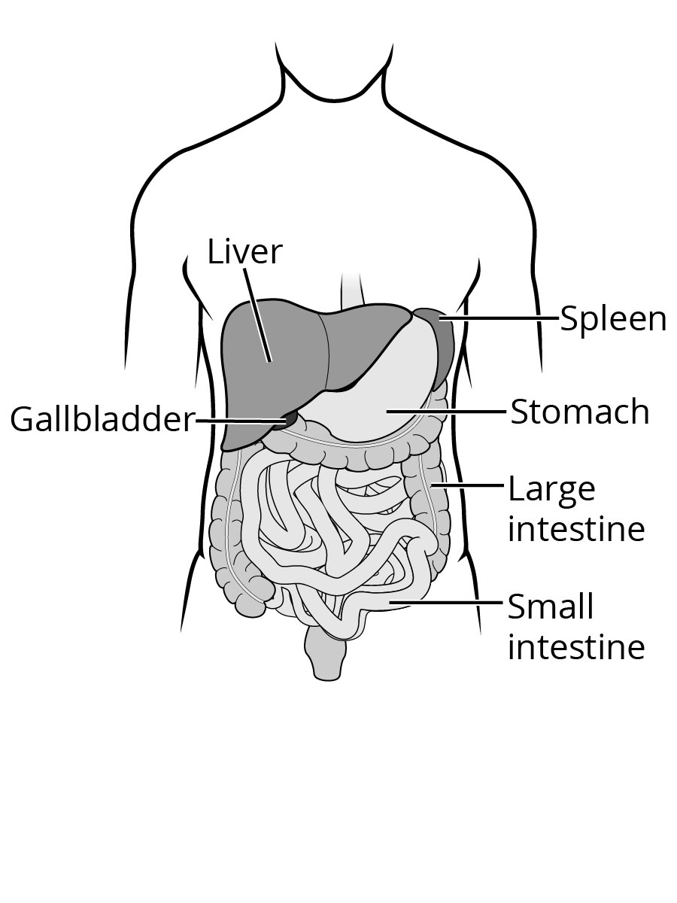
- Removes excess sugar and amino acids from the blood.
- Releases sugar into the blood when blood sugar levels are low.
- Removes waste products such as bilirubin, ammonia, and other toxins from the blood.
- Absorbs and stores fat, sugars, vitamins, iron, and other minerals.
Homeostasis is a healthy state that is maintained by the constant adjustment of biochemical and physiological processes needed to keep the body stable enough to function properly. Failure to maintain homeostasis may result in illness or death.

- Produces cholesterol that is important for cell membrane structure.
- Produces important proteins such as albumin and blood clotting enzymes.
- Breaks down (metabolizes) alcohol and many drugs.

- List at least five ways in which liver damage result in a lack of homeostasis for Luis.
- ______________________________________________________________________
______________________________________________________________________
- ____________________________________________________________________________________________________________________________________________
- ____________________________________________________________________________________________________________________________________________
- ____________________________________________________________________________________________________________________________________________
- ____________________________________________________________________________________________________________________________________________

- Do you think that Luis can survive if his liver does not begin functioning again? Explain why or why not.
_________________________________________________________________________
_________________________________________________________________________

A person who took an overdose of acetaminophen usually shows no symptoms until two days after the overdose. By then it may be too late for medical treatment to be effective, and liver damage could lead to death. Luis is very lucky because he received medical treatment within one day of his acetaminophen overdose.

Luis is responding well to treatment with Acetadote, a medicine used to treat acetaminophen overdoses. Luis has been in the hospital’s intensive care unit for four days. Recent tests indicate that Luis’s liver function is gradually returning to normal. He is expected to return home in a week or two.

For more information on acetaminophen overdose see:
- MedlinePlus: Acetaminophen Overdose https://www.nlm.nih.gov/medlineplus/ency/article/002598.htm
- eMedicine Health: Acetaminophen (Tylenol) Poisoning http://www.emedicinehealth.com/acetaminophen_tylenol_poisoning/article_em.htm

- Some products have safety warning labels to be certain that people understand the risks of using these products. On a separate sheet of paper, design an acetaminophen warning label that could be used on any medicine that contains acetaminophen. This label should:
- Be easily understood by someone with limited ability to read English.
- Make people aware that serious liver damage may result from an acetaminophen overdose.

Data Table: Laboratory Test Results

Laboratory Tests | Results  (low, normal, or high) | Interpretation of Results:  What do the results indicate about Luis Cordera’s liver function?  Hint: Refer to the information about each test under the test title.
Plasma Bilirubin Test
Plasma Albumin Test
ALT Enzyme Test

