
Cold, Flu, or Allergy?

Core Concepts:
- Colds, the flu, and respiratory allergies have similar symptoms but they are treated with different drugs.
- The Drug Facts label on over-the-counter drugs provides information essential for selecting and using drugs safely.
- A doctor or pharmacist can provide advice to help people select over-the-counter drugs.

Class time required:
2-3 forty-minute class periods

Teacher Provides:
For each student
- Copy of student handout entitled Cold, Flu, or Allergy?

For Part 1 - Each team of students will need:
- Small plastic bag labeled “Eva Miller” containing a single-ended cotton swab that has been dipped into a 2% phenolphthalein solution and allowed to air dry. Purchase regular cotton swabs and then use scissors to cut one cotton end off. Phenolphthalein solution can be purchased from a science supply company such as Ward’s Science or Carolina Biological Supply.
- Small plastic bag labeled “Kyla Miller” containing a single-ended cotton swab. Do NOT treat this cotton swab with phenolphthalein.
- Small plastic bag labeled “Danielle Miller” containing a single-ended cotton swab. Do NOT treat this cotton swab with phenolphthalein.
- Rapid Flu Test Strip printed on plastic transparency (see page vii). Alternatively, you can print it on paper and place the paper strip into a plastic sheet protector.
- Small tube labeled “Rapid Flu Test Solution” containing at least 1 mL of pH 10 buffer solution (or 1 mL of household ammonia diluted 1:10 with tap water). Purchase pH 10 buffer solution from a science supply company such as Ward’s Science or Carolina Biological Supply.
- Dropper (plastic transfer pipet) labeled “Rapid Flu Test Solution”

For Part 2 – Each team of students will need:
- Color copies of the 4 over-the-counter drug labels (see pages viii-xi). Optional: To make look more realistic, cut along the dotted lines to remove the white space from around the labels.
- Optional: Copy of General Safety Precautions for each pair of students (see page vi).
- Optional: Copy of How to Read a Drug Facts Label for each pair of students (see page xii).
Copyright © 2017 by University of Rochester. All rights reserved. May be copied for classroom use. This lesson was developed with support from the National Institutes of Health under Award Number R25OD010494. The content is solely the responsibility of the authors and does not necessarily represent the official views of the National Institutes of Health.
Teacher Resources:

- CDC - Influenza (Flu) provides a wide variety of resources related to influenza. http://www.cdc.gov/flu/

- CDC - Common Cold and Runny Nose provides information on the common cold. http://www.cdc.gov/getsmart/community/for-patients/common-illnesses/colds.html

- WebMD - Allergies Health Center provides information on allergies. http://www.webmd.com/allergies/

- WebMD - Cold, Flu, & Cough Health Center provides information on colds and influenza. http://www.webmd.com/cold-and-flu/default.htm

- WebMD - Allergy Medications lists and describes OTC and prescription drugs to relieve allergy symptoms. http://www.webmd.com/allergies/guide/allergy-medications

Warning: It is essential that you maintain families’ legal rights to privacy related to health and medicine use. Do not allow students to provide or discuss examples of medicines or dietary supplement used by their family.

Note: The everyday use of the words “drugs”, “medicines”, and “dietary supplements” is different from the definitions used by the FDA (Food and Drug Administration). The Fact Sheet uses the FDA language. However, to help students relate the activity to their lives, we have used the words “drug” and “medicine” interchangeably.

Suggested Class Procedure:

- Pose the questions below to the class and allow time for students to share their answers with the class:
- How could you tell whether your symptoms are caused by allergies, a cold, or the flu?
- There are many different kinds and brands of allergy, cold, and flu products that you can buy without a prescription. How do you or your parents choose the appropriate products to relieve symptoms caused by allergies, a cold, or the flu?
- Distribute Cold, Flu, or Allergy? student instructions to each student. Note: Teachers may want to distribute the student instructions in parts so that students do not read ahead. Distribute pages 1 and 2 first, then distribute pages 3 through 8 distributed after students have completed and analyzed the flu tests.
- Read the introduction to students. Have students predict which daughter, or daughters, have the flu. Select students to share and explain one of their predictions.
- Explain that they will be conducting lab tests to determine if Eva, Danielle, and Kyla Miller have the flu.
- Optional: Distribute and review General Safety Precautions.
- Distribute supplies for the Rapid Flu Test to each pair of students:
  - Bag labeled “Eva Miller” containing a cotton swab treated with 2% phenolphthalein
  - Bag labeled “Kyla Miller” containing a cotton swab
  - Bag labeled “Danielle Miller” containing a cotton swab
  - Rapid Flu Test Strip
  - Tube of “Rapid Flu Test Solution”
  - Dropper labeled “Rapid Flu Test Solution”
- Students complete Part 1: Rapid Influenza Tests
- Collect bags and tubes of Rapid Flu Test Solution for reuse in additional classes. Students should be instructed to discard the used cotton swabs and used Rapid Flu Test Strips.
- Distribute color copies of the 4 drug labels.
- Optional: Distribute a copy of How to Read an Over-The-Counter Drug Facts Label to each pair of students.
- Ask students to work with their partner to complete Part 2: Danielle’s Case.
- Students work with their partner to complete Part 3: Kyla’s Case and Part 4: Eva’s Case. Note: Students can complete Parts 2, 3, and 4 for homework.
- Optional extensions:
- Create a comparison chart that summarizes the similarities and differences between cold, flu, and allergy causes and symptoms.
- Make a list of the four most important things you learned about selecting and using over-the-counter drugs for cold, flu, or allergy symptoms. Have students share their lists to create a class list.
- Create a comparison chart to show the similarities and differences between cold, flu, and allergy. Include both symptoms and causes.
- Some people have proposed that antibiotics should be made available as over-the-counter medicines. Explain why most scientists are opposed to this proposal.
- What are the advantages and disadvantages for using combination versus single symptom medications?
- Optional: The multiple choice questions on pages iv- v may be used for homework or a quiz.

Multiple Choice Questions - Cold, Flu, or Allergy?

- It can be difficult to tell whether a person has a cold, the flu, or allergies because these all
- Are caused by viruses that damage the respiratory system.
- Cause respiratory system symptoms.
- Are treated using the same medicines.

- Which are symptoms of the flu, but not of allergies or the common cold?
- A high fever and body aches.
- A cough and runny nose.
- Itchy eyes and nose.

- Which type of over-the-counter medicine would be most effective for treating allergy symptoms?
- Analgesics
- Antihistamines
- Decongestant

- A long-lasting illness that can be treated but not cured is called
- An acute disease.
- A chronic disease.
- A respiratory disease.

- A 13 year old boy has a really bad cold and a bad headache. He wants to take both Multi-Symptom Cold Medicine for his cold symptoms and Tylenol for his headache. This may be dangerous if both medicines
- Contain the same pain reliever.
- Are used to treat allergies.
- Treat different symptoms.

- Prescription antiviral medicines such as oseltamvir and zanamivir
- Should only be used if flu symptoms last for more than three days.
- Provide immunity to influenza viruses.
- Reduce and shorten the duration of flu symptoms.

- Medicines used to suppress coughs are called
- Antitussives
- Decongestants
- Expectorants

- Medicines used to thin mucus and promote the clearing of mucus from the respiratory system are called
- Antitussives
- Decongestants
- Expectorants

- An analgesic/antipyretic is used to reduce
- Fever and pain.
- Itchy nose and eyes.
- Cough and nasal congestion.

- Young children, people over 65 years old, and people with chronic diseases are
- Not susceptible to antiviral medicines.
- Usually advised to avoid getting the influenza (flu) vaccination.
- Most at risk for serious complications from influenza (“the flu”).

- Any effect of a medicine that is in addition to its intended effect, especially an effect that is harmful or unpleasant, is called
- A side effect
- A drug interaction
- An overdose

- A decongestant makes it easier to breathe because it
- Reduces swelling of tissues in the nose.
- Prevents allergies by blocking antihistamines.
- Suppresses coughs and increases mucus production.

- Doctors usually do not prescribe antibiotics for the common cold because antibiotic use may promote
- A decrease in viruses, but not bacteria.
- Side effects and drug interactions.
- The evolution of antibiotic resistant bacteria.

- During an allergic reaction
- Allergens are produced by antihistamines.
- Histamines cause allergy symptoms.
- Immune systems action is decreased.

- Taking two medicines with the same active ingredient is most likely to lead to
- Harmful drug interactions and side effects.
- Unpleasant digestive system problems.
- An overdose of the ingredient.

General Safety Precautions
- Work in a clean, uncluttered area. Cover the work area to protect the work surface.
- Read and follow all instructions carefully.
- Pay particular attention to following the specific safety precautions included in the instructions.
- Wear safety goggles while performing experiments using chemicals.
- Do not use droppers as “squirt guns”.
- Never taste or ingest any chemicals used for this activity - they may be toxic.
- Do not eat, drink, or apply make-up or contact lenses while performing experiments.
- Wash your hands before and after performing experiments.
- Chemicals used in experiments may stain or damage skin, clothing or work surfaces. If spills occur, wash the area immediately and thoroughly.
- Follow your teacher’s instructions for end-of-experiment clean-up.

General Safety Precautions
- Work in a clean, uncluttered area. Cover the work area to protect the work surface.
- Read and follow all instructions carefully.
- Pay particular attention to following the specific safety precautions included in the instructions.
- Wear safety goggles while performing experiments using chemicals.
- Do not use droppers as “squirt guns”.
- Never taste or ingest any chemicals used for this activity - they may be toxic.
- Do not eat, drink, or apply make-up or contact lenses while performing experiments.
- Wash your hands before and after performing experiments.
- Chemicals used in experiments may stain or damage skin, clothing or work surfaces. If spills occur, wash the area immediately and thoroughly.
- Follow your teacher’s instructions for end-of-experiment clean-up.

Rapid Flu Test Strip

Danielle Miller Kyla Miller Eva Miller

Rapid Flu Test Strip

Danielle Miller Kyla Miller Eva Miller

Rapid Flu Test Strip

Danielle Miller Kyla Miller Eva Miller

Rapid Flu Test Strip

Danielle Miller Kyla Miller Eva Miller

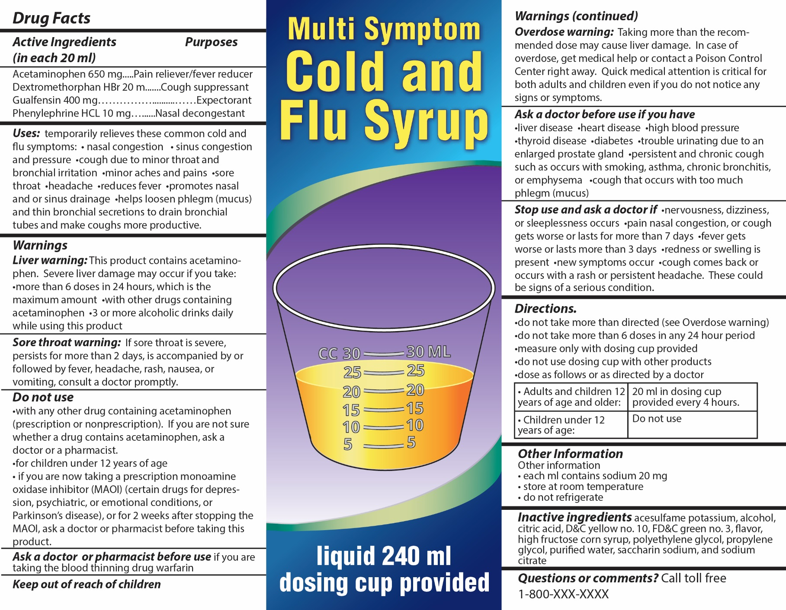
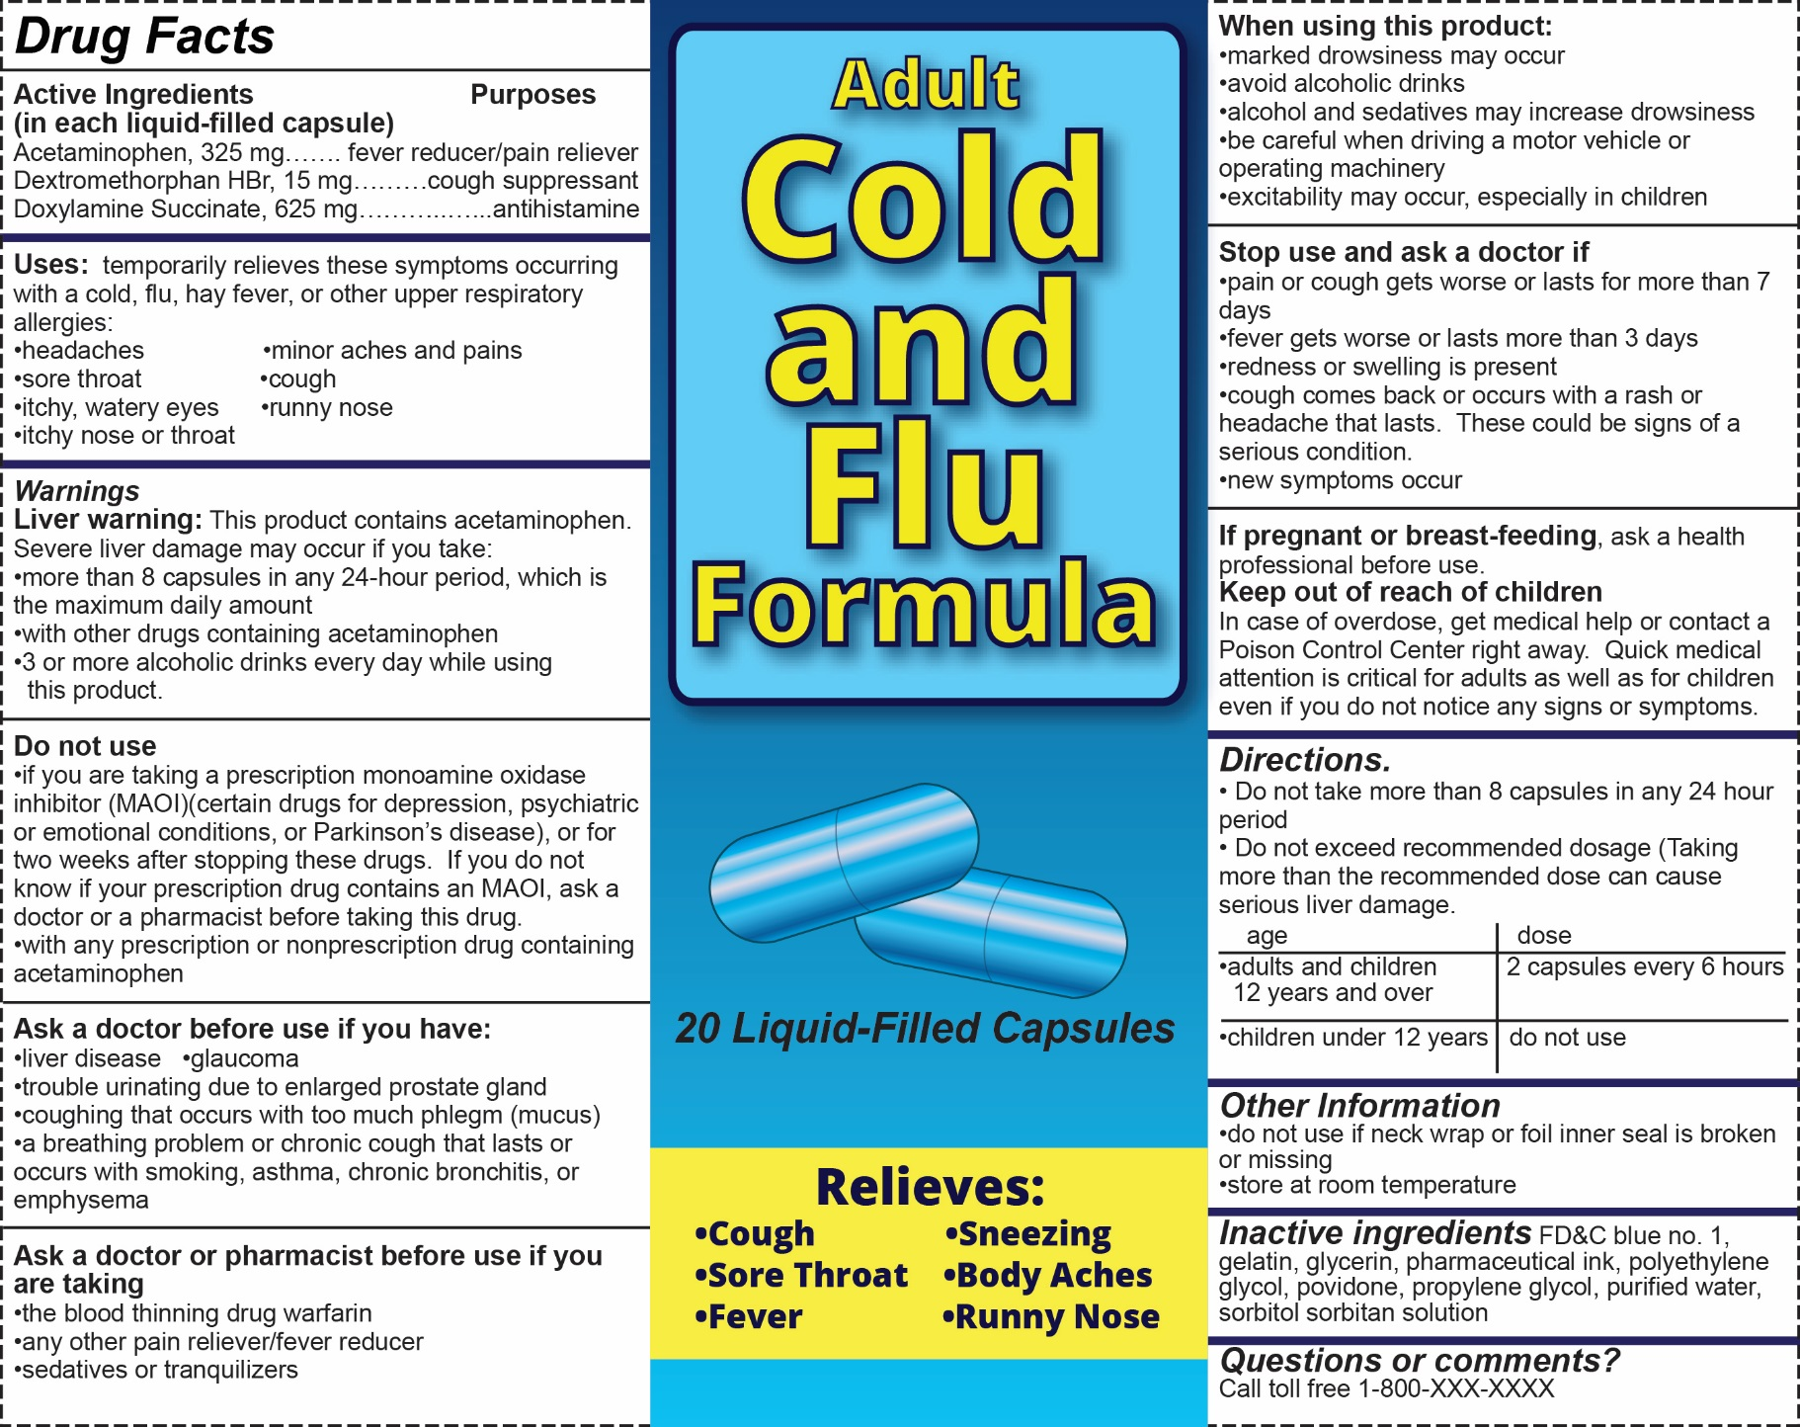
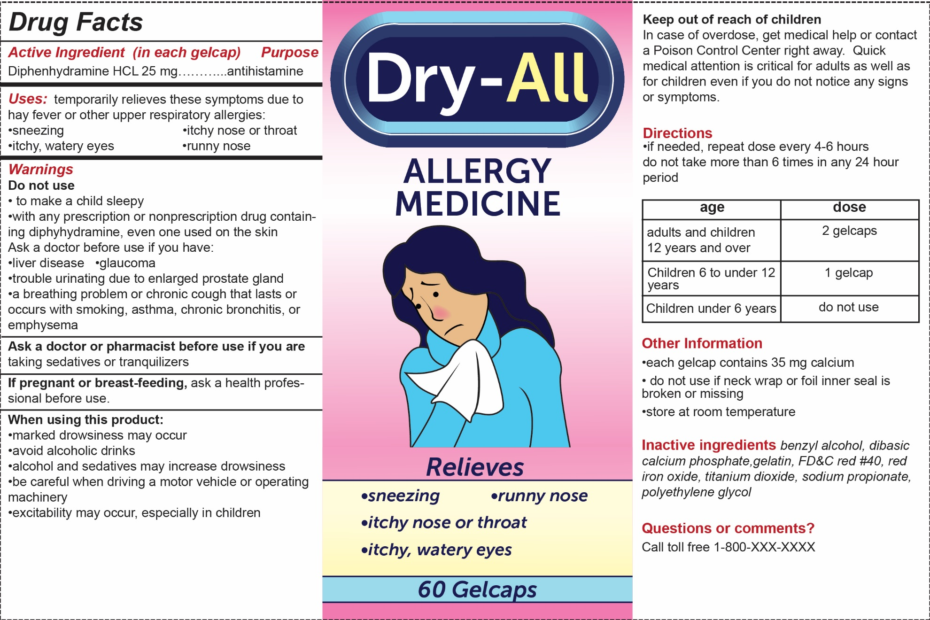

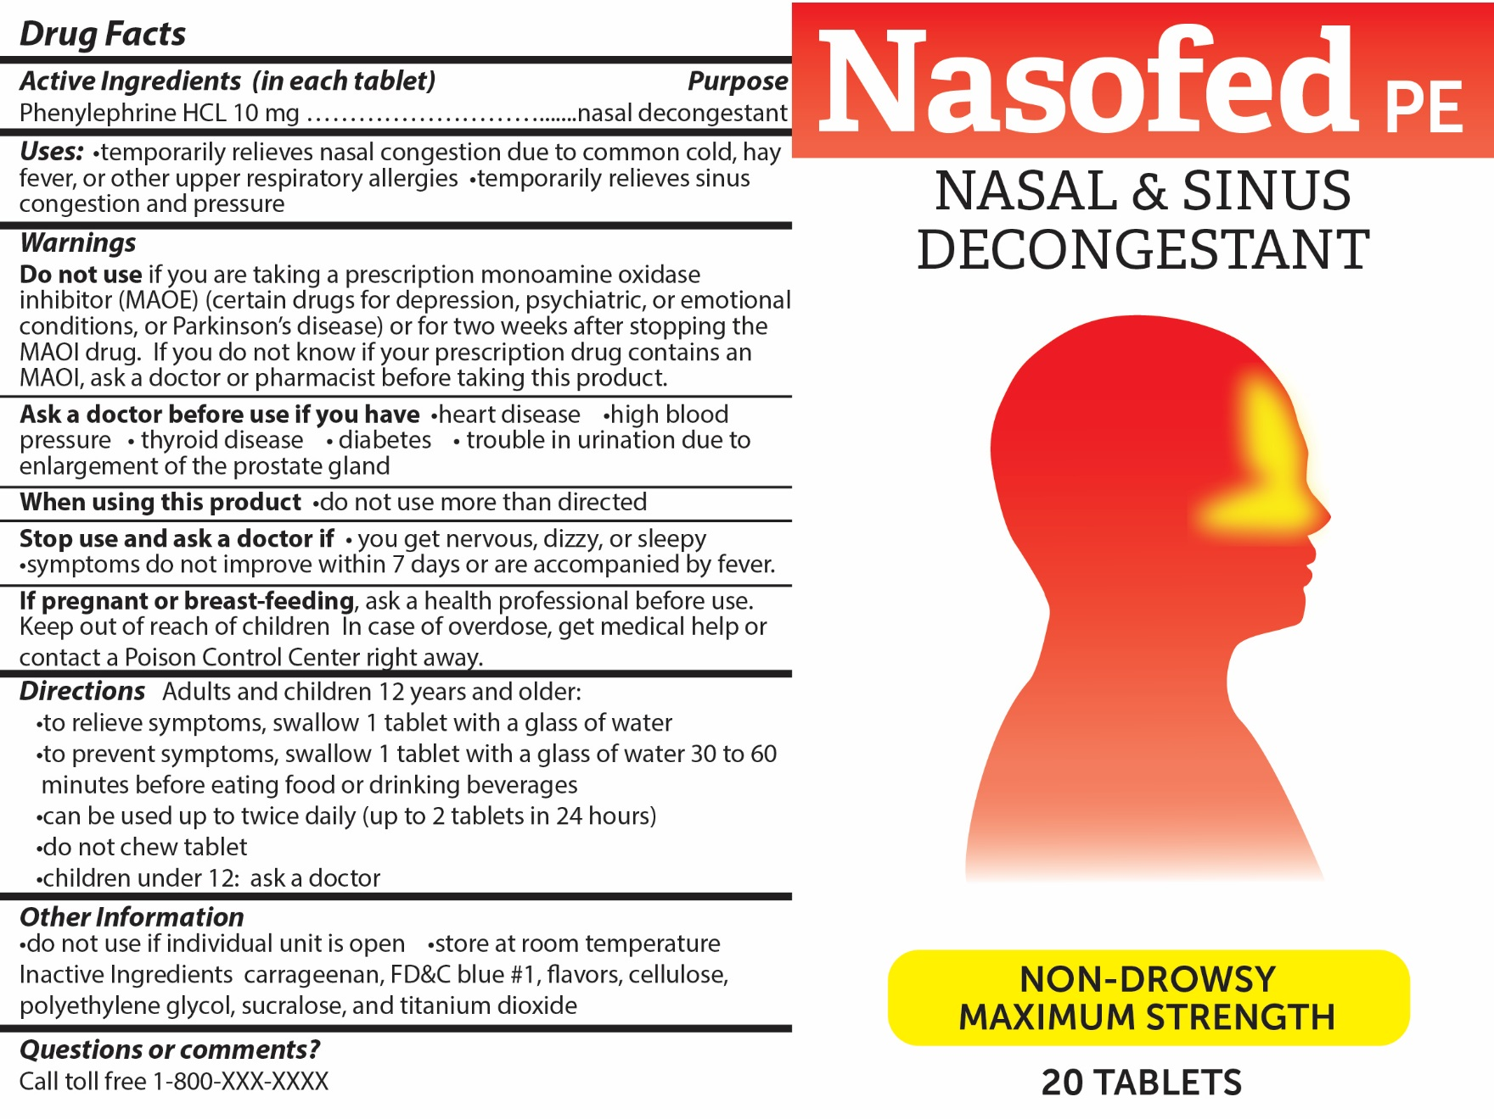

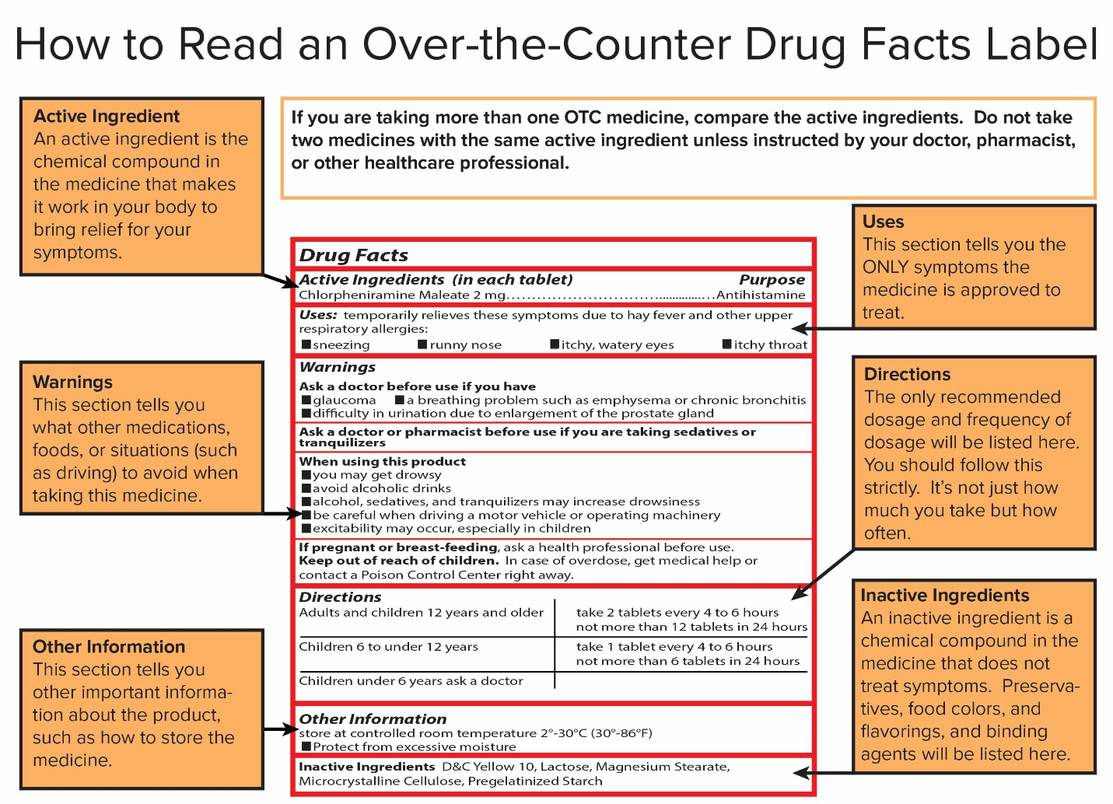

Cold, Flu, or Allergy?

Introduction:

A cold, the flu, and allergies all affect the respiratory system and have many similar symptoms. It can be difficult to tell whether someone has a cold, the flu, or allergies.

The Respiratory System

Mrs. Miller took her three daughters to see their doctor because they have respiratory system symptoms.

- Danielle Miller (13 years old) has been sniffling, coughing and sneezing for about a week.

- Kyla Miller (16 years old) has a bad cough and a runny nose. She also has a headache and a 100ºF fever.

- Eva Miller (12 years old) has asthma so she usually has a cough. Today she notices that she is very tired and it is difficult for her to breathe. She has a 102ºF fever.

Part 1: Rapid Influenza Tests

Mrs. Miller is worried that her daughters may have influenza (the flu). Do the Miller girls have influenza (the flu)? Often, a doctor can make a flu diagnosis simply based on the person's symptoms. However, the Miller family’s doctor has asked you to conduct rapid influenza tests to determine if any of the three Miller girls have influenza.

- The rapid influenza test begins by using a swab to take a sample of mucus from a patient’s nose. You have three bags that each contain a cotton swab with a (pretend) mucus sample from either Danielle’s, Kyla’s or Eva’s nose.

- Place 2 drops of Rapid Flu Test Solution onto each of the circles on the Rapid Flu Test Strip. Then, close the lid of the Rapid Flu Test Solution tube to prevent spills.

- Dip each cotton swab into the appropriate circle of the Rapid Flu Test Strip.

- Record the results of the flu tests in the data table below.
- If the swab turns pink, the patient has the flu.
- If the swab remains white, the patient does not have the flu.

Name | Color of Swab | Interpretation (Flu or Not Flu)
Danielle
Kyla
Eva

- Discard the Rapid Flu Test Strip and the swabs. Save the dropper and tube of Rapid Flu Test Solution.

- Which of the Miller girls have the flu? Explain how you can tell.
_________________________________________________________________________
_________________________________________________________________________

Part 2: Danielle’s Case

Use the results of the Rapid Flu Tests and the Allergy Facts below to answer questions 1 through 6.

Allergy Facts

Normally, the immune system fights germs called pathogens. An allergy occurs when a person’s immune system overreacts to an allergen that is harmless for most people. Allergens that cause allergic reactions include things as pollen, dust mites, mold spores, pet dander, some foods, insect stings, and some drugs.

During an allergic reaction the immune system releases an excess of chemicals called histamines. Histamines can cause symptoms such as a runny nose, sneezing, itching, rashes, swelling, ear congestion or asthma. Medicines that contain antihistamines as active ingredient can be used to treat allergies because antihistamines block the action of histamines.

- Based on the results of the flu test, the doctor explained that Danielle’s symptoms are most likely due to exposure to an allergen. What is an allergen?
_________________________________________________________________________
_________________________________________________________________________

- Danielle’s allergic reaction symptoms include sneezing, itchy cough, runny nose, and watery eyes. What chemical made in the body causes Danielle’s symptoms?

_________________________________

- The doctor suggested that Danielle treat her allergy with an over-the-counter allergy drug. What active ingredient should Danielle look for if she wants a drug that blocks the action of the chemical you selected for question 2?

_________________________________

- When selecting a drug, it is best to select a drug that only treats the symptoms that you are experiencing. Look at the four drug labels provided. Which drug would you recommend for relieving Danielle’s allergy symptoms? Explain your choice.
_________________________________________________________________________
_________________________________________________________________________

- What side effects should Danielle be aware of before she takes this drug?
Side Effect
Any effect of a drug or dietary supplement that is in addition to its intended effect, especially an effect that is harmful or unpleasant.

Drug Interaction
A drug interaction occurs when a substance (another drug, food, or a dietary supplement) affects the activity of a drug when both are administered together. Drug facts labels may warn that the drug should not be taken with another drug or food.

_____________________________________________________________________________________________________________________

- What drug interactions should Danielle be aware of before she takes this drug?
_____________________________________________________________________________________________________________________

Part 3: Kyla’s Case

Use the results of the Rapid Flu Tests and the Cold Facts below to answer questions 1 through 9.

Cold Facts

The common cold is the most common contagious infectious disease in humans. A cold is caused by a rhinovirus, a type of virus that is usually less harmful than the influenza virus that causes the flu. The body’s reaction to the cold virus causes cold symptoms such as sore throat, cough, mild fever, ear congestion, blocked nose, and runny nose. Colds are common because the human body cannot develop immunity to all of the different types of rhinoviruses that can cause the common cold.

Antibiotics are not effective in treating colds. They do not cure a cold or speed up recovery because they kill bacteria but do not kill the viruses that cause a cold. Doctors will not prescribe antibiotics for a common cold because they are concerned that overuse of antibiotics will promote the evolution of antibiotic resistant bacteria that are not killed by antibiotics. Colds are usually treated by using over-the-counter drugs, drinking fluids, and getting plenty of rest.

- Based on the results of the flu test, the doctor explained that Kyla has a cold, not the flu. Kyla asks the doctor for a prescription for an antibiotic, but the doctor said she did not need one. Explain why he would not give her a prescription for an antibiotic.
_________________________________________________________________________
_________________________________________________________________________

- For her cough, the doctor suggested that she could take an antitussive. Antitussives are cough suppressant drugs that block the cough reflex. Look at the four drug labels provided. Which drug(s) contain an antitussive to suppress Kyla’s cough?
_________________________________________________________________________

- For her stuffy nose, Kyla could take a decongestant. Decongestants reduce the swelling of tissues in your nose, making breathing easier. Look at the four drug labels provided. Which drug(s) contain a decongestant to relieve Kyla’s stuffy nose?
_________________________________________________________________________

- If Kyla’s respiratory tract (lungs, trachea, and bronchi) is clogged with mucus, she could use an expectorant. Expectorants are drugs that thin the mucus and promote removal of mucus from the respiratory tract. Look at the four drug labels provided. Which drug(s) contain an expectorant to promote removal of mucus from Kyla’s respiratory tract?
_________________________________________________________________________
- To relieve Kyla’s headache, she could take an analgesic. Analgesics are drugs that relieve pain. If you have a fever, you could take an antipyretic. Antipyretics are drugs used to reduce fevers. The common over-the-counter fever reducers (aspirin, ibuprophen, and acetaminophen) are also pain relievers. Look at the four drug labels provided. Which drugs contain an analgesic/antipyretic to relieve Kyla’s headache?
_________________________________________________________________________

- To avoid potential overdoses, it is important to NOT take two drugs with the same ingredient. This is especially true for acetaminophen, a common fever reducer and pain reliever found in a variety of cold medications. Taking too much acetaminophen increases the risk of liver damage. Select the one cold drug that you would recommend that Kyla purchase and use for treating her cold symptoms. Explain your selection.
_________________________________________________________________________
_________________________________________________________________________

- List two side effects that Kyla should be aware of when she takes the drug you selected for question 6.
A side effect is any effect of a drug that is in addition to its intended effect, especially an effect that is harmful or unpleasant.
- _______________________________________________
- _______________________________________________

- Would it be safe for Kyla to take both the drug you selected for question 6 and a pain reliever that contains acetaminophen for her headache? Explain why or why not.
_________________________________________________________________________
_________________________________________________________________________

Pharmacists are a good source of information for both prescription and over-the-counter drugs. Kyla isn’t sure she has chosen the best drug for her cold so she asks the pharmacist for advice. The pharmacist asks Kyla if she is already taking any prescription or other non-prescription drugs.

The pharmacist discovers that Kyla is taking a prescription antidepressant - a drug used to treat depression. He points out that some antidepressant drugs may result in dangerous drug interactions with ingredients in some cold drugs. The pharmacist also shows Kyla the warnings on the drug that she was considering buying. He recommends that Kyla talk with her doctor for advice on what drugs to take to treat her cold symptoms.
A drug interaction is a situation in which a substance (usually another drug) affects the activity of a drug when both are administered together. Drug interactions usually have a harmful effect.

- Explain why it is important for Kyla to talk with a doctor before she takes medicine such as Multi-Symptom Cold + Flu Syrup.
_________________________________________________________________________
_________________________________________________________________________
Part 4: Eva’s Case

Use the results of the Rapid Flu Tests and the Flu Facts below to answer questions 1-6 on the next page.

Flu Facts

The flu (also known as influenza) is a viral infection that attacks the respiratory system — the nose, throat and lungs. The flu viruses may cause respiratory system symptoms such as cough and runny nose that may also be associated with colds or allergies. People should suspect they have the flu if they also have a high temperature (101ºF or above), cold sweats, shivers, aching joints, aching limbs, headaches, and extreme fatigue.

Because the flu is highly contagious, it is important that people who have the flu stay home and try to avoid contact with other people. The flu can be deadly, particularly for young children, people over 65 years old, and people with chronic diseases (long lasting diseases that can be treated but not cured) such as asthma, heart disease, immune system problems, kidney disease, and diabetes.

Because the flu is caused by a virus, antibiotics will not reduce flu symptoms or cure the flu. The flu is usually treated by using over-the-counter drugs, drinking fluids, and getting plenty of rest. Inhaling steam may also help ease the symptoms. However, it is important to not take over-the-counter drugs if a doctor has prescribed drugs, such as a pain reliever, fever reducer or a cough suppressant to treat flu symptoms. A dangerous overdose may result if the active ingredients in prescription drugs are the same as the active ingredients in over-the-counter drugs.

The flu can be prevented by getting an influenza (flu) vaccination each year. A yearly influenza vaccination is important because the flu virus mutates rapidly and this year’s flu vaccine may not work to prevent the new flu viruses next year.

At the first sign of flu symptoms, it is wise to call the doctor to ask if you would benefit from prescription antiviral flu drugs, such as Tamiflu or Relenza. Antiviral drugs do not cure or prevent the flu, they just reduce the severity and duration of flu symptoms. To be most effective, these antiviral drugs need to be given within one to three days of first flu symptoms.

- The doctor explained that Eva’s symptoms made him suspect that she has the flu. List two flu symptoms that are not usually associated with a cold or allergies.
- ______________________________________________________________________
- ______________________________________________________________________

- The results of the rapid flu test show that Eva definitely has the flu. Explain two reasons why people who have flu symptoms should seek prompt medical advice from a doctor.
- ______________________________________________________________________
- ______________________________________________________________________

- Eva has two chronic diseases—asthma and diabetes. Explain how a chronic disease is different from diseases such as the flu or a cold.
_________________________________________________________________________
_________________________________________________________________________

- The doctor gave Eva a prescription for an antiviral drug (Tamiflu). This antiviral drug will not prevent or cure the flu. Why would Eva want to take the antiviral drug?
_________________________________________________________________________
_________________________________________________________________________

- The doctor also gave Eva prescriptions for a pain and fever reducer (acetaminophen) and a cough suppressant (dextromethorphan). Which over-the-counter flu drug would you recommend that Eva use for treating her flu symptoms? Explain your selection.
_________________________________________________________________________
_________________________________________________________________________

- Danielle and Kyla know that the flu is contagious. They do not want to “catch” the flu from Eva. Should they take some of Eva’s prescription antiviral drug? Explain why or why not.
_________________________________________________________________________
_________________________________________________________________________

