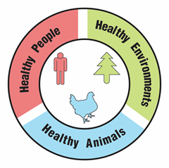
Can Insects Save the Planet?

Teacher Guide

Lesson Summary:
Follow the story of two college roommates as they explore possible protein sources in their diets. Are all protein sources equal in value? What effect does protein food production have on the environment? Why would someone choose to limit their source of protein?

Core Concepts:
- Proteins are composed of amino acids.
- Foods contain varying types and amounts of protein.
- Protein deficient food poses a risk to both human and animal health.
- Large scale protein-rich food production has negative impacts on the environment
- A One Health approach identifies and seeks solutions to problems that affect the health of humans, animals, and the environment.

Suggested Grade Level: Grades 9-12

Class time required (approximate):
- Part 1: You’re going to eat what? 30 minutes
- Part 2: Food and Health – Why is protein important? 40 minutes
- Part 3: Does my pet’s protein matter? 30 minutes
- Part 4: Investigating Claims – Can insects save the environment? 30 minutes
- Part 5: One Health and protein sources 40 minutes

Copyright © 2022 by University of Rochester. All rights reserved. May be copied for classroom use. This lesson was developed with support from the National Institutes of Health under Award Number R25GM132758. The content is solely the responsibility of the authors and does not necessarily represent the official views of the National Institutes of Health.
Teacher Preparation:

Part(s) | Materials needed for each pair of students
1-5 | - 2 copies of student handout Can Insects Save the Planet?
1 | - 1 copy of CHiPS FAQs. See page vi  - 1 copy of each of the 7 Nutrition Facts Labels. See pages vii-x (Optional: Place the labels into a large envelope)
2 | - 1 copy of Menu of Common Meals. See page xi  - 1 copy of Amino Acid Cards. See page xii (Optional: bead bags- see part 2 of suggested procedure)  - 1 Protein Chart (Note: print and cut in half). See page xiii
3 | - 1 copy of Facts about Choosing a Pet Food. See page xiv
4 | - 1 copy of Why CHiPS? See page xv
5 | - For class debriefing: 6 sheets of poster paper. Use these titles for the poster paper: Animal Problem, Human Problem, Environment Problem, Animal Solutions, Human Solutions, Environment Solutions.

Suggested Class Procedure:

General
- Distribute 1 copy of Can Insects Save the Planet? to each student.
- Students work individually or with a partner to complete this lesson.
- NOTE: The topic of protein sources is rich enough to trigger conversations and questions that go beyond the immediate content in this lesson. Teachers may set up a “Parking Lot” for collecting student questions or ideas for additional connections/research.
Parking Lot Strategy
- Make a large poster paper or bulletin board area in the classroom as your Parking Lot.
- When students have a question or additional connection, have them write it on a sticky note and hand it to you or put it in the Parking Lot.
- Only answer questions immediately if they are essential for completing the lesson.
- Put sticky notes with other questions or connections in the Parking Lot.
- At the end of the lesson, review the Parking Lot questions.
- Remove questions that were answered by the lesson.
- Ask students which remaining questions and connections they would like to discuss.

Part 1: You’re going to eat what? (30 minutes)
- Read the information in the text box to the class.
- Distribute a copy of the CHiPS FAQs to each individual or pair of students.
- Distribute 1 envelope containing the 7 Nutrition Facts Labels to each individual or pair of students.
- Ask students to share their evaluation of the claim about cricket protein and the evidence they feel supports their idea.

Part 2: Food and Health – Why is protein important? (40 minutes)
- Ask 1-2 students to read the text box aloud to the class.
- Distribute a copy of the Menu of Common Meals to each individual or pair of students.
- Distribute a set of Amino Acid Cards to each individual or pair of students. Optional: The teacher could prepare baggies containing the appropriate color beads to replace the amino acid cards for tactile learners.
- Distribute a Protein Chart to each individual or pair of students.
- Ask students to identify which proteins Abshir could not produce, and to explain how he was malnourished even though he was eating protein.
- Discuss the importance of obtaining essential amino acids through a proper diet. Why might impoverished people have health/medical problems that we typically do not see in non-developing nations?
Part 3: Does my pet’s protein matter? (30 minutes)
- Students individually read the text box information. Ask one student to identify the question to which the boys were interested in finding answers.
- Distribute a copy of Facts about Choosing a Pet Food to each group.
- Ask students to identify why a good quality pet food is important for the health of their dog/cat.

Part 4: Investigating Claims – Can insects save the environment? (30 minutes)
- Ask a student to read the information in the text box aloud to the class.
- Distribute a copy of the Why CHiPS? page to individuals or pairs of students.
- Differentiation – for students who require extra support reading graphs, the teacher should focus student attention on the graph axes and titles. Ask a few probing questions to be certain students are interpreting the information in the graph correctly.
- Ask students to share their answers for 1-4.
- Discuss the impact food choice has on their environment. This is a good time to discuss how the goal is to minimize malnutrition without impacting the health of the environment.

Part 5: One Health and protein sources (20 minutes)
- Read the information in the first text box aloud to the class.
- Students work with their partner to complete question 1.
- Have several students share their answer to question 1. It is important for students to have this correct before moving on to question 2.
- Display the following video from the CDC to add to student understanding of One Health. https://www.youtube.com/watch?app=desktop&v=TG0pduAYESA
- Read the information in the second text box aloud to the class.
- Students work with their partner to complete question 2 – their digital slide. Note: Students without access to digital slide programs like Google or PowerPoint can produce a paper version.
- Suggestion – Collect the digital slides into one slide deck. Share this slide deck with the class. If you have ample class time, you may consider having students present and explain their slides.
- Students receive full credit if their slide links choices of protein sources to the health of humans, animals and the environment.

Optional Extensions:
- Have students identify another example of a One Health problem. Have students use their idea to create a similar slide/poster that explains why their example is a One Health problem. Students can use examples from their community or from the One Health CDC website.
- Students keep a 24-hour food log to identify their sources of protein. They then research the impact each of their protein sources has on the environment.

Suggested Resources:

- Centers for Disease Control and Prevention (CDC) - One Health Video
https://www.youtube.com/watch?app=desktop&v=TG0pduAYESA

- Centers for Disease Control and Prevention (CDC) - One Health
https://www.cdc.gov/onehealth/index.html

- Protein Needs in Developing Countries
https://www.sciencedaily.com/releases/2016/02/160223132807.htm

- Menu from the world
https://borgenproject.org/10-poorest-countries-eating/

- Targets to increase food production: One Health implications
https://www.tandfonline.com/doi/full/10.3402/iee.v5.27708

- Benefits and food safety of edible insects
https://www.sciencedirect.com/science/article/pii/S235236461930046X

- Greenhouse gas emissions and agriculture (2007)

http://rstb.royalsocietypublishing.org/content/363/1492/789

- Edible insects produce smaller quantities of greenhouse gasses than cattle (2011)
https://www.wur.nl/en/show/Edible-insects-produce-smaller-quantities-of-greenhouse-gasses-than-cattle.htm

Scan the QR code with your smartphone or tablet camera app to link to a file with all the websites.





Frequently Asked Questions (FAQs)

Q. What is cricket powder?
Cricket powder (also known as cricket flour) is made by grinding crickets, and results in a coarse or fine grain powder. Because cricket powder is milled from whole crickets, it provides a full nutritional profile that is high in protein, nutrients, and amino acids.

Q. What does cricket powder taste like?
Cricket powder has a mild nutty and earthy flavor. Some say it tastes slightly like some strains of dried mushrooms or shellfish. Depending on what they are cooked with, crickets can take on many different flavors.

Q. Can I bake with cricket powder?
Yes. Cricket powder can be used in baking but because of the high protein profile and content, you must add other flours to pure cricket powder before baking. Typically, people will use a combination of tapioca flour, coconut flour, or other gluten-free flours mixed with cricket powder to make baked goods. Of course, you may also add a few scoops of our cricket powder to your favorite recipes to boost your protein and nutrient profiles.

Q. Who eats crickets?
More than 2 billion people worldwide, eat over 1,900 species of edible insects, including crickets. (Source: FAO 2013) Insect rearing and collection is a promising source of income for the lowest, most vulnerable parts of society as it requires very little land, water, feed and other resources. Many programs around the world are being established to alleviate poverty through insect rearing and/or collection.

Q. Are there cricket allergies?
Yes. If you have a crustacean or shellfish allergy, you may be allergic to crickets and should not try them. Crickets are arthropods and just like shrimp, crabs, and lobsters, they can cause allergic reactions for individuals with a crustacean or shellfish allergy.

Q. How many crickets are in a serving of cricket powder?
Depending on the cricket processing and milling equipment, it takes approximately 225 crickets to make one serving of cricket flour. That’s about 5000 crickets per pound of flour!

Q. Are crickets OK for vegans or vegetarians?
No. Typically, vegans and vegetarians do not eat crickets. However, if your food choices are based on environmental or sustainable concerns, crickets are a great solution. Crickets use only 1/10th the amount of water and 1/6th the amount of feed of competing protein sources such as beef. In addition, crickets do not produce the significant levels of greenhouse gases that cows do, and they do not feed solely on the same crops that people do.

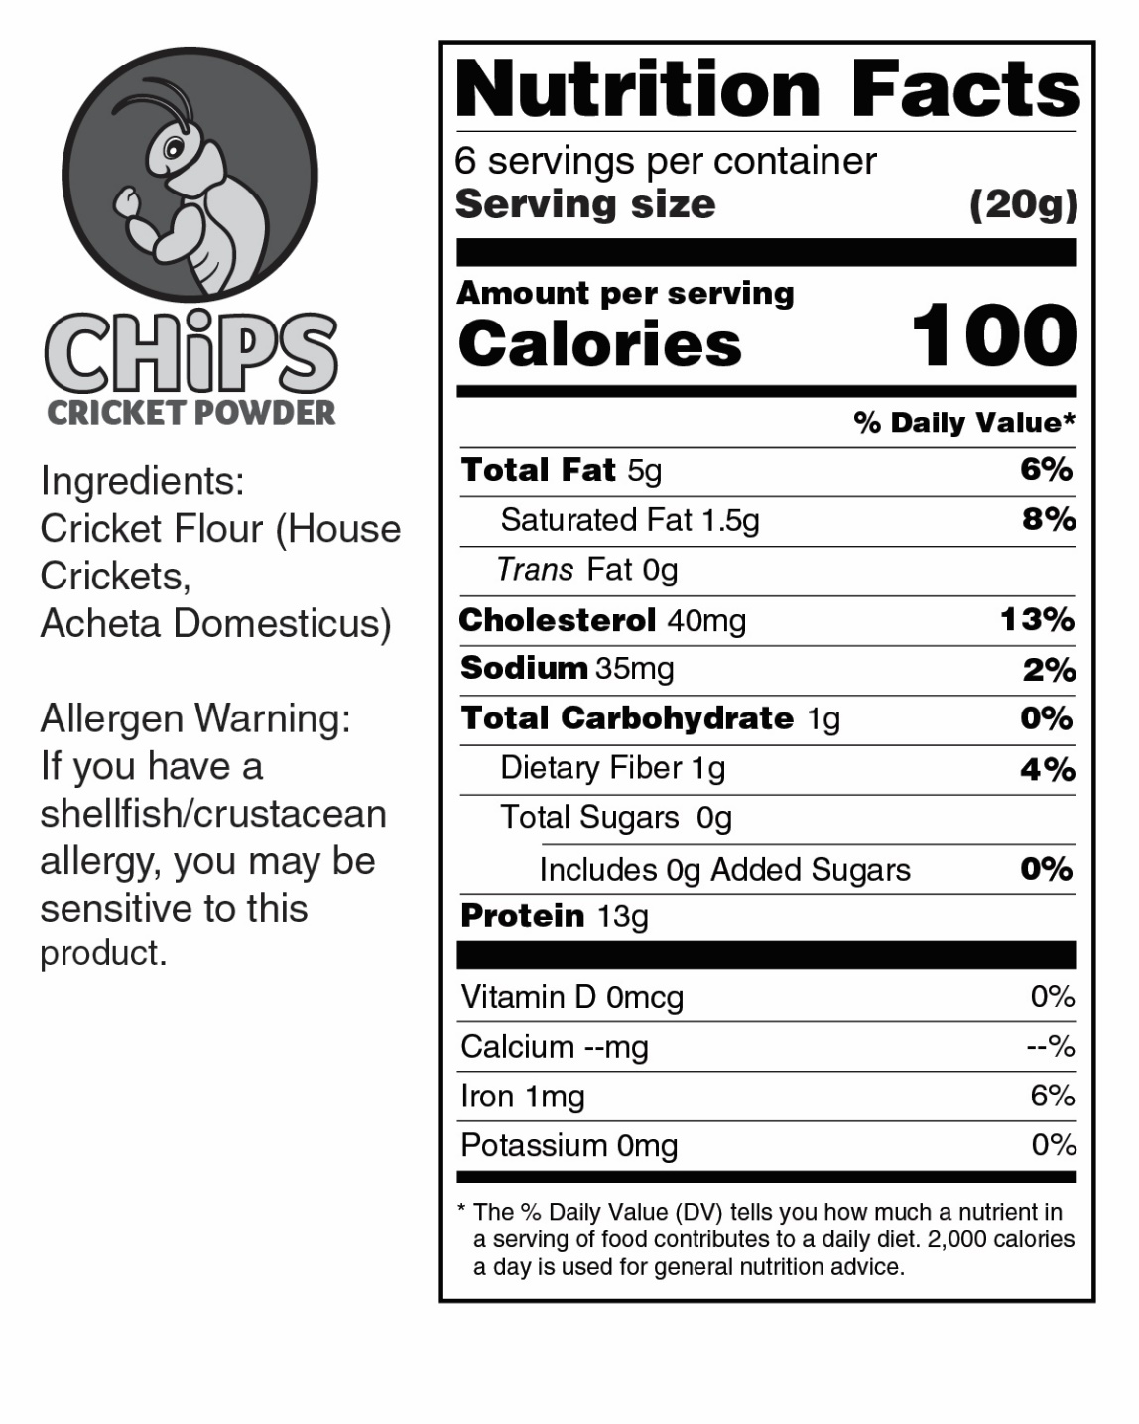

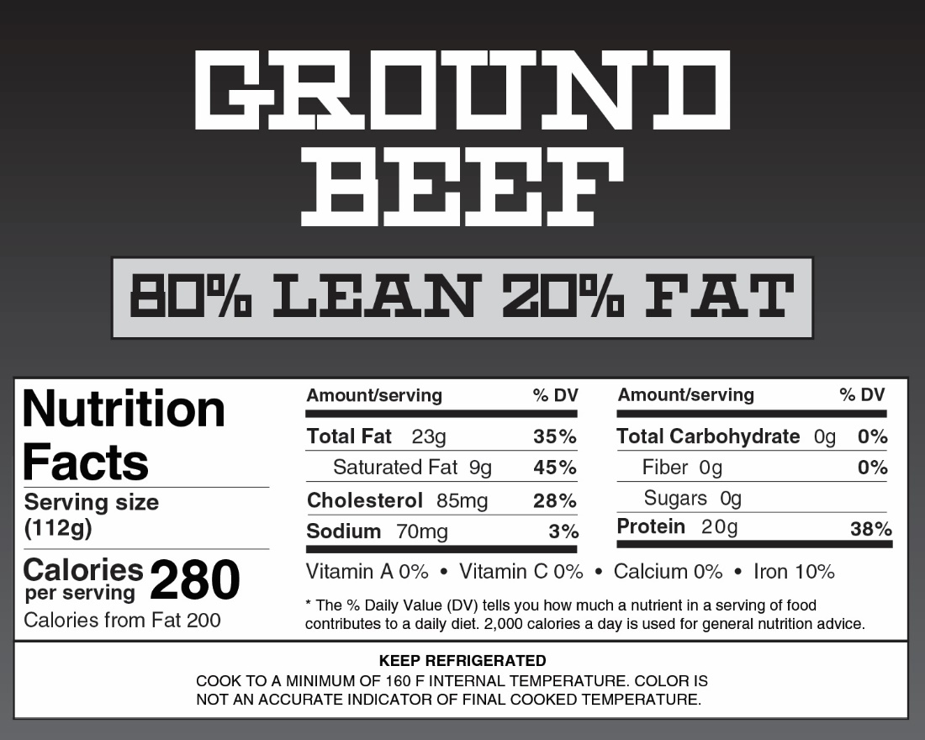

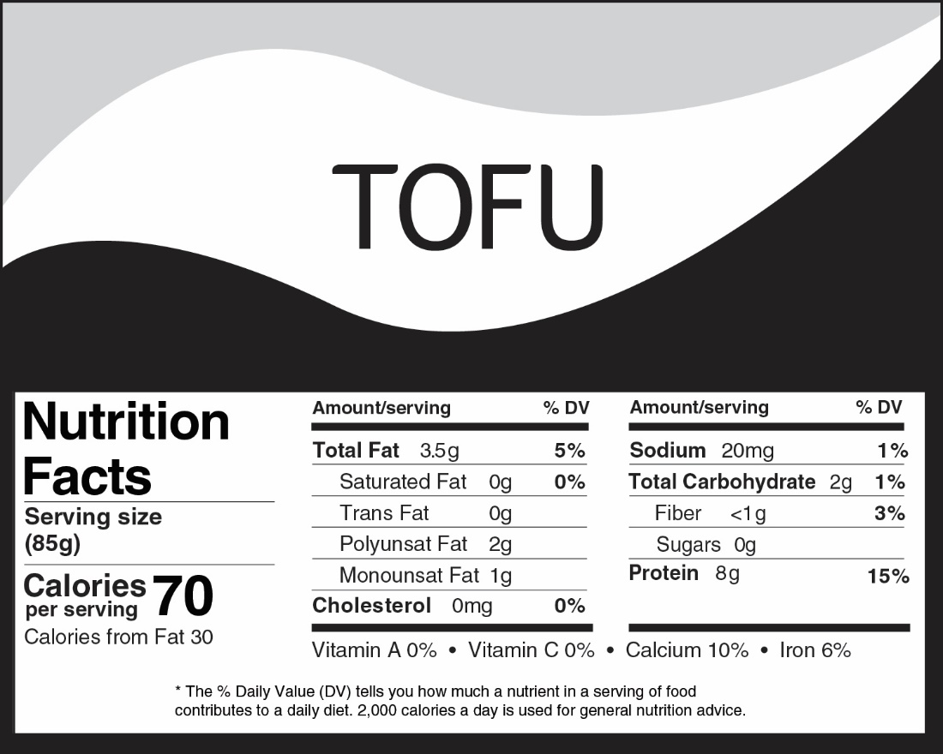

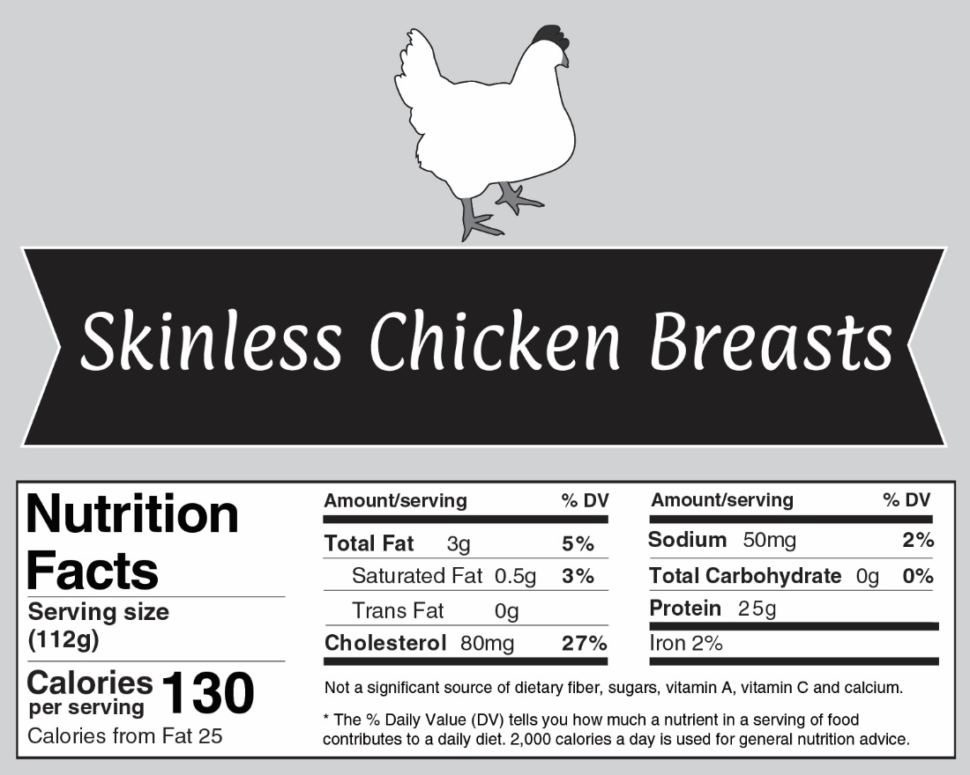

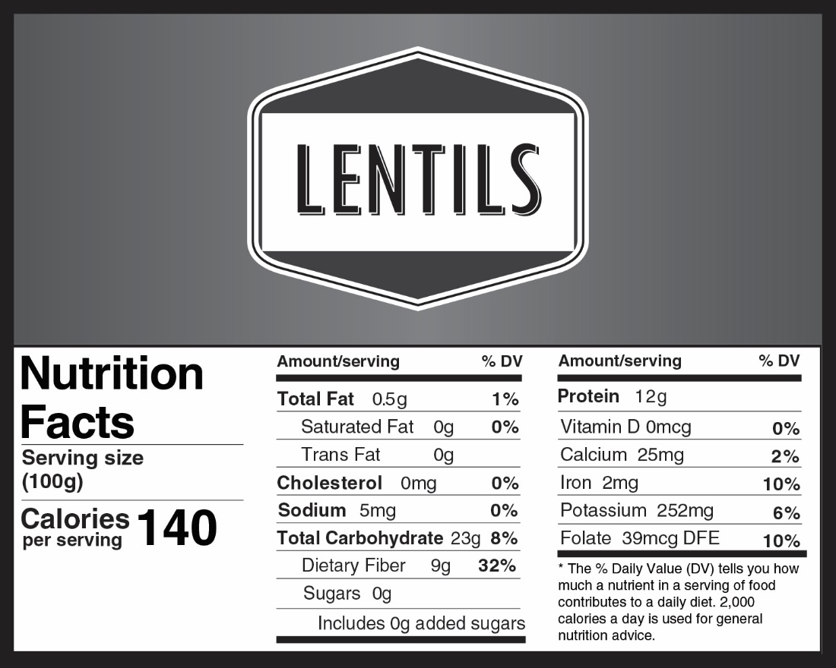

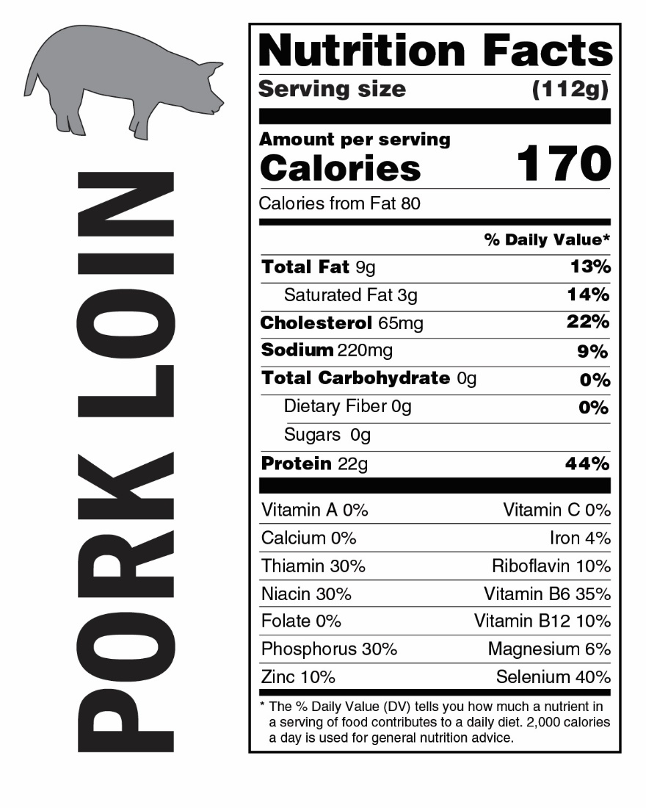

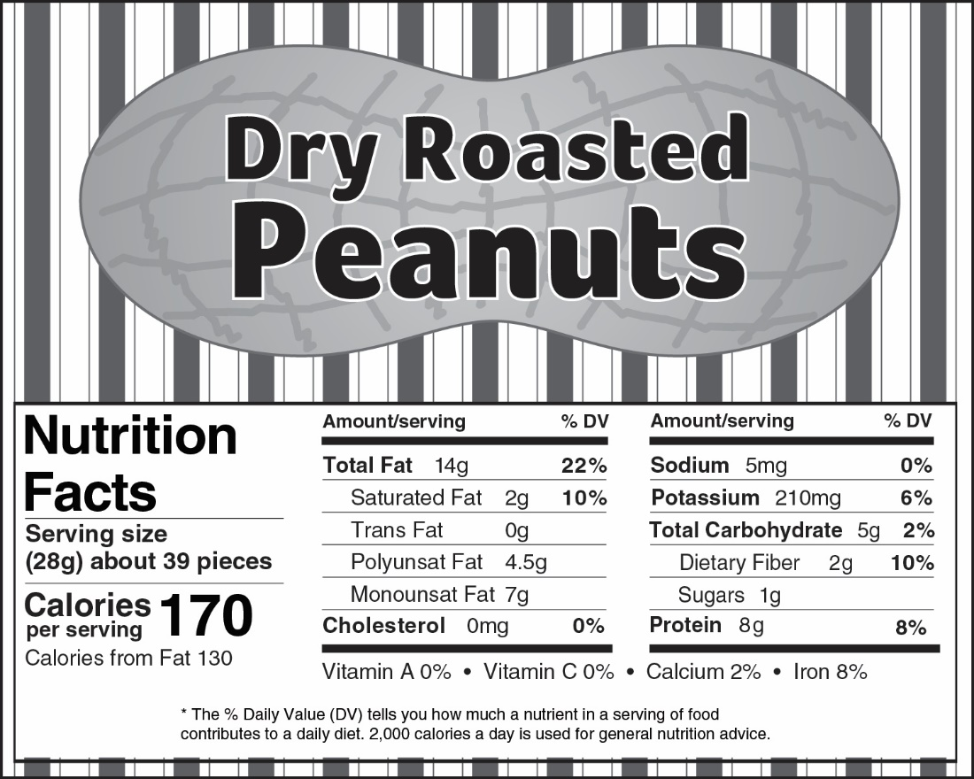

Menu of Common Meals
Democratic Republic of Congo  - A simple dish, called saka saka is a staple.  - Ingredients include: Cassava leaves (a starchy tree root), onions, green peppers, garlic paste, peanut butter, black pepper, spinach, habanero pepper, palm oil. | 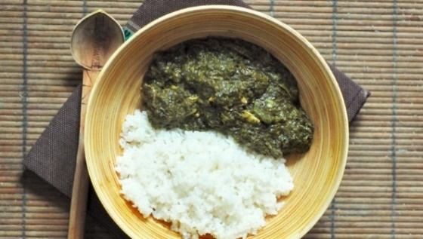
Zimbabwe  - The national dish is called sadza.  - It is a cornmeal mush  - It is generally served with a leafy vegetable stew.  - Those who cannot afford meat rely on a wide variety of fried insects for protein.  - Meats such as beef, springbok, kudu and goat are consumed by the few who can afford it. | 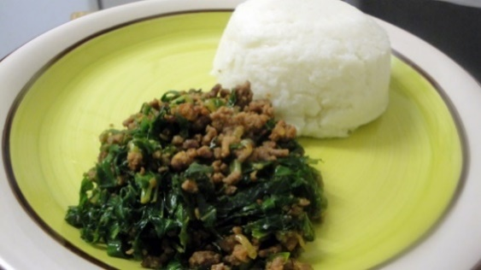
Burundi  - The Burundi meal is a cassava porridge made by boiling and mashing the cassava.  - Beans are the most common source of protein added to the porridge. | 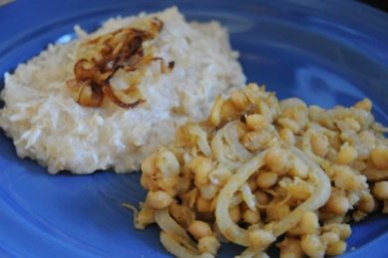
Central African Republic  - The base of most meals is usually a millet porridge made with millet, vegetables and spices such as garlic, onions, chili peppers, okra.  - Peanuts are used to add flavor.  - Meat is scarce and expensive, so nuts serve as daily protein. | 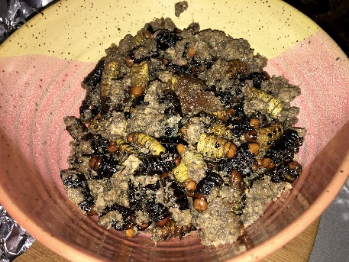
Malawi  - Maize (corn)is the staple of their diet.  - Cooked maize is shaped into patties that are called nsima.  - The nsima is dipped into a bowl containing ndiwo, a thick soup of spicy cabbage, beans and vegetables. | 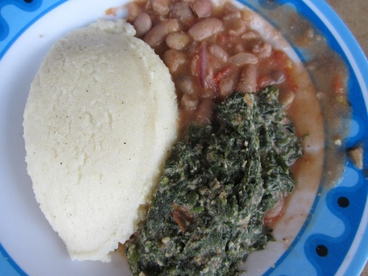

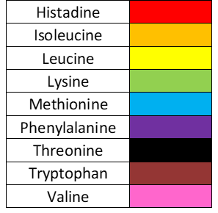 | Democratic Republic of Congo  Saka Saka | Zimbabwe  Sadza
Burundi  Cassava Porridge with Beans | Central African Republic  Millet and Insect Porridge | Malawi  Nsima with Vegetable Ndiwo
Pepperoni Pizza (USA) | Grilled Cheese Sandwich (USA) | Impossible Burger (USA)
Peanut Butter & Jelly Sandwich (USA) | “Chirps” Cookies | Any meal containing  Beef, pork, chicken, fish, insects
Amino Acid Cards
KEY - Essential Amino Acids
Protein Chart

Protein Name | Amino Acids required to build the protein
Actin
(needed for muscles)
Collagen
(connective tissue)
Insulin
(hormone that regulates blood sugar)
Hemoglobin
(transports oxygen)

Protein Chart

Protein Name | Amino Acids required to build the protein
Actin
(needed for muscles)
Collagen
(connective tissue)
Insulin
(hormone that regulates blood sugar)
Hemoglobin
(transports oxygen)


Facts about Choosing a Pet Food

There are many kinds of pet food that can be purchased, but not all foods offer full nutritional value. Pet foods that do not meet standards could actually harm your pet! Dogs need several different kinds of nutrients to survive: amino acids from proteins, fatty acids and carbohydrates, vitamins, minerals, and water. Your dog’s unique nutritional requirements will depend on its size, its breed, and its stage in life, among other factors.

Dogs cannot survive without protein in their diets. Dietary protein contains 10 specific amino acids that dogs cannot make on their own. Dietary fats, supply essential fatty acids that cannot be synthesized in the body and serve as carriers for important fat-soluble vitamins. Fatty acids play a role in cell structure and function. Essential fatty acids are necessary to keep your dog’s skin and coat healthy. Puppies fed ultra-low-fat diets develop dry, coarse hair and skin lesions that become increasingly vulnerable to infections. Deficiencies in the so-called “omega-3” family of essential fatty acids may be associated with vision problems and impaired learning ability.

Traditional Pet Foods
- Contain a mixture of animal-based proteins, grains, and vegetables to provide a nutritionally sound food for your dog.
- The animal-based protein comes from meat by-products. By-products are cleaned parts derived from animals after the meat for human consumption has been removed. By-products (which do not include hair, horns, teeth or intestinal contents) are healthy and are very good-quality sources of protein that pets enjoy. The best way to feed our pets meat-based diets with minimal ecological footprint is to use every part of the animals we slaughter for human food, including the by-products.
- Contain about 23% crude protein per serving and contain all essential amino acids required by both dogs and cats.

“Gourmet” Pet Foods
- Animal-based proteins as their main ingredient.
- The meat used in these foods is fit for human consumption. Using this type of animal-based protein increases the amount of animals that need to be raised and slaughtered in order to meet the needs of the pet food industry.
- Contain about 34% crude protein per serving and contain all of the essential amino acids required by both dogs and cats.


Vegan Pet Foods
- Dogs require 10 essential amino acids. When the correct protein sources are mixed, a complete dog food can be made using only plant-based proteins.
- Cats require 11 essential amino acids. Two of these amino acids can only be derived from animal-based protein sources. Therefore, cats should never be fed a vegan diet.
- Vegan dog foods usually contain about 24% crude protein per serving
- Food that meets the AAFCO standard contains all of the essential amino acids required by dogs.
- Vegan diets can help animals with food allergies. This is because allergies can develop to ingredients fed often and usually include animal-based protein sources.

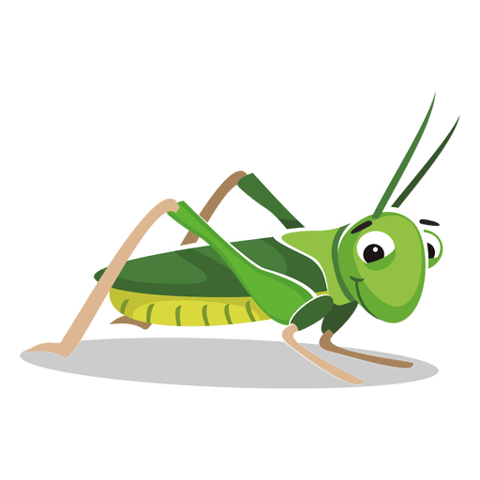
Why CHiPS?
Eat CHiPs – Save Water!

70 percent of the world’s water that is withdrawn from aquifers, streams and lakes goes towards growing crops. (FAO Rome, 2011)

Eat CHiPs – Reduce Land Use!

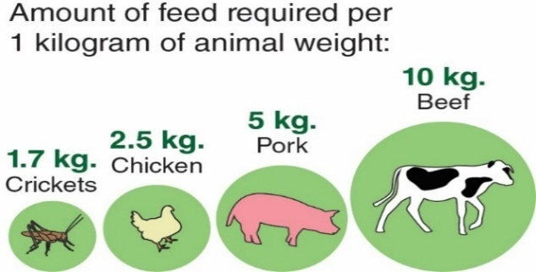
Livestock uses up 60 percent of all agricultural land, and on top of that a third of all crops we grow are used for livestock feed. Reducing this land use can increase biodiversity and improve ecosystem services. (FAO, 2013)

Agriculture and land use account for 24% of greenhouse gas emissions across the globe. Greenhouse gases are responsible for trapping heat, “forcing” climate change. (Smith,2008)
Eat CHiPs – Save the Planet
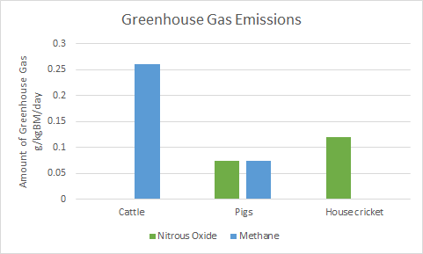
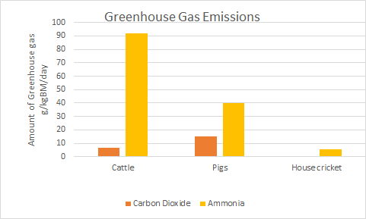

NGSS Correlation:

Working Towards Performance Expectations
MS-LS2-2. Construct an explanation that predicts patterns of interactions among organisms across multiple ecosystems. [Clarification Statement: Emphasis is on predicting consistent patterns of interactions in different ecosystems in terms of the relationships among and between organisms and abiotic components of ecosystems. Examples of types of interactions could include competitive, predatory, and mutually beneficial.]
HS-LS2-6. Evaluate the claims, evidence, and reasoning that the complex interactions in ecosystems maintain relatively consistent numbers and types of organisms in stable conditions, but changing conditions may result in a new ecosystem. [Clarification Statement: Examples of changes in ecosystem conditions could include modest biological or physical changes, such as moderate hunting or a seasonal flood; and extreme changes, such as volcanic eruption or sea level rise.]
Science and Engineering Practices  - Construct an explanation that includes qualitative or quantitative relationships between variables that predict phenomena. | Disciplinary Core Ideas  - Predatory interactions may reduce the number of organisms or eliminate whole populations of organisms. Mutually beneficial interactions, in contrast, may become so interdependent that each organism requires the other for survival. Although the species involved in these competitive, predatory, and mutually beneficial interactions vary across ecosystems, the patterns of interactions of organisms with their environments, both living and nonliving, are shared.  - A complex set of interactions within an ecosystem can keep its numbers and types of organisms relatively constant over long periods of time under stable conditions. If a modest biological or physical disturbance to an ecosystem occurs, it may return to its more or less original status (i.e., the ecosystem is resilient), as opposed to becoming a very different ecosystem. Extreme fluctuations in conditions or the size of any population, however, can challenge the functioning of ecosystems in terms of resources and habitat availability. | Cross Cutting Concepts  - Patterns can be used to identify cause and effect relationships.  - Much of science deals with constructing explanations of how things change and how they remain stable. (Stability and Change)  - Cause and effect relationships may be used to predict phenomena in natural or designed systems.

Can Insects Save the Planet?

Part 1: You’re going to eat what?

Garrett was interested in meeting his new college roommate, Andre. The boys were not able to speak directly all summer because Andre was participating in an internship with a relief organization in the African country of Malawi. Through their text messages and social media posts, Garrett learned that Andre is health conscious and very interested in saving the planet. Andre even texted Garrett several ideas on how they could reduce their ecological footprint as they set up their dorm room. He also let Garrett know that he did not eat meat, but he didn’t consider himself a vegetarian because he frequently ate alternative protein sources.

On move-in day, Andre was quick to offer Garrett his famous chocolate “chirp” cookies. Andre explained that he calls them chocolate “chirps” because they are made with cricket powder. Garrett wondered, “What is cricket powder and why would anyone add it to cookies?” Andre shared a website for CHiPs cricket powder. He encouraged Garrett to explore the website to learn more about the benefits.

Garrett began his search on the CHiPS FAQ page, because it was full of information.

- Based on the FAQs, identify at least 3 reasons why people might use cricket powder.

- Based on the FAQs, identify at least 2 reasons why people might not want to use cricket powder.

- What is the benefit of adding cricket powder to a recipe?

- Garrett thinks that eating crickets is just a fad. Why might Andre disagree with him?

- Use the Nutrition Facts Labels from common protein sources to complete the data table below.

Protein Source | Serving size in grams | Calories per Serving | Total Fat (g) per Serving | Protein (g) per Serving
Chicken
Pork
Beef
Tofu
Lentils (beans)
Cricket Powder (insects)
Peanuts (nuts)

- According to the CHiPS FAQ page, how many whole crickets would a person need to eat in order to obtain the same amount of protein contained in 1 serving of cricket powder?

- The CHiPS website advertises cricket powder is high in protein. Based on the nutrition facts labels, is this a valid claim? Support your answer with evidence.

Part 2: Food and Health - Why is protein important?

Garrett noticed that Andre had a picture of a young child on his desk. When asked about the child, Andre explained that this was Abshir, the child he sponsors through the relief organization he interned with in Malawi. Andre told Garrett about the extreme poverty he witnessed in Malawi. Most people he was helping lacked the basic necessities of life – food, water, medicine, even shelter. Since many children who live in extreme poverty suffer from malnutrition, Andre decided to sponsor Abshir hoping to make his life a little easier.

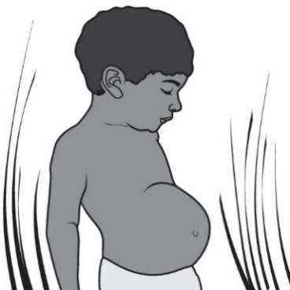
According to the World Health Organization (WHO), 1.2 billion people worldwide live in extreme poverty. The WHO defines extreme poverty as an income of less than one dollar per day. Many people who live in extreme poverty suffer from malnutrition, which is a major health burden for developing countries. The two components of malnutrition are protein deficiency and micronutrient deficiency (a lack of vitamins and minerals).

The most severe form of protein deficiency is known as kwashiorkor (kwaa·shee·or·kor). It most often occurs in children in developing countries where famine and protein-poor diets are common. The symptoms of kwashiorkor include swelling (especially in the abdomen), greater risk of bone fracture, stunted growth in children and an increase in the severity of infection. Too little protein may cause changes in body composition that develop over a long period of time, such as muscle wasting.

- Read each of the meal descriptions in the Menu of Common Meals of some of the world’s poorest countries. Underline the protein sources in each meal.

- Use the Protein Source data table from Part 1 to identify the number of grams of protein that would be available to someone eating each meal. Assume the person is getting one serving for each protein source.

Country | Meal | Protein source | Amount of protein in 1 serving
Democratic Republic of Congo | Saka Saka
Zimbabwe | Sadza in a poor family
Burundi | Cassava Porridge
Central African Republic | Millet Porridge
Malawi | Nsima and Ndiwo
- Scientists determine that children between the ages of 1-3 years require 13 grams of protein per day. Children 4-8 years need 19 grams of protein per day. Children 9-13 years need 34 grams of protein per day. In many of the world’s poorest countries, there is only one meal a day. Use the data table in question 2 on the previous page to identify countries where children may not get enough protein in their diet. Support your choice(s) with evidence.

- The grams of protein, although important, are not the whole story of nutrition. Proteins are large molecules made of amino acids. The human body is able to synthesize all but nine amino acids. Those nine amino acids that can’t be synthesized are called essential amino acids and must be ingested in the foods we eat. Complete the chart below using the Amino Acid Cards for each of the common meals. Each colored dot represents one of the nine essential amino acids.

Meal | Are all 9 essential amino acids present? | Missing amino acid(s)
Saka Saka
Sadza
Cassava Porridge
Millet and Insect Porridge
Nsima and Ndiwo
Pepperoni Pizza
Grilled Cheese Sandwich
Plant-based Impossible Burger
Peanut butter & jelly sandwich
“Chirps” Cookies

- Based on the amino acid composition of these typical meals, which meals do NOT provide all of the necessary amino acids and could result in malnutrition if they are the only food source for the day?

- What is the relationship between meals with animal-based protein sources and the number of essential amino acids in the meal?

During digestion, proteins are broken down into amino acids. These amino acids are absorbed by cells. Cells use these amino acids to build proteins needed by the body. The Protein Chart lists a few of the proteins the body synthesizes and a portion of the amino acids required to build that protein.

- Assume Abshir only eats nsima and ndiwo. Determine which proteins he will be able to synthesize. Note: Gray circles represent non-essential amino acids that can be synthesized by the body and do not limit protein production.

Protein Name | Can Abshir’s body make this protein?
Actin  (needed for muscles) | Yes No
Collagen  (connective tissue) | Yes No
Insulin  (hormone that regulates blood sugar) | Yes No
Hemoglobin  (transports oxygen) | Yes No

- Explain how Abshir’s diet may provide enough protein, but still cause him to be malnourished?

- Explain why this type of malnourishment may cause stunted growth and serious health problems. Support your answer with information from the data table.

Part 3: Does my pet’s protein matter?

After college, Garrett and Andre decided to adopt a shelter dog to have as an apartment pet. One week after adopting their dog, Garrett and Andre scheduled an appointment with a veterinarian to have their dog examined and to answer a few questions they had about pet health.

Andre wanted to feed their dog vegan dog food. The veterinarian was concerned that the vegan pet food may not meet all of the dog’s nutritional needs. He offered Andre and Garrett a fact sheet that explained the benefits and risks of different types of pet food.

  - Use the Facts about Choosing a Pet Food sheet provided by the veterinarian to provide at least two reasons why the veterinarian might be concerned about the type of pet food Garrett and Andre choose for their dog.

  - Garrett wanted to use the “gourmet” pet food because he didn’t like the sound of meat by-products and felt the gourmet pet food would be healthier. Provide at least one piece of evidence to show that traditional dog food is just as healthy as the gourmet pet food.

  - Andre would prefer to feed their dog the vegan diet. Is this a good nutritional choice? Support your answer with information from the fact sheet.

  - In Europe, insect-based pet foods are available for pet owners who care about the environment and do not want to burden the livestock industry. These foods have not been approved in the United States yet. Based on what you have learned, what advantage would insect-based dog food have over a vegetarian dog food?

Part 4: Investigating Claims – Can eating insects help the environment?

Garrett asked Andre why someone who has many protein food options would choose to use cricket powder as a protein source. Andre explained that he was interested in decreasing his ecological footprint. Garrett did not know that his food choices could harm the environment. He wanted to learn more about how eating insects might help solve some environmental problems.

The Why CHiPS? page was loaded with information on how eating crickets benefits the health of the environment. Although there is no one definition of sustainable, most people agree that in order for food to be considered sustainable it should:
- be produced using methods that protect the diversity of plants and animals
- protect the welfare of farmed and wild species
- avoid damaging or wasting natural resources
- promote health and use practices that contribute to local economies

- Garrett began thinking about his typical daily diet. He realized that he eats beef or chicken at least twice a day most days. Provide at least 2 reasons why Garrett’s food choice may contribute to climate change.

- Identify at least three reasons why shifting to insect-based protein sources might help the environment.

- Based on the information provided, identify one action concerned people could take to help with sustainability that does not involve eating insects.

4. Dogs and cats eat about 25% of the animal derived calories in the United States. Additionally, about 33-43% of the beef industry is used for pet food. If you were a pet owner concerned about the environment, which one of the pet food types (traditional, “gourmet”, or vegan) would you consider feeding your pet? Explain your choice.

Part 5: One Health and protein sources

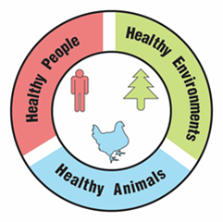
One Health Problem

A university is suggesting that the local government take a One Health approach to solving complex local problems, such as protein malnutrition. A One Health approach uses the idea that complex problems often involve the health of people, animals, and the environment. Therefore, solutions to One Health problems must be designed to protect the health of people, animals, and the environment.

- Use the information in the textbox above to explain what must be involved in a complex problem for it to be considered a One Health problem.

To support adoption of a One Health approach, the university officials want to create a series of slides to provide examples of One Health problems in the community. Your team has been hired to create a slide to answer the question, “Why is the choice of protein in our diet a One Health problem?”

Remember how the CDC video used images with captions to help people understand what One Health problems and solutions involve. Using pictures and captions will help people understand and remember what the One Health approach involves.

- Use the information in the text box above and what you learned about the choice of protein in our diet to develop your slide. Use the following template to organize your slide:

Why is the choice of protein in our diet a One Health problem?
Picture and a caption to explain how animals are involved in the problem | Picture and a caption to explain how humans are involved in the problem | Picture and a caption to explain how the environment is involved in the problem

