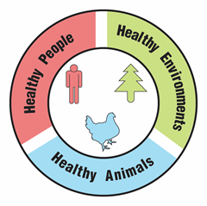
Disappearing Bees

Teacher Guide

Lesson Summary:
Bees are dying! Explore how the loss of bees will affect your food supply. Use simulated lab tests and data from scientific research to identify possible reasons for the decline of honey bee populations. Explore actions that could be taken to prevent protect insect pollinators.

Core Concepts:
- Multiple environmental factors may be responsible for the decrease in honey bee populations.
- The decrease in honey bee and native bee pollinators affects the health of humans, animals, and the environment.
- A One Health approach identifies and seeks solutions to problems that affect the health of humans, animals, and the environment.

Suggested Grade Levels: Grades 9-12

Class Time Required (approximate):
- Part 1 - A World Bee Day event 20 minutes
- Part 2 - A bee problem 15 minutes
- Part 3 – Sick bees: Are colony losses caused by parasites and pathogens? 30 minutes
- Part 4 – Poisoned bees: Are colony losses caused by pesticides? 40 minutes
- Part 5 – Hungry bees: Are colony losses caused by poor nutrition? 10 minutes
- Part 6 – Protecting pollinators 30 minutes
- Part 7 – One Health and disappearing bees 40 minutes

Copyright © 2022 by University of Rochester. All rights reserved. May be copied for classroom use. This lesson was developed with support from the National Institutes of Health under Award Number R25GM132758. The content is solely the responsibility of the authors and does not necessarily represent the official views of the National Institutes of Health.
Teacher Preparation:

Part(s) | Materials needed for each pair of students
1 - 8 | - 2 Copies of student handout Disappearing Bees  - Access to internet and computer for each student.
3 | - 1 plastic dropper  - 1 Bee Virus Test Sheet printed on white cardstock paper. Use a cotton swab to apply 1% phenolphthalein solution to the Bee Paralysis Virus circle and the Deformed Wing Virus circle on each Bee Virus Test Sheet. Do not put phenolphthalein in the Cloudy Wing Virus circle. See page iv.  - 1.5 ml of washing soda solution in a small tube labeled Viruses from Judy’s Bees. Prepare the washing soda solution by mixing 1 tablespoon of washing soda (not baking soda) with one cup (250 ml) of warm water. Washing soda can be found in laundry aisle of a supermarket.
4 | NOTE: Follow the instructions on page iii - Preparation for Part 4 Chromatography.  You will need these items:  - 1 strip of chromatography paper (6 inch by 0.75 inches)  Suggested: Wards:470004-492 Chromatography Paper Strips Pack of 50  - McCormick green food color  - Black permanent fine point marker  - 1 or 2 cotton swabs (Q-tips)  - 6 inch metric ruler  - Table salt  - Teaspoon or metric balance  - Measuring cup or graduated cylinder to measure 250 ml  - Tap water  *These items can be reused for multiple classes  - 1 clear 10 ounce plastic cup per pair of students *  Recommended: 10 oz. Solo or Dart TP10D plastic cups  - 3 ounce opaque cup labeled Salt Water per pair of students *  - 1 plastic coffee stirrer (5-6 inches) per pair of students *
7 | - Access to Google, PowerPoint or similar digital program for making slides, or poster paper and markers.

Bee Virus Test Sheets
Bee Virus Test Sheet

Bee Paralysis Cloudy Wing Deformed Wing
Virus Virus Virus

Bee Virus Test Sheet

Bee Paralysis Cloudy Wing Deformed Wing
Virus Virus Virus
Bee Virus Test Sheet

Bee Paralysis Cloudy Wing Deformed Wing
Virus Virus Virus
Bee Virus Test Sheet

Bee Paralysis Cloudy Wing Deformed Wing
Virus Virus Virus
Bee Virus Test Sheet

Bee Paralysis Cloudy Wing Deformed Wing
Virus Virus Virus
Preparation for Part 4 Chromatography
Chromatography Strip with Spot of Extract C

Doing chromatography for three extracts can be time consuming for both the teacher and the students. To save teacher prep time and class time, chromatography will be done for only one extract. The following preparation is suggested to produce consistent results.
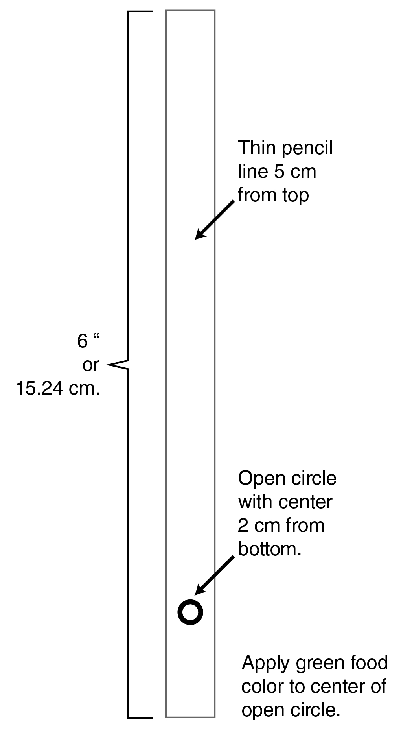
- For each pair of students, prepare 1 chromatography strip.
Suggestion: Make extras in case students do not follow the instructions properly.
- Use strips of chromatography paper (6” X 0.75”).
- Use a pencil to draw lines that are 5 centimeters from the top of each paper strip. Note: The position of the pencil line may need to be adjusted for cups/beakers that are shallower or deeper than the recommended cups. Read the student instructions on page 9 to determine the distance BEFORE drawing this line.
- Use a permanent marker to make an open circle approximately 2 centimeters from the bottom end of each paper strip.
- Dip a cotton swab (Q-tip) into green food coloring. For consistent results, use only McCormick brand green food coloring.
- Briefly press the green end of the Q-tip into the centers of the black circles. If the green coloring is light, repeat one or two times.
- Allow the strips to dry throughly.
- For each pair of students, prepare a 10 ounce clear plastic cold cup by drawing a permanent black marker line 1 centimeter from the bottom of each cup.
- Prepare a table salt solution by mixing 250 ml water with 1 teaspoon (5.7 grams) of table salt. Dispense approximately 25 ml in small opaque cups labeled Salt Water to each pair of students. Alternative: Teacher pours the salt solution up to the black line of each 10 ounce cup before giving these cups to the students.

Suggested Class Procedure:

General
- Distribute 1 copy of A Case of Disappearing Bees to each student.
- Students may work individually or in pairs.
- NOTE: The topic of disappearing bees is rich enough to trigger conversations and questions that go beyond the immediate content in this lesson. Teachers may set up a “Parking Lot” for collecting student questions or ideas for additional connections/research.
Parking Lot Strategy
- Make a large poster paper or bulletin board area in the classroom as your Parking Lot.
- When students have a question or additional connection, have them write it on a sticky note and hand it to you or put it in the Parking Lot.
- Only answer questions immediately if they are essential for completing the lesson.
- Put sticky notes with other questions or connections in the Parking Lot.
- At the end of the lesson, review the Parking Lot questions.
- Remove questions that were answered by the lesson.
- Ask students which remaining questions and connections they would like to discuss.

Part 1: A World Bee Day event (20 minutes)
- Read the information in the text box aloud to the class.
- Work with the class to explain how to do Question 1 for the Fish Tacos.
- Students work with their partner to complete Part 1. Note: Look for students to get the basic concept from the activity. It is not important that students are exactly correct, as long as they understand that many foods rely directly or indirectly on pollinators.
- Optional: students share their ideas for sandwiches, beverages, and desserts that rely on bee pollinators on a sheet of paper that can be posted in the room. This could be done by writing their ideas on sheets of paper that are posted in the room.

Part 2: A bee problem (15 minutes)
- Ask one student to read the information in the text box to the class. OR - Ask a student to use the information in the text box to play the role of Judy.
- Students work with their partner to complete Part 2.
- Optional: Make a class list of possible causes for the death of Judy’s bee colonies.

Part 3: Sick bees—Are colony losses caused by parasites and pathogens? (30 minutes)
- Ask students to read the information in the Test for Pathogens text box and prepare to briefly describe why Judy wants to test her bees for viruses. Call on several students to share their brief description.
- Distribute the following to each pair of students: a plastic dropper, a tube of Viruses from Judy’s Bees, and a Bee Virus Test Sheet prepared with phenolphthalein.
- Students work with their partner to complete questions 1-4 in Part 3.
- Debrief by having several students share their answers to question 4. It will be important for students to understand that “support” does not mean “prove.”
- Ask students to read the information in the Test for Parasites text box and prepare to briefly describe why beekeepers want to test their bee hives for Varroa mites. Call on several students to share their brief description.
- Students work with their partner to complete questions 5 and 6 in Part 3.
- Debrief by having several students share their answers to question 6. Remind students that “support” does not mean “prove.”

Part 4: Poisoned bees—Are colony losses caused by pesticides? (40 minutes)
- Ask one or two students to read the information in the text box aloud to the class.
- Distribute the following materials to each pair of students:
IMPORTANT
* See instructions on page iv of teacher information

- Prepared chromatography strip*
- Opaque 3 ounce cup labeled Salt Water containing ~25 ml of salt water*
- Clear 10 ounce cup with black line about 1 cm from the bottom of the cup*
- Coffee stirrer
- Students work with their partner to complete Part 4.
- Debrief by asking several students to share their answers to question 12 in Part 4.

Part 5: Hungry bees—Are colony losses caused by poor nutrition? (20 minutes)
- Tell students that the information in the text box will help them answer the questions in Part 5.
- Students should work with their partner to complete Part 5. Explain that they should be prepared to explain how the ones that they “X’d” would lead to hungry bees.
- Debrief by asking students to share their explanations.

Part 6: Protecting pollinators (30 minutes)
- Have students read the information in the text box and answer questions 1 and 2.
- Students use the information in the video 8 Practical Things You Can Do to Help The Bees to answer question 3. https://www.youtube.com/watch?v=TMyd8JtFSzQ
- Students share and explain their choices for question 4.
- Optional: To review what students have learned, show the Ted Talk video - Why Bees are Disappearing. Ask students to identify one new thing that they learned about disappearing bees from the video. https://www.ted.com/talks/marla_spivak_why_bees_are_disappearing?language=en
- Optional: Encourage students to explore four other TED Talk videos at or find additional videos using the search term “Disappearing Bees.” https://www.ted.com/playlists/341/why_we_need_bees

Part 7: One Health and disappearing bees (40 minutes)
- Read the information in the first text box aloud to the class.
- Students work with their partner to complete question 1.
- Have several students share their answer to question 1. It is important for students to have this correct before moving on to question 2.
- Display the following video from the CDC to add to student understanding of One Health. https://www.youtube.com/watch?app=desktop&v=TG0pduAYESA
- Read the information in the second text box aloud to the class.
- Students work with their partner to complete question 2 – their digital slide. Note: Students without access to digital slide programs like Google or PowerPoint can produce a paper version.
- Suggestion – Collect the digital slides into one slide deck. Share this slide deck with the class. If you have ample class time, you may consider having students present and explain their slides.
- Students receive full credit if their slide links tick-borne diseases to the health of humans, animals and the environment.
- Optional extension: Have students identify another example of a One Health problem. Have students use their idea to create a similar slide/poster that explains why their example is a One Health problem. Students can use examples from their community or from the One Health CDC website.

Note: This lesson is based on winter honey bee decline, not colony collapse disorder. Colony collapse disorder usually happens during warmer months. Teachers may wish to have their students do research on colony collapse disorder after they have completed this activity. Students could also do research on other pollinators such as wild bees and moths.
Suggested Resources:

- Centers for Disease Control and Prevention (CDC): One Health video used in Part 7
https://www.youtube.com/watch?app=desktop&v=TG0pduAYESA

- Centers for Disease Control and Prevention (CDC): One Health
https://www.cdc.gov/onehealth/index.html

- This lesson is based on these two recent news articles about winter honey bee colony loss:
Winter Bee Declines Greatest in 13 Years: Survey
https://www.the-scientist.com/news-opinion/winter-bee-declines-greatest-in-13-years--survey-66068
Nearly 40% decline in honey bee population last winter 'unsustainable,' experts say
https://abcnews.go.com/US/40-decline-honey-bee-population-winter-unsustainable-experts/story?id=64191609
- Bee Informed Partnership https://beeinformed.org/
- Bee declines driven by combined stress from parasites, pesticides, and lack of flowers. https://www.ncbi.nlm.nih.gov/pubmed/25721506
- ARS Honey Bee Health and Colony Collapse Disorder https://www.ars.usda.gov/oc/br/ccd/index/
- New Law Could Help Bees but Leave Other Pollinators Out in the Cold https://www.scientificamerican.com/article/new-law-would-help-bees-but-could-leave-other-pollinators-out-in-the-cold/
- Beyond honey bees: Wild bees are also key pollinators, and some species are disappearing https://theconversation.com/beyond-honey-bees-wild-bees-are-also-key-pollinators-and-some-species-are-disappearing-89214
- Pollinators in Peril https://www.biologicaldiversity.org/campaigns/native_pollinators/pdfs/Pollinators_in_Peril.pdf
- Confronting the Plight of Pollinators
https://www.natureserve.org/news-events/news/confronting-plight-pollinators

Scan the QR code with your smartphone or tablet camera app to link to a file with all the websites for the teacher resources and student hyperlinks used within the lesson.


NGSS Correlation:

Working Towards Performance Expectations
MS-LS2-2. Construct an explanation that predicts patterns of interactions among organisms across multiple ecosystems. [Clarification Statement: Emphasis is on predicting consistent patterns of interactions in different ecosystems in terms of the relationships among and between organisms and abiotic components of ecosystems. Examples of types of interactions could include competitive, predatory, and mutually beneficial.]
HS-LS2-2. Use mathematical representations to support and revise explanations based on evidence about factors affecting biodiversity and populations in ecosystems of different scales. [Clarification Statement: Examples of mathematical representations include finding the average, determining trends, and using graphical comparisons of multiple sets of data.] [Assessment Boundary: Assessment is limited to provided data.]
HS-LS2-7. Design, evaluate, and refine a solution for reducing the impacts of human activities on the environment and biodiversity.* [Clarification Statement: Examples of human activities can include urbanization, building dams, and dissemination of invasive species.]
Science and Engineering Practices  - Construct an explanation that includes qualitative or quantitative relationships between variables that predict phenomena.  - Design, evaluate, and refine a solution to a complex real-world problem, based on scientific knowledge, student-generated sources of evidence, prioritized criteria, and tradeoff considerations. | Disciplinary Core Ideas  - Extreme fluctuations in conditions or the size of any population, however, can challenge the functioning of ecosystems in terms of resources and habitat availability.  - Moreover, anthropogenic changes (induced by human activity) in the environment — including habitat destruction, pollution, introduction of invasive species, overexploitation, and climate change — can disrupt an ecosystem and threaten the survival of some species  - Humans depend on the living world for the resources and other benefits provided by biodiversity. But human activity is also having adverse impacts on biodiversity through overpopulation, overexploitation, habitat destruction, pollution, introduction of invasive species, and climate change. Thus sustaining biodiversity so that ecosystem functioning and productivity are maintained is essential to supporting and enhancing life on Earth. | Cross Cutting Concepts  - Patterns can be used to identify cause and effect relationships.  - Much of science deals with constructing explanations of how things change and how they remain stable. (Stability and Change)  - Cause and effect relationships may be used to predict phenomena in natural or designed systems.  - Using the concept of orders of magnitude allows one to understand how a model at one scale relates to a model at another scale.

Disappearing Bees

Part 1: A World Bee Day event

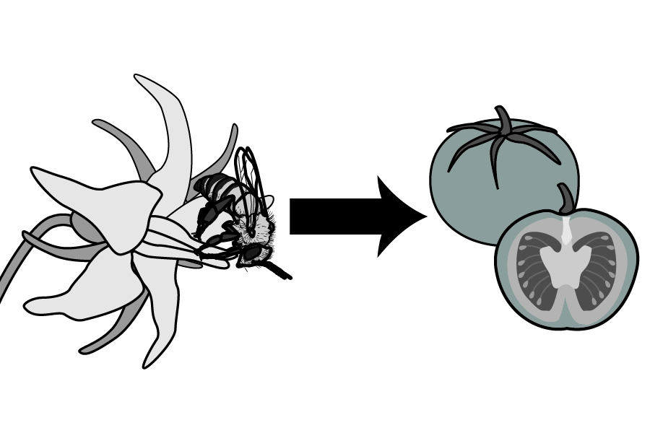
The next time you see a bee buzzing around, remember it may be carrying pollen from one flower to another. Once a flower has been pollinated, it can produce seeds and fruit. Without the assistance of pollinators, many plants cannot produce fruits and seeds that are an important food source for people and wildlife.
Flower develops into fruit and seed
Bee pollinating a flower
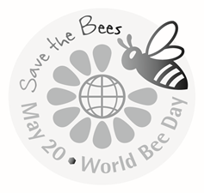

World Bee Day is celebrated on May 20 to remind people that much of the food they eat depends on pollination by insect pollinators. Reema, a food truck owner, would like to celebrate World Bee Day by deleting all foods on the food truck menu that depend on honey bees, wild bees, or other pollinators. The menu for Reema’s food truck is shown below.

Fish Taco
Blackened Fish, purple cabbage, mango and lime salsa on a soft wheat tortilla.

Crunchy Beef Taco
Seasoned beef, cheese, lettuce, and avocado in a crunchy corn tortilla.

Classic Hamburger
Beef patty with American cheese, tomato, and onion on a sesame seed bun.

Veggie Burger
A patty of black beans, brown rice, corn, spinach, carrots, and peppers on a roll.

Beverages Coffee, Tea, Apple Juice, Vanilla Milkshake
Desserts Chocolate Cookies, Peach Pie, Watermelon Slice

- Cross off all foods on Reema’s food truck menu that you think rely on insect pollinators. Note: See the cross outs for Fish Taco as an example.

Many nutritious crops in your diet (including many fruits and vegetables) rely on insect pollinators. Pollinators also pollinate crops used for animal feed. For example, alfalfa requires a pollinator. Cows eat alfalfa, and cows produce milk, dairy products, and meat. A decrease in pollinators may disturb ecosystems by decreasing food available for wildlife.

Not all crops are insect pollinated. Leafy veggies, such as lettuce and spinach, do not rely on pollinators. Some foods, such as wheat, rice, and corn, are wind pollinated so pollinator decline does not affect these crops.

- Read the information in the text box above. Based on the information in the text box:

- List additional foods that you should cross off the menu because they rely on insect pollinators. Explain why these foods should be crossed off the menu.

- List foods that should not be cross off the menu because they do not rely on insect pollinators. Explain why these foods should not be crossed off the menu.

Part 2: A bee problem

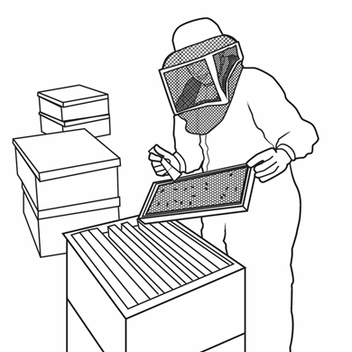
Judy is a beekeeper. She started keeping honey bees as a hobby but it has turned into a profitable business for her. Last year, Judy and her two employees maintained approximately 2,000 hives. Each hive contains one colony of honey bees.
Judy sells honey from her hives. However, most of Judy’s profit from her business comes from renting her honey bee hives to farmers. Farmers rent hives from Judy because the honey bees from the hives pollinate the flowers of fruit and vegetable plants.
Judy’s hives are shipped throughout the country—to California for almond tree pollination, to Florida to pollinate orange trees, and to the Northeast to pollinate a variety of fruits and vegetables. In the Fall, Judy’s hives are returned to her farm in Texas where the bee colonies produce more honey and prepare for the winter.
Over the past few years, Judy noticed that the bee colonies in many of her hives were dying. She lost 50% of the bee colonies in her hives during the 2018-2019 winter. Judy wonders why her bee colonies are dying.

- Why would farmers rent honey bee hives from Judy?

- What ideas do you have for things that might have caused the death of Judy’s bee colonies during the 2018-2019 winter? List at least two possibilities.

Judy and other beekeepers in the United States contribute bee health data and samples of honey bees from their hives to The Bee Informed Partnership (https://beeinformed.org/). The Bee Informed Partnership conducts laboratory tests and analyzes data to identify possible causes for the loss of bee colonies.

- Use the information in the data table to update the graph below (Annual Estimated U.S. Honey Bee Colony Losses).
- Plot the data for total annual losses and winter losses for the 2017-2018 and 2018-2019 reporting years.
- Then, connect the lines to the data from previous years.

Data Table

Reporting Year | Total Annual Losses (% of colonies lost) | Winter Losses  (% of colonies lost)
2017-2018 | 42 | 30
2018-2019 | 42 | 38

Graph: Annual Estimated U.S. Honey Bee Colony Losses Modified from https://beeinformed.org
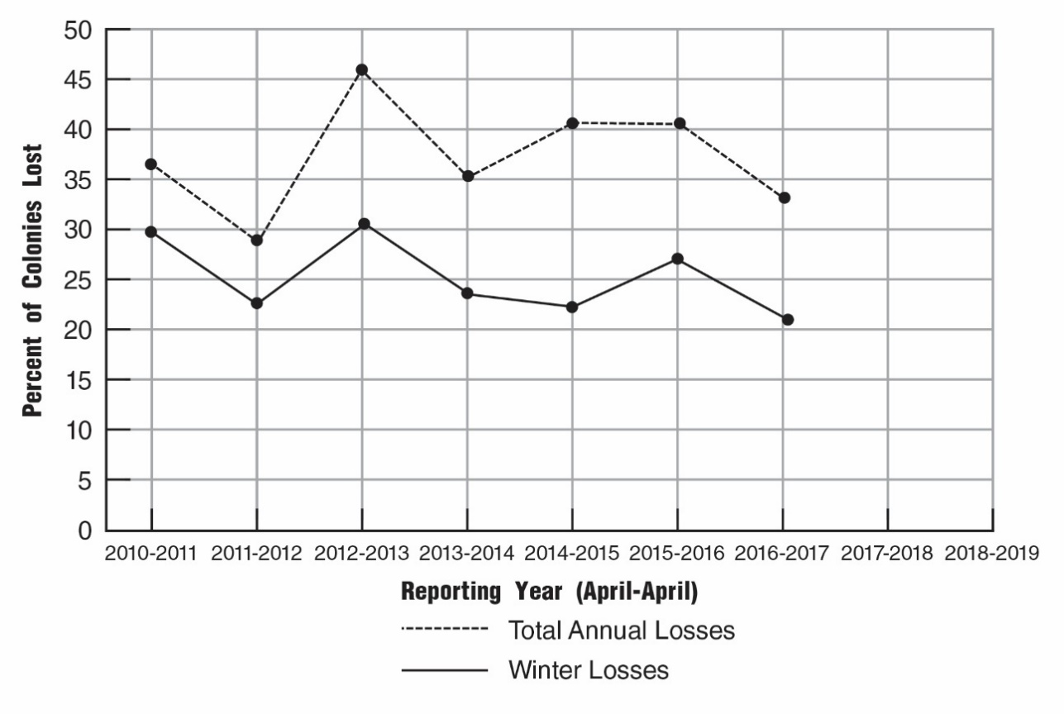
- Judy lost 50% of the bee colonies in her hives during the winter of 2018-1019. Compare her bee colony loss with the bee colony loss experienced by other beekeepers. Support your answer with evidence from the graph.

Part 3: Sick bees - Are colony losses caused by pathogens and parasites?

Test for Pathogens

Some beekeepers claim that the health of a bee colony is severely threatened if bees become infected with pathogens such as viruses that affect their ability to fly. Bees need to fly to collect food (pollen and nectar) that is stored in the hive to support the bees during the winter.

In August, Judy sent a sample of 100 bees from one of her hives to the Bee Informed lab. Chemists in the lab prepared a sample of concentrated viruses from Judy’s bees.

A Bee Virus Test Sheet can be used to determine which types of viruses are present in the sample. Each circle on the test sheet contains a different chemical that can attach to one type of virus. If the viruses attach to the chemical, the circle on the test sheet will turn pink.

- Use a dropper to add 2 drops of Viruses from Judy’s Bees to each of the circles on the Bee Virus Test Sheet.

- Color in the circles below to show what happened when you added the virus sample to the circles on the test sheet.

Bee Virus Test Sheet

Bee Paralysis Cloudy Wing Deformed Wing
Virus Virus Virus

- Based on the results of the virus tests, what type(s) of viruses are present in the sample from Judy’s bees?

- Explain how evidence from the virus tests that you conducted supports the claim that viruses contribute to winter die-off.

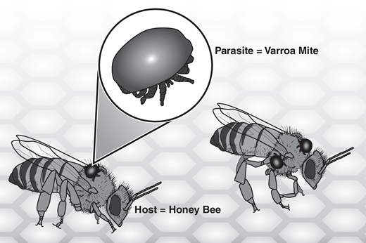
Tests for Parasites

Some beekeepers claim that winter bee colony losses are due to parasites that weaken or kill the bees. High Fall parasite levels make it more difficult for bees to survive the winter.

Varroa mites are tiny parasites that attach to bees. These mites weaken the bees when they feed on the bees’ body fat. Varroa mites also carry viruses and bacteria that can cause bee diseases.

- Judy and other bee keepers completed tests for varroa mites each month for a year. The results of these tests are shown in the graph below.

Varroa Mites by Sampling Month
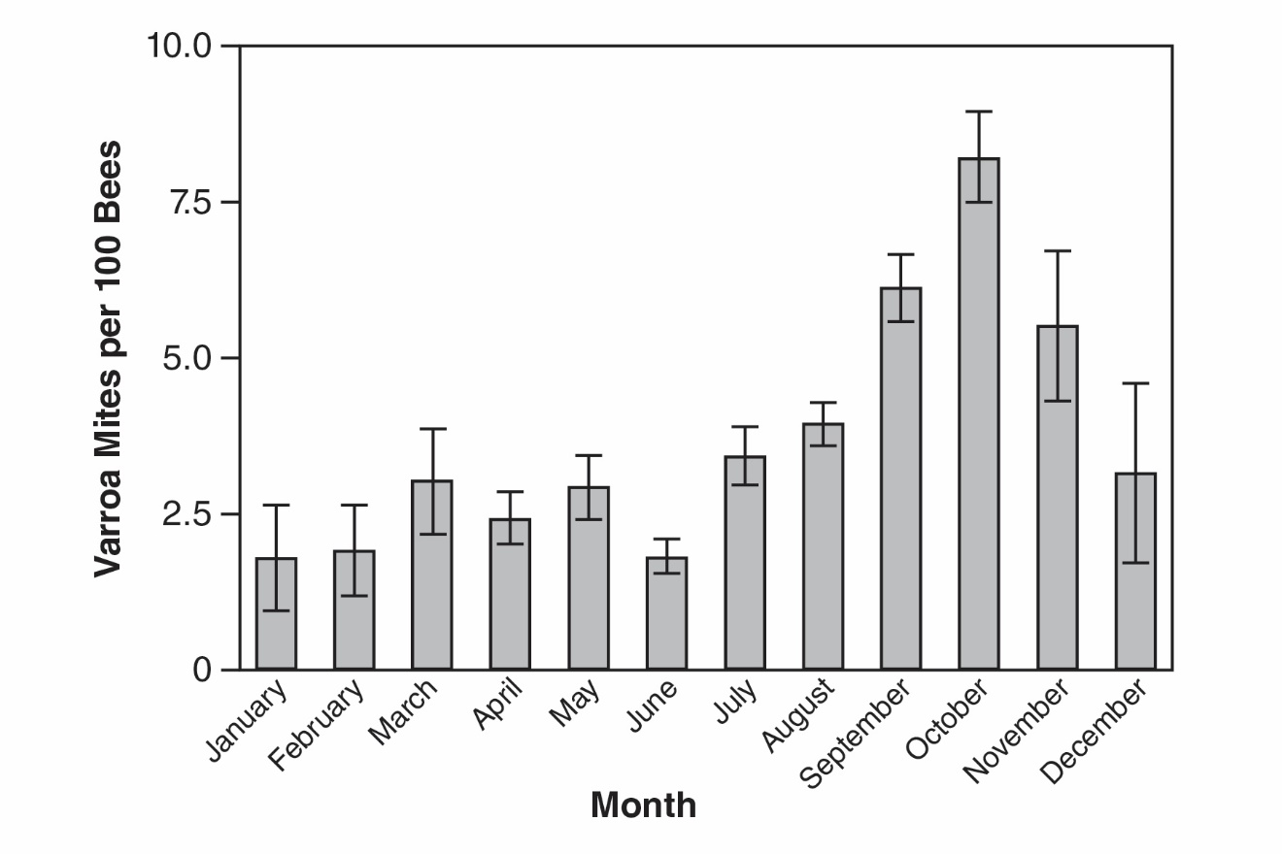
Source: https://www.vanengelsdorpbeelab.com/student-updates/the-national-honey-bee-disease-survey-varroa-nosema-in-the-us

- Explain why high Varroa mite infections in a hive might increase the likelihood of winter die-off for a hive.

- According to the information in the Varroa Mites by Sampling Month graph, during what month would it be most important to treat bee hives to kill Varroa mites?

Part 4: Poisoned Bees - Are Colony Losses Caused by Pesticides?

Pesticides are chemicals used to kill various pests such as insects, weeds, and fungus. Unfortunately, the use of pesticides is not good for bees. Flowers, nest sites, and the general environment around bees are often contaminated with pesticides. Bees are exposed to pesticides through pollen, nectar, and through the air, water or soil.

Pesticides known to pose a threat to bee health include:
- Insecticides that kill insects that feed on crops
- Herbicides that kill weeds that compete with crop plants
- Fungicides that kill fungus that causes crop diseases

To provide data related to pesticides in her hives, Judy sent samples of bee wax to the Bee Informed lab for pesticide analysis. The chemists at the Bee Informed lab created concentrated extracts from the bee wax. The chemists then used paper chromatography to separate and identify the pesticides from the bee wax extracts.

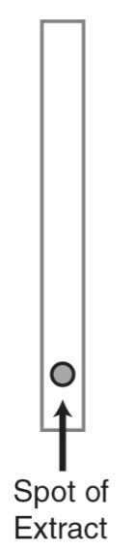
- The chemists used droppers to apply a spot of the bee wax extract onto a strip of chromatography paper, as shown in the diagram to the right.

- Next, the chemists dipped the end of the chromatography paper into a liquid.

- As the liquid moved up the paper, the different pesticides in the bee wax extract dissolved in the liquid. The different pesticides move through the chromatography paper at different rates. This separates the pesticides into colored bands as shown in the diagram below.

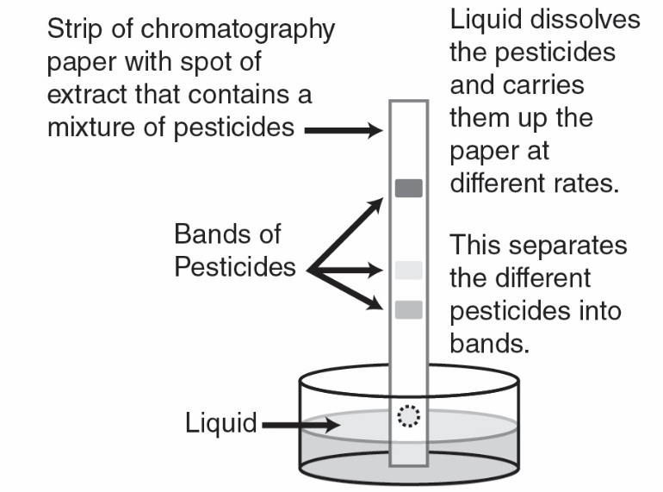

- Column 1 in the data table below summarizes the colors of bands that resulted from paper chromatography of bee wax extracts A and B. Use the Key on the right to identify the pesticides that are present in extracts A and B. Write the names of these pesticides in Column 2.
KEY
Red-Pink Band = Insecticide
Blue Band = Fungicide
Yellow-Green Band = Herbicide

Results of Paper Chromatography of Bee Wax Extracts
Bee Wax Extract | Column 1  Color of Bands | Column 2  Which pesticides are present in the bee wax extract?
A  Extract from a bee hive sent to almond and orange orchards in California | Red-Pink  Yellow-Green
B  Extract from a bee hive sent to soybean farms in North Dakota and Michigan | Red-Pink  Yellow-Green  Blue
C
Extract from a bee hive that remained at Judy’s farm in Texas

- Extract C is from a hive that remained on Judy’s farm in Texas. You will use paper chromatography to determine what pesticides are in Extract C.

- Your teacher will give you a strip of chromatography paper has a spot of extract C prepared from bee wax in a hive that remained on Judy’s farm in Texas. You will use paper chromatography to separate and identify the pesticides present in the spot of extract C.
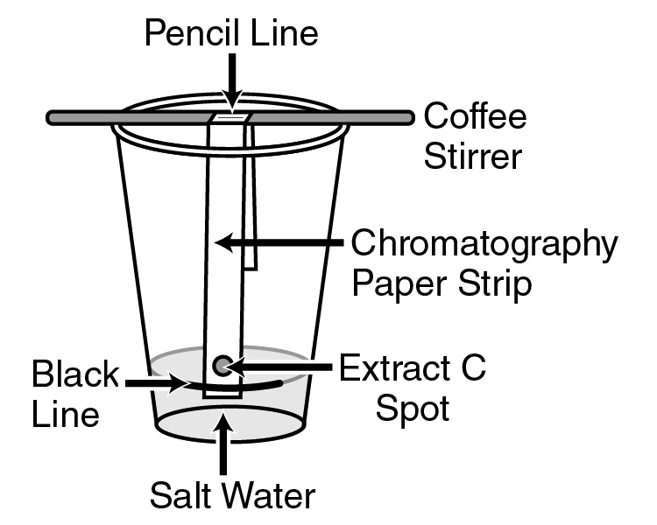
- Note the black line on the clear cup. Add salt water to the cup so that the salt water comes up to the black line on the cup.

- Place a coffee stirrer on top of the cup.

- Fold the end of the chromatography paper strip at the pencil line near the middle of the strip.

- Hang the folded chromatography strip on the coffee stirrer so that the end of the paper strip is in the salt water. Note: The spot of extract C should NOT be in the salt water.

- Watch as the salt water in the cup moves up the chromatography paper. Note that the pesticides in the extract separate as they move up the paper strip.

- Remove the chromatography paper strip from the cup once the liquid is about 2/3 of the way up the paper strip. Observe the colored bands on the chromatography paper strip.
- Complete the Results of Paper Chromatography of Bee Wax Extracts chart above by writing the colors of the bands and the type of pesticides present in the Extract C.

Base your answers to questions 8 through 12 on the information in the Results of Paper Chromatography of Bee Wax Extracts chart.

- What types of pesticides are present in extract C?

- Which bee wax extract (A, B, or C) contained the greatest variety of pesticides? Support your answer

- Which bee wax extracts contained insecticides? Support your answer.

- Which location (orchards or soybean farms) is likely to cause the greatest winter die off when the bee hive returns to Judy’s farm?

- Does the data from Judy’s bee wax sample support the claim that pesticide use may lead to winter bee colony loss? Explain why or why not.

Part 5: Hungry Bees - Are colony losses caused by poor nutrition?

Bees feed on flower pollen and flower nectar (a sweet secretion that attracts insects or birds). They collect and carry this food back to the hives to feed developing young bees and to store it for use during the winter. This means that bee colonies need a supply of different kinds of flowers near their hives throughout the bee season (spring, summer, and fall).

Natural areas with a diversity of wildflowers that bloom at different times of the year are important in providing nutrition for bees. Poor bee nutrition results when there are not enough blooming flowers during all parts of the bee season. Poor nutrition leads to winter loss when bees cannot store enough food to feed the hive for the winter.

Put an X in front of the 6 descriptions below that are most likely to contribute to poor bee nutrition (“bee hunger”) for Judy’s bee colonies.

- _____ The farms surrounding Judy’s bee hives use monoculture (growing only one kind of crop).
- _____ A developer turned a large farm near where Judy kept her bee hives into a shopping mall.
- _____ Homeowners near Judy’s hives apply herbicides to their yards to kill flowering weeds.
- _____ Judy’s farm in Texas is surrounded by her vegetable garden and natural areas with many different wildflowers.
- _____ A neighbor planted a pollinator garden of colorful and scented plants that bloom during different parts of the year.
- _____ The dairy farm near Judy’s bee farm grows alfalfa to feed their herd and has natural areas between fields to act as windbreaks and wildlife habitats.
- _____ Climate change (increased temperatures and decreased rainfall) has affected the kinds of crops and wildflowers that can survive in the part of Texas where Judy lives.
- _____ Climate change has caused “season creep” with flowering no longer happening when Judy’s bees are emerging from their hives in the spring.
- _____ Climate change has resulted in unpredictable and severe weather (droughts and flooding) in the area around Judy’s farm.

Part 6: Protecting Pollinators

Bees are essential for a healthy environment because they maintain biodiversity (the variety of life in a particular habitat or ecosystem). Bees maintain biodiversity by contributing to the complex, interconnected relationships that allow many different species to co-exist in an ecosystem.

It’s not just farm-grown fruits and vegetables that rely on pollinators to thrive. Many species of wild plants depend on insect pollinators as well. Bees are responsible for the production of many seeds, nuts, berries, and fruit, which serve as a vital food source for wild animals. Bees also support the growth of trees, flowers, and other plants which serve as food and shelter for animals.

Bees are also a source of food for animals. Raccoons, opossums, and insects will raid beehives to eat the nutritious honey and the bee larvae. At least 24 species of birds, including the blackbird, ruby-throated hummingbird, and starling, prey on bees. Many spiders and insects, like dragonflies and praying mantises, eat bees as well.

- Biodiversity is essential for the health of the environment. Describe two ways that a decline in bee populations could result in a loss of biodiversity in an ecosystem.

- Protecting pollinators is important for the health of humans, animals, and the environment. Based on what you learned in Parts 1-5, suggest three things that people could do to protect bees.

- The video below suggests ways that people can reduce the decline in bee populations. View this video to find three additional things that you could do to protect bee populations.
8 Practical Things You Can Do To Help The Bees - https://www.youtube.com/watch?v=TMyd8JtFSzQ
Scan the QR code with your smartphone or tablet camera app to link to the video.



- Circle the one action from questions 2 and 3 that you think would have the greatest impact on protecting insect pollinators. Explain why you think this action would have the greatest impact.

Part 7: One Health and disappearing bees
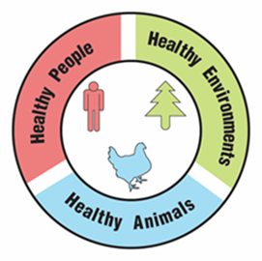
One Health

A university is suggesting that the local government take a One Health approach to solving complex local problems, such as disappearing bees. A One Health approach uses the idea that complex problems often involve the health of people, animals, and the environment. Therefore, solutions to One Health problems must be designed to protect the health of people, animals, and the environment.

- Use the information in the text box above to explain what must be involved in a complex problem for it to be considered a One Health problem.

To support adoption of a One Health approach, the university officials want to create a series of slides to provide examples of One Health problems in the community. Your team has been hired to create a slide to answer the question, “Why are disappearing bees a One Health problem?”

Remember how the CDC video used images with captions to help people understand what One Health problems and solutions involve. Using pictures and captions will help people understand and remember what the One Health approach involves.

- Use the information in the text box above and what you learned about disappearing bees to develop your slide. Use the following template to organize your slide:

Why are disappearing bees a One Health problem?
Picture and a caption to explain how animals are involved in the problem | Picture and a caption to explain how humans are involved in the problem | Picture and a caption to explain how the environment is involved in the problem

