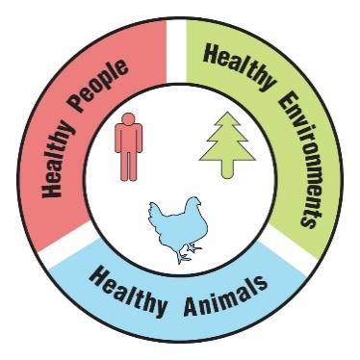
Mosquito Invasion

Teacher Guide

Lesson Summary
A man and his dog are both infected with heartworm, a disease that is caused by a worm carried by mosquitoes. Explore how an invasive species of mosquito combined with climate change can lead to an increase in heartworm and other diseases carried by mosquitoes.

Core Concepts:
- Asian tiger mosquitoes can transmit diseases to humans and other animals.
- Asian tiger mosquitoes are an invasive species whose range in the United States is expanding.
- Climate change is predicted to expand the range of the Asian tiger mosquito and lead to outbreaks of mosquito-borne diseases.
- A One Health approach identifies and seeks solutions to problems that affect the health of humans, animals, and the environment.

Suggested Grade Levels: Grades 9 – 12

Class Time Required (approximate):
- Part 1 – A surprising diagnosis 15 minutes
- Part 2 – Pets and heartworm 25 minutes
- Part 3 – Mosquitoes and heartworm 20 minutes
- Part 4 – Climate change and mosquitoes 30 minutes
- Part 5 – One Health and invasive Asian tiger mosquitoes 40 minutes

Copyright © 2022 by University of Rochester. All rights reserved. May be copied for classroom use. This lesson was developed with support from the National Institutes of Health under Award Number R25GM132758. The content is solely the responsibility of the authors and does not necessarily represent the official views of the National Institutes of Health.
Teacher Preparation:

Chemicals are used for Part 2 of this lesson. Follow your school’s Chemical Hygiene Plan and review relevant laboratory safety procedures with your students.

Part(s) | Materials needed for each pair of students
1 - 5 | - 2 copies of student handout entitled Mosquito Invasion  - Internet access and computer for each student. Note: Parts 2, 3, and 4 require use of internet resources. If your students do not have internet access, be prepared to show class videos and make copies of appropriate print resources.
2 | - 2 ml microtube or small test tube labeled Sasha’s Blood Plasma containing 2 ml of pH 10 buffer. If you use a small test tube, you will need to add enough pH 10 buffer to allow a depth of at least 2 cm. Note: A solution of 1 teaspoon of washing soda (not baking soda) mixed with 1 cup of tap water may be substituted for pH 10 buffer.  Buffer pH 10 may be ordered from Ward’s Science: https://www.wardsci.com/store/product/8868691/buffer-solution  Microcentrifuge tubes (2ml) may be ordered from Globe Scientific: https://www.globescientific.com/certified-microcentrifuge-tubes-in-self-standing-bags.html?psku=111574&cid=0  - Small bag labeled Rapid Test Strips that contains at least one strip of paper prepared as shown on the right. Use card stock paper or file cards to make the test strips.  Thin black line made with a fine permanent marker  Tiny spot of 1% phenolphthalein made using a cotton swab  Paper strip—0.5 cm x 6 cm  1.5 cm  1% phenolphthalein solution may be ordered from Ward’s Science:  https://www.wardsci.com/store/product/8883525/phenolphthalein
3 | - Distribution of Aedes albopictus Mosquitoes map. Print in color. Laminate for use in multiple classes. Optional: Printing on transparencies would allow students to overlap the maps. See page vii.  - Distribution of Veterinary Cases of Heartworm map. Print in color. Laminate for use in multiple classes. Optional: Printing on transparencies would allow students to overlap the maps. See page viii.
4 | - Asian Tiger Mosquitoes: Vectors for Diseases illustration. Print in color. See page ix. Laminate or put in sheet protector if this will be used in multiple classes.
5 | - Access to Google, PowerPoint or similar digital program for making slides, or poster paper and markers.
Suggested Class Procedure

General
- Distribute 1 copy of Mosquito Invasion to each student.
- It is suggested that students work in pairs.
- NOTE: The topics of heartworm and invasive mosquitoes are rich enough to trigger conversations and questions that go beyond the immediate content in this lesson. Teachers may set up a “Parking Lot” for collecting student questions or ideas for additional connections/research.
Parking Lot Strategy
- Make a large poster paper or bulletin board area in the classroom as your Parking Lot.
- When students have a question or additional connection, have them write it on a sticky note and hand it to you or put it in the Parking Lot.
- Only answer questions immediately if they are essential for completing the lesson.
- Put sticky notes with other questions or connections in the Parking Lot.
- At the end of the lesson, review the Parking Lot questions.
- Remove questions that were answered by the lesson.
- Ask students which remaining questions and connections they would like to discuss.

Part 1: A surprising diagnosis (15 minutes)
- Read the four paragraphs aloud to the class.
- Students work with their partner to answer the questions in Part 1. Alternative: Students work independently to read and answer questions and then pair to share answers.

Part 2: Pets and heartworm (25 minutes)
- Read the information in the text box aloud to the class.
- Explain that the video (https://youtu.be/oy8JwuCIXbY) includes vocabulary that may be difficult for them to understand. The video will give them an idea of how heartworm affects dogs. Students view the video (3.6 min) as individuals, pairs, or the entire class. The video includes vocabulary and concepts beyond that typical for high school students. Explain that they do not need to know the details of heartworm infection. After the video, you will give them a chance to ask questions or explain what they learned or found interesting.
- Ask students “What parts of the body are harmed by the heartworm?”
- Provide an opportunity for students to ask questions about the video or explain what they learned or found interesting.
- Students should read the information in the second text box. They will need the information in the second text box to complete Part 2.

- Distribute materials for simulated heartworm testing to each pair of students.
- Tube of Sasha’s Blood Plasma
- Bag containing one or more Rapid Test Strips
- Students work with their partner to do the heartworm testing and answer the questions in Part 2.

Part 3: Mosquitoes and heartworm (20 minutes)
- Ask students to read the information in the text box. Call on several students to summarize what they learned from this reading.
- Students should read and follow the instructions in question 1. Students view the video (2.2 min) as individuals, pairs, or the entire class (https://www.youtube.com/watch?v=s1ED2eJ4_s0). The video moves quickly, so students may need to view the video several times to identify four reasons why Asian tiger mosquitoes pose a more serious disease threat than native mosquito species.
- Consider having students share their answers to question 1.
- Distribute colored copies of the Distribution of Aedes albopictus Mosquitoes map and the Distribution of Veterinary Cases of Heartworm map.
- Optional: Ask students to talk with their partner to describe what they observe about the two maps for 2 minutes. Call on students to share their observations. Then, give students another 2 minutes to discuss what questions they have. Share as a whole class.
- Students work with their partner to answer the questions in Part 3.
- It is important to have students share and discuss their answers to question 4 in Part 3.

Part 4: Changing climate and mosquitoes (30 minutes)
- Some students may not be aware of what climate change is. You might want to begin by asking students for examples of changes that are occurring as a result of climate change.
- Read the two paragraphs aloud to the class.
- Distribute Asian Tiger Mosquitoes: Vectors for Diseases.
- Students work with their partner to answer the questions in Part 4. Remind students that they will need the information in the text box.
- Students will need internet access to answer questions 5 and 6. Specific websites are provided to save time needed for research.
- Teachers or students may be concerned about the suggested use of pesticides. Note that pesticide use is included in both of the recommended web sites are from the CDC (Centers for Disease Control and Prevention). Consider asking students to circle or underline the things that people or communities could do that do not involve pesticide use.

Part 5: One Health and invasive Asian tiger mosquitoes (40 minutes)
- Read the information in the first text box aloud to the class.
- Students work with their partner to complete question 1.
- Have several students share their answer to question 1. It is important for students to have this correct before moving on to question 2.
- Display the following video from the CDC to add to student understanding of One Health. https://www.youtube.com/watch?app=desktop&v=TG0pduAYESA
- Read the information in the second text box aloud to the class.
- Students work with their partner to complete question 2 – their digital slide. Note: Students without access to digital slide programs like Google or PowerPoint can produce a paper version.
- Suggestion – Collect the digital slides into one slide deck. Share this slide deck with the class. If you have ample class time, you may consider having students present and explain their slides.
- Students receive full credit if their slide links tick-borne diseases to the health of humans, animals and the environment.
- Optional extension: Have students identify another example of a One Health problem. Have students use their idea to create a similar slide/poster that explains why their example is a One Health problem. Students can use examples from their community or from the One Health CDC website.

Teacher Resources:

- Centers for Disease Control and Prevention (CDC): One Health (video used in Part 5)
https://www.youtube.com/watch?app=desktop&v=TG0pduAYESA

- Centers for Disease Control and Prevention (CDC): One Health
https://www.cdc.gov/onehealth/index.html

- USDA: Asian Tiger Mosquito
https://www.invasivespeciesinfo.gov/profile/asian-tiger-mosquito
- Man’s best friend: How humans can develop Dirofilaria immitis infections https://www.ncbi.nlm.nih.gov/pmc/articles/PMC4816904/
- Dirofilariasis: An Emerging Zoonoses
https://www.ncbi.nlm.nih.gov/pmc/articles/PMC3745666/
- American Heartworm Society: Pet Owner Resources
https://www.heartwormsociety.org/pet-owner-resources
- American Heartworm Society - Education Resources https://www.heartwormsociety.org/veterinary-resources/client-education/think-12
- Invasive Mosquito Brochure https://www.cdph.ca.gov/Programs/CID/DCDC/CDPH%20Document%20Library/InvasiveMosquitoesBrochure.pdf
- Mosquito Citizen Science: Asian Tiger Mosquito Invasive Boundary Project
https://www.neregionalvectorcenter.com/invasive-albopictus-project.php

Scan the QR code with your smartphone or tablet camera app to link to a file with all the websites for the teacher resources and student hyperlinks used within the lesson.



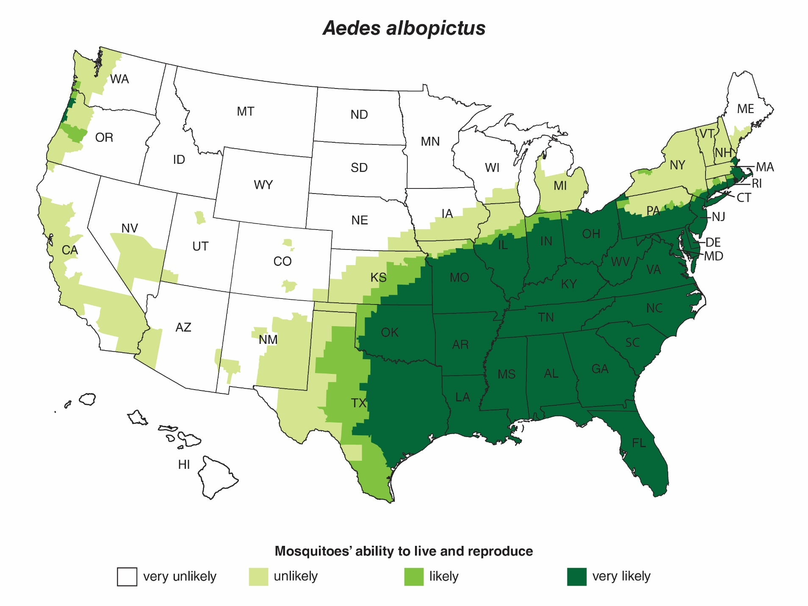
Modified from: https://www.cdc.gov/zika/vector/range.html
Distribution of Aedes albopictus Mosquitoes

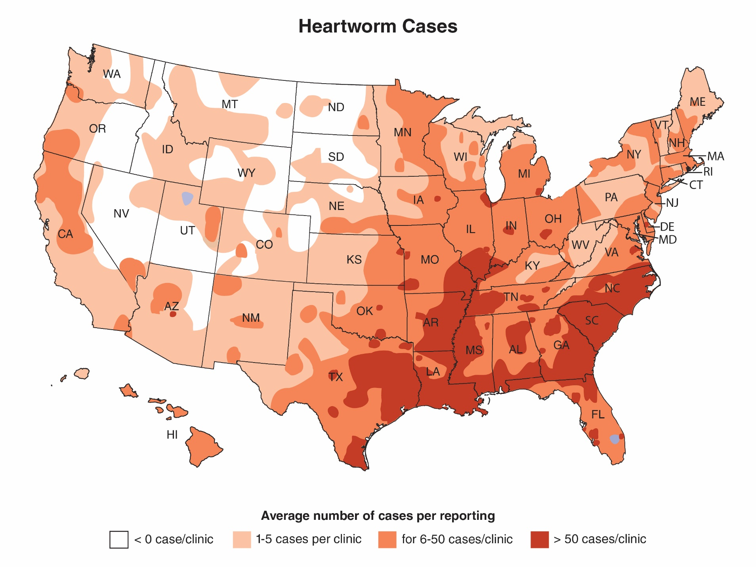
Blue spots indicate areas where data on heartworm cases was not available.
Distribution of Veterinary Cases of Heartworm

Modified from: https://www.heartwormsociety.org/pet-owner-resources/incidence-maps

Asian Tiger Mosquitoes: Vectors for Diseases
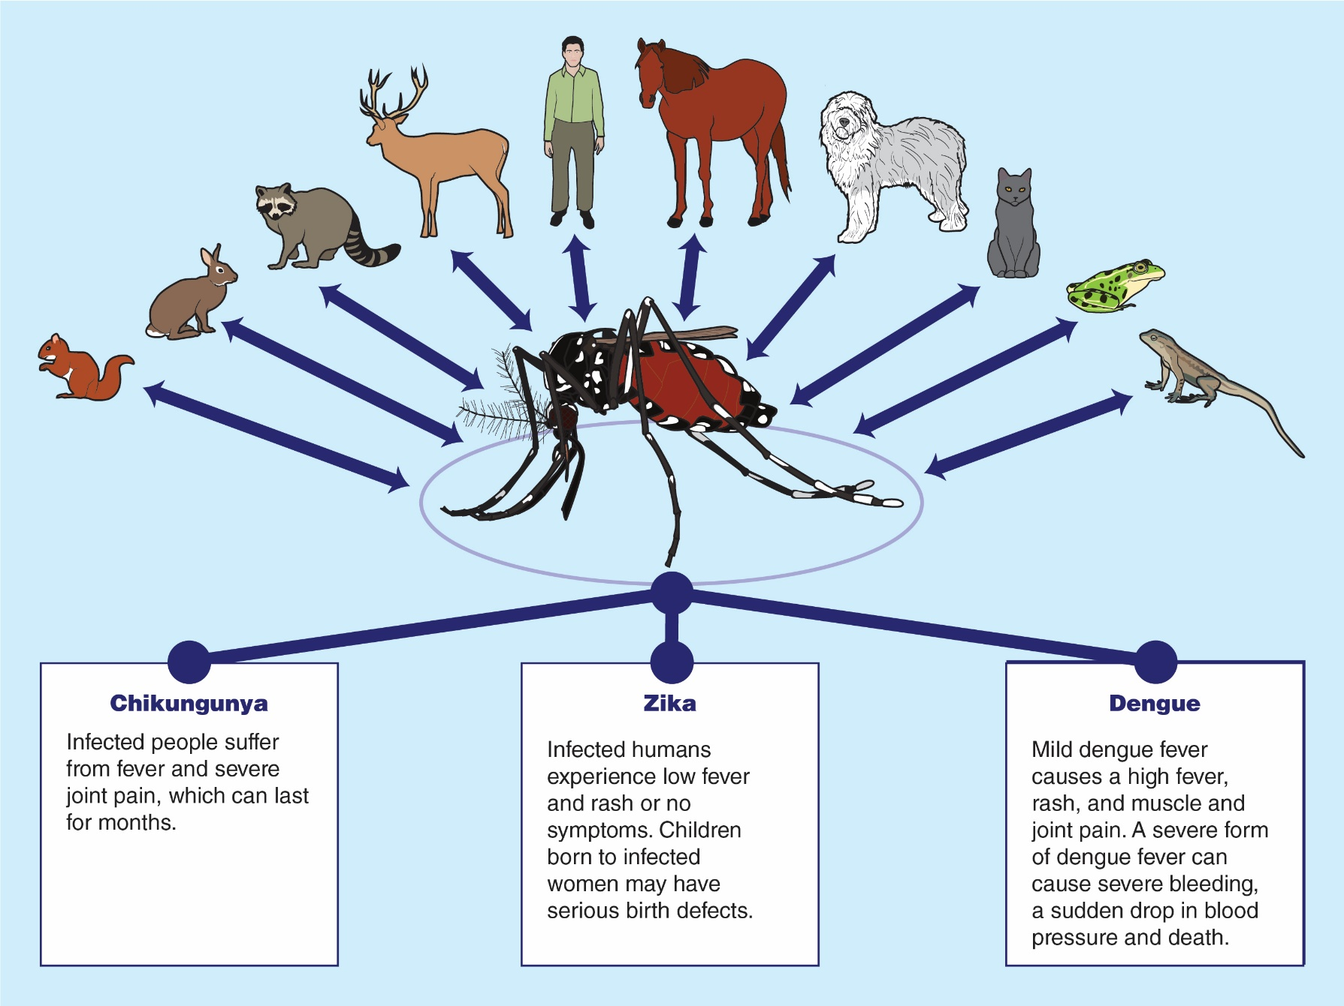

NGSS Correlation:

Working Towards Performance Expectations
- MS-LS2-2. Construct an explanation that predicts patterns of interactions among organisms across multiple ecosystems.
- HS-LS2-6. Evaluate the claims, evidence, and reasoning that the complex interactions in ecosystems maintain relatively consistent numbers and types of organisms in stable conditions, but changing conditions may result in a new ecosystem.
Science and Engineering Practices  - Use graphical displays (e.g., maps, charts, graphs, and/or tables) of large data sets to identify temporal and spatial relationships. | Disciplinary Core Ideas  - Similarly, predatory interactions may reduce the number of organisms or eliminate whole populations of organisms. Mutually beneficial interactions, in contrast, may become so interdependent that each organism requires the other for survival. Although the species involved in these competitive, predatory, and mutually beneficial interactions vary across ecosystems, the patterns of interactions of organisms with their environments, both living and nonliving, are shared.  - A complex set of interactions within an ecosystem can keep its numbers and types of organisms relatively constant over long periods of time under stable conditions. If a modest biological or physical disturbance to an ecosystem occurs, it may return to its more or less original status (i.e., the ecosystem is resilient), as opposed to becoming a very different ecosystem. Extreme fluctuations in conditions or the size of any population, however, can challenge the functioning of ecosystems in terms of resources and habitat availability. | Cross Cutting Concepts  Stability and Change:  - Much of science deals with constructing explanations of how things change and how they remain stable.

Mosquito Invasion

Part 1: A surprising diagnosis

Mario had a mild but annoying cough. His doctor recommended that he have a lung CT scan to screen for lung cancer. His CT scan (Figure 1) revealed a pulmonary (lung) nodule.
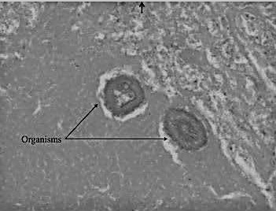
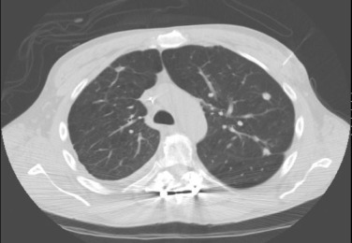
Pulmonary nodule
Dirofilaria immitis worms
cross section
Figure 1: CT scan of Mario’s lungs Figure 2: Biopsy of Mario’s lung

Because pulmonary nodules may be cancerous, the doctor ordered a biopsy. Mario had surgery to remove the pulmonary nodule. Microscopic examination of the biopsy tissue (Figure 2) did not reveal cancer. Instead, the pulmonary nodule tissue from Mario’s lung contained parasitic worms called Dirofilaria immitis. The common name for Dirofilaria immitis is “heartworm.”
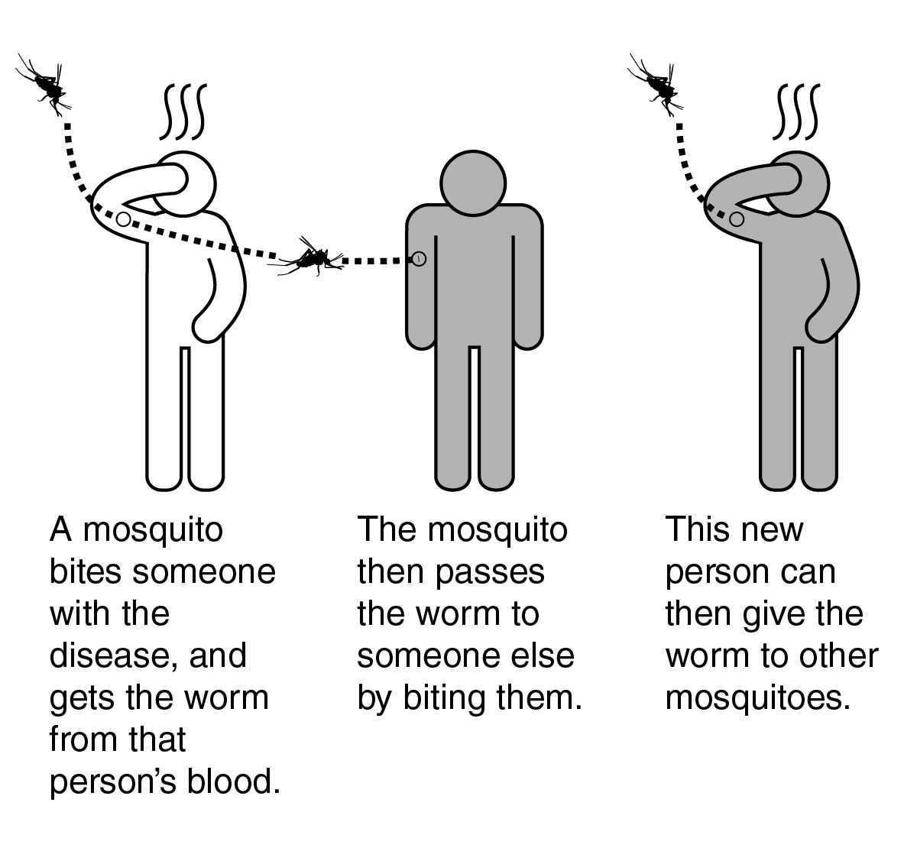
Mario’s doctors explained that mammals, such as humans and dogs, become infected with heartworm when they are bitten by mosquitoes that carry Dirofilaria immitis. Mosquitoes act as vectors (carriers). When they bite one mamma infected with the worm they pick up small worms. They can transfer the worms when they bite another mammal.

Diagnosed cases of Dirofilaria immitis in humans are rare. People infected with Dirofilaria immitis usually experience no symptoms. Inside humans, heartworms grow and then die in blood vessels of the lungs. Treatment is not needed because the worms do not reproduce in humans.

- How did Mario become infected with Dirofilaria immitis?

- Why is Mario’s diagnosis “surprising?”

- Explain why it is likely that there are humans with undiagnosed cases of Dirofilaria immitis.

Part 2: Pets and heartworm

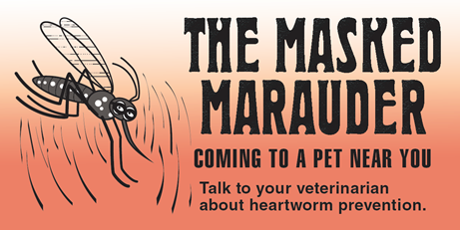
Mario is worried about his dog, Sasha. Sasha has been losing weight. She is not as active as she used to be. Mario took Sasha to a veterinary clinic for a heartworm test.

One poster (shown on the right) in the vet clinic waiting room caught Mario’s attention. He never realized that mosquitoes could bite pets and transmit diseases to them.


- There was a video about dog heartworm playing on the monitor in the waiting room. Watch the video and in the space below write one question you have and one thing that you found interesting about heartworm.
Scan this QR code with your smartphone or tablet camera app to link to the videos and websites used in this lesson.
Click on this link to see the video: https://youtu.be/oy8JwuCIXbY

- One question you have:

- One thing you found interesting about heartworm:

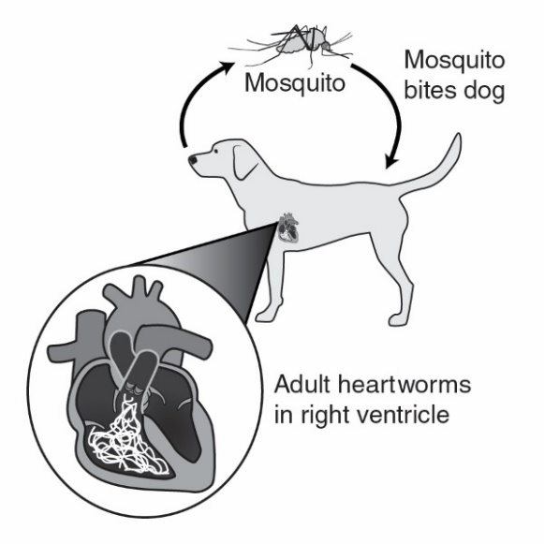
The veterinarian explained that heartworm is caused by a parasitic worm called Dirofilaria immitis. Mosquitoes act as vectors (carriers) to spread heartworm from one dog to another. In a dog, the heartworms cause serious health problems because they live, grow, and reproduce in the dog’s heart.

All dogs should have yearly heartworm tests. Luckily there is a simple and inexpensive test that can be done at the vet clinic to determine if a pet is infected with Dirofilaria immitis worms.

- A veterinary assistant prepared a sample of Sasha’s blood plasma (liquid part of the blood). Follow the instructions below to test the blood plasma sample from Sasha for Dirofilaria immitis.

- Dip the end of the Rapid Test Strip with the black line into Sasha’s Blood Plasma for approximately 5 seconds. Be certain that at least half of the test strip is dipped into the plasma.
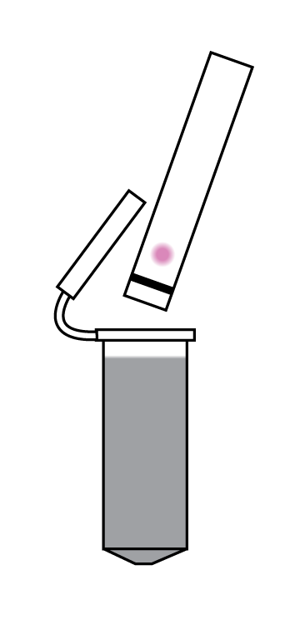
Black line inserted into blood plasma

Pink on test strip

- Remove the test strip from the plasma and observe the test strip.
- If there is no pink on the test strip, the result is negative—Sasha does not have Dirofilaria immitis that causes heartworm disease.
- If there is a pink area on the test strip, the result is positive—Sasha has Dirofilaria immitis that causes heartworm disease.

- Does Sasha have heartworm disease? Support your answer with data from the testing.

- Discard the test strip. Close the lid on the tube of Sasha’s Blood Plasma and return it to your teacher.

- Mario had a few questions that are below. Use the resources provided by the American Heartworm Society (https://www.heartwormsociety.org/pet-owner-resources) to answer his questions.

- Is heartworm contagious? Could dogs, cats, or people who are in contact with Sasha get heartworm disease from her?

- The treatment for heartworms is expensive and complex. What will the Dirofilaria immitis worms do to Sasha’s body if I do not have her treated? Be specific.

- I have a cat. Should my cat be tested for heartworm? Explain why or why not.

- What should I do to keep my pets from getting heartworm in the future? Be specific.

- Explain why veterinarians should include information on mosquito control in their advice for pet owners.

Part 3: Mosquitoes and heartworm

Mario lives in Vermont. In the past, mosquitoes were only a problem for him in the early morning or evening. For the last few years, he has noticed a new kind of mosquito that bites aggressively during the day.

Local TV news programs have warnings about the new mosquito in the area. These mosquitoes are called the Asian tiger mosquito. The Asian tiger mosquito (scientific name Aedes albopictus) is an invasive species of mosquito originally found in the tropics. Asian tiger mosquitos were first introduced in Texas in 1985. Since then, they have spread to many parts of the United States.

Adult Aedes albopictus mosquitoes cannot survive cold winter temperatures. However, there is growing evidence that their eggs can survive drying and freezing temperatures and can hatch when temperatures rise in the Spring.

- Asian tiger mosquitoes have characteristics and behaviors that make them excellent vectors (carriers) for heartworm (Dirofilaria immitis). View the animation Tiger Mosquitoes/Seasonal Science at https://www.youtube.com/watch?v=s1ED2eJ4_s0 .

List four reasons why the Aedes albopictus species poses a more serious disease threat than native mosquito species.

Base your answers to questions 2 through 4 on the green map (Distribution of Aedes albopictus Mosquitoes) and the orange map (Distribution of Veterinary Cases of Heartworm).

- Is Aedes albopictus the only type of mosquito that can transmit the heartworm? Support your answer with evidence from the maps.

- Explain why it is possible for Aedes albopictus to move into areas of the United States that are marked “unlikely” on the map.

- Do the two maps support the claim that the spread of Aedes albopictus will result in an increase in the incidence of heartworm cases in the United States? Why or why not?

Part 4: Changing climate and mosquitoes

Mario, his parents and his neighbors have noticed that the climate in Vermont is gradually changing. Due to climate change, the summers in Vermont have been getting longer, warmer, and wetter.

Climate change, which increases the temperature and rainfall, is affecting many areas in the United States. Climate change doesn’t just shift weather patterns. It can change the distribution of plants, people, animals, insects — and disease. Climate change is also making it possible for Asian tiger mosquitoes to move into new areas. It has also led to longer “mosquito seasons.” As mosquito seasons get longer, Asian tiger mosquito populations have more time to reproduce and spread disease.

- Describe two ways that climate change will increase the number of people who are bitten by Asian tiger mosquitoes.

Base your answers to questions 2 through 5 on the illustration entitled Asian Tiger Mosquitoes: Vectors for Diseases.

- Explain why the feeding habits of Aedes albopictus mosquitoes make it likely that they could spread serious diseases from a variety of animals to humans.

- Predict what the future might be like if climate change resulted in large populations of Asian tiger mosquito populations in your community.

- As climate change occurs, it will be important for individuals in many parts of the country to take actions to control mosquitoes in and around their homes. Use information from the website below to identify at least 2 things that individuals could do to control mosquitoes in or near their homes.
https://www.cdc.gov/zika/prevention/controlling-mosquitoes-at-home.html

- As climate change occurs, it will be important that communities use Integrated mosquito management (IMM) methods to develop plans for controlling Asian tiger mosquitoes and preventing outbreaks of diseases that they carry. Use the information at the website below to identify at least 3 things that communities could do to reduce the risks of mosquito-borne diseases.

https://www.cdc.gov/westnile/vectorcontrol/integrated_mosquito_management.html

Part 5: One Health and invasive Asian tiger mosquitoes

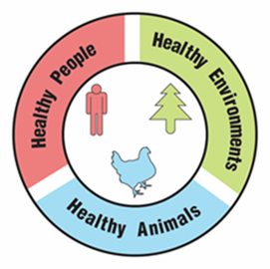
One Health

A university is suggesting that the local government take a One Health approach to solving complex local problems, such as invasive Asian tiger mosquitoes. A One Health approach uses the idea that complex problems often involve the health of people, animals, and the environment. Therefore, solutions to One Health problems must be designed to protect the health of people, animals, and the environment.

- Use the information in the text box above to explain what must be involved in a complex problem for it to be considered a One Health problem.

To support adoption of a One Health approach, the university officials want to create a series of slides to provide examples of One Health problems in the community. Your team has been hired to create a slide to answer the question, “Why are invasive Asian tiger mosquitoes a One Health problem?”

Remember how the CDC video used images with captions to help people understand what One Health problems and solutions involve. Using pictures and captions will help people understand and remember what the One Health approach involves.

- Use the information in the text box above and what you learned about invasive Asian tiger mosquitoes to develop your slide. Use the following template to organize your slide:

Why are invasive Asian tiger mosquitoes a One Health problem?
Picture and a caption to explain how animals are involved in the problem | Picture and a caption to explain how humans are involved in the problem | Picture and a caption to explain how the environment is involved in the problem

