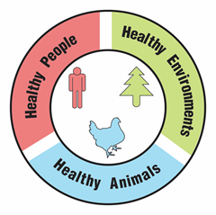
Mysterious Case of Brain Illness

Teacher Guide

Lesson Summary:

Doctors, environmental investigators, and veterinarians work together to identify the cause of an outbreak of encephalitis (a brain illness). What actions could prevent future outbreaks and protect the health of people, animals, and the environment?

Core Concepts:
- Mosquito-borne viruses pose a growing risk to human and animal health.
- Mosquito control may reduce human health risks.
- A One Health approach identifies and seeks solutions to problems that affect the health of humans, animals, and the environment.

Suggested Grade Levels: Grades 9 – 12

Class time required (approximate):
- Part 1 – What is causing an outbreak of encephalitis? 20 minutes
- Part 2 – Is there a link between bird deaths and the encephalitis outbreak? 40 minutes
- Part 3 – How is the West Nile virus transmitted and spread? 30 minutes
- Part 4 – Should people spray insecticides to prevent the spread of West Nile virus? 30 minutes
- Part 5 – One Health and the West Nile virus 20 minutes

Copyright © 2022 by University of Rochester. All rights reserved. May be copied for classroom use. This lesson was developed with support from the National Institutes of Health under Award Number R25GM132758. The content is solely the responsibility of the authors and does not necessarily represent the official views of the National Institutes of Health.
Teacher Preparation:

Chemicals are used for Part 1 of this lesson. Plan to follow your school’s Chemical Hygiene Plan and review relevant laboratory safety procedures with your students.

Part(s) | Materials needed for each pair of students
1 - 5 | - 2 Copies of student handout Mysterious Cases of Brain Illness  - Access to internet and computer for each student.
1 | - 1 copy of Virus Test Kit Instructions. See page vii. (Note: Cut page in half. Each pair of students gets ½ of the page) Laminate or put in sheet protector if used for multiple classes.  - 1 Virus Test Sheet. Print on cardstock paper. See page viii. Use a cotton swab or small brush to “paint” the circle labeled “E” with 1% phenolphthalein solution.  1% phenolphthalein solution may be ordered from Ward’s Science:  https://www.wardsci.com/store/product/8883525/phenolphthalein  - 1 microtube or small test tube labeled Patient 1 Blood Plasma that contains at least 1 ml of pH 10 buffer solution. Note: A solution of 1 teaspoon of washing soda (not baking soda) mixed with 1 cup of tap water may be substituted for pH 10 buffer.  Buffer pH 10 may be ordered from Ward’s Science: https://www.wardsci.com/store/product/8868691/buffer-solution  - 1 transfer pipet or small dropper  Small transfer pipets may be ordered from Globe Scientific: https://www.globescientific.com/narrow-stem-transfer-pipets.html?psku=138040&cid=0
2 | - One copy of Known RNA Sequences for Four Viruses Carried by Mosquitoes sheet. See page ix. Print on colored paper. Laminate or put in sheet protector if used for multiple classes.
5 | - Access to Google, PowerPoint or similar digital program for making slides, or poster paper and markers.

Suggested Class Procedure:

General
- Distribute 1 copy of Mysterious Cases of Brain Illness to each student.
- It is suggested that students work in pairs.
- NOTE: The topic of West Nile Viruses is rich enough to trigger conversations and questions that go beyond the immediate content in this lesson. Teachers may set up a “Parking Lot” for collecting student questions or ideas for additional connections/research.
Parking Lot Strategy
- Make a large poster paper or bulletin board area in the classroom as your Parking Lot.
- When students have a question or additional connection, have them write it on a sticky note and hand it to you or put it in the Parking Lot.
- Only answer questions immediately if they are essential for completing the lesson.
- Put sticky notes with other questions or connections in the Parking Lot.
- At the end of the lesson, review the Parking Lot questions.
- Remove questions that were answered by the lesson.
- Ask students which remaining questions and connections they would like to discuss.

Part 1: What is causing an outbreak of encephalitis? (20 minutes)
- Read the information in the top text box aloud to the class. Tell students that this activity is based on actual events that occurred in New York in 1999. Alternatively, the teacher might tell this as a story and then ask students to read the text box to see if any information was left out of the story.
- Distribute one Virus Test Kit to each pair of students. This kit should contain:
- 1 copy of Virus Test Kit Instructions
- 1 Virus Test Sheet
- 1 tube of Patient 1 Blood Plasma
- 1 dropper
- Students work with their partner to complete Part 1. Note: Students can complete this by simply looking at the circles. They do not need prior knowledge of the immune system.
- Students should discard the Virus Test Sheet. Collect the other parts of the Virus Test Kits.
- After completing Part 1, students could watch one of the patient story videos on the Encephalitis Society website at https://www.encephalitis.info/what-is-encephalitis. Most of the videos are approximately 9 minutes long.

Part 2: Is there a link between bird deaths and the encephalitis outbreak? (40 minutes)
- Ask a student to read the information in the first text box aloud to the class. Alternatively, the teacher might tell this as a story and then ask students to read the information in the text box to determine if anything was left out.
- Distribute one copy of Known RNA Sequences for Four Viruses Carried by Mosquitoes to each pair of students. Note: Students can complete this by simply looking at patterns. They do not need prior knowledge of DNA and RNA.
- Students work with their partner to complete Part 2. Students may need a hint for answering question 7. An easy way to provide a hint is to circle the binding site/antigen area of the illustration.

Part 3: How is West Nile virus transmitted and spread? (30 minutes)
- Explain that the text boxes in Part 3 provide information that they will need to answer the questions. They may read the questions first and then go back to the text boxes to look for the answers.
- Students work with their partner to complete Part 3.

Part 4: Should people spray insecticides to prevent the spread of West Nile virus? (30 minutes)
- Read the information in the text box aloud to the class.
- Ask students to read and follow the instructions in 1. Students work individually to read the two-page simulated news article. If they are working individually, they should underline benefits and circle risks. If they are working with a partner, consider:
  - Assigning one student in each pair to underline the benefits and the other student to circle the risks.
  - Having both students work individually to underline benefits and circle risks. Then partners compare/discuss what they have circled and underlined.
- Students work with their partner to answer questions 2 and 3.
- Optional: Divide class in half. One-half of the class contributes to a poster that presents information that supports spraying. The other half of the class contributes to a poster to present information that opposes spraying.
- Students complete Part 4.
- Call on students to share and discuss their answers to questions 4 through 7.

Part 5: One Health and the West Nile virus (40 minutes)
- Read the information in the first text box aloud to the class.
- Students work with their partner to complete question 1.
- Have several students share their answer to question 1. It is important for students to have this correct before moving on to question 2.
- Display the following video from the CDC to add to student understanding of One Health. https://www.youtube.com/watch?app=desktop&v=TG0pduAYESA
- Read the information in the second text box aloud to the class.
- Students work with their partner to complete question 2 – their digital slide. Note: Students without access to digital slide programs like Google or PowerPoint can produce a paper version.
- Suggestion – Collect the digital slides into one slide deck. Share this slide deck with the class. If you have ample class time, you may consider having students present and explain their slides.
- Students receive full credit if their slide links tick-borne diseases to the health of humans, animals and the environment.
- Optional extension: Have students identify another example of a One Health problem. Have students use their idea to create a similar slide/poster that explains why their example is a One Health problem. Students can use examples from their community or from the One Health CDC website.

Teacher Resources:

- Centers for Disease Control and Prevention (CDC): One Health
https://www.cdc.gov/onehealth/index.html

- Centers for Disease Control and Prevention (CDC): One Health (video used in Part 5)
https://www.youtube.com/watch?app=desktop&v=TG0pduAYESA

- This lesson is based on an actual outbreak of West Nile Virus in New York City.
  - The Outbreak of West Nile Virus Infection in the New York City Area in 1999 https://www.nejm.org/doi/full/10.1056/NEJM200106143442401

An outbreak of West Nile virus in a New York City captive wildlife population https://www.ncbi.nlm.nih.gov/pubmed/12363067

- Centers for Disease Control and Prevention (CDC) - West Nile Virus
https://www.cdc.gov/westnile/index.html

- Centers for Disease Control and Prevention (CDC) – Mosquito Life Cycle
https://www.cdc.gov/westnile/resources/pdfs/FS_MosquitoLifeCycle-508.pdf

- Centers for Disease Control and Prevention (CDC) – Mosquito Control
https://www.cdc.gov/westnile/vectorcontrol/index.html

- CDC/ArboNet: Map of West Nile distribution for humans, mosquitoes, birds, sentinel animals, and veterinary cases
https://wwwn.cdc.gov/arbonet/Maps/ADB_Diseases_Map/index.html

- One Health Commission
https://www.onehealthcommission.org/

Scan the QR code with your smartphone or tablet camera app to link to a file with all the websites.



Virus Test Kit Instructions

If a patient is infected with a virus, the patient’s immune system will produce antibodies that will be present in the blood plasma of the patient. These antibodies attach to proteins on the surface of viruses. These virus surface proteins are called virus antigens.

- The 6 circles on the Virus Test Sheet in this kit have been coated with virus antigens from 6 different types of viruses. carried by mosquitoes in the eastern United States.
Virus Antigen
Patient’s Antibody
Test Strip Circle
A = Dengue Virus D = Yellow Fever Virus
B = Chikungunya Virus E = Saint Louis Encephalitis Virus
C = La Cross Virus F = Eastern Equine Encephalitis Virus

- Add 2 drops of the Patient 1 Blood Plasma to each of the circles.

- Observe the color of the test sheet circles. If a circle turns pink, it means that the patient’s antibodies attached to the virus antigens on that circle.

Virus Test Kit Instructions

If a patient is infected with a virus, the patient’s immune system will produce antibodies that will be present in the blood plasma of the patient. These antibodies attach to proteins on the surface of viruses. These virus surface proteins are called virus antigens.

- The 6 circles on the Virus Test Sheet in this kit have been coated with virus antigens from 6 different types of viruses. carried by mosquitoes in the eastern United States.
Virus Antigen
Patient’s Antibody
Test Strip Circle
A = Dengue Virus D = Yellow Fever Virus
B = Chikungunya Virus E = Saint Louis Encephalitis Virus
C = La Cross Virus F = Eastern Equine Encephalitis Virus

- Add 2 drops of the Patient 1 Blood Plasma to each of the circles.

- Observe the color of the test sheet circles. If a circle turns pink, it means that the patient’s antibodies attached to the virus antigens on that circle.

Virus Test Sheet
The area inside each circle is coated with antigens from a different virus

A | B | C | D | E | F


Virus Test Sheet
The area inside each circle is coated with antigens from a different virus

A | B | C | D | E | F

Virus Test Sheet
The area inside each circle is coated with antigens from a different virus

A | B | C | D | E | F

Virus Test Sheet
The area inside each circle is coated with antigens from a different virus

A | B | C | D | E | F

Known RNA Sequences for Four Viruses Carried by Mosquitoes

Saint Louis Encephalitis Virus
aacagcgaugaaacaccuucugaguuuuaagaaagaacuagggaccuugaccagugcuaucaaucggcgg

Dengue Virus
augcccagugcugucggccgguaaugauccagaagacaucgacuguuggugcacaaagucagcagucuac

West Nile Virus
ugacaaacuuaguaguguuugugaggauuaacaacaauuaacacagugcgagcuguuucuuagcacgaag

Yellow Fever Virus
aguuguguuugucgugcuguugcucuugguggcuccagcuacagcuucaacugccuuggaaugagcaac

NGSS Correlation:

Working Towards Performance Expectations
MS-LS2-2. Construct an explanation that predicts patterns of interactions among organisms across multiple ecosystems. [Clarification Statement: Emphasis is on predicting consistent patterns of interactions in different ecosystems in terms of the relationships among and between organisms and abiotic components of ecosystems. Examples of types of interactions could include competitive, predatory, and mutually beneficial.]
HS-LS2-6. Evaluate the claims, evidence, and reasoning that the complex interactions in ecosystems maintain relatively consistent numbers and types of organisms in stable conditions, but changing conditions may result in a new ecosystem. [Clarification Statement: Examples of changes in ecosystem conditions could include modest biological or physical changes, such as moderate hunting or a seasonal flood; and extreme changes, such as volcanic eruption or sea level rise.]
Science and Engineering Practices  - Construct an explanation that includes qualitative or quantitative relationships between variables that predict phenomena. | Disciplinary Core Ideas  - Predatory interactions may reduce the number of organisms or eliminate whole populations of organisms. Mutually beneficial interactions, in contrast, may become so interdependent that each organism requires the other for survival. Although the species involved in these competitive, predatory, and mutually beneficial interactions vary across ecosystems, the patterns of interactions of organisms with their environments, both living and nonliving, are shared.  - A complex set of interactions within an ecosystem can keep its numbers and types of organisms relatively constant over long periods of time under stable conditions. If a modest biological or physical disturbance to an ecosystem occurs, it may return to its more or less original status (i.e., the ecosystem is resilient), as opposed to becoming a very different ecosystem. Extreme fluctuations in conditions or the size of any population, however, can challenge the functioning of ecosystems in terms of resources and habitat availability. | Cross Cutting Concepts  - Patterns can be used to identify cause and effect relationships.  - Much of science deals with constructing explanations of how things change and how they remain stable. (Stability and Change)  - Cause and effect relationships may be used to predict phenomena in natural or designed systems.

Mysterious Case of Brain Illness

Part 1: What is causing an outbreak of encephalitis?

Eight patients were admitted to intensive care units at hospitals located in the same area of New York City. These patients experienced fever, seizures, confusion, muscle pain, and muscle weakness. Based on their symptoms, doctors suspected that the patients have encephalitis. Encephalitis is an inflammation (swelling) of the brain, often caused by a viral infection. It can lead to death or permanent disabilities.

Interviews with the patients and their families revealed only two things that the eight patients had in common. All of them lived in the same 2 X 2-mile area. All of them were involved in outdoor activities around their homes. These activities took place in the evenings when mosquitoes would be active and biting.

Environmental health investigators examined the patients’ yards and neighborhoods. They found large populations of adult and developing mosquitoes. The environmental health investigators also observed many things filled with standing (stagnant) water such as buckets, trash cans, old tires, clogged gutters, and toys. Mosquitoes can breed (lay their eggs and develop) in even small amounts of standing water.

The environmental investigations led doctors to suspect that the outbreak of encephalitis cases might be caused by viruses carried by mosquitoes. People could become infected with these viruses when they are bitten by a mosquito that carries the virus.

- What did the environmental health investigators learn that helped the doctors understand what might be causing the encephalitis outbreak?

Researchers wanted to conduct tests to identify what type of virus was causing the encephalitis. When a person is infected with a virus, their immune system will produce antibodies. These antibodies prevent virus diseases by attaching to antigens (proteins) on the surface of viruses.

You will conduct tests to determine what antibodies are present in blood plasma (the liquid part of blood) from Patient 1. This will help you determine if Patient 1 has been infected with an encephalitis-causing virus known to be carried by mosquitoes in the United States.

- Use the materials and instructions in the Virus Test Kit to test blood plasma from Patient 1 to determine what type of virus is causing his encephalitis. The circles on the Virus Test Sheet have been coated with antigens from viruses known to be carried by mosquitoes found in the United States.

- What is the name of the virus that is causing Patient 1’s encephalitis? Support your answer with evidence from the antibody tests.

Tests conducted on plasma from the other seven patients showed that their immune systems produced antibodies against the same type of virus as Patient 1. Testing of patients from surrounding towns and cities revealed that the same antibodies were present in the plasma of approximately 50 additional patients.

- Explain how this virus spread to affect the additional patients.

Part 2: Is there a link between bird deaths and the encephalitis outbreak?

For several weeks before and during the encephalitis outbreak in humans, veterinarians at a nearby zoo noticed a large die-off of birds. Captive birds, such as flamingos, and native birds, such as crows, were dying. Veterinarians examined the dead birds and discovered that the birds had died from encephalitis.

The veterinarians wondered if there might be a link between the outbreaks of bird encephalitis and the outbreaks of human encephalitis. Could the bird deaths be caused by the Saint Louis Encephalitis virus? This seemed unlikely because the Saint Louis Encephalitis virus had never been found in birds.

The veterinarians conducted genetic tests on the viruses from the brains of several dead crows and zoo birds. To identify the viruses that killed the birds, they compared the genetic information from these viruses to the genetic information from other animal viruses known to cause encephalitis.

- Why did the veterinarians conduct genetic tests on viruses from the brains of the dead birds?

- The genetic information for the viruses that cause encephalitis is coded in a sequence of nucleotide bases (A, U, C, G) in RNA molecules. The sequence of letters below represents part of an RNA molecule from the virus that killed one of the birds.

aguaguguuugugaggauuaacaacaauua

- Compare this sequence of letters above with the sequences of letters on the Known RNA Sequences for Four Viruses Carried by Mosquitoes sheet.

- Which type of virus most likely caused the bird encephalitis? Support your answer with evidence from the genetic information.

The veterinarians reported the results of the genetic tests on birds to the city Department of Health. Because the bird encephalitis and human encephalitis cases occurred at about the same time, scientists at the Department of Health wondered if the human encephalitis cases might be caused by West Nile virus instead of Saint Louis Encephalitis virus.

To test this, the scientists added blood plasma from one of the human patients with encephalitis to a test strip that had been coated with antigens from Saint Louis Encephalitis virus and antigens from West Nile virus. Both areas of the test strip turned pink, indicating that the patient’s antibodies had attached to the antigens from both Saint Louis Encephalitis virus and West Nile virus.

Test strip area coated with antigens from
West Nile
Virus turned pink.
Test strip area coated with antigens from
Saint Louis Encephalitis Virus turned pink.

- Antibodies have specific binding sites and will only attach to parts of antigens that fit into their binding site.

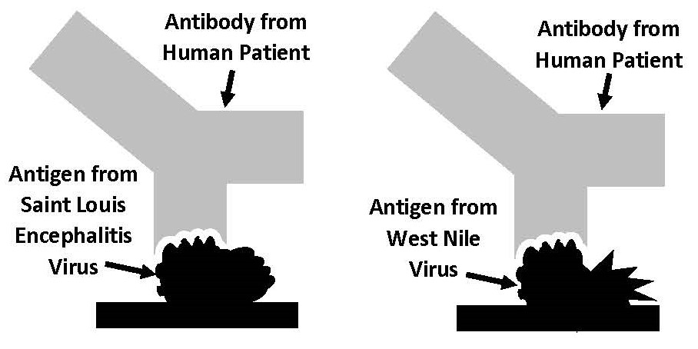
Binding
Site
Binding
Site
Test Strip
Test Strip

Use the information in the diagram above to explain why the antibodies in Patient 1’s blood plasma could attach to antigens from BOTH the Saint Louis Encephalitis virus and the West Nile virus.

- To determine whether Saint Louis Encephalitis virus or West Nile virus was causing the human encephalitis outbreak, scientists from the Health Department did genetic tests on the viruses that cause human encephalitis. The genetic information below represents part of an RNA molecule from a virus that caused the outbreak of human encephalitis.

gugaggauuaacaacaauuaacacagugcg

- Compare this genetic information (sequence of letters) with the Known RNA Sequences for Four Viruses Carried by Mosquitoes.

- Which type of virus caused the human encephalitis outbreak? Support your answer with evidence from the genetic information.

- Explain how the work done by veterinarians was important in protecting human health.

Part 3: How is West Nile virus transmitted and spread?

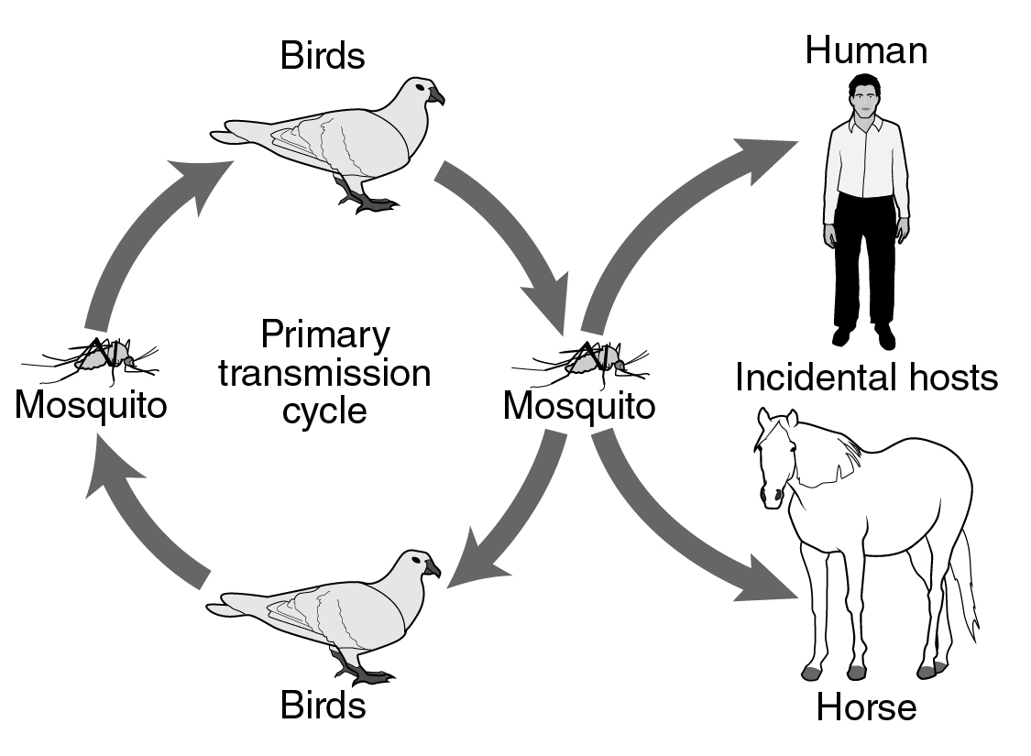
Transmission of West Nile Virus

Virus Transmission (from organism to organism)

West Nile virus primarily infects birds, but it can also infect bats, horses, cats, dogs, chipmunks, skunks, squirrels, domestic rabbits, alligators and humans. West Nile viruses are kept in the environment because they are easily transmitted between birds (the natural hosts of the virus) and mosquitoes.

West Nile viruses are spread by the bite of an infected mosquito. The number of birds and mosquitoes infected with West Nile virus increases as mosquitoes pass the virus from bird to bird.

Note: Mosquitoes usually do not become infected with the virus when they bite a human or horse. This is because the concentration of West Nile viruses in human and horse blood is too low to transmit the virus to mosquitoes.

Base your answers to questions 1 and 2 on the Virus Transmission illustration and the text above.

- The transmission of West Nile virus is shown in the illustration above. Based on the illustration, put an “X” in front of the statements below that are correct.

_____ Birds can become infected with West Nile virus when they are bitten by mosquitoes.

_____ Humans and horses can become infected with West Nile virus when they are bitten by mosquitoes.

_____ Mosquitoes can become infected with West Nile virus when they bite birds.

_____ Birds can transmit West Nile virus to other birds.

_____ Birds can transmit West Nile virus to humans.

_____ Mosquitoes can become infected with West Nile virus when they bite humans or horses.

_____ West Nile virus can be transmitted by human to human contact.

- Before 1999, the West Nile virus had never been found in the United States. It had only been found in Europe, the Middle East, and Africa. What two organisms most likely carried West Nile virus to the United States from Europe, the Middle East, or Africa?

Virus Spread (from place to place)

Birds infected with West Nile Virus and mosquitoes that bit the infected birds have spread West Nile virus to humans and animals in other parts of the United States. The black areas on the continental United States maps below show cases of West Nile virus encephalitis in 1999, and 10 years later in 2009.

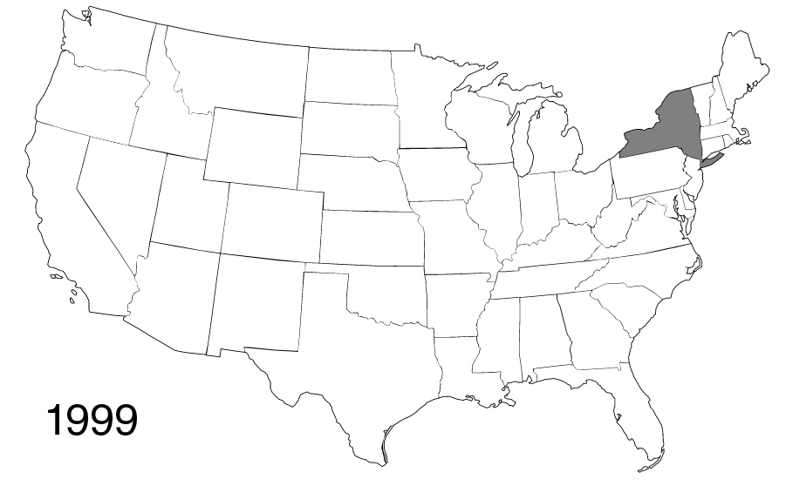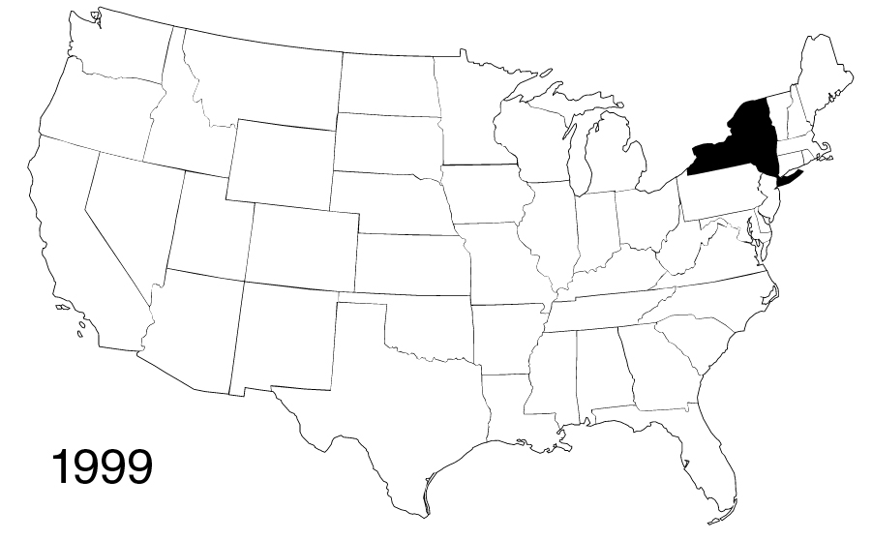
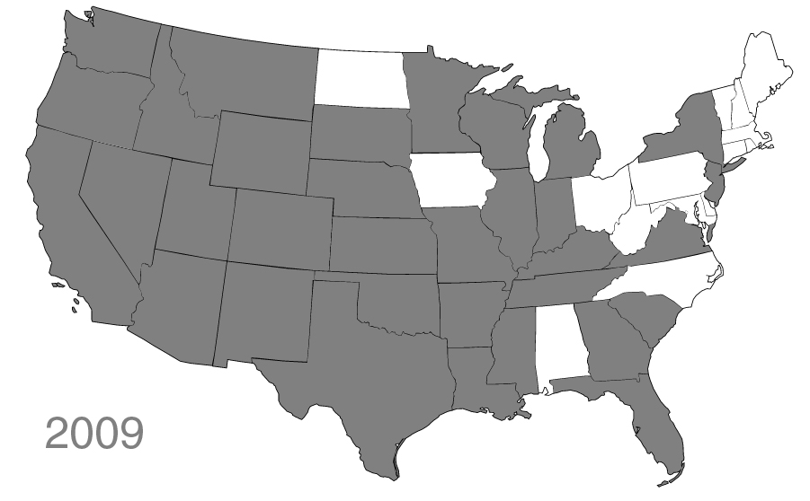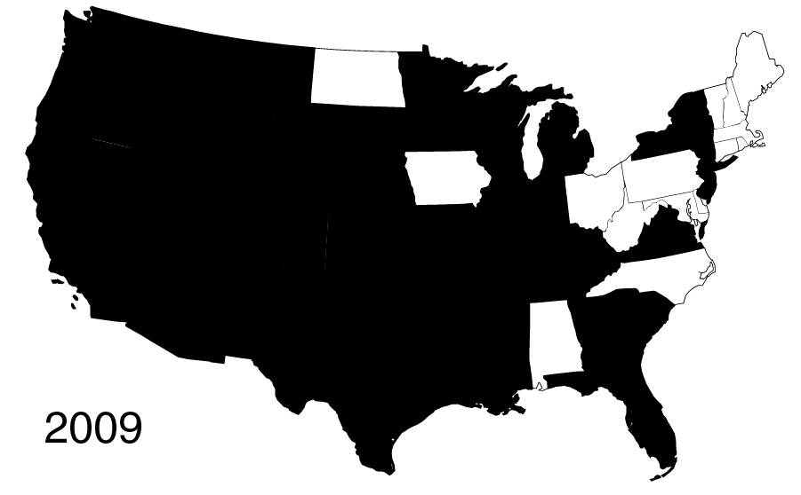

Modified from: https://www.cdc.gov/westnile/statsmaps/finalmapsdata/index.html

Base your answers to questions 3 and 4 on the Virus Spread illustration and the text above.

- Explain how West Nile virus could spread so rapidly throughout the continental United States.

- Predict where in the continental United States you would expect to find West Nile virus in 2019.

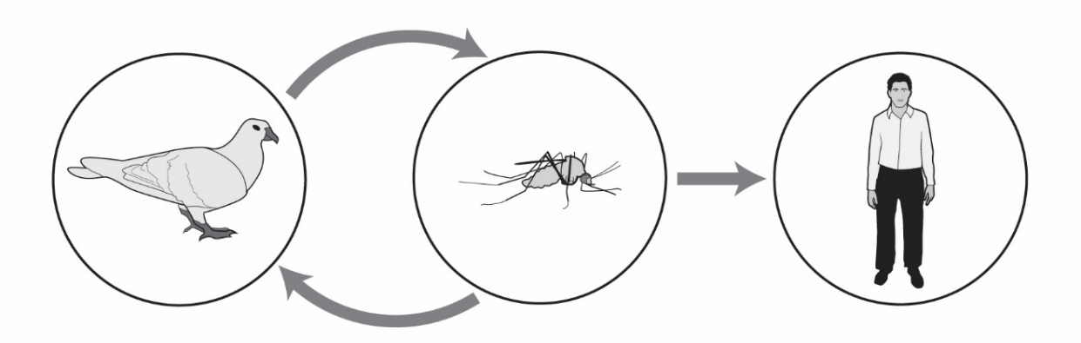

Climate Change and West Nile Virus
Natural Host
Birds
Warmer winters, a longer frost-free season, and earlier spring arrival may change the migration patterns and survival of birds that are the natural hosts of the West Nile Virus.
Insect Vector Host
Mosquitoes
Rising temperature, changing precipitation patterns, and extreme weather events are likely to increase aquatic habitats for mosquito breeding and increase mosquito and viral reproduction rates.
Incidental Host
Humans
Humans are not central to the West Nile Virus transmission cycle, but they can suffer serious health consequences if infected. Changing weather patterns will likely impact human behavior and exposure to mosquitoes that carry West Nile virus.

Base your answers to questions 5 through 10 on the Climate Change and West Nile Virus illustration and the text above.

- How would an increase in bird populations affect the number of mosquitoes that carry the West Nile virus?

- How would an increase in mosquito populations affect the number of birds infected with West Nile virus?

- How would an increase in mosquito populations affect the number of humans infected with West Nile virus?

- What environmental factors might lead to increased bird populations in an area?

- What environmental factors might lead to increased mosquito populations in an area?

Climate change is a change in the average conditions — such as temperature and precipitation — in a region over a long period of time. NASA scientists have observed that the Earth’s surface is warming and the distribution of precipitation is changing.

Modified from: https://climatekids.nasa.gov/climate-change-meaning/

- Scientists claim that climate change is likely to cause an increase in the number of people infected with West Nile virus. Cite two pieces of evidence from the Climate Change and West Nile Virus illustration and text on the previous page to support this claim.

Part 4: Should insecticides be sprayed to prevent the spread of West Nile virus?

The State Health Department has announced plans to use planes to spray insecticides that kill mosquitoes.
Spraying Saves
Lives
Ban Mosquito Spraying!

Some residents oppose the plan to spray insecticides. Others support the planned spraying. A public meeting will be held to allow residents to express their support or opposition to the insecticide spraying.

- Read the news article (below and on the next page) about a State Health Department’s plan to spray insecticides to control the spread of West Nile virus. As you read:
- Underline information that someone could use to convince people that insecticides should be sprayed
- Circle or highlight information that someone could use to convince people that insecticides should not be sprayed

News Article: West Nile Virus Has Killed 3 in the State
An outbreak of encephalitis caused by West Nile virus has occurred in 13 counties. There have been 9 confirmed human cases of West Nile disease and 3 of these cases resulted in death. There have also been 27 cases among animals, including horses, deer, and dogs.
According to the state’s public health veterinarian, “Aerial spraying is a tool we should use to protect human and animal health.” The state plans to spray an organic insecticide to control populations of mosquitoes in 13 counties. Planes flying at 300 feet will spray an organic insecticide over 720,000 acres, at an estimated cost of between $1.5 million and $1.8 million. The insecticide is toxic to insects and it is commonly used to control mosquitoes, fleas, flies, moths, ants and many other insect pests. Scientific tests have shown that the insecticide will not pose a health risk to humans, pets, or farm animals. Aerial spraying is not expected to affect surface water or drinking water.
Some community members are concerned about exposure to the insecticide spray. State officials suggest that people with asthma or chemical sensitivities remain indoors, close windows and doors, shut off fans and air conditioners, and wash any garden produce before eating it.

An ecologist with the State Department of Natural Resources is concerned about the effects of the insecticide on the environment. The insecticide being used is a “broad spectrum insecticide that has the potential to affect any insect it comes in contact with, including beneficial species (bees and other pollinators) and threatened species (butterflies and moths).”
Many beekeepers and farmers are worried that the spraying of insecticides will contaminate crops and kill bees that pollinate crops. However, one beekeeper stated, “While the death of bees will affect my source of income, I really don’t want to see one of my friends become sick with this virus.”
Even with the planned spraying, state health officials say the risk for contracting West Nile disease from mosquitoes in affected areas will continue until after the season’s first “hard frost.” State health officials encourage residents in the affected counties to:
- Empty water from mosquito-breeding sites around the home such as buckets, unused pools, old tires, clogged gutters, or similar places with standing water where mosquitoes may lay eggs.
- Avoid being outdoors from dusk to dawn when mosquitoes that carry the West Nile virus are most active.
- Wear long-sleeved shirts and pants.
- Apply insect repellents that contain the active ingredient DEET, or another U.S. Environmental Protection Agency-approved product to exposed skin or clothing.
- Maintain window and door screening to help keep mosquitoes outside.
- More information about mosquito control is available at https://www.cdc.gov/westnile/vectorcontrol/integrated_mosquito_management.html

Modified from https://www.northjersey.com/story/news/nation/2019/09/27/eastern-equine-encephalitis-michigan-aerial-insecticides/3793737002/

- Based on the information in the news article, list the two most important things someone might say to convince people that insecticides should be sprayed to kill mosquitoes and prevent West Nile disease.

- Based on the information in the news article, list the two most important things someone might say to convince people that insecticides should not be sprayed to kill mosquitoes and prevent West Nile disease.

- Is the news article biased - prejudiced in favor of spraying or against spraying? Support your answer.

- The news article does not include all of the information that people might need to make an informed decision about the planned insecticide spraying. List at least two kinds of additional information that might help people to make an informed decision about whether to spray, or not spray, to control mosquito populations.

- A trade-off is a compromise where people give up one thing in order to get something else that they want. The State Health Department insists that spraying is the best way to reduce the spread of the West Nile virus. Concerned citizens are against spraying because they are concerned that spraying will harm humans, animals, and the environment. Suggest a possible tradeoff (compromise) that both groups could accept. Be prepared to explain your tradeoff to the class.

- Do you support the spraying of insecticides to kill mosquitoes and prevent the spread of West Nile virus? Explain why or why not.

Part 5: One Health and the West Nile virus
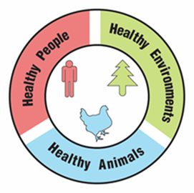
One Health

A university is suggesting that the local government take a One Health approach to solving complex local problems, such as West Nile viruses. A One Health approach uses the idea that complex problems often involve the health of people, animals, and the environment. Therefore, solutions to One Health problems must be designed to protect the health of people, animals, and the environment.

- Use the information in the text box above to explain what must be involved in a complex problem for it to be considered a One Health problem.

To support adoption of a One Health approach, the university officials want to create a series of slides to provide examples of One Health problems in the community. Your team has been hired to create a slide to answer the question, “Why are West Nile viruses a One Health problem?”

Remember how the CDC video used images with captions to help people understand what One Health problems and solutions involve. Using pictures and captions will help people understand and remember what the One Health approach involves.

- Use the information in the text box above and what you learned about West Nile viruses to develop your slide. Use the following template to organize your slide:

Why are West Nile viruses a One Health problem?
Picture and a caption to explain how animals are involved in the problem | Picture and a caption to explain how humans are involved in the problem | Picture and a caption to explain how the environment is involved in the problem

