
The Problem With Microplastics

Teacher Guide

Lesson Summary:
Microplastics are found in the air, water, living things, and in many of the products we use every day. Analyze simulated brain tissue to discover if microplastics can be found in the human body. Use a model of the human body to explain how microplastics enter the brain. Use evidence from research studies to explore the possible health risks of microplastics. Learn about factors that influence microplastic toxicity.

Core Concepts:
- Microplastics are small (<5mm) pieces of plastic.
- Microplastics can be intentionally produced for use in products like cosmetics or glitter.
- Microplastics can form when larger plastic items like water bottles, clothing and food containers break down.
- Microplastics are found in every ecosystem on Earth.
- Microplastics have entered the food chain and are found in the tissues of organisms, including humans.
- The health effects of microplastics on the human body are unknown and require extensive research.

Class time required: Approximately 2-3 forty-minute class periods

Teacher Preparation:
Each student will need:
- 1 copy of The Problem With Microplastics student handout

For Part 1, each team of students will need:
- What are Microplastics? handout (see page v)
- Sampling Protocol handout (see page vi)
- 50 ml of Tissue Dissolving Solution (see recipe on the following page)
- A beaker or cup containing a grape-sized piece of Brain Tissue Sample EC09-02 (see recipe on the following page)
- Spoon or stirrer
- 1 piece of “select a size” white Bounty paper towel cut in half to make a filter paper square
- Beaker or cup to support the filter paper
- Hand lens (optional)
For Part 2, each team of students will need:
- Are Microplastics a Problem? handout (see page vii)
- Human Body Model handout (see page viii)
- 1 plastic bingo chip (“microplastic chip”). Purchase online from Amazon: https://www.amazon.com/MR-CHIPS-Plastic-Transparent-Counting/dp/B08WPRPBCM/ref=ast_sto_dp_puis?th=1
For Part 3, each team of students will need:
- Are Microplastics a Problem? handout (see page vii)

Tissue Dissolving Solution – Recipe:
Ingredients
- 150 g Kosher salt
- 1,000 ml water
Mix the salt and water until the salt is dissolved. Each student group will need 50 ml of Tissue Dissolving Solution for part 1.

Brain Tissue Sample EC09-02 – Recipe:
Ingredients
- 1/4 cup Instant Snow Polymer. Purchase online from Educational Innovations: https://www.teachersource.com/product/instant-snow-polymer
- 2 cups water
- 1/2 cup Elmers School Glue
- 1/2 teaspoon each of 4 different colors and different sizes of Hemway biodegradable glitter (0.2 mm, 0.4 mm, 1 mm, and 3 mm size glitter). Purchase online from Amazon: https://www.amazon.com/Hemway-Friendly-Biodegradable-Cosmetic-Eyeshadow/dp/B07YNTPNMD?ref_=ast_sto_dp&th=1
  - 0.2 mm Red glitter
  - 0.4 mm Blue glitter
  - 1 mm White glitter
  - 3 mm Mother of Pearl glitter
Mix 1/4 cup of Instant Snow with 2 cups of water until the Instant Snow is “fluffy”. Add 1/2 cup of Elmers School Glue and mix well with a sturdy spoon or with your hands (wear disposable gloves for this). Add 1/2 teaspoon of each of the 4 different colors/sizes of glitter and mix well so the glitter is distributed throughout the “Brain Tissue”. Each student group will need a grape-sized piece of the Brain Tissue Sample.

Teacher Notes:
- Part 1 of this lesson is inspired by this research article:
Nihart, A.J. et al., Bioaccumulation of microplastics in decedent human brains. Nature Medicine (2025). https://doi.org/10.1038/s41591-024-03453-1
- In part 1, students may need a review of minimum, maximum, median, and mean. This is a great opportunity to review simple statistics and data reporting. Time permitting, students could create box and whisker plots to visually compare the 2016 and 2024 data.
- For part 4, the class could develop a “driving question board” that displays their research questions. As an optional extension, students could use google scholar to see if any scientists are researching a closely related topic.
- For reasons explored in this lesson, much is unknown about how microplastics affect human health, and the science is changing rapidly. Students should be encouraged to explore recent updates in scientific research on microplastics. For example, pairs of students could each research one section in the “Are Microplastics a Problem?” infographic to see what has recently been learned about each possible health impact of microplastics.
- This topic (and parts 2 and 3 of this lesson) provides a rich opportunity to discuss the difference between association and causation. Right now, most research on microplastics and human health is based on associations, but the causation (how microplastics might contribute to the observed health effect) is not known.
- Consider asking students to develop a newsletter article, graphic, video, etc. to highlight the issue of microplastics for people outside of their class.
- Consider showing the following video after completing the lesson: Agrawal, N., & Tae, T. (2025, April 8). Video: Microplastics Are in Our Brains. What Does That Mean? The New York Times. https://www.nytimes.com/video/well/100000010085694/microplastics-are-in-our-brains-what-does-that-mean.html

Supplementary Resources:
- “Microplastics: The What, Where, Why and Impact” (Northeast Recycling Council, NRC) https://www.nerc.org/add-a-blog-post-title3
- “Microplastics” (Interstate Technology Regulatory Council, ITRC) – Extensive background information about microplastics https://mp-1.itrcweb.org/microplastics/
- Lake Ontario MicroPlastics Center (LOMP) https://www.urmc.rochester.edu/environmental-medicine/lake-ontario-microplastics-center
- “Microplastics and Microfiber Research in the Classroom” (National Oceanic and Atmospheric Administration, NOAA) - Classroom Resources for microplastic sampling https://marinedebris.noaa.gov/curricula/microplastics-microfibers-research-classroom
- Chartres, N. et al., Effects of Microplastic Exposure on Human Digestive, Reproductive, and Respiratory Health: A Rapid Systematic Review. Environ. Sci. Technol. 2024, 58, 52, 22843–22864 https://pubs.acs.org/doi/10.1021/acs.est.3c09524
Next Generation Science Standards (NGSS) Correlation:

Working Towards Performance Expectation(s)

HS-LS1-2. Develop and use a model to illustrate the hierarchical organization of interacting systems that provide specific functions within multicellular organisms.

HS-LS2-7. Design, evaluate, and refine a solution for reducing the impacts of human activities on the environment and biodiversity.

Science and Engineering Practices  Developing and Using Models  - Develop and use a model based on evidence to illustrate the relationships between systems or between components of a system.  Conducting Explanations and Designing Solutions  - Design, evaluate, and refine a solution to a complex real-world problem, based on scientific knowledge, student-generated sources of evidence, prioritized criteria, and tradeoff considerations. | Disciplinary Core Ideas  LS1.A: Structure and Function  - Multicellular organisms have a hierarchical structural organization, in which any one system is made up of numerous parts and is itself a component of the next level.  LS2.C: Ecosystem Dynamics, Functioning, and Resilience  - Moreover, anthropogenic changes (induced by human activity) in the environment — including habitat destruction, pollution, introduction of invasive species, overexploitation, and climate change — can disrupt an ecosystem and threaten the survival of some species.  ETS1.B: Developing Possible Solutions  - When evaluating solutions it is important to take into account a range of constraints including cost, safety, reliability and aesthetics and to consider social, cultural and environmental impacts. | Cross Cutting Concepts  Systems and System Models  - Models (e.g., physical, mathematical, computer models) can be used to simulate systems and interactions—including energy, matter, and information flows— within and between systems at different scales.  Stability and Change  - Much of science deals with constructing explanations of how things change and how they remain stable.

What Are Microplastics

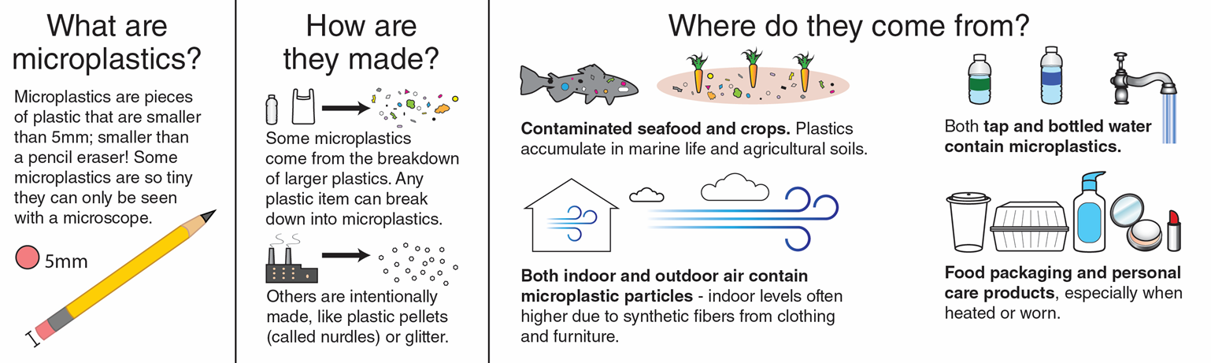

Sampling Protocol

- Pour 50 ml of Tissue Dissolving Solution into the brain tissue sample container.
- Gently stir the Brain Tissue Sample container for 1-2 minutes, or until all the brain tissue is dissolved.
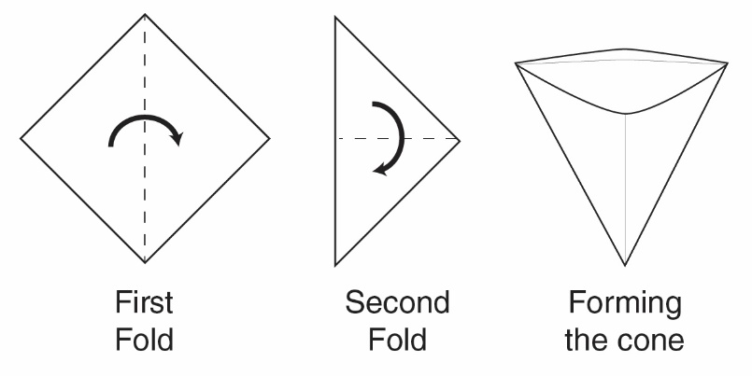
- Fold your square filter paper in half and then in half again.
- Open the folded filter paper so that you have a cone-shaped filter.
- Place the folded filter paper into a beaker or cup.
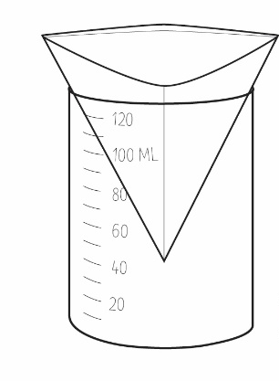
- Pour the dissolved brain tissue sample contents through the filter paper.
- Once all the liquid has passed through the filter, carefully pull out the filter paper.
- Unfold the filter paper and observe any microplastics left on the filter paper.
Note: You may find it useful to observe the microplastics with a hand lens provided by your teacher.

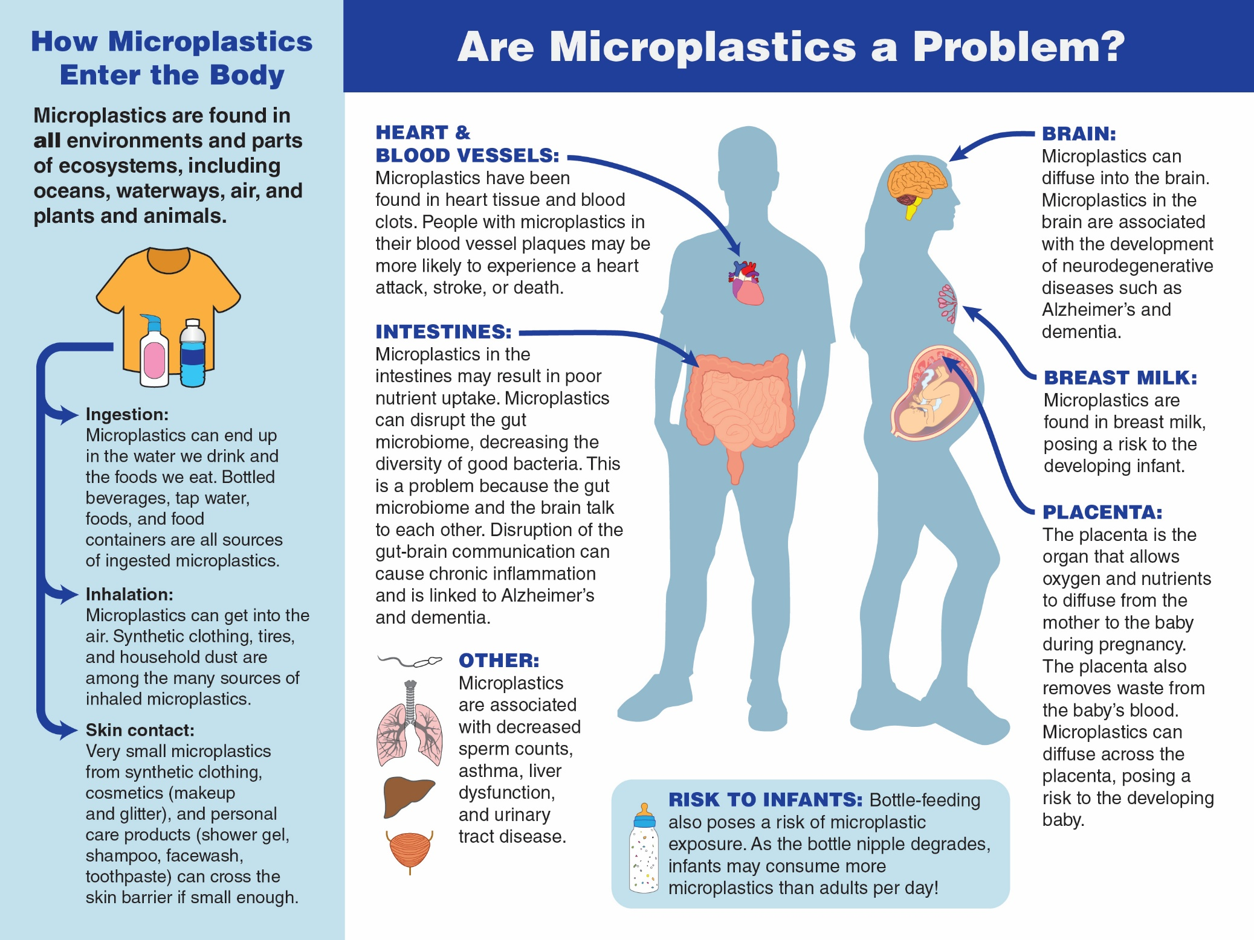
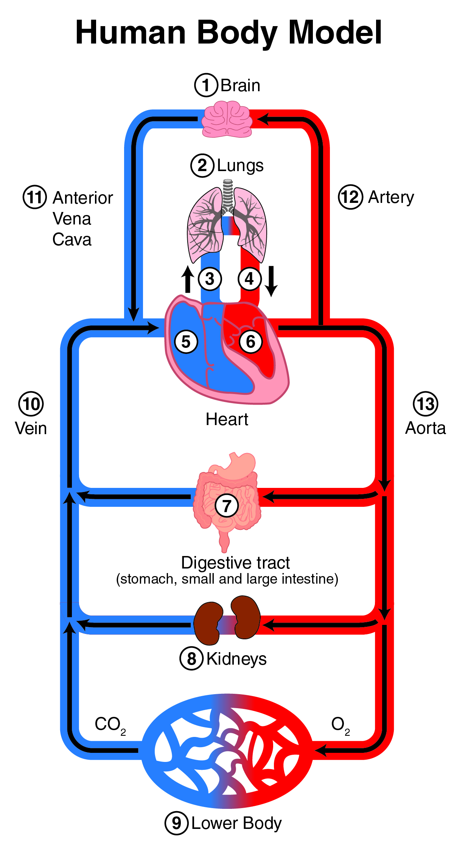
Human Body Model

The Problem With Microplastics


Part 1: What are microplastics?

Casey was watching a video on social media when she saw an advertisement encouraging the purchase of personal care products (like shampoo and face wash) with the “zero plastic inside” label. The influencer encouraged purchasing these kinds of products because they are healthier and help reduce exposure to microplastics.

Casey wondered what microplastics are and why she should reduce her exposure to them. A quick internet search led her to the What are Microplastics? infographic. Use the infographic to answer the following questions.

- According to the What are Microplastics? infographic, what are microplastics?

- Explain how your plastic water bottle could be a source of microplastics.

- Read the list of sources of microplastics. List at least two products you used in the last 24 hours that might have exposed you to microplastics.

- List two questions you have about microplastics.

Casey realized that she uses a lot of products that could be a source of microplastics. She wanted more information, so she did an internet search. She found a study conducted by a research team in New Mexico that looked interesting.

The research team wondered if these tiny plastic particles could make their way into the human body. To answer the research question, the research team gathered samples of human tissue from deceased donors. The researchers sampled kidney, liver, and brain tissue from 91 individuals over several years. After obtaining the tissue samples, the research team used a tissue dissolving solution that dissolves the body tissue so that the only thing left from the sample was microplastics. The team counted the microplastics they found in each sample.

Your kit contains a sample of brain tissue from the research lab. Use the Brain Tissue Sample and the Sampling Protocol to determine if microplastics are present in this sample. Once you are finished with the protocol, complete the data table below:

Brain Tissue Sample | Presence of Microplastics | Are all microplastics the same size? | Are all microplastics the same color? | Are all microplastics the same shape?
EC09-02 | YES NO | YES NO | YES NO | YES NO

- Based on your observations, do you think that the microplastics found in the brain tissue sample all came from the same source? Support your claim with evidence.

- Based on your observations, were there more large (easy to see) microplastics or more small (difficult to see) microplastics?

- Why do you think there are more microplastic particles of the size you answered for #6?

The research lab used very precise scales to determine the weight of microplastic in one gram of each brain tissue sample. The following data table includes the data from sample EC09-02 as well as all the samples from 2016 observed in the lab.
1,000,000 µg = 1 gram


1 paperclip = 1 gram
Sample | Date of sample | Amount of microplastic in sample (µg microplastic/g of brain tissue)
EC09-01 | 2016 | 3454
EC09-02 | 2016 | 2509
EC09-03 | 2016 | 5526
EC09-04 | 2016 | 4512
EC09-05 | 2016 | 4268
EC09-06 | 2016 | 8861
EC09-07 | 2016 | 2811
EC09-08 | 2016 | 5014
EC09-09 | 2016 | 6519
EC09-10 | 2016 | 6018
EC09-11 | 2016 | 3215
EC09-12 | 2016 | 3621
EC09-13 | 2016 | 3715
EC09-14 | 2016 | 298
EC09-15 | 2016 | 2005
EC09-16 | 2016 | 3419
EC09-17 | 2016 | 8511
EC09-18 | 2016 | 8709
EC09-19 | 2016 | 8103
EC09-20 | 2016 | 3643
EC10-01 | 2016 | 8827
EC10-02 | 2016 | 3317
EC10-03 | 2016 | 1503
EC10-04 | 2016 | 3345
EC10-05 | 2016 | 7123
EC10-06 | 2016 | 1201
EC10-07 | 2016 | 3351
EC10-08 | 2016 | 2207
EC10-09 | 2016 | 3013
EC10-10 | 2016 | 3518
- List two reasons that may explain why there is a wide range of microplastic amounts in the brain tissue samples.

- Are there any brain tissue samples without microplastics?

- Based on your answer to question #9, do you think we can conclude that everyone’s brain contains microplastics? Explain your answer.

The lab organized the data from 2016 and compared it to samples taken from different donors in 2024. The data table below shows those comparisons.

Total Brain Microplastics (µg/g)
 | 2016 | 2024
Number of samples | 30 | 28
Minimum | 298.5 | 2216.0
Median | 3345.0 | 4917.0
Mean (average) | 3420.0 | 4763.0
Maximum | 8861.0 | 6791.0

- What do you notice about the average (mean) amount of microplastics in brain samples between 2016 and 2024? Support your answer with data.

- Notice that the maximum amount of microplastics is less in the 2024 samples. Your friend claims that this means that exposure to microplastics is going down over time. Use the information in the data table to support or refute your friend’s claim.

- Microplastics are difficult to study because scientists may introduce microplastics into the sample during their research procedure. This creates error in the sample amount. Review the procedure you used to identify microplastics in the brain sample. Identify at least one source of microplastics that may add error to the sample amount.

- How could the researchers modify the procedure to reduce the error you identified in question #13?

- Do you think the data from the research study should be ignored because there may be some error in the sampling procedure? Support your answer with reasoning.

Part 2: How did microplastics get there?

Casey wondered how the microplastics ended up in the brain tissue samples. She asked her library media specialist to help her search for how microplastics get into the body and deposit in brain tissue. Their search led them to an infographic titled, Are Microplastics a Problem? Use this infographic to answer the following questions.

- Identify the three ways that microplastics can enter the human body.

- Are there specific environments where microplastics are located?

- Locate the Human Body Model diagram. Which organ, labeled on the model, would be the first to be exposed to inhaled airborne microplastics? Explain your reasoning.

Locate the round microplastic chip. This chip will be used to represent tiny pieces of microplastics flowing through the body.

- Use the Human Body Model diagram, the microplastic chip, and the steps below to figure out how microplastics inhaled from the air could end up in the brain. Use the arrow diagram below to keep track of the movement of the chip through the human body.
- Place the chip on the Human Body Model diagram to identify where the microplastics enter the body after being inhaled.
- Write the number of the location under START on the arrow diagram below
- Move the chip to the next numbered location on its pathway to the brain.
- Write the number of the next location to the right of your starting number on the arrow diagram below.
- Continue moving the chip on the pathway toward the brain. Record each numbered location your chip moves through on the arrow diagram below.

START BRAIN

__________________________________________ _____________________

- Use the Human Body Model diagram to identify an organ, found on the diagram, that would be the first to be exposed to ingested microplastics. Explain your reasoning.

- Use the Human Body Model diagram and the microplastics chip to explain how microplastics ingested from food or bottled water could end up in the brain. Follow the steps below to record the path the microplastics would travel in the human body.
- Place the chip on the diagram to identify where the microplastics enter the body after being ingested.
- Write the number of the location under START on the arrow diagram below.
- Using the arrows on the Human Body Model as a guide, move the chip to the next numbered location on its pathway to the brain.
- Write the number of the next location to the right of your starting number on the arrow diagram below.
- Continue moving the chip on the pathway toward the brain. Record each numbered location your chip moves through on the arrow diagram below.

START BRAIN

________________ ________ _________________________ ________ _____________

- The research team claims that finding microplastics in brain tissue means that microplastics are present in other organs. Explain why they would expect microplastics in other parts of the body.

- Your observations in Part 1 indicated that there were more of the small-sized microplastics in the brain tissue samples. Based on the Human Body Model, why do you think there are more small-sized microplastics in the brain?

Part 3: Why should we be concerned about microplastics?

Since microplastics are everywhere, Casey was concerned that she has microplastics in many parts of her body. She wondered how microplastics might affect the human body. Casey used the Are Microplastics a Problem? infographic to find information about microplastics and human health.

- Based on the Are Microplastics a Problem? infographic, why should people be concerned about exposure to microplastics?

- What are some ways that microplastics might impact a developing baby?

- Describe how microplastics may be associated with the development of Alzheimer’s disease.

- How might microplastics be associated with a decreased ability to reproduce?

- Parents have two methods to feed their newborn infants - breast feeding (with breast milk) and bottle feeding (with formula). Based on the information provided, which option would you choose to reduce an infant’s exposure to microplastics? Explain your choice.

Part 4: Why is it difficult to study microplastics?

You have already seen how microplastics can affect multiple parts of the body with a wide range of symptoms. Research also indicates that the toxicity and adverse (harmful) effects of microplastics can vary depending on their size, shape, age, chemical composition, surface charge, and co-contaminants. The information in the box below describes how the characteristics of microplastics can affect how they impact human health.

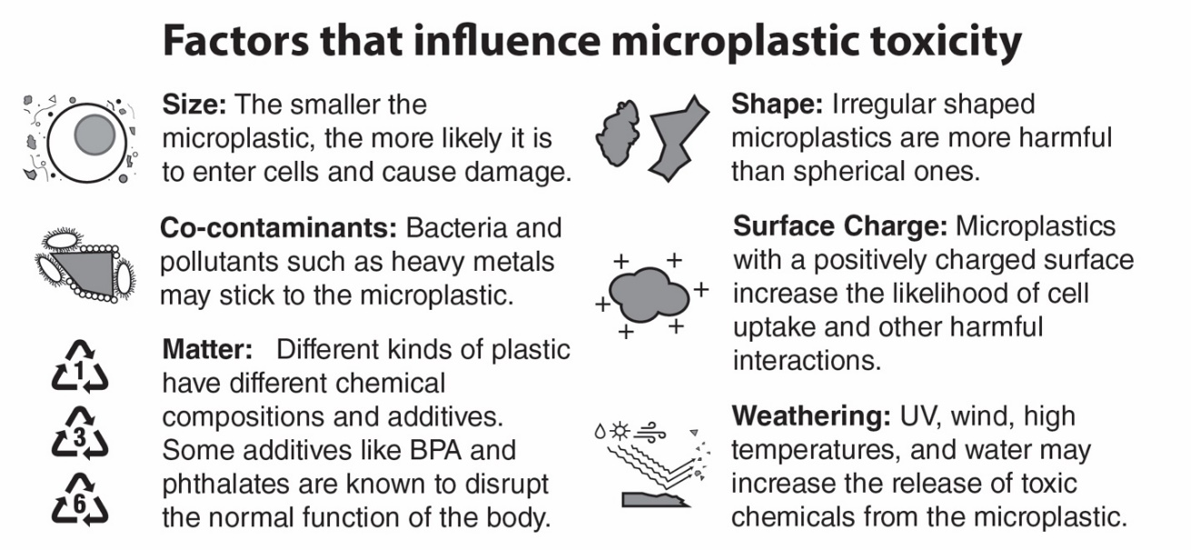

- Based on the information in the box above, describe at least three characteristics that would make a microplastic more likely to be harmful to human health.

- Construct an explanation for why you think irregularly shaped microplastics might be more harmful to human health than spherical (round) shaped microplastics.

- Scientists recommend that people do not microwave food in plastic containers. Using the information in the box above, explain why heating plastic containers may increase the health risks related to microplastics.

- Researchers make different claims about the causes of health problems due to microplastic exposure. Some researchers claim that the health problems result from the type of plastic material the microplastic is made of. Other researchers claim that the health problems are caused by the toxic substances that attach to the microplastics. Support each claim with evidence from the Factors that influence microplastic toxicity information on the previous page.

Claim | Evidence Supporting the Claim
The substance making the microplastic causes health problems.
Toxic substances attaching to the microplastic causes health problems.

The research team in New Mexico began their study with the observation that microplastics are found in all environments. They wondered if microplastics were also found in specific organs of the human body. To begin their research, they asked a specific research question: “What is the quantity of microplastics in human livers, kidneys and brains?” Notice that the research question focuses on microplastics and specific organs in the human body. Research questions must be specific to provide useful data.

Building on the original research team’s work, another research team wondered how microplastics entered the human body. Their research question was “Do microplastics enter the human body through inhalation?” Notice that this research question is also very specific!

These two research studies plus many other research studies resulted in the understanding that microplastics enter the body and can be found in most organs. Now, researchers must ask new questions to find out how the different characteristics of microplastics may affect the health and function of the many organs and tissues we have in the human body. Imagine all the different research questions that can be asked based on the different combinations of characteristics the microplastic particles may have! Combine these different characteristics of microplastics with different body systems that can be affected, and you have a very complicated problem to study.

- Complete the table below to create some ideas for new research questions. In column one, identify a characteristic of microplastics to study. In column two, identify an organ in the human body as the focus of the research. In column three identify the possible health effect or health problem. Row one provides an example to help get you started. Note: You may refer to the introduction in Part 4 for the characteristics of microplastics.

Characteristic of Microplastic | Organ in the Body | Health Effect or Problem
Shape of microplastic | lungs | Asthma or increased congestion

- Now it’s time to design specific research questions from the table above. A research question for the example in the first row of the table might be, “What effect does the shape of microplastic have on increased congestion in the lungs?” Circle one of the rows of your table above. Use the information in that row to write your own research question.

- What kinds of data might you need to collect to answer your research question?

- Based on the process you used to design your research question, why do you think scientists are doing so many different research studies on how microplastics affect human health?

- Many people don’t understand why so many research studies are needed before we can understand how microplastics affect human health. In your own words, explain to someone who is complaining about the number of research studies on microplastics why more research is necessary (or why one research study is not enough).

Once research is published, the news media usually reports the results of the research. The table below lists media headlines and the original research study title.

Original Research Study Title | Media Headline
Bioaccumulation of microplastics in decedent human brains | Your brain is full of microplastics: Are they harming you?
The potential of micro- and nanoplastics to increase the health impacts and global burden of diseases | Microplastics: Are we facing a new health crisis – and what can be done about it?
A global estimate of multi-ecosystem photosynthesis losses under microplastic pollution | Scientists Just Discovered Something Absolutely Horrifying About Microplastics

- Media headlines often use words that create fear or panic – this is called a “sensationalized headline”. What is an advantage of using a sensationalized headline instead of the original study title?

- What is a disadvantage of using a sensationalized headline instead of the original research study title?

- During an interview with a newspaper publishing a story on microplastic research, a scientist involved in the research commented, “I reduced my consumption of bottled water in half. I still drink bottled water, just less.” How do quotes like this help reduce the impact of the sensational headlines?

- The scientist identified drinking less bottled water as way to reduce microplastic exposure. List two other ways people could reduce their exposure to microplastics.

