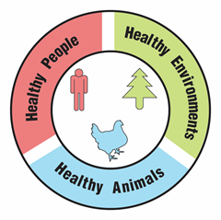
Ticks, Biodiversity, and Climate

Teacher Guide

Lesson Summary:
Follow a high school student as she volunteers at a local veterinary hospital. During the course of her internship, she helps diagnose a patient with a tick-borne disease. Examine the data to figure out why the incidence of tick-borne diseases are on the rise. What factors contribute to increases in ticks and the diseases they carry?

Core Concepts:
- The increased risk of tick-borne pathogens may be related to biodiversity and climate change.
- Tick-borne pathogens pose a growing risk to human health.
- A One Health approach identifies and seeks solutions to problems that affect the health of humans, animals, and the environment.

Suggested Grade Levels: Grades 9-12

Class time required (approximate):
- Part 1: What kinds of ticks are present in the ecosystem? 10 minutes
- Part 2: What pathogens can ticks carry? 10 minutes
- Part 3: Analyzing patterns in tick-borne diseases 20 minutes
- Part 4: Do living things influence the pattern of tick-borne diseases? 40 minutes
- Part 5: What should concerned pet owners know about tick-borne diseases? 30 minutes
- Part 6: One Health and tick-borne diseases 40 minutes

Copyright © 2022 by University of Rochester. All rights reserved. May be copied for classroom use. This lesson was developed with support from the National Institutes of Health under Award Number R25GM132758. The content is solely the responsibility of the authors and does not necessarily represent the official views of the National Institutes of Health.
Teacher Preparation:

Part(s) | Materials needed for each pair of students
1-6 | - 2 copies of student handout Ticks, Biodiversity and Climate
1 | - 1 copy of Tick Identification Key. See page vii  - 1 page of Tick Photographs. Print on cardstock paper and cut into individual cards. See page viii  - 1 copy of Human Diseases Transmitted by Ticks. See page ix  - Optional: One hand lens per student
2 | Bag or basket labeled Tick Pathogen Detection Kit that contains these items:  - 1 copy of Tick Pathogen Detection Kit Instructions. See page x  - 1 Simulated Electrophoresis Gel. Print on card stock paper. Use a cotton swab to “paint” very thin lines of 1% phenolphthalein in the boxes shown on the next page. See page xi.  1% phenolphthalein solution may be ordered from Ward’s Science: https://www.wardsci.com/store/product/8883525/phenolphthalein  - 1 copy of Tick Pathogen Standard Key (Optional: Print on plastic transparency sheet). See page xii  - 1 graduated cup or cylinder to measure 20 ml of water  - 1 zip-lock sandwich bag labeled “DNA Stain” containing 1/8 teaspoon of washing soda (sodium carbonate) available in laundry section of supermarket. Do NOT use baking soda (sodium bicarbonate). Be careful to place the labels on the bags so that they will not interfere with viewing electrophoresis gel in the bags. The bag should be large enough to hold the Simulated Electrophoresis Gel.
4 | - 1 copy of Complex Interactions Model printed on plain paper. See page xiii  - 1 copy of Steps to Infection overlay printed on a plastic transparency sheet. See page xiv  - 1 dry erase marker
5 | - A device with internet access.
6 | - Access to Google, PowerPoint or similar digital program for making slides, or poster paper and markers.

Simulated Electrophoresis Gel

 | Max |  | Daisy |  | Lainey
13
12 |  |  |  |  | --------
11
10 |  |  |  |  | --------
9
8 |  |  | --------
7 | --------
6
5 |  |  |  |  | --------
4
3 | --------
2
1

Print the “blank” simulated gels on page xi on uncoated card stock paper.
Use a cotton swab to “paint” very thin lines of 1% phenolphthalein in the boxes indicted in pink above.
Suggested Class Procedure:

General
- Distribute a copy of Ticks, Biodiversity and Climate to each student.
- Students work individually or in pairs to complete this lesson.
- NOTE: The topic of ticks is rich enough to trigger conversations and questions that go beyond the immediate content in this lesson. Teachers may set up a “Parking Lot” for collecting student questions or ideas for additional connections/research.
Parking Lot Strategy
- Make a large poster paper or bulletin board area in the classroom as your Parking Lot.
- When students have a question or additional connection, have them write it on a sticky note and hand it to you or put it in the Parking Lot.
- Only answer questions immediately if they are essential for completing the lesson.
- Put sticky notes with other questions or connections in the Parking Lot.
- At the end of the lesson, review the Parking Lot questions.
- Remove questions that were answered by the lesson.
- Ask students which remaining questions and connections they would like to discuss.

Part 1: What kinds of ticks are present in the ecosystem? (20 minutes)
- Read the information in the top text box aloud to the class.
- Distribute to each pair of students:
- 1 copy of Tick Identification Key
- 1 set of Tick Photographs
- 1 copy of Human Diseases Transmitted by Ticks
- Students work with their partner to complete Part 1.
- Collect the Tick Identification Key and Tick Photographs.

Part 2: What pathogens can ticks carry? (20 minutes)
- Ask 1-2 students to read the information in the top box aloud to the class.
- Distribute a Tick Pathogens Detection Kit to each pair of students.
- 1 copy of Tick Pathogen Detection Kit Instructions
- 1 Simulated Electrophoresis Gel
- 1 copy of Tick Pathogen Standard Key
- 1 bag of DNA Stain
- 1 graduated cup or cylinder to measure 20 ml of water
- Students work with their partner to complete Part 2.
- Collect Tick Pathogens Detection Kit. Discard simulated gel in the trash. Discard simulated gel stain down the drain.

Part 3: Analyzing patterns in tick-borne diseases (30 minutes)
- Ask 1-2 students to read the information in the top text box aloud to the class.
- Students work with their partner to complete Part 3.
- Note: For the Relatively Humidity graph students may need help understanding that 0.2 = 20%.

Part 4: Do living things influence the pattern of tick-borne diseases? (40 minutes)
- Read the information in the top text box aloud to the class.
- Distribute the Complex Interactions Model and Steps to Infection overlay to students.
- Students work with their partner to complete Part 4.
- Debrief answers as a class. The teacher may consider asking questions like, “What patterns do you notice?”, “What differences do you see across the three maps?”

Part 5: What should concerned pet owners know about tick-borne diseases? (30 minutes)
- Ask 1-2 students to read the information in the Part 5 text box aloud to the class.
- Students need individual devices with internet access.
- Provide students with the following internet resources:
- https://www.cdc.gov/ticks/avoid/on_people.html (Tick prevention - Humans)
- https://www.cdc.gov/ticks/avoid/on_pets.html (Tick prevention - pets)
- https://www.cdc.gov/ticks/removing_a_tick.html (Removing ticks)
- https://www.avma.org/resources/pet-owners/petcare/lyme-disease-pet-owners-guide (pet-human connection)
- Students work individually to answer each of the questions. Alternatively, students could work in groups of four. Each student could research one question. As a team of four, students would develop the FAQ page which can be paper or electronic. Optional: Teacher can consider having students develop an FAQ webpage.
- Debrief student answers to the FAQs.

Part 6: One Health and tick-borne diseases (40 minutes)
- Read the information in the first text box aloud to the class.
- Students work with their partner to complete question 1.
- Have several students share their answer to question 1. It is important for students to have this correct before moving on to question 2.
- Display the following video from the CDC to add to student understanding of One Health. https://www.youtube.com/watch?app=desktop&v=TG0pduAYESA
- Read the information in the second text box aloud to the class.
- Students work with their partner to complete question 2 – their digital slide. Note: Students without access to digital slide programs like Google or PowerPoint can produce a paper version.
- Suggestion – Collect the digital slides into one slide deck. Share this slide deck with the class. If you have ample class time, you may consider having students present and explain their slides.
- Students receive full credit if their slide links tick-borne diseases to the health of humans, animals and the environment.
- Optional extension: Have students identify another example of a One Health problem. Have students use their idea to create a similar slide/poster that explains why their example is a One Health problem. Students can use examples from their community or from the One Health CDC website.

Suggested Resources:

- Centers for Disease Control and Prevention (CDC) - One Health
https://www.cdc.gov/onehealth/index.html

- Centers for Disease Control and Prevention (CDC) – Ticks
https://www.cdc.gov/ticks/index.html

- Climate and Tick Behavior
https://www.ncbi.nlm.nih.gov/pmc/articles/PMC5226345/

- Lyme Disease Geographic Distribution and Tick Behavior
https://www.usgs.gov/news/it-s-heat-and-humidity-new-study-finds-why-lyme-disease-common-north-rare-south

- Tick Life Cycle and Ecology
https://www.pnas.org/content/109/27/10942

Scan the QR code with your smartphone or tablet camera app to link to a file with all the websites for the teacher resources and student hyperlinks used within the lesson.

Tick Identification Key

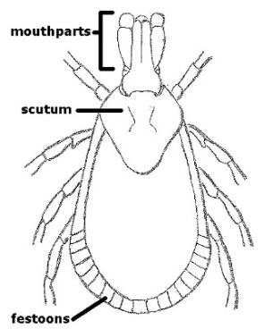
1. Does the rear edge of the tick have a band that appears segmented with many square plates known as festoons? (See illustration below.)
YES: Go to 3.
NO: Go to 2.
2. Are the mouthparts long enough that they extend out from the body and are visible when looking at the tick from above?
YES: This may be a blacklegged tick, also known as the “deer tick” (Ixodes scapularis). They range from dark brown to bright red and have black legs.
NO: This is a “soft tick” (Argasidae). These ticks are soft, while all other ticks mentioned here are “hard ticks.” Soft ticks rarely, if ever, transmit disease. They are often associated with domestic birds upon which they feed.

3. Are there several irregular silvery-white marks in the center of the tick’s back?
YES: This is an American dog tick (Dermacentor variabilis). It usually feeds on dogs and other small mammals, but will bite people. The silvery-white marks streak across the backs of males. On females, the silvery-white marks are found only on the scutum. These ticks are oval shaped and their mouthparts are relatively short and broad.
NO: Go to 4.

4. Are there white markings on the rear edge of the tick’s back OR a single white spot in the center of the back?
YES: This is the lone star tick (Amblyomma americanum). They have long, narrow mouthparts and their bodies are somewhat round in shape rather than oval-shaped like other ticks.
NO: This may be a brown dog tick (Rhipicephalus sanguineus). The brown dog tick is oval in shape and has shorter and thicker mouthparts than some other ticks. It feeds primarily on dogs. This tick seldom bites or transmits disease to people.

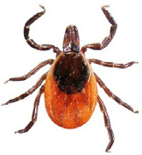

Tick removed from Lainey

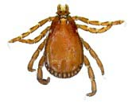

Tick removed from Max

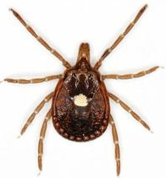

Tick removed from Daisy

Human Diseases Transmitted by Ticks

Disease | Transmitted by | Symptoms
Anaplasmosis | Blacklegged tick | Fever, chills, severe headache, nausea, vomiting, diarrhea, rash
Babesiosis | Blacklegged tick  Brown Dog Tick | Common: Fever, chills, sweats, fatigue, joint pain, headache, nausea  Less common: cough, sore throat, depression
Ehrlichiosis | Brown Dog Tick  Lone Star Tick | Fever, chills, headache, muscle pain, nausea, vomiting, diarrhea, altered mental status, rash
Lyme disease | Blacklegged tick | Red ring-like expanding rash; classic rash not present in all cases, flu-like symptoms, headache, fever, joint pain, muscle pain, heart abnormalities, facial paralysis
Rocky Mountain Spotted Fever | Brown Dog Tick  Lone Star Tick  American Dog Tick | High fever, severe headache, muscle pain, swelling around eyes and on the back of hands, nausea, vomiting, altered mental status, coma, respiratory distress, multi-organ system damage
'Stari' borreliosis | Lone Star Tick | Red, expanding “bull’s-eye” lesion, fatigue, headache, fever, and muscle pains.
Tularemia | American Dog Tick | Fever, chills, headache, fatigue, muscle pain, chest discomfort, cough, sore throat, vomiting, diarrhea, abdominal pain

Tick Pathogen Detection Kit Instructions

- Make DNA stain by adding 20 ml of tap water to the plastic bag labeled DNA Stain.

- Seal the plastic bag and gently swirl the contents of the bag to dissolve the gel stain crystals.

- Add the Simulated Electrophoresis Gel to the plastic bag.

- Seal the plastic bag then lay it flat on your desk.

- Wait about 5 minutes then observe the banding patterns (pink bands) for each of the dogs (Max, Daisy, Lainey).

Tick Pathogen Detection Kit Instructions

- Make DNA stain by adding 20 ml of tap water to the plastic bag labeled DNA Stain.

- Seal the plastic bag and gently swirl the contents of the bag to dissolve the gel stain crystals.

- Add the Simulated Electrophoresis Gel to the plastic bag.

- Seal the plastic bag then lay it flat on your desk.

- Wait about 5 minutes then observe the banding patterns (pink bands) for each of the dogs (Max, Daisy, Lainey).

Tick Pathogen Detection Kit Instructions

- Make DNA stain by adding 20 ml of tap water to the plastic bag labeled DNA Stain.

- Seal the plastic bag and gently swirl the contents of the bag to dissolve the gel stain crystals.

- Add the Simulated Electrophoresis Gel to the plastic bag.

- Seal the plastic bag then lay it flat on your desk.

- Wait about 5 minutes then observe the banding patterns (pink bands) for each of the dogs (Max, Daisy, Lainey).

Simulated Electrophoresis Gel Simulated Electrophoresis Gel

 | Max |  | Daisy |  | Lainey |  |  |  | Max |  | Daisy |  | Lainey
13 |  |  |  |  |  |  |  | 13
12 |  |  |  |  |  |  |  | 12
11 |  |  |  |  |  |  |  | 11
10 |  |  |  |  |  |  |  | 10
9 |  |  |  |  |  |  |  | 9
8 |  |  |  |  |  |  |  | 8
7 |  |  |  |  |  |  |  | 7
6 |  |  |  |  |  |  |  | 6
5 |  |  |  |  |  |  |  | 5
4 |  |  |  |  |  |  |  | 4
3 |  |  |  |  |  |  |  | 3
2 |  |  |  |  |  |  |  | 2
1 |  |  |  |  |  |  |  | 1
Simulated Electrophoresis Gel Simulated Electrophoresis Gel

 | Max |  | Daisy |  | Lainey |  |  |  | Max |  | Daisy |  | Lainey
13 |  |  |  |  |  |  |  | 13
12 |  |  |  |  |  |  |  | 12
11 |  |  |  |  |  |  |  | 11
10 |  |  |  |  |  |  |  | 10
9 |  |  |  |  |  |  |  | 9
8 |  |  |  |  |  |  |  | 8
7 |  |  |  |  |  |  |  | 7
6 |  |  |  |  |  |  |  | 6
5 |  |  |  |  |  |  |  | 5
4 |  |  |  |  |  |  |  | 4
3 |  |  |  |  |  |  |  | 3
2 |  |  |  |  |  |  |  | 2
1 |  |  |  |  |  |  |  | 1

Tick Pathogen Standard Key

 | Borrelia  Burgdorferi |  | Ehrlichia chaffeensis |  | Francisella tularensis |  | Anaplasma  phagocytophilum
13
12
11
10
9
8
7
6
5
4
3
2
1

Tick Pathogen Standard Key

 | Borrelia  Burgdorferi |  | Ehrlichia chaffeensis |  | Francisella tularensis |  | Anaplasma  phagocytophilum
13
12
11
10
9
8
7
6
5
4
3
2
1

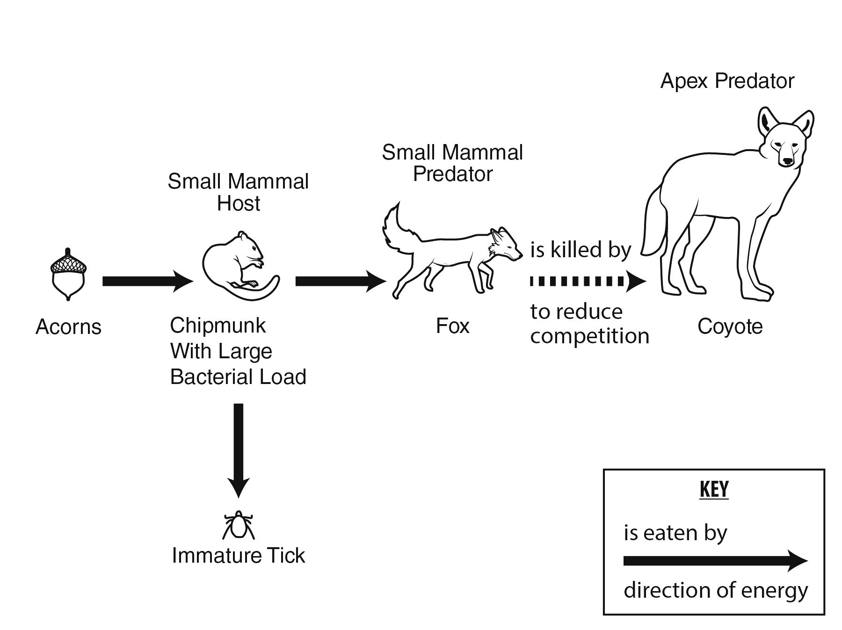
Complex Interactions Model
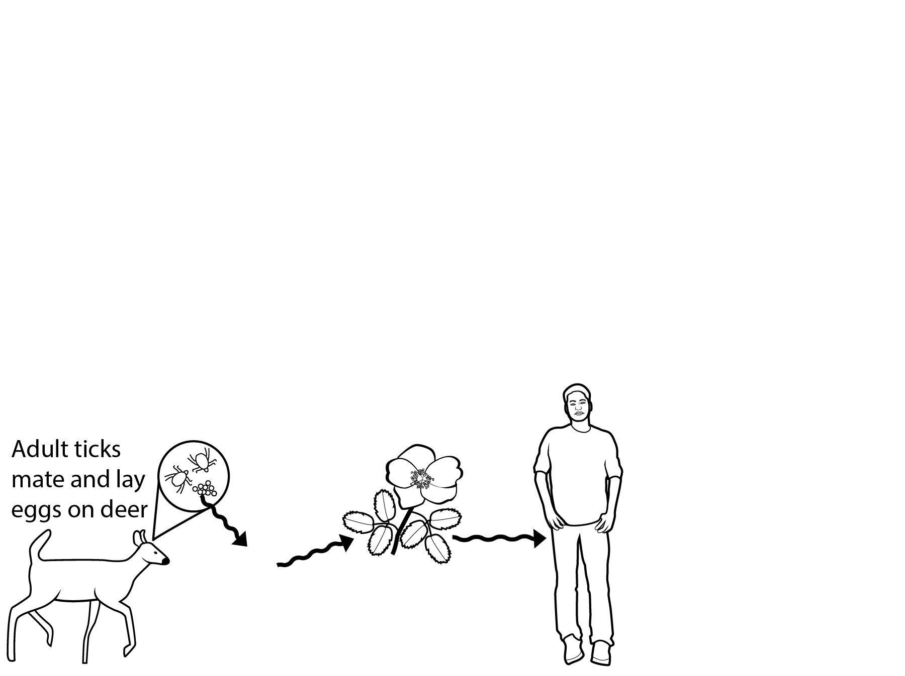
Steps to Infection

NGSS Correlation:

Working Towards Performance Expectations
MS-LS2-2. Construct an explanation that predicts patterns of interactions among organisms across multiple ecosystems. [Clarification Statement: Emphasis is on predicting consistent patterns of interactions in different ecosystems in terms of the relationships among and between organisms and abiotic components of ecosystems. Examples of types of interactions could include competitive, predatory, and mutually beneficial.]
MS-LS2-4. Construct an argument supported by empirical evidence that changes to physical or biological components of an ecosystem affect populations. [Clarification Statement: Emphasis is on recognizing patterns in data and making warranted inferences about changes in populations, and on evaluating empirical evidence supporting arguments about changes to ecosystems.]
HS-LS2-6. Evaluate the claims, evidence, and reasoning that the complex interactions in ecosystems maintain relatively consistent numbers and types of organisms in stable conditions, but changing conditions may result in a new ecosystem. [Clarification Statement: Examples of changes in ecosystem conditions could include modest biological or physical changes, such as moderate hunting or a seasonal flood; and extreme changes, such as volcanic eruption or sea level rise.]
Science and Engineering Practices  - Construct an explanation that includes qualitative or quantitative relationships between variables that predict phenomena.  - Construct an oral and written argument supported by empirical evidence and scientific reasoning to support or refute an explanation or a model for a phenomenon or a solution to a problem. | Disciplinary Core Ideas  - Predatory interactions may reduce the number of organisms or eliminate whole populations of organisms. Mutually beneficial interactions, in contrast, may become so interdependent that each organism requires the other for survival. Although the species involved in these competitive, predatory, and mutually beneficial interactions vary across ecosystems, the patterns of interactions of organisms with their environments, both living and nonliving, are shared.  - A complex set of interactions within an ecosystem can keep its numbers and types of organisms relatively constant over long periods of time under stable conditions. If a modest biological or physical disturbance to an ecosystem occurs, it may return to its more or less original status (i.e., the ecosystem is resilient), as opposed to becoming a very different ecosystem. Extreme fluctuations in conditions or the size of any population, however, can challenge the functioning of ecosystems in terms of resources and habitat availability.  - Ecosystems are dynamic in nature; their characteristics can vary over time. Disruptions to any physical or biological component of an ecosystem can lead to shifts in all its populations. | Cross Cutting Concepts  - Patterns can be used to identify cause and effect relationships.  - Much of science deals with constructing explanations of how things change and how they remain stable. (Stability and Change)  - Cause and effect relationships may be used to predict phenomena in natural or designed systems.  - Small changes in one part of a system might cause large changes in another part.

Ticks, Biodiversity, and Climate

Part 1: What kinds of ticks are present in the ecosystem?

Jada’s high school required twenty hours of community service in order to graduate. Jada was interested in a career as a veterinary technician (“vet tech”). As a vet tech, Jada would assist the veterinarian in diagnosing and treating animals. To learn what is involved in the job of a vet tech, Jada decided that she would volunteer at her local veterinarian’s office. Dr. Louis, the veterinarian, encouraged Jada to join her during most pet examinations.

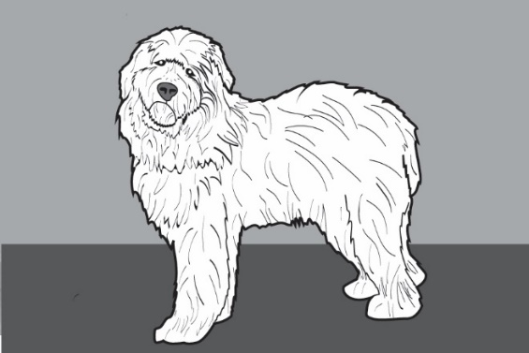
The first patient of the morning was Max, a large sheepdog mix. As Dr. Louis examined Max’s ears, she noticed a small white “bump”. Dr. Louis showed Jada and explained that this bump was actually a tick. Ticks are tiny animals that embed their pointy mouth parts in their host’s skin to feed on blood. Dr. Louis immediately removed the tick from Max’s ear and placed it in a petri dish. Dr. Louis said that the tick could be carrying diseases that could harm Max. In order to find out if the tick was dangerous, they would first need to identify what kind of tick was on Max.

- Use the photograph of the tick found on Max and the Tick Identification Key to identify the tick found on Max. What type of tick was found on Max?

- Support your identification by checking the characteristics the tick had that helped in identification.
____ Festoons
____ Long mouth parts
____ Several silvery markings
____ One single white spot

- Use the Human Diseases Transmitted by Ticks reference page to determine what diseases, if any, this kind of tick is likely to be carrying.

Throughout the course of the day, Dr. Louis examined two more dogs, Lainey and Daisy. Both dogs loved the outdoors and took long walks through the woods with their human companion. Dr. Louis removed ticks from each of these dogs as well!

- Use the Tick Identification Key to identify the tick found on Lainey. What type of tick was found on Lainey?

- Support your identification by checking the characteristics the tick had that helped in identification.
____ Festoons
____ Long mouth parts
____ Several silvery markings
____ One single white spot

- Use the Human Diseases Transmitted by Ticks reference page to determine what diseases, if any, this kind of tick are likely to be transmitted to humans.

- Use Tick Identification Key to identify the tick found on Daisy. What type of tick was found on Daisy?

- Support your identification by circling the characteristics the tick had that helped in identification.
____ Festoons
____ Long mouth parts
____ Several silvery markings
____ One single white spot

- Use the Human Diseases Transmitted by Ticks reference page to determine what diseases, if any, this kind of tick is likely to transmit to humans.

Part 2: What pathogens can ticks carry?

Dr. Louis was concerned that the ticks might be carrying pathogens (viruses and other disease-causing microorganisms) that could harm the dogs. These pathogens would be living inside of the tick’s body and are transmitted to the dog during the bite. Dr. Louis packaged the ticks into sealed plastic bags and sent them to the local veterinary laboratory for analysis.

To test for pathogens, a lab technician places DNA samples from the ticks into different wells on an electrophoresis gel. Gel electrophoresis separates DNA fragments (pieces) on the basis of size. Large DNA fragments move slowly through the gel. Small DNA fragments move quickly through the gel.

Your lab kit contains a simulated paper version of the electrophoresis gel that you will use to test for pathogens in each of the ticks removed from Max, Lainey and Daisy. You can’t see the DNA pieces on this gel because DNA is colorless. In order to see the DNA, you will need to add a DNA stain to the gel. This stain will attach to the DNA fragments on the gel and turn them pink.

- Use the Tick Pathogen Detection Kit to determine if any of the ticks removed from Dr. Louis’ patients were carrying pathogens. Record the banding pattern on the diagram of the simulated electrophoresis gel below.

Simulated Electrophoresis Gel

 | Max |  | Daisy |  | Lainey
13
12
11
10
9
8
7
6
5
4
3
2
1

The Tick Pathogen Standard Key displays banding patterns for common tick-borne pathogens. Compare the banding patterns in the tick samples to the Tick Pathogen Standard Key.

- Complete the laboratory form to return the results to Dr. Louis by placing an “X” in the box where pathogens were detected.

 | Type of Pathogen Detected
Patient’s Name | Borrelia  burgdorferi  (Lyme Disease) | Ehrlichia  chaffeensis (Ehrlichiosis ) | Francisella  tularensis  (Tularemia) | Anaplasma phagocytophilum  (Anaplasmosis)
Max
Daisy
Lainey

- Which pet’s owners should be notified of possible pathogen transmission to their dog?

- During a follow up visit with Lainey, Dr. Louis was informed that Lainey’s owner was walking through the woods with Lainey when she was bitten by the tick. Dr. Louis was concerned that Lainey’s owner may also have been exposed to the pathogen through a tick bite. List some of the symptoms that Lainey’s owner might exhibit if he was exposed to this pathogen.

Part 3: Analyzing patterns in tick-borne diseases

The veterinary lab that Dr. Louis uses participates in a research project that collects data on tick-borne diseases in dogs. The US Centers for Disease Control and Prevention (CDC) collects similar data on tick-borne diseases in humans. Researchers can use this data to recognize patterns in the dog and human tick-borne infections.

Total number of reported tick-borne diseases in humans from 2004-2018

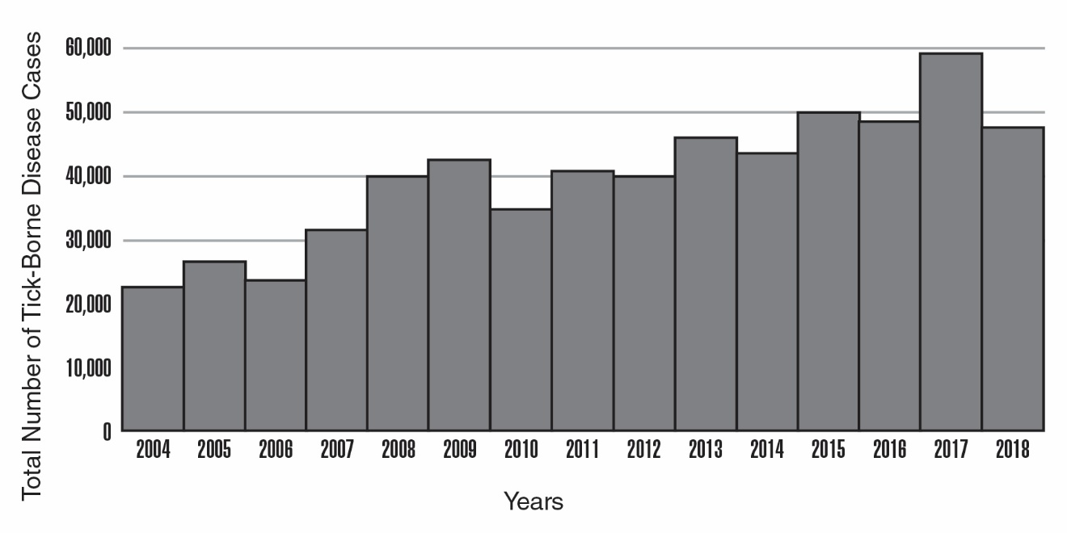
Modified from CDC https://www.cdc.gov/ticks/data-summary/index.html

- Use the graph above to describe the overall trend in the incidence of tick-borne diseases in the United States.

Researchers decided to focus on the blacklegged tick because this tick can carry several diseases that are transmissible to humans, including the pathogen that causes Lyme disease. In 2018, the CDC developed a map to illustrate the geographic distribution of the blacklegged tick in the United States. This map is shown below.

Map of Blacklegged Tick Distribution
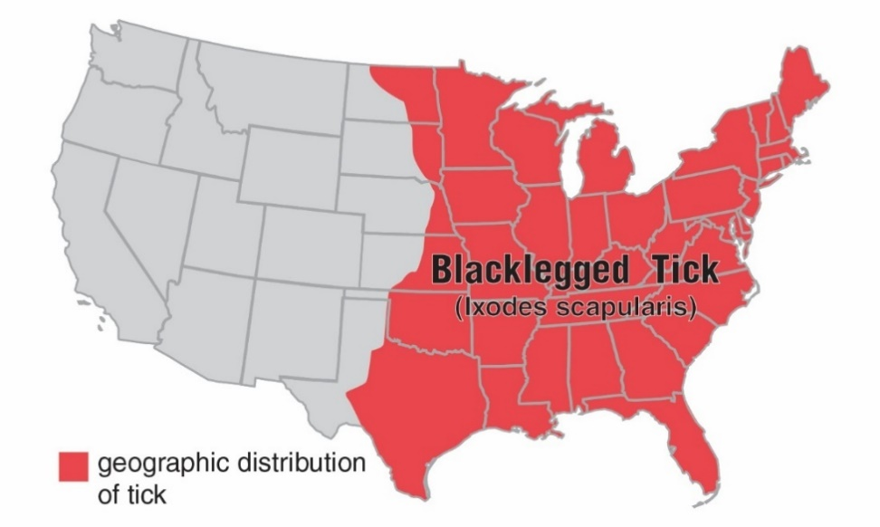

Modified from CDC https://www.cdc.gov/ticks/geographic_distribution.html

- What part of the United States would you most likely find blacklegged ticks?

Red dots on the following maps of the U.S. illustrate the geographic distribution for several blacklegged tick-borne diseases in humans. The data was collected in 2016.

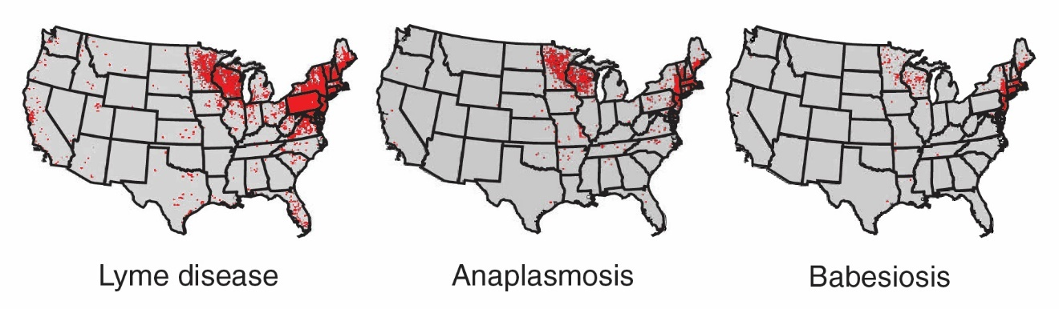
Modified from CDC https://www.cdc.gov/ticks/tickbornediseases/overview.html

- On the map below, circle the region of the country researchers focus on because blacklegged tick-borne diseases are prevalent there.

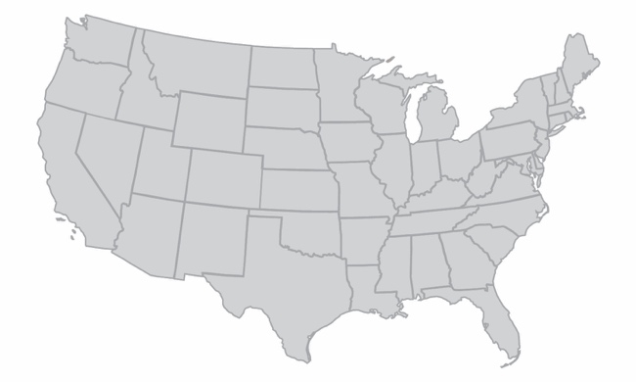

- Does the incidence of these diseases correlate with the entire geographic range of the blacklegged tick? Support your answer.

The first step in determining a cause for the trend in tick-borne diseases is to find non-living, environmental factors (abiotic factors) related to the tick’s life cycle that correlate with the trend. The first data studied by the scientists was temperature data. The scientists wondered if changes in annual average temperature for the region could explain the trend in tick-borne diseases.

Change in Average Annual Temperature
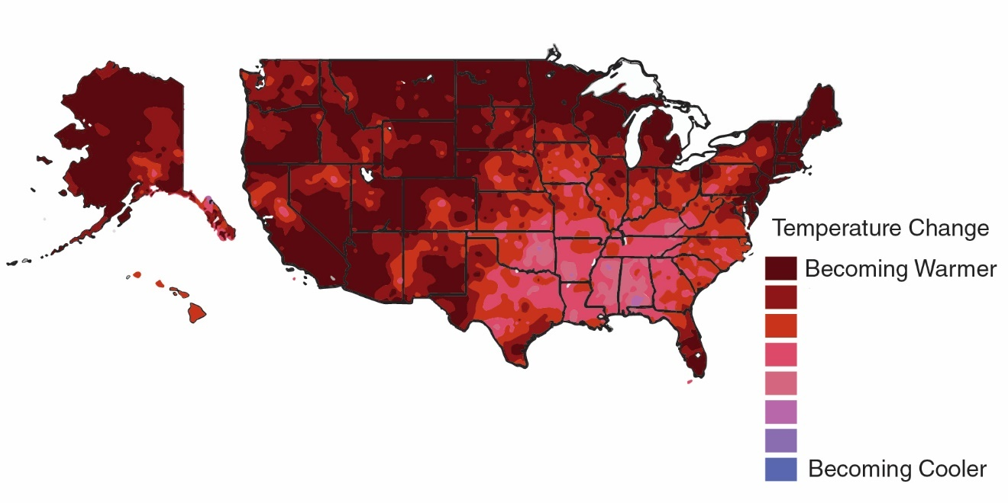
Modified from Climate Science Special Report https://science2017.globalchange.gov/chapter/6/

- What is the trend in annual temperature in the region you identified as important to tick-borne diseases?

- Can this pattern in temperature change provide an explanation for the increase in tick-borne diseases in this entire region? Support your answer with information from the Change in Average Annual Temperature map and the previous maps.

Researchers continued to look at environmental data from this region. This time they focused on changes in annual average precipitation over time.

Change in Average Annual Precipitation
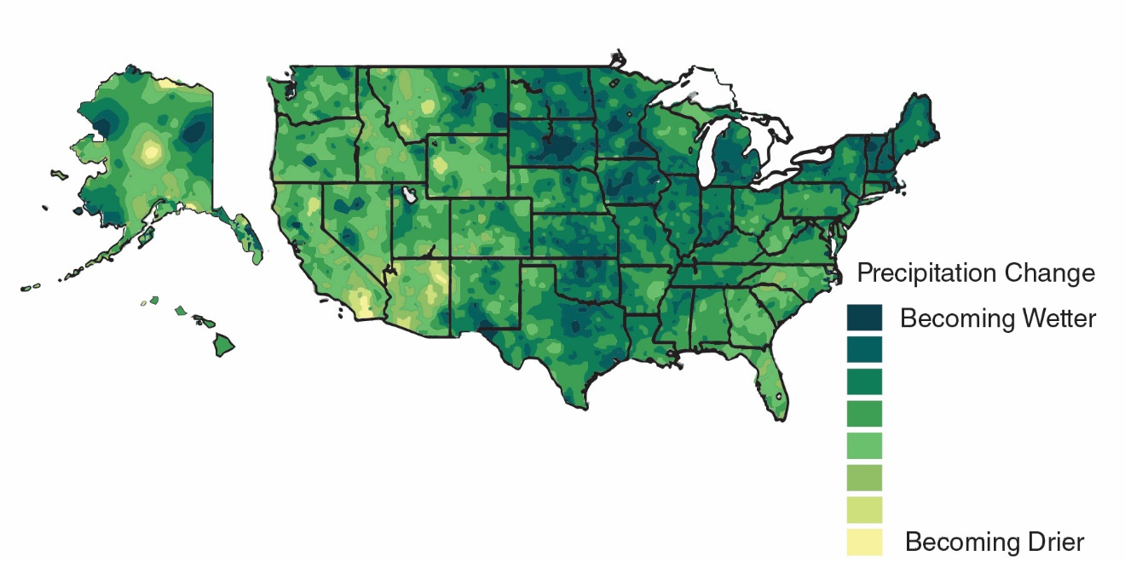

Modified from Climate Science Special report https://science2017.globalchange.gov/chapter/7/

- What is the trend in annual precipitation in the region you identified as important to tick-borne disease?

- Can this pattern in precipitation change provide an explanation for the increase in tick-borne diseases in this entire region? Support your answer with information from this map and the previous maps.

Even though rainfall has increased in the Northeast, the overall relative humidity of the Northeast remains lower than the relative humidity of the Southeast. The researchers hypothesized that this lower relative humidity in the northeast promotes tick survival and reproduction. To test this idea, scientists placed ticks in environments with different humidity levels and monitored their survival rate over time.
Relative Humidity
a measure of the amount of moisture in the air

This graph represents the data that the scientists collected:

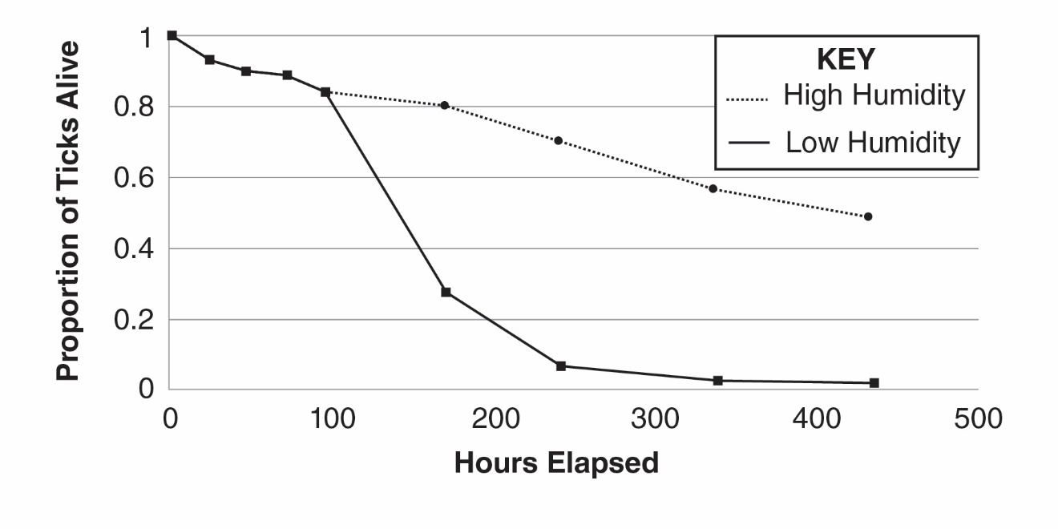
Modified from PLoS ONE https://www.ncbi.nlm.nih.gov/pmc/articles/PMC5226345/

- What effect does relative humidity have on the proportion of ticks alive after 200 hours?

- Does the data support the scientists’ hypothesis? Why or why not?

In addition to abiotic (non-living) factors like temperature, rainfall and humidity, researchers also investigated factors related to living things (biotic factors). The scientists discovered that ticks from the Northeast U.S behave differently compared to ticks in the Southeast U.S. Ticks in the Southeast tend to hide under leaf litter located on the ground. Ticks in the Northeast climb on plant stems.

- Explain how this difference in behavior could lead to more tick-borne pathogens spreading to humans in the Northeast.

Part 4: Do living things influence the pattern of tick-borne diseases?

The researchers involved in the voluntary reporting project studying the patterns in tick-borne diseases realized that this was a very complex problem that may involve even more factors. They decided to enlist the help of an environmental scientist. Environmental scientists use their knowledge of science to protect the environment. They gather data and monitor environmental conditions related to ecosystems, which are an intertwined web of interacting abiotic and biotic factors. The environmental scientist explained that ticks are part of a complex system of interactions. Models are a way to visualize interactions within an ecosystem. Scientists use models to help answer the question, “Are biotic factors in the ecosystem involved in the pattern of tick-borne diseases?”

    - Locate the Complex Interactions Model sheet. According to this model, what organism do immature ticks feed on?

    - What effect would an increase in acorns have on the number of ticks in the environment? Explain.

    - What effect would an increase in the number of small mammal predators have on the number of ticks?

    - Locate the clear plastic overlay sheet called, Steps to Infection. Place this overlay sheet DIRECTLY on top of the Complex Interactions Model sheet. The squiggly arrows represent the movement of ticks through the ecosystem.

    - Using a dry erase marker, draw a circle on the overlay to show where the bacteria that causes Lyme disease is transferred to the tick.

    - Use the information from the two diagrams to explain how Lainey and her owner were most likely exposed to Borrelia burgdorferi, the bacteria that causes Lyme disease. Write numbers (2-8) on the lines to place the events in the correct order.

_____ Immature tick feeds on chipmunk.

_____ Ticks bite Lainey and her owner.

__1__ Adult ticks mate on deer.

_____ Immature ticks leave deer to find a small mammal host.

_____ Tick leaves small mammal host, waits for new host on plants.

_____ Bacteria are transferred from chipmunk to tick.

_____ Immature ticks hatch from eggs on deer.

_____ Ticks leave the plant for a dog or human host.

__9__ Tick bites transfer bacteria to Lainey and her owner.

    - People often read in the newspaper that when deer populations are high, there is an increased risk for tick-borne diseases. Explain why a large deer population may increase the transmission of tick-borne diseases.

The environmental scientist had been monitoring the number of small mammal hosts, acorns and ticks for eight years. Her data are below:

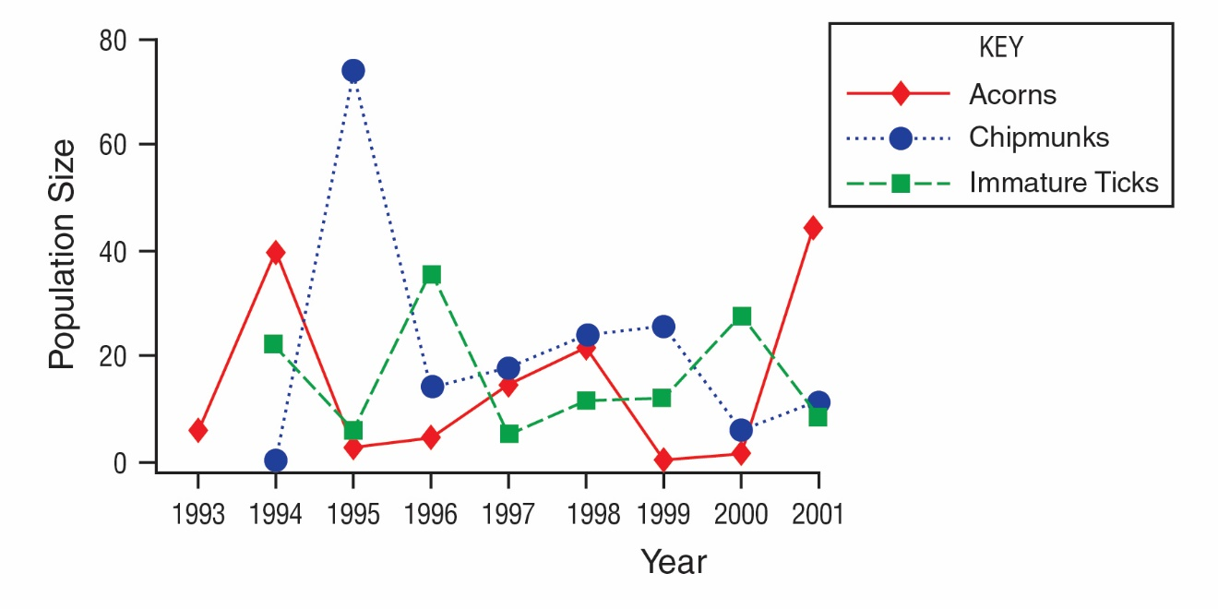
Modified from PLoS Biology https://www.ncbi.nlm.nih.gov/pmc/articles/PMC1457019/

    - Below is a timeline that will help make sense of events in this ecosystem. Use the graph above to:
      - Place a letter A in the box on the timeline below corresponding to each year there was a peak in the number of acorns.
      - Place a letter C in the box on the timeline below corresponding to each year there was a peak in the number of chipmunks.
      - Place a letter T in the box on the timeline below corresponding to each year there was a peak in the number of immature ticks.

1993 | 1994 | 1995 | 1996 | 1997 | 1998 | 1999 | 2000 | 2001

- Describe how the pattern of peaks in the chipmunk population compares to the pattern of peaks in the acorn population.

- Provide an explanation for this pattern.

- Describe how the pattern of peaks in the chipmunk population compares to the pattern of peaks in the tick population.

- Provide an explanation for this pattern.

- In what 2 years (between the years of 1993 and 2011) would you expect to see an increase in tick-borne diseases? Why?

- Assume that 2001 is a peak in the acorn population. What year, following this peak would you warn people about a potential increase in tick-borne diseases? Why?

The environmental scientist explained that increasing the number and kinds of small mammal predators (fox) is important in controlling the transmission of tick-borne diseases. She said that some environmental scientists think that the key to controlling the number of ticks is the size of the population of apex predators such as coyotes and other animals at the top of the food chain.

- Would environmental scientists worried about tick-borne diseases recommend an increase or a decrease in the population of apex predators?

- Explain why environmental scientists would make this recommendation.

- Provide at least two additional actions an environmental scientist might suggest to decrease the number of tick-borne diseases that are transmitted to humans, based on the complex interactions in this ecosystem.

Part 5: What should pet owners know about tick-borne diseases?

Dr. Louis, the veterinarian, was not surprised at the positive results. She has been seeing an increase in tick-borne diseases within the last few years. She keeps a visual reminder in her office to inform her clients about the increase in these diseases. Every time she receives a positive result back, she places a plastic coin in a jar on her office’s welcome counter labeled, “Positive – Tick-borne Disease.” Next to the jar, Dr. Louis posted a statement from the American Veterinary Medical Association:

Because people and their pets often spend time in the same environments where Lyme and other disease-transmitting ticks are found, the American Veterinary Medical Association (AVMA) and the American Academy of Pediatrics (AAP) are working together to offer advice to households with both children and pets. People who have been diagnosed with Lyme disease should consult their veterinarian to determine their pet's risk based on the animal's lifestyle and possible environmental exposures. Likewise, people whose animals have been diagnosed with Lyme disease may want to consult their physician about their own or their children’s risk if they have concerns that the animals and family members might have been exposed to similar environmental risks.

Increasingly, Dr. Louis’s clients have been inquiring about tick-borne diseases because of the doctor’s visual reminder. Dr. Louis asked Jada to develop a FAQ sheet to display on the vet’s website.

- The following questions were identified by Dr. Louis as being most important to address for her veterinary clients.
- What should I do if I see a tick on my pet?
- What kind of precautions can I take to prevent tick bites on me?
- What kind of precautions can I take to prevent tick bites on my pet?
- If my pet is diagnosed with a tick-borne disease, why should I contact my own doctor?

- Use the internet resources provided in the chart on the next page to develop well-written responses to the questions that can be included in the FAQ sheet for Dr. Louis.
Scan this QR code with your smartphone or tablet camera app to link to the websites.



Questions | Answers
What should I do if I see a tick on my pet?
https://www.cdc.gov/ticks/removing_a_tick.html
What kind of precautions can I take to prevent tick bites on me?
https://www.cdc.gov/ticks/avoid/on_people.html

What kind of precautions can I take to prevent tick bites on my pet?
https://www.cdc.gov/ticks/avoid/on_pets.html
If my pet is diagnosed with a tick-borne disease, why should I contact my own doctor?
https://www.avma.org/resources/pet-owners/petcare/lyme-disease-pet-owners-guide

Part 6: One Health and tick-borne diseases

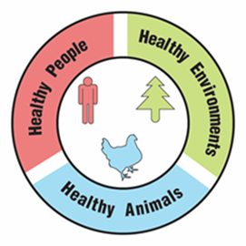
One Health

A university is suggesting that the local government take a One Health approach to solving complex local problems, such as an increase in tick-borne diseases. A One Health approach uses the idea that complex problems often involve the health of people, animals, and the environment. Therefore, solutions to One Health problems must be designed to protect the health of people, animals, and the environment.

- Use the information in the text box above to explain what must be involved in a complex problem for it to be considered a One Health problem.

To support adoption of a One Health approach, the university officials want to create a series of slides to provide examples of One Health problems in the community. Your team has been hired to create a slide to answer the question, “Why is the increase in tick-borne diseases a One Health problem?”

Remember how the CDC video used images with captions to help people understand what One Health problems and solutions involve. Using pictures and captions will help people understand and remember what the One Health approach involves.

- Use the information in the text box above and what you learned about ticks and tick-borne diseases to develop your slide. Use the following template to organize your slide:

Why is an increase in tick-borne diseases a One Health problem?
Picture and a caption to explain how animals are involved in the problem | Picture and a caption to explain how humans are involved in the problem | Picture and a caption to explain how the environment is involved in the problem

