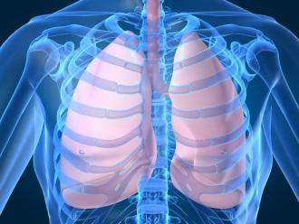

Save the date!
The 11th Annual Lung Research & Trainee day is Friday, January 11, 2019

- Poster viewing: Morning in Flaum Atrium
- Keynote Speaker: Noon in Class of 62
Jeffrey A. Whitsett, MD
Co-Director of the Perinatal Institute
Chief, Division of Neonatology, Perinatal and Pulmonary Biology
Professor of Pediatrics
Children’s Hospital Medical Center
Cincinnati, Ohio
- Career Development Round Table: Afternoon

Lunch will be provided at the seminar

Please register to attend:
https://www.urmc.rochester.edu/lung-biology/lung-research-trainee-day/registration.aspx

