George Washington Corner Society
for the History of Medicine

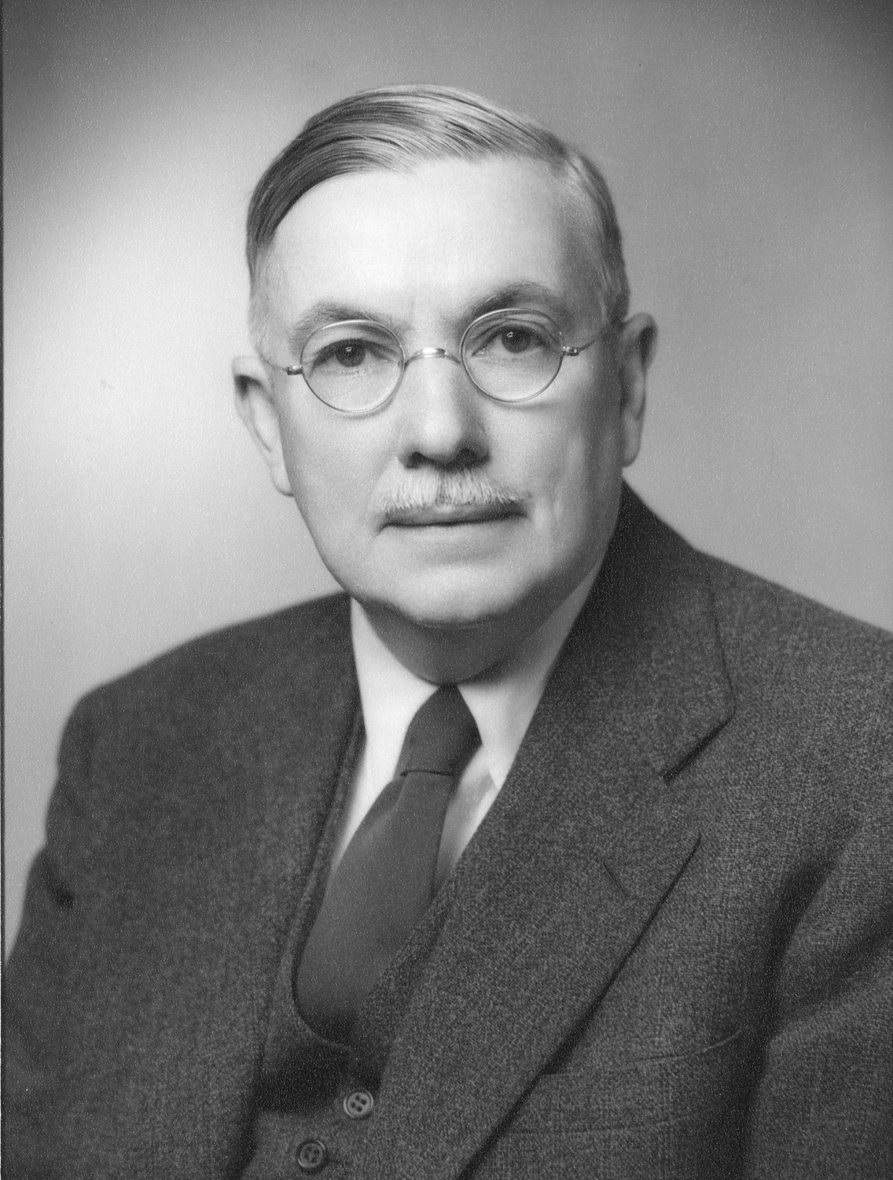

George W. Corner, M.D.

Dr. George Washington Corner was the first professor of anatomy at the University of Rochester Medical School. In 1934 he organized a medical history club to provide opportunities to attend lectures and enjoy lively discussions on topics in medical history. He attracted speakers from all departments in the medical school, as well as members of the community who were knowledgeable in a wide variety of topics in medical history. The club was eventually named in his honor.

Today, The George Washington Corner Society for the History of Medicine, or simply “The Corner Society,” continues the tradition of bringing together stimulating speakers and groups of physicians, students and others with an interest in the history of medicine.

During the 2019-2020 academic year, The Corner Society will offer nine evening events on a variety of medical history topics. Lectures are held at the Rochester Academy of Medicine, 1441 East Avenue. Each event begins with refreshments and a social hour starting at 5:30 p.m. followed by the lecture at 6:30 p.m.

The Corner Society offers a wonderful opportunity to enjoy an evening of stimulating conversation and intellectual exploration of a wide range of topics in the field of medical history.

We encourage you to consider joining us for this year’s lectures.

Larry Guttmacher, M.D. and Bob Riley, M.P.H. are the co-chairs for the 2019-2020 academic year.

For more information, contact Larry Guttmacher, M.D. at
(585) 275-5469 or Laurence_Guttmacher@urmc.rochester.edu

