Perspectives

The art of medicine
Presence
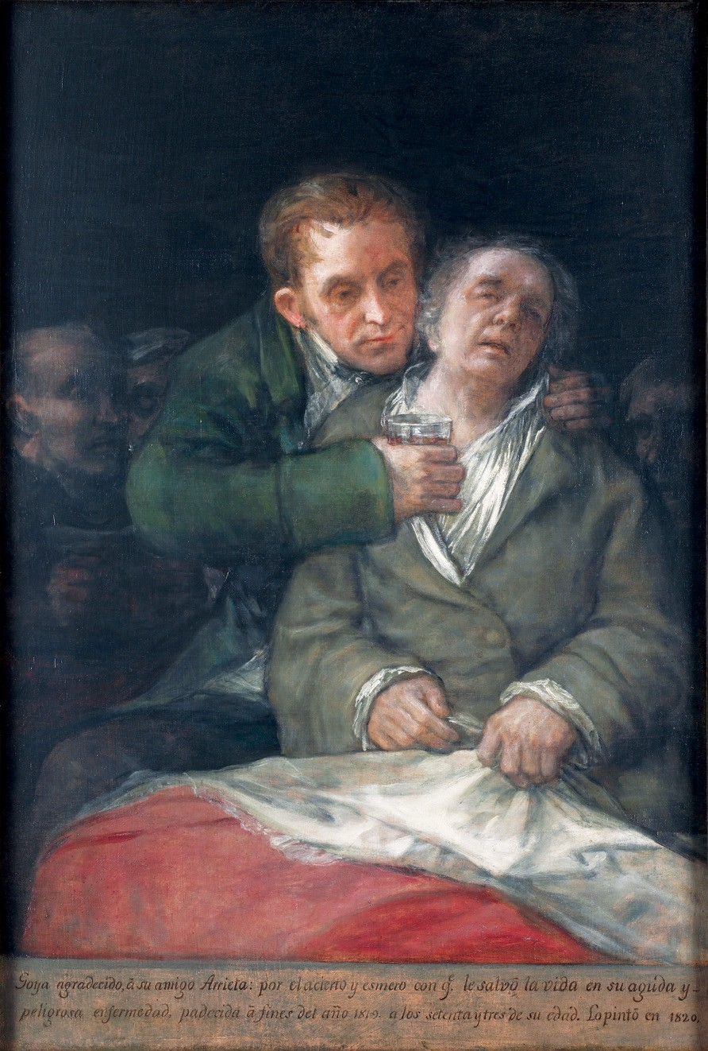
I graduated 50 years ago from Stanford Medical School; and this year, with a sad sense of loss, I converted my medical licence from active to inactive, bringing my clinical career to an oﬃcial close. Looking back on my experience as a clinician, teacher, mentor, researcher, and family caregiver what stands out vividly are my memories of presence. By this I mean the intensity of interacting with another human being that animates being there for, and with, that person. Presence is a calling forward or a stepping toward the other. It is active. It is looking into someone’s eyes, placing your hand in solidarity on their arm, speaking to them directly and with authentic feeling. Presence is built out of listening intensely, indicating that the person and their story matter, and explaining carefully so that you are understood. It animates the physical examination, so that simple acts of positioning, palpating, auscultating, and the like are done not mechanically, but vitally. All those ways of interacting, examining, and treating when taken together define caregiving.
Minneapolis Institute of Arts, MN, USA / The Ethel Morrison Van Derlip Fund / Bridgeman Images

Francisco Jose de Goya y Lucientes, Self-Portrait with Dr Arrieta (1820)

Co-presence, as Irving Goﬀman, the influential American sociologist, used the term may be more evocative, because presence is an interpersonal process that mobilises vitality from both clinician and patient, and from family caregiver and recipient of care. It occurs in the space between them as much as in their emotions. Presence is drawn from within. Ordinary though it is, it can be exhilarating. The experience resonates between the protagonists. Here I am. I am ready. In this case, ready to witness, ready to respond to suﬀering. Here for you.
The Chinese characterise what I am calling presence as spiritedness or liveliness in adults and shining or sunniness in children. Traditional Chinese medicine practitioners see it as evidence of enhanced qi (vital energy) and an indication of positive health and vitality. Marriage matchmakers and teachers look for it as a defining sign of a good prospect or a promising student. Ordinary folks believe it enlivens a social network (guanxi wang) and enriches friendship.
Seen from the caregiver’s side, the accompanying picture of Goya being propped up and given a potion to drink by his physician, seemingly infuses his pallor and weakness with the healer’s robustness. Care is pictured here as revitalising. Presence conjures vitality from the dustbin of medical history where it was long ago unfairly consigned along with the appropriate abandonment of the notion of vitalism.
We know presence by its absence. The bureaucratic indiﬀerence on the phone of a barely listening health insurance programme representative, or anybody who makes you feel you and your questions don’t matter to them, and they are simply going through the motions because that is all they need to do. In consultation-liaison psychiatry and global health work, I have had many experiences where I felt physicians and nurses (and even family members) were responding to their patients (and to me) in this mechanical, dispiriting way: at times disrespectful, at other times as if uninterested and on autopilot; almost always while looking down and away as if there was no human being there. This attitude seems to be the definition of bureaucratic caregiving as experienced by those who are, for example, subjected to institutional procedures such as the administration of antipsychotic drugs in nursing homes to restrain older people who are frail and have dementia. Such treatment conveys the message: you yourself don’t matter, this is for the institution’s good. Even in global health do we value presence—and other aspects of quality caregiving—as fundamental as access to care?
Presence, and its absence, is not limited to professional and institutional settings. Family caregivers also experience these states, possibly with the same consequences of

Perspectives

enlivening or deadening caregiving relationships. Just as in the hospital and the clinic, in the setting of everyday family life one’s presence is a moral act, the act of being responsible for responding to the needs of others who mean something to us. In such relationships, presence comes alive as a force that animates friendships and deepens ties of intimacy, while inspiring a sick or demoralised family member or friend. In a relationship where emotions are reciprocated, the caregiver in turn is inspired to persist: the feeling can be almost magically buoying in a sea of trouble. You must and you can endure because your care is crucial.
It is less usual to imagine presence in self-care. And yet, isn’t demoralisation and defeat the very absence of that vital force that can animate inner repair and evoke care of the self? Depression diminishes or even eliminates presence. Conversely, we can and do come alive for ourselves. When it is out of awareness, perhaps this is the still mysterious placebo response. And when we consciously conjure what is alive within us, we can mobilise energy, hopefulness, and also health-enhancing behaviours.
I personally believe it is the clinician’s repeated experience of presence that sustains clinical work over the long and diﬃcult journey of a career in medicine. And this may be part of avoiding or overcoming burnout. But there is something larger here as well. The practice of presence becomes ritualised in work and embedded in life, not as an empty gesture, but in the way the great American psychologist-philosopher William James believed habits work to invest liveliness and meaning in the routine.
A serious eﬀort to rebuild caregiving in health care should build on the eﬀorts of those programmes that strive to select medical, nursing, and other students for this human quality, and to find ways to systematically support and sustain it in their training. This means more, however, than crafting opportunities within the curriculum for students to practise and discuss clinical encounters or to reflect on their own responses to patients and clients. It means more than junior health professionals, especially trainee doctors, aspiring to listen intently and respond meaningfully to patients. It also means that they must have the capacity and resources, the skill and the confidence, to do so what-ever the pressures of time and administrative demands. And yet, it is widely acknowledged within medicine that many young clinicians are bedevilled at various times by exhaustion, depression, anxiety, and burnout. Amplifying the uncertainties and expectations that accompany the responsibilities of internship and residency are too often the experience of being belittled, intimidated, or harassed by their seniors, working in understaﬀed services, of being diverted from clinical work by the instrumental demands of administrative tasks, and of fearing for their careers if they evidence weakness, or worse still, invite the stigma of admitting to mental ill health. All these erode their capacity
to be present for those who look to them for reassurance, knowledge, and skill. A weighty responsibility rests with those of us who are charged with teaching and mentoring the new generations of practitioners, and it is to be present for them as well.
The quality and safety movement in health care that has emerged to address patient harm, such as the risks of hospital-acquired infections or medical error, has been progressively codified and translated into edicts and routines designed to protect the patient and the institution. Surveys, audits, scorecards, and clinical governance reports all play an important part in monitoring and addressing the risk of harm. It is less straightforward to count and assess the quality of care as expressed in the therapeutic connection between practitioner and patients and the lived values and spirit of the health-care organisation. A direct measure of the quality of care—which we do not now possess—would evaluate presence as subjective reality and interpersonal process. That would require qualitative ethnographic and clinic process measures that are only now becoming legitimised in health systems’ research. It would also be instructive to better understand why these things are not central preoccupations of health-care institutions in their assessments of the quality of care.
The emotional and moral consequences of presence clearly would challenge the current hegemony of economic and administrative imperatives and the values that stand behind them. Evidence-based medical ideology eclipses the wisdom of clinical experience and the art of healing, marginalising caregiving qualities. There is neither a good logical nor scientific reason for this sad state of aﬀairs. It is the result of policy and programmatic bullying, and bureaucratic hostility to what is most human in the art of medicine. But physicians have let it happen. So the enemy is us. We have failed to advocate for what we do best and what patients and families want. History will not mistake the complicity of the profession of medicine in our era in the demise of caregiving. Turning our collective backs on presence is but one example of how the perfidious practice of algorithmic medicine has come to dominate health care to the woe of patients and practitioners. Still there are many caring physicians. Young caring physicians need to be encouraged to cultivate their practice of presence; and health systems need to sustain that crucial practice.
And so I say goodbye to a half century of clinical work. Being a clinician liberated me from inveterate personality faults. It taught me a great lesson in humanity. It has enriched and deepened my life experience. Not least it made me more present to others and to myself.
Arthur Kleinman
Departments of Anthropology and Global Health and Social Medicine, Harvard University, Cambridge, MA 02138, USA kleinman@fas.harvard.edu

