Around the MAG

Learning to Look
“It’s like deciphering a puzzle,” said one of ten young physicians participating in an unusual col-laboration between MAG and UR Medical School.
The ten, all residents in psychiatry, were learning to read visual cues—a skill that would serve them equally well looking at art and interacting with patients.
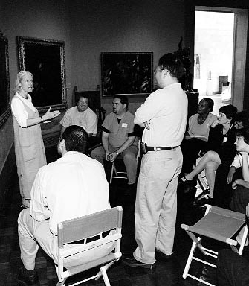
They began by examining an unnamed work, later revealed to be Tavern Scene by 17th-century Flemish artist David Teniers the Younger. Led by Susan Daiss, the Gallery’s director of education, they
JAMES M. VIA
inventoried the elements of the work, described what they thought they were seeing, guessed at time and place, and shared personal reactions. It was a slow, painstaking process, as the residents learned not to jump to conclusions, or (in medical terms) “premature closure.”
In the case of the Teniers, it soon became clear that things aren’t always what they seem. As Daiss pointed out, a sketch pinned to the wall is not just for decoration. It shows an owl,with eyeglasses and candle, representing his failure to see the folly of his ways.
Formally titled “The Art of Observation,” the program began when Daiss’s phone rang in fall 2002. Stephanie Brown Clark, an MD-PhD and an assistant professor in the department of medical humanities, had read about an intriguing collabora-tion between Yale Center for British Art and that
university’s medical school. She and Daiss immediately set up a series of brainstorming ses-sions with Brown Clark’s medical colleague Jules Cohen, student Rachel Kowal, and MAG curator Nancy Norwood.
Out of their discussions came an eight-week elective course for first-year students in spring 2003. “The Art of Observation” alternated between the Gallery, where the 14 students looked at art, and the medical center, where they observed patients. In fall 2003 a new course was offered for second-year students.
This time the sessions were less general: portraits (reading expressions and body language) were paired with psychiatry; signs of aging in works of art, with a visit to geriatric patients at Monroe Community Hospital; looking at prints with looking at pathology specimens.
In addition to the courses and sessions for residents, the MAG-URMC team hosted all 100 new medical students during orientation week; held an event for students’ family and friends; and participated in seminars for high school biology teachers and teens considering careers in medicine.
“What we’ve developed on MAG’s end,” says Daiss, “is a version of the same methodology that we use in helping everyone—from kindergarten students to
docents—learn to look. And it was wonderful to have Stephanie as a partner in this process because she was always questing for parallels. What she initially thought was concrete skill building turned out to be much more complex. And the complexity, I think she and I would agree, is in the nature of art itself—the essential humanity that’s embedded in these objects.”
What started as an exploratory project is quickly growing into a full-fledged program, one that recently acquired a new team member. Helping create a new course for spring 2005 is Hannah Solky, a physician who also happens to be one of 38 new MAG docents.

