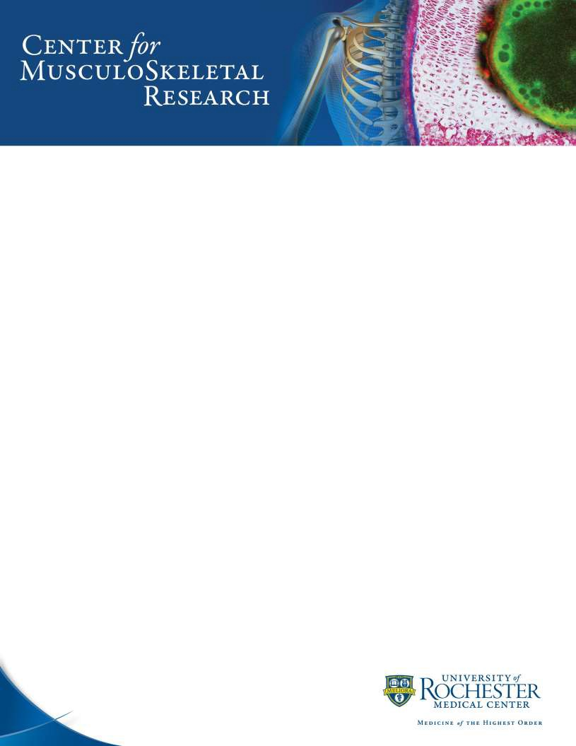

MASSON TRICHROME STAIN

Paraffin-embedded, formalin fixed tissue

Notes: Muscle fibers, keratin, fibrin red Nuclei black
Collagen blue

SOLUTIONS:

Bouin’s Solution

Bouin’s solution – Fisher Scientific: NC0827069

Modified Weigert’s Iron Hematoxylin

Solution A
Hematoxylin crystals, C.I. 75290 -- 4.0 g
Alcohol, 80% 200 ml

Solution B
Ferric chloride (EMS 15510) -- 8.0 g
Distilled water 190 g
HCl, concentrated 36.5-38% --2.0 ml

Working Modified Weigert’s Iron Hematoxylin

Equal parts of Solution A and Solution B mixed well, keep in dark.

2/2020

MASSON TRICHROME STAIN

Biebrich Scarlet-Acid Fuchsin Solution
Bibrich scarlet, C.I. 26905 -- 2.25 gm
Acid fuchsin, C.I. 42685 -- 0.25gm
Acetic acid, glacial -- 2.5 gm
Distilled water 250 ml

1% Phosphomolybidic Acid Solution

Phosphomolybdic acid -- 2.5 gm
Distilled water 250 ml

1.8 % Aniline Blue Solution
Aniline blue, C.I. 42755 -- 4.5 gm
Acetic acid, glacial -- 4.5 ml
Distilled water 250 ml

1% Acetic Acid Solution
Acetic acid, glacial -- 2.5 ml
Distilled water 250 ml

Acid-Alcohol Differentiation Solution

0.5% hydrochloric acid in 70% alcohol

2/2020

MASSON TRICHROME STAIN

STAINING PROCEDURE:
- Deparaffinize and hydrate to distilled water

- Mordant in Bouins’s solution which has been preheated to 58˚ C for 15 minutes

- Wash slides with distilled water

- Modified Weigert’s Iron Hematoxylin (keep in dark) for 5 minutes
- Wash with 3-4 changes of distilled water

- Differentiate in acid-alcohol solution for 3-5 seconds
- Wash slides with 3-4 changes of distilled water

- Biebrich Scarlet-Acid Fuchsin solution for 5 minutes
- Rinse in 3 changes of distilled water

- 1% Phosphomolybdic acid solution for 2 minutes
- Aniline Blue solution for 5 minutes

- Rinse with 1 change of distilled water
- Acetic acid solution for 30 seconds

- Rinse with 2 changes of distilled water
- Dehydrate in graded alcohols

- Clear in Xylene
- Coverslip
2/2020

