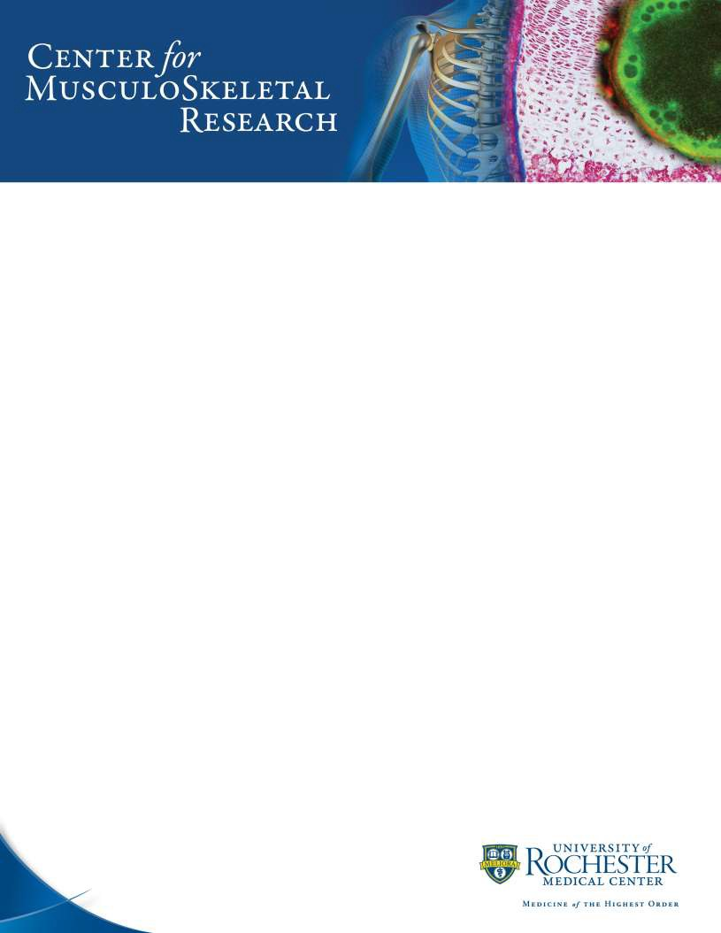

Hematoxylin and Eosin Stain (H&E)

TECHNIQUE: Formalin fixed, paraffin tissue sections

REAGENTS:

Mayer’s Hematoxylin (Fisher Scientific cat: NC9220898 )
0.5% Acid Alcohol
70% Ethanol 995ml
Hydrochloric Acid, (36.5% - 38%) 5ml
1X PBS (pH 7.2-7.3)

Alcoholic-Eosin

1.0% Eosin Y

Eosin Y (CAS# 17372-87-1) -- 1.0 g
Distilled water 100 ml

1.0% Phloxine B
Phloxine B (CAS# 18472-87-2) -- 0.5 g
Distilled water -- 50.0 ml

Working Alcoholic-Eosin Solution

1.0% Eosin Y -- 50.0 ml
1.0% Phloxine B -- 5.0 ml
95% Ethanol -- 390.0 ml
Acetic acid, glacial -- 4.0 ml

3/2020

PROCEDURE:

Hematoxylin and Eosin Stain (H&E)
5 micron Paraffin Sections

- Deparaffinize and rehydrate slides to distilled water
- Stain in Mayers Hematoxylin for 1 minute

- Wash with 4-5 changes of Tap water or until blue stops coming off slides
- Blue nuclei in 1X PBS for 1 minute

- Wash with 3 changes of distilled water
- Counterstain in Alcoholic-Eosin for 1 minute (DO NOT RINSE)

- Dehydrate through 3 changes of 95% EtOH and 2 changes of 100% EtOH 1 minute each
- Clear in 3 changes of Xylene 1 minute each change

- Mount and coverslip

*Do NOT rinse with water after Alcoholic-Eosin! Go directly into dehydration of slides.

RESULTS:

Nuclei blue
Cytoplasm pink
Erythrocytes bright red
All other eosinophilic structures red, pink, or orange

3/2020

Hematoxylin and Eosin Stain For Fresh Frozen Section

(H&E)

PROCEDURE:
- Take slides immediately from freezer and place in cold fixative (10% Neutral Buffered Formalin or 4% PFA) for 10 minutes

- Rinse slides in 1X PBS, 2 times for 3 minutes each to remove OCT or other tissue embedding compound
- Rinse in a gentle stream of tap water for 1 minute

- Stain in Mayers Hematoxylin for 30 seconds
- Wash in a gentle stream of tap water for 1 minute

- Blue nuclei in 1X PBS for 20 seconds
- Wash in a gentle stream of tap water for 1 minute

- Dip in 70% EtOH for 30 seconds
- Dip in 95% EtOH for 30 seconds

- Counterstain in Alcoholic-Eosin for 30 seconds
- Dehydrate through 2 changes of 95% EtOH and 3changes of 100% EtOH for 15 seconds each

- Clear through 3changes of Xylene for 1 minute each and coverslip

RESULTS:

Nuclei blue
Cytoplasm pink
Erythrocytes bright red
All other eosinophilic structures red, pink, or orange

2/2020

Hematoxylin and Eosin Stain For Frozen Section

(H&E)

PROCEDURE:

- Rinse slides in 1X PBS for 3 minutes
- Rinse in a gentle stream of tap water until OCT is washed off for 3 minutes

- Stain in Mayers Hematoxylin for 30 seconds
- Wash in a gentle stream of tap water for 1 minute

- Blue nuclei in 1X PBS for 20 seconds
- Wash in a gentle stream of tap water for 1 minute

- Dip in 70% EtOH for 30 seconds
- Dip in 95% EtOH for 30 seconds

- Counterstain in Alcoholic-Eosin for 30 seconds
- Dehydrate through 2 changes of 95% EtOH and 3changes of 100% EtOH for 15 seconds each

- Clear through 3changes of Xylene for 1 minute each and coverslip

RESULTS:
Nuclei blue
Cytoplasm pink
Erythrocytes bright red
All other eosinophilic structures red, pink, or orange

3/2020

PROCEDURE:

Hematoxylin and Eosin Stain for soft tissue (H&E)
4 micron Paraffin Sections

- Deparaffinize and rehydrate slides to distilled water
- Stain in Mayers Hematoxylin for 4 minutes

- Wash with 4-5 changes of Tap water or until blue stops coming off slides
- Decolorize with 1 dips in 0.5% acid alcohol

- Wash in 3 changes of distilled water
- Blue nuclei in 1X PBS for 1 minute

- Wash with 3 changes of distilled water
- Counterstain in Alcoholic-Eosin for 30 seconds (DO NOT RINSE)

- Dehydrate through 3 changes of 95% EtOH and 2 changes of 100% EtOH 1 minute each
- Clear in 3 changes of Xylene 1 minute each change

- Mount and coverslip

*Do NOT rinse with water after Alcoholic-Eosin! Go directly into dehydration of slides.

RESULTS:
Nuclei blue
Cytoplasm pink
Erythrocytes bright red
All other eosinophilic structures red, pink, or orange

3/2020

