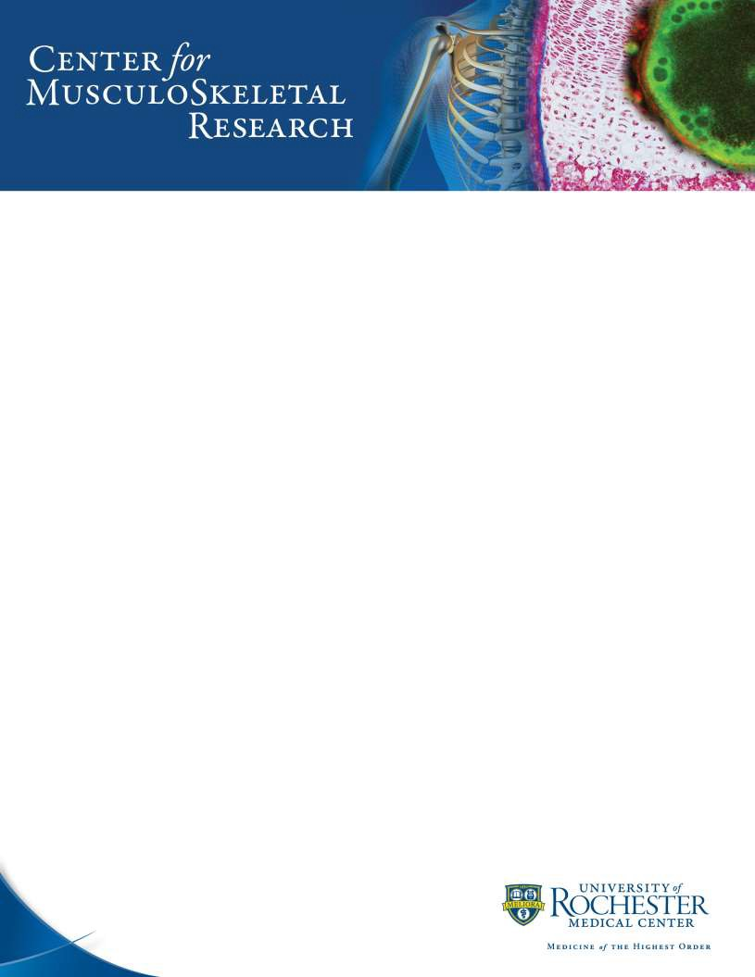

PAS (Periodic Acid Schiff) Staining Protocol
Used for the detection of glycogen in tissues such as liver, cardiac and skeletal muscle on formalin-fixed paraffin-embedded tissue sections, and may be used for frozen sections as well.

Solutions and Reagents:
0.5% Periodic Acid Solution
Periodic acid -- 0.5 g
Distilled water 100 ml

Schiff’s reagent
Schiff’s reagent: Fisher Scientific (cat: 50-301-27)
Test for Schiff’s reagent: Pour 10 ml of 10% formalin to a beaker, add a few drops of the Schiff’s reagent to be tested. Good Schiff’s reagent will rapidly turn a red purple color. A deteriorating Schiff’s reagent will give a delayed reaction and the color produced will be a deep blue-purple.

Mayer’s hematoxylin
Mayer’s modified hematoxylin: Fisher Scientific (cat: NC9220898) Procedure:
- Deparaffinize and hydrate to water.

- Oxidize in 0.5% Periodic Acid solution for 5 minutes.
- Rinse in 3 changes of distilled water.

- Place in Schiff’s reagent for 15 minutes (Sections become light pink color during this step).
- Wash in tap water for 5 minutes (Sections immediately turn dark pink).

- Counterstain in Mayer’s hematoxylin for 1 minute.
- Wash in tap water for 5 minutes then rinse in distilled water.
- Dehydrate, coverslip and mount using Xylene based mounting media

3/2020

PAS (Periodic Acid Schiff) Staining Protocol

Results:

Glycogen, mucin and some basement membranes Red/ purple
Fungi Red/ purple
Background Blue

3/2020

