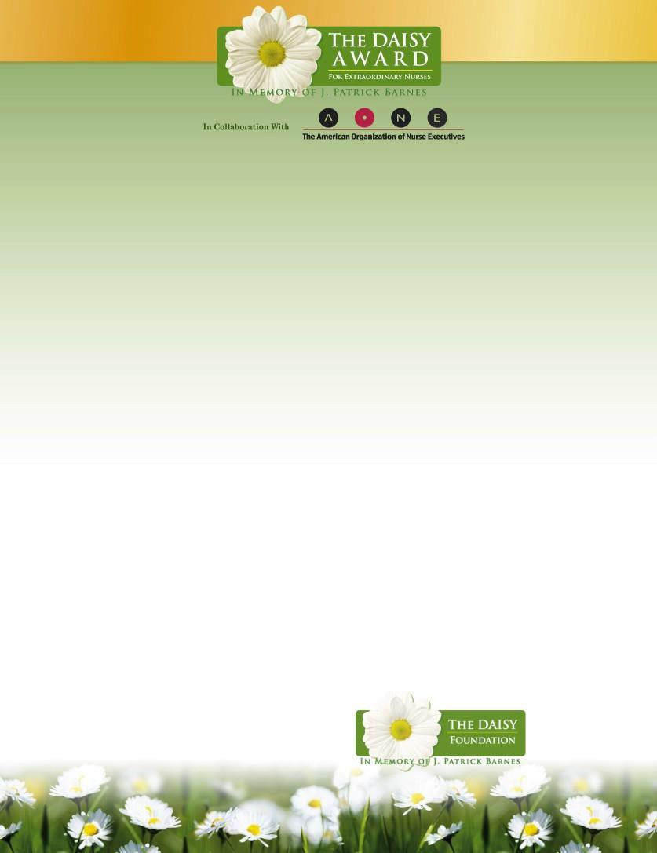
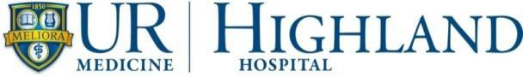

Patients, visitors, nurses, physicians, employees and volunteers may nominate a deserving nurse for the DAISY Award. This nationwide program rewards and celebrates the extraordinary clinical skill and compassionate care given by nurses every day. Highland is proud to be a DAISY Award Hospital Partner and will recognize one of our nurses with this special honor quarterly.

The DAISY Foundation was established in 2000 by the family of J. Patrick Barnes who died at age 33 of an auto- immune disease. DAISY is an acronym for diseases attacking the immune system. During Pat’s 8-week hospitalization his family was awestruck by the care and compassion his nurses provided to Pat and everyone in his family. When he died, they created the foundation in his memory to honor nurses, the “unsung heroes.”

Criteria for the Daisy Award at Highland Hospital is as follows:

The nurse exemplifies extraordinary kindness and skill that is selflessly given and is the kind of nurse that patients and families recognize as an outstanding role model. Additionally, this nurse exhibits many of the following attributes:
- Fellow nurses say, “I would want this nurse to take care of my mother”
- Generates enthusiasm and energy towards meeting the challenges of nursing and provides a vision of hope
- Establishes a special caring and compassionate connection with patients and families through trust and emotional support
- Excellent clinical skills
- Dedicated mentor
- Passionate about life
- Team player

Each DAISY Award winner will be recognized at a public ceremony at Highland and will receive: a beautiful certificate, a DAISY award pin and a hand-carved stone sculpture entitled, “A Healer’s Touch.” Additionally, everyone on the unit will celebrate with Cinnabon cinnamon rolls. The rolls were a favorite of Pat’s and the family hopes that whenever and wherever nurses smell the wonderful cinnamon aroma they will stop for a moment and think about how special they are.

Nomination forms are available on the Nursing page on the Highland intranet. Please email completed forms
to meredith_metzler@urmc.rochester.edu or mail them to the Nursing Administration Office, Box 63. Additionally, hard copies of the forms are available at the front desk, on the nursing units and in receptacles on the walls near the Shining Example forms. You can also place completed nomination forms in the Shining Example boxes.
Nominations received by the 1st of January, April, July and October will be considered for the quarterly
DAISY Award. If you have any questions, please contact Sarah_Leone@URMC.Rochester.edu.

4-24-2026

