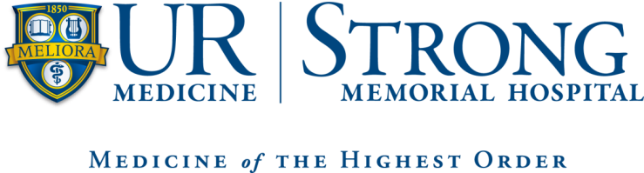

Neonatal Intensive Care

Advanced Practice Provider

Fellowship Program Application

2023-2024

The APP Fellow MUST meet the following qualifications:
- Nurse Practitioner
  - Master’s degree in Nursing
  - Active New York State licensure as Registered Nurse and Nurse Practitioner in good standing
  - Current national certification as a Nurse Practitioner (completed during program)
- Physician Assistant
  - Completion of an AMA approved Physician Assistant program
  - Active New York State Physician Assistant licensure in good standing
  - Current national certification as a Registered Physician Assistant
Applicants for the Neonatal Intensive Care APP Fellow position should demonstrate clinical competence as well as excellent verbal and written communication skills. The APP Fellow should have excellent customer relation skills, a passion for Neonatal Care and an active desire to learn.
Application Process:
- Complete the on-line job application for the NICU – Nurse Practitioner/Physician Assistant Fellow position located on the Human Resources/Office of Nursing Recruitment website:
  - http://www.rochester.edu/people/nursing

Helpful Hints:
- Our software works with a variety of web browsers including, Mozilla Firefox, Opera, and Safari. We recommend you use the most current version of these browsers since using old versions may create problems when applying for jobs. If you encounter any technical problems, applicants can contact our Help Desk at (585) ASK-URHR – (585) 275-8747, Mondays through Fridays, 8:00 am – 5:00 pm.
  - Please review the completed online application carefully – the system reads your resume and attempts to automatically populate your application for you, please ensure the information was populated correctly. If you encounter problems trying to upload your resume or cut and paste your resume you may want to manually complete the application and then forward your resume to NursingRecruitment@urmc.rochester.edu Both the application and resume are required to apply.
  - While answering the questions on the 4th page, the screen refreshes after each entry you make. Please go slowly and wait 5-10 seconds after each click to allow the page to refresh before answering the next question.
- Current University of Rochester Employees do not need to complete an online application. Simply forward your resume to NursingRecruitment@urmc.rochester.edu
- Use the side bar on left to navigate through the system (i.e. Job Search Tips)

- Please send the following items to the Neonatal Intensive Care APP Fellowship Director, Taylor Aspenleiter
  - Current Resume or Curriculum Vitae
  - Official academic transcript to date
  - Submit 2 professional references:
    - Request a confidential recommendation from a Nurse Practitioner/Physician Assistant/Physician clinical preceptor during your academic program.
    - Request a confidential recommendation from a Faculty member from your academic program.
  - Letter of Interest:
    - Provide a letter of interest which reflects on your interest in the Fellowship program, your passion for Neonatal Medicine, and how this opportunity will impact your future as a Neonatal APP. Please also comment on why you think this program will be a good fit for you.
- Applications for consideration for the 2023-2024 Fellowship program are due by March 1th, 2023.
- Candidates will be contacted in mid-March to arrange for interview
- Return complete application to via mail or e-mail:
  - Taylor Aspenleiter
  - Mail
Strong Memorial Hospital
Neonatal Intensive Care Department
601 Elmwood Avenue
Box 651
Rochester, NY 14642
- Taylor_aspenleiter@URMC.rochester.edu
- Please e-mail Taylor Aspenleiter with any questions or concerns about this application and the application process.

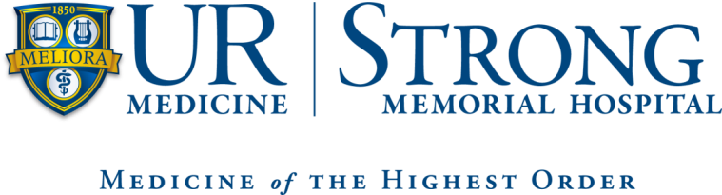

Neonatal Intensive Care

Advanced Practice Provider

Reference Form
Nurse Practitioner/Physician Assistant Program: ________________________________________________
Date:________________________
_________________________________ (name of applicant) has applied for a position in the Neonatal Intensive Care APP Fellowship Program at Strong Memorial Hospital in Rochester, NY.
We would appreciate your evaluation of this applicant’s general ability and professional proficiency in academic and clinical practice. We would like to know what you consider the applicant’s strengths and weaknesses to be. You can be assured that all information will be treated confidentially.
Please be advised that all recommendations are to be completed confidentially and recommender should be provided an envelope to enclose their recommendation which must have a signature across the seal of the envelope and can be submitted with the application.

I hereby authorize the release of my academic/clinical record to Strong Memorial Hospital, Neonatal Intensive Care Department.
Applicant Signature: _________________________________________
Applicant Printed Name: ______________________________________
******************************************************************************************
The above APP was a student in your academic/clinical setting during what period of time? ________________________
In comparison with the other students in the class, how would your rank this student academically?
Upper 10% ( ) Upper 25% ( ) Middle ( ) Lower 25% ( ) Lower 10% ( ) N/A ( )
In comparison with the other students you have worked with clinically, how would you rank this student clinically?
Upper 10% ( ) Upper 25% ( ) Middle ( ) Lower 25% ( ) Lower 10% ( ) N/A ( )

Please Rate the Applicant on the Following:

 | Above Average | Average | Below Average
Critical Thinking Skills

Organizational Skills

Leadership Potential

Flexibility/Adapts to Change

Professional Attitude

Clinical Competence

Appropriately selects and interprets diagnostic testing findings
Medical Decision Making Process

Demonstrates therapeutic communication with patients & families
Demonstrates professional communication with other professionals
Works in a collaborative fashion with health care team
Appropriate documentation

Procedural skills

Attendance/Punctuality

Overall Recommendation

Please include a statement about the applicant’s strengths/weaknesses and whether you feel this applicant will be a good fit for our Neonatal Intensive Care APP Fellowship program. Please feel free to provide any additional comments.
Recommender Signature: _________________________________________________________
Recommender Title: _____________________________________________________________
Date: ____________________
Contact Information: ______________________________________________________________

