Module 1. Think Like a Writer

Hallmarks of Good Scientific Writing
The following four hallmarks of good scientific writing should provide a useful target for your work as you progress through this writing course. I have listed them in priority order.
- Accuracy: Get the facts straight and convey them without distortion.
- Clarity: Your style should facilitate understanding of your meaning, not interfere.
- Brevity: Do not waste your reader's time and patience with wasted words. However, if brevity interferes with clarity, prioritize a clear statement of meaning.
- Elegance: Make your prose easy to read, interesting, and pleasant to the ear. Avoid lifeless verbs, clichéd expressions, and monotonous rhythms in paragraphs.
In scientific writing, accuracy must hold first place. That is what science is all about! But clarity and accuracy go hand in hand. A statement that is unclear does not serve the purpose of accuracy. I have placed clarity before brevity, even though journal and grant requirements make us devote extensive time and energy to reducing word counts. Brevity that defeats clarity is simply counterproductive.
Elegance is at the bottom of the priority list for scientific writing, even though it is the dominant force in most poetry and fiction! Nonetheless, elegance serves a key purpose in scientific prose: if sentences are full of exhausted and vague words, if paragraphs are repetitive and boring, or if an article’s conclusion makes a weak statement of the argument, the author’s purpose is defeated. Once you have achieved the goals of accuracy, clarity, and brevity in your writing, take time to make your word choices interesting and dynamic, and the flow of words smooth rather than choppy. Listen to your paragraphs to make sure they do not contain bumps, which often indicate logical gaps. Perhaps you can even add a creative metaphor occasionally. In Module 3, I use metaphors to help explain paragraph strategies: a chain that needs strong links (p.11), and a path through the woods that needs blazes on the trees (p.13). Throughout your writing, “elegant” techniques help to keep your reader awake and engaged.

What makes ordinary writing into good writing?
- Good writing comes from good thinking. Improving your thinking on a subject will almost always improve your writing about it. Conversely, the process of writing usually helps writers to improve their thinking (at least about the subject of their prose).

Writing is a vehicle for converting your ideas into a form that can teach, persuade, or activate the reader. Ideally, you can achieve all three of these goals by effective presentation of your ideas.


- Good writing is the product of good re-writing. Many authors obsess over the composition of their first draft of a paper. In fact, what matters most about the first draft is only that it gets written. Your writing will be judged by the quality of the final draft.

What happens in between the first and final draft is self-editing, a key focus of this course. In Module 2 (sentences) and Module 3 (paragraphs), I will be sharing a number of writing tips, and will ask you to apply these tips by editing samples of “unperfected” writings by others. It is usually much easier to see flaws in other people’s work than in your own. This writing practice will also help you to view your writing from the perspective of the reader (see below). In the appendices to Modules 4 (articles) and 5 (grant proposals), I offer well written examples, with my editorial comments, to provide you with helpful models to study. These models will help you to aim your revisions at a good target.

- Good writing comes from understanding your work from the reader's perspective. As a good scientific writer, you choose words that economically express your meaning. Then you place these words in a structure that conveys your meaning clearly to reader.
Well-chosen words are precise (not approximate or clichéd), simple (concrete > abstract), and essential (not redundant or superfluous). These are the building blocks of your sentences.
The “structure” of a sentence or paragraph may seem like an abstract concept, but you create a structure for your words all the time when you write: after you choose the right words, you put them in an order that makes sense.

- In sentences, you create structure by following the rules of good grammar and punctuation. In Module 2, I will discuss additional structural techniques: organizing a sentence by putting related words near each other, and managing repetitions and lists within sentences.

- In paragraphs, you create structure by choosing a central topic, and logically ordering sentences that address this topic. The first sentence usually tells the reader what the paragraph is about. In Module 3, I will also discuss ways to create continuity within a paragraph. These are verbal and structural techniques that link ideas, thereby clarifying the paragraph’s structure to help articulate its meaning.

- Your document as a whole also needs careful structuring to build its argument. Organization of a document requires sound logic, deep understanding of content, and skillful use of the conventions of the writing form. This complex topic is addressed in Module 4 and Module 5, which discuss writing research articles and grant proposals.

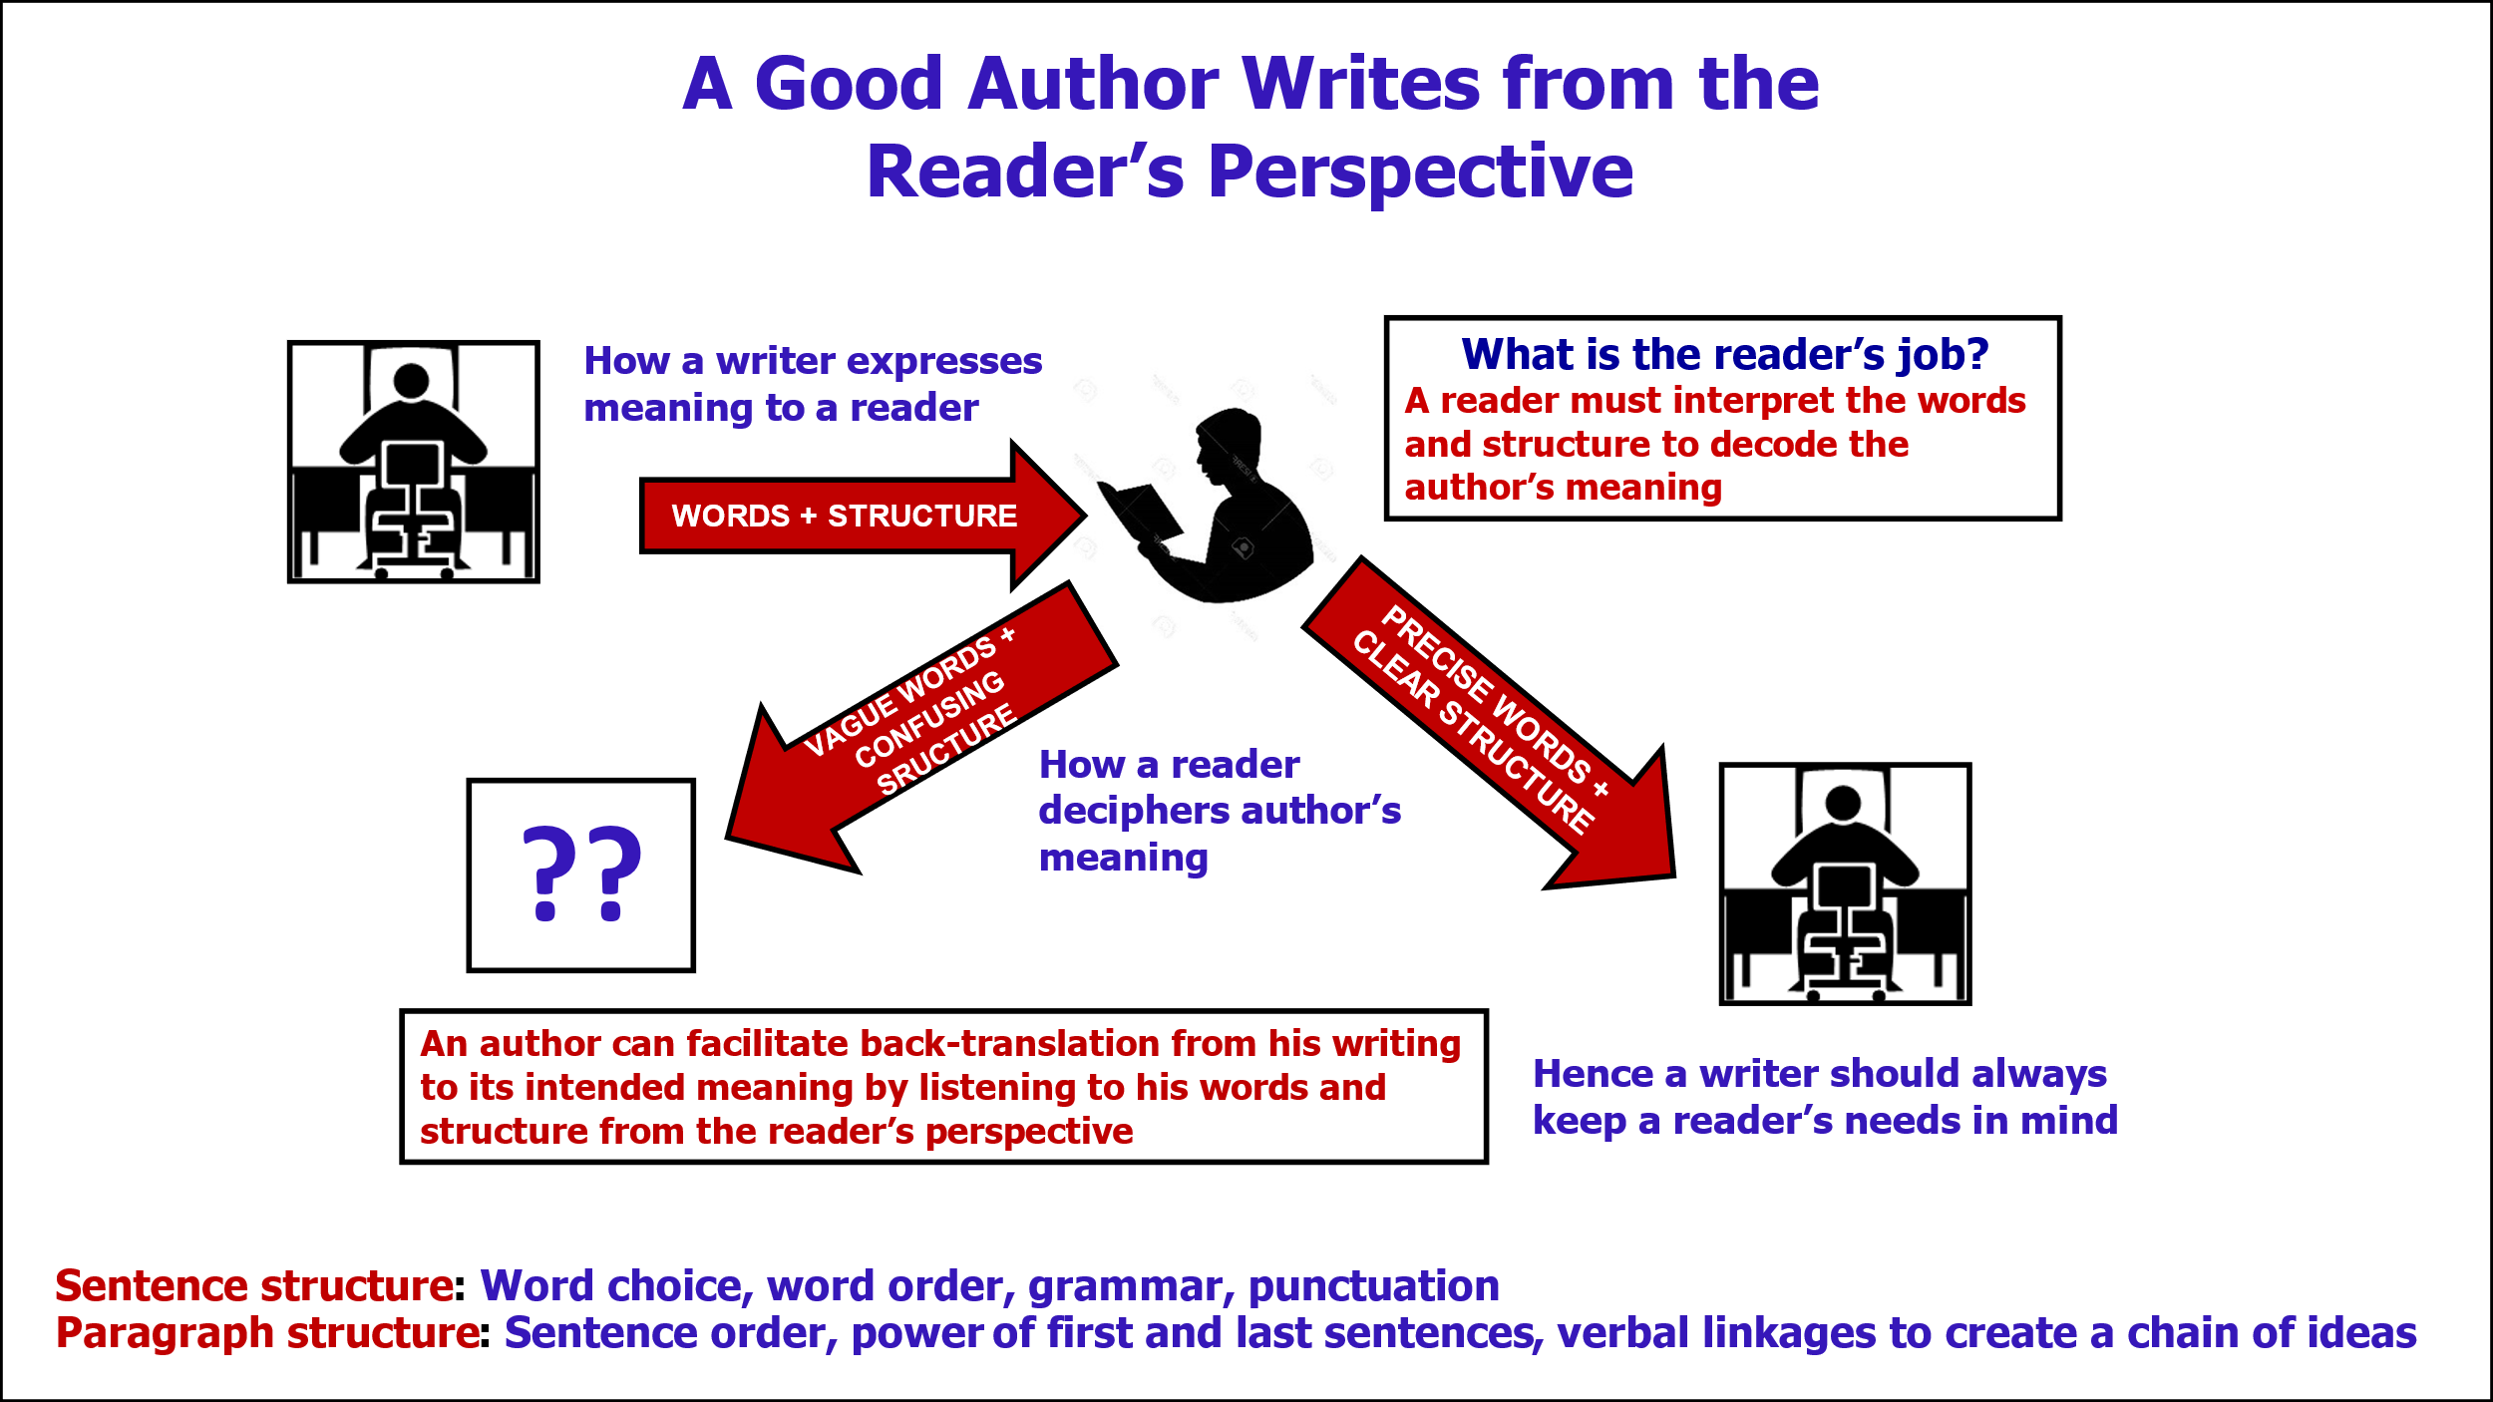

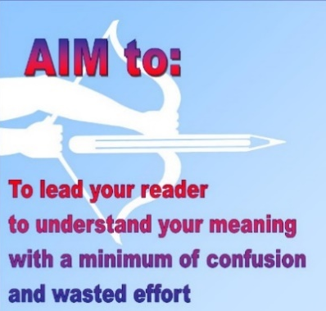
Words + structure are key tools for you to express your meaning, and for the reader to interpret your meaning. To decode a sentence, your reader must interpret your chosen words in the context of your sentence/paragraph structure. If you “listen” to your writing during composition and edit to help your readers “hear” the meaning, they will find it easier to back-translate from your written words to your intended meaning. I edit my own writing by reading it “aloud” in my head, word by word. My inner ear follows the progression of ideas and can help me identify awkward phrases, incomplete thoughts, non sequiturs, or other sources of confusion. This is what I mean by saying that a good author writes from the reader’s perspective.

So, what does all this tell us about the scientific reader? The challenge of reading scientific prose is that decoding a complex sentence requires mental energy to 1) interpret the words, then 2) discern the structure, and finally 3) decipher how these connect. If complex prose is poorly written, this challenge may become impossible. Readers who waste too much energy interpreting the words and structure of a sentence may give up trying to capture the meaning. If sentence structure fails, the meaning may well be indecipherable. As a reader yourself, you know how easy it is to give up and just skip to another paragraph, or another article! [Adapted from comments of Judith Swan, a scientific writing instructor at Princeton University. See Gopen and Swan,1990 (Course Introduction, A Short List of Resources for Scientific Writers, p. 6)
A QUICK DEMONSTRATION OF STRUCTURE IN WRITING

An English professor asked the class to punctuate this sentence:
Woman without her man is nothing.
The men punctuated it: Woman, without her man, is nothing!
The women punctuated it: Woman! Without her, man is nothing.
THE PUNCTUATION SAYS IT ALL!
Source not found (appears in many places and in multiple languages)

An evaluation form specific to this module, in MS Word format, is included as Module 1, App. 1 Evaluation Form. Please complete it on your computer and email to:
constance_baldwin@urmc.rochester.edu. Your input will help me to improve this writing course! C. Baldwin

