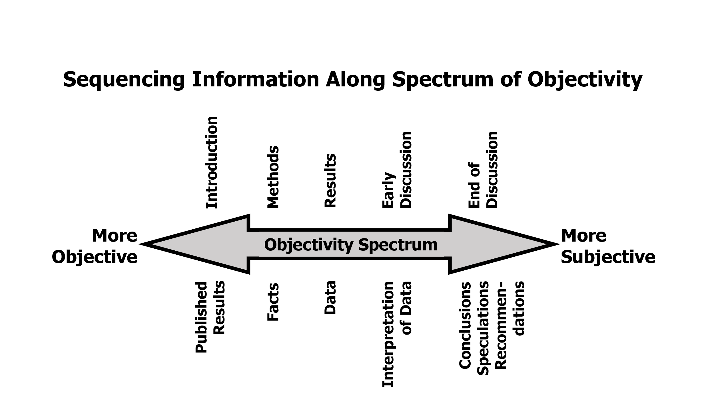
Module 4. Appendix 1A: Guidelines for Writing a Quantitative Research Article

Initial Planning Questions
- How shall I convert my project into a reportable study?
- What is this paper trying to prove? Why does it matter?
- What challenges do I face in putting the argument across?
Where and how will I address these issues?
- What journal should I target?

Abstract
Strategies | Content and organization
- Write abstract to help readers decide whether to read or download  - Make it clear and informative: address importance, validity, applicability  - Be sure the primary question and conclusions of the paper come through clearly | - Journals provide length limits and formats
 | - Follow same order as sections of the paper (with subheadings if required)
 | - Clear summary is more important than detailed data (this is not a meeting abstract)
 | - State your conclusion clearly, but with essential qualifications: Don’t let the brevity of an abstract lure you into overstatement!
Introduction
Strategies | Content and organization
- Define question to be addressed  - Establish the study’s importance and novelty  - For biomedical journals, keep the introduction short and focused (social science journals allow much more detail) | - Adhere to journal style for length, content
 | - In first paragraph, concisely state question and why it matters
- Next, review essential literature:
- Be selective! Summarize background to explain:
  - choice of question/hypothesis
- claim to novelty and significance
- Save detailed comparisons with previous studies for Discussion
- In final paragraph, briefly describe:
- Study question or hypothesis
- Sample
- Design and Methods
Materials & Methods
Strategies | Content and organization
- Keep it simple and brief  - Define key variables, use names consistently  - Use headings for clarity, easy navigation and reference  - Literature references here should focus on methods | - Overview of design  - Define type: e.g., retrospective or case-control study; randomized controlled trial  - Say enough about design to allow reader to evaluate the study
- Description of sample
- Population and setting for recruitment
- Planned sample size and power
- Inclusion/exclusion criteria
- Comparison groups, precautions to minimize bias
 | - Study protocol: subject assessment, time course, treatment/intervention, follow-up
- Specific procedures or instruments
- Methods for initial assessments (e.g., diagnostic methods)
- Methods to obtain outcome measures (survey instruments, physical measurements, biological assays)
- Give more detail where methods are novel, less where previously published
- Statistical plan and methods
- Define terms and describe tests (briefly)
- Explain rationale for unfamiliar statistical methods
Results
Strategies | Content and organization
- Present results systematically; generally use same order throughout paper  - Keep like things alike:  - Label variables consistently  - Use similar formats for tables/figures and statistical notations  - Answer all research questions; include negative findings  - Let the data speak for themselves:  - Presentation may indicate trend in your reasoning, BUT  - Generally avoid interpretation of results  - Strictly avoid broad conclusions and speculations | - Typical order of presentation:  - Describe sample collected first  - Then follow order of hypotheses, chronology, or design elements  - Provide subsection headings clarity and easy reference  - In general:  - present simple results before complex  - give prominence to strongest findings
- Numerical data
- Limit graphs, tables to key data; design them to highlight important results
- Choose best presentation format:
  - Use graphics to show relations between data sets
  - Use tables if specific numbers are essential
  - Otherwise, use narrative
- Briefly interpret figures, tables, images in narrative (but don’t reiterate data: bottom line is enough)
- Narrative presentation of results
- Stick to the facts
- Keep story as simple and focused as possible without distorting meaning
  - Avoid over-explanation
  - Avoid detailed data if summary is adequate
- Omission of tangential data will almost always strengthen your paper
Discussion
Strategies | Content and organization
- Highlight key findings and forestall criticisms  - Relate conclusions to original hypotheses  - Seek balance in interpreting results:  - Overstatement can be fatal, but  - Understatement may hide the importance of study  - Be selective! Discuss only results that deserve comment  - Don’t disparage or attack previous studies; do try to explain differences  - Separate conclusions/speculations from interpretations of results  - End with a clear statement of why the study matters | - General plan for Discussion:  - First, highlight key findings in the context of the central purpose of study (1 paragraph)  - Next, evaluate findings in relation to literature (3-5 paragraphs)  - Then discuss limitations of study (1 paragraph)  - End with conclusions (1-2 paragraphs)
- Strategic issues in ordering Discussion:
- Begin and end with most exciting, convincing, novel results. Put in the middle what is debatable, complicated, or boring.
- Avoid speculations, save conclusions and recommendations until the end
- Discuss other studies in order to:
- Compare previous results with your findings
- Clarify complex issues, ambiguities raised by your results
- Don’t repeat literature review from Introduction!
  - There you establish study’s importance and novelty
  - Here you use previous reports to confirm, question, or clarify your results (or theirs)
- Discuss limitations as well as strengths
- Design weaknesses: cluster in a paragraph before conclusions
- Methodological problems: discuss in the context of specific findings (earlier in Discussion)
- Serious problems: indicate how much they undermine confidence in validity of results (i.e., spin to minimize the damage)
- End with a summary of key findings and brief interpretation of their significance
- Clearly label speculations and recommendations that go beyond data
- Propose specific future studies if suggested by novel results (not simple confirmatory studies)
- At end, craft a statement about why the topic matters and how the findings may make an important difference (e.g., lay foundation for future research)

1B. Guidelines for Writing a Qualitative Educational Research Article
Overall Considerations: Data & the Narrative  - Use first person, “I” or “we”.  - Describe your analytic process.  - Identify quotations that led to identified themes.  - Identify important divergences between respondents’ experiences.  - Look for vivid detail to help reader “connect.”  - Interpretation of findings will be subjective, based on researchers’ experiences--they are not “neutral. | Initial Planning Questions  - How shall I convert my project into a reportable study?  - What is the problem that was addressed? Why is it important for the theory and practice of education?  - Is there a theoretical framework (literature or your own) tying everything together?  - What challenges do I face in putting the argument across? Where and how will I address them?  - What journal should I target? Make sure chosen journal publishes qualitative work.
Abstract
Strategies | Content & Organization
- Write abstract to help readers decide whether to read or download.  - Make it clear and informative (address importance, transferability to other educational settings)  - Be sure the primary question and conclusions (often in the form of themes) of the paper come through clearly. | - Journal provides length (usually 250-300 words) and format (structured or unstructured).  - Begin with single sentence objective statement: “The purpose of this research was…”  - Methods: # participants, where, when, how data were analyzed.  - Results: List (often numbered) major themes and provide a summary sentence of results.  - Conclusions: Major lessons learned and how other institutions can incorporate into their training programs.
Introduction
Strategies | Content & Organization
- Let reader know: What’s new about this study? “So what?”  - Literature background, context.  - Justification of qualitative approach.  - ”Story” of the study—why your group chose this study and method. | - Introduce topic or problem to be addressed by linking to an educational practice or policy  - Connect topic to broader educational community by linking to relevant literature: educational theory, research or practice.  Brief final paragraph:  - What did you plan to accomplish in your educational setting with this research.  - Describe your analytic framework (e.g., grounded theory, directed content analysis) and general research questions.  - Briefly outline how research was done.

Methods
Strategies | Content & Organization (adapt to specific qualitative method)
- Who, what, where: for researchers as well as participants  - Often contains more detail than quantitative methods articles  - Study questions (may be more general than in a quantitative study)  - Data analysis | - Describe curriculum or educational phenomenon you are studying.  - Describe study design, participants (key informants, “purposive” sampling) and setting.  - Data collection: sources and context of data. If relevant: how many sessions, how long, how did you know when you were finished?  - If relevant: Interview questions and formats.  - Data analysis: software or “hand” coding, coding by multiple researchers, how decisions made on themes.  - How you assured trustworthiness- different data sources, multiple analyzers, member checking.
Results
Strategies | Content & Organization
- Participant information  - Results usually organized by themes  - Sometimes organized with reference to a theoretic framework (novel or literature-based) | - How many participants? Their characteristics?  - Section describing overall results (e.g., focus group highlights). Include list of themes.  - Themes divided into separate sections: describe observations about each theme with quotes to illustrate.  - Selected quotes may be interspersed in narrative or put into tables.
Discussion
Strategies | Content & Organization
- Relate themes to original study questions.  - Be selective. Discuss only results that deserve comment. (But okay to discuss discrepant data: these may illuminate or clarify future studies)  - Discuss results in context of literature.  - Discuss limitations, evaluate their potential impact on usefulness of results (especially important in qualitative work with small numbers of participants or sites)  - What meaning have you derived from the study? What are implications for medical education? | - Begin with paragraph summarizing results as related to study question.  - Discuss each theme in same order as results  - Cite literature relating to each theme and how it confirms or differs from your study conclusions.  - Optional: tie themes together using model or other framework.  - Limitations often address transferability to other programs. Common limitations include: small number of participants and sites, and shorter duration of data collection.  - Conclusions: “Take home lessons” for other programs who wish to use similar educational approaches.
For more detailed information: Rowan M and Huston P. Qualitative research articles: Information for authors and peer reviewers. Can Med Assoc J 1997; 157: 1442-6. [http://www.ncbi.nlm.nih.gov/pmc/articles/PMC1228487/pdf/cmaj_157_10_1442.pdf]

INITIAL PLANNING WORKSHEET FOR AN ARTICLE
Note: You can use this worksheet for the first stages of planning a quantitative or qualitative paper, before moving on to the GUIDELINES FOR WRITING A RESEARCH ARTICLE
Introduction:
- What is this paper trying to prove?
- Why does it matter?
- What literature needs to be discussed?
Methods:
- Methods description: What part needs most detail?
- What potential weaknesses need to be addressed?
Results:
- How much data should be included? If you are expanding an abstract, do you have enough results for a paper?
- Consider which results should be presented in graphics, tables, or narrative.
Discussion:
- What is the strongest, most interesting finding to highlight?
- What results need more careful discussion (e.g., in relation to previous reports?)
- What are the limitations of the study?
- Are the conclusions stated with sufficient qualifiers (e.g., findings in our sample suggest, may indicate, are consistent with the interpretation that…, ?)

