Patient Telemedicine instructions:

Step 1: At least two hours prior to your Zoom meeting
  - From your mobile device (iPad, iPhone, Android tablet, etc.) Go to your App Store and download the free Zoom Cloud Meetings App onto the device you will be using. The Zoom Cloud Meeting icon looks like this:
Alternately, you can go to https://zoom.us/ on your computer.
Step 2: The Zoom Meeting Location
a. Go to a private, quiet, well lit location where you are getting a good Internet
connection for this appointment.

b. PLEASE NOTE: It is highly recommended to use WiFi at your home or work. If you are
meeting over a cellular network (example: 4G, 5G etc.), this will use a considerable
amount of your data.

Step 3: Zoom Meeting
a. About 10 minutes before your appointment time below, open your Zoom app and under
“Join a Meeting” enter your 9 digit ID number in your MyChart message you’re your provider and tap “Join”.

b. Wait for your provider to arrive.
TIP: Make sure your microphone and camera are not muted:
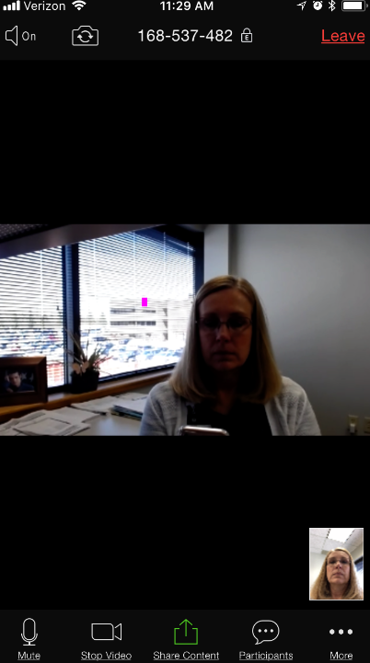
If you tap on the screen, tools will appear across the bottom. Make sure your speaker and camera are not muted.
HELP IS HERE! If you are having any technical issues, please contact us immediately at _________________
Thank you for allowing us to be partners in your care,

