TeamSTEPPS
Real Tools for Improving Patient Safety
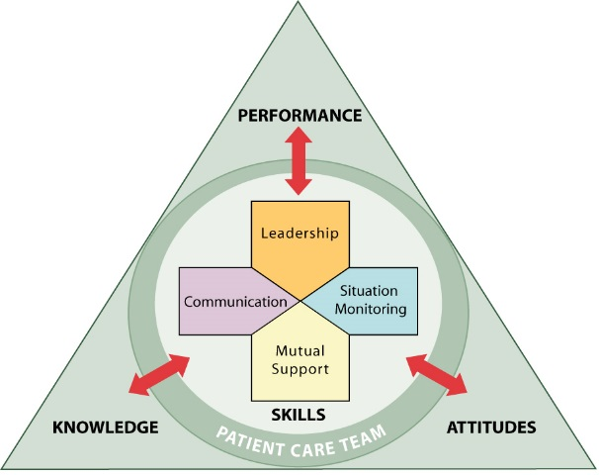

General TeamSTEPPS
Sat, Nov 4, 2017 (1-9576) or
Tue, Nov 14, 2017 (3-6408)

Office Practice TeamSTEPPS
Sat, Nov 11, 2017 (1-9425) or
Tue, Nov 28, 2017(2-6424)

Breakfast provided

This course offers participants the opportunity to learn evidence-based field-tested approaches to improve patient safety through enhanced communication, team leadership, and situational awareness.

Objectives:

- Define the importance of using standard leadership and team behaviors across disciplines to reduce medical errors.
- Discuss how to use the tools and strategies presented to promote patient safety and decrease medical error.
- Apply the tools and strategies to real-life situations.
- Employ tools and strategies for overcoming barriers to team effectiveness.
Course Director
Robert Panzer, MD
Georgia & Thomas Gosnell Professor in Quality and Safety

Anticipated Presenters (to date)

Michael Apostolakos, MD Kevin Hudson, RN
John Bisognano, MD Anna Lambert, RN
John Gassler, MD Pat Milot, RN
Neil Herendeen, MD Daniel Nowak RN
Steve Judge, MD Samuel Sullivan, RN
Peter Knight, MD Ive Vicente, RN
Michael Leonard, MD Bonnie Walden, RN
Matt Miller, MD Amy Wasilewski, RN
Robert Panzer, MD Jaclyn Wilmarth, RN
Dick Wissler, MD

The University of Rochester School of Medicine and Dentistry is accredited by the Accreditation Council for Continuing Medical Education to provide continuing medical education for physicians.

The University of Rochester School of Medicine and Dentistry designates this live activity for a maximum of 3.5 AMA PRA Category 1 creditsTM. Physicians should claim only the credit commensurate with the extent of their participation in the activity.

The University of Rochester Center for Nursing Professional Development is accredited with distinction as a provider of continuing nursing education by the American Nurses Credentialing Center’s Commission on Accreditation.
Participants will receive 3.5 Nursing Contact Hours. Nurses must attend the live session and complete the Blackboard evaluation to receive the Nursing Contact Hour Certificate.
To Register:
Print this page and:
Mail to: Heidi Poltorak, Box 612
Or Fax to 273-1118, Attn: Heidi Poltorak
OR via email send message with “TeamSTEPPs Fall 2017” in the subject line and information below in the body of the email to:
Heidi_Poltorak@urmc.rochester.edu
Please register by the Monday before the course date.
TeamSTEPPS
8:00 am – 12:00 noon
Date (choose one):
General TS Office Practice TS
___ Sat, Nov 4 ___ Sat, Nov 11
___ Tue, Nov 14 ___ Tue, Nov 28

Name: ________________________________________________

Email: ________________________________________________

Department Name: ______________________________________

Credentials (e.g. MD, RN): ______________

Date of Birth (mm/dd): _________________
(For Continuing Education record keeping purposes)

