TeamSTEPPS
Real Tools for Improving Patient Safety
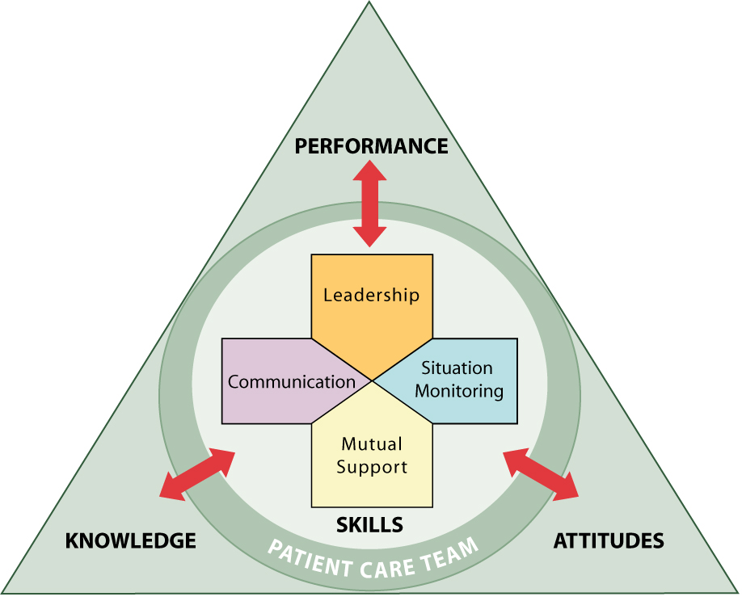

Coaching TeamSTEPPS
Sat, Nov 18, 2017 (2-7520) or
Thu, November 30, 2017 (2-7536)

Breakfast provided

This course offers participants the opportunity to learn evidence-based field-tested approaches to improve patient safety through enhanced communication, team leadership, and situational awareness.

Objectives:

- Define coaching and its outcomes
- Describe the role of a TeamSTEPPS coach
- List competencies of an effective coach
- Describe how to implement coaching in TeamSTEPPS

Course Director
Robert Panzer, MD
Georgia & Thomas Gosnell Professor in Quality and Safety

Presenters

Christine Arnold, RN
Robert Hance, RN
Bonnie Walden, RN
Jaclyn Wilmarth, RN

The University of Rochester School of Medicine and Dentistry is accredited by the Accreditation Council for Continuing Medical Education to provide continuing medical education for physicians.

The University of Rochester School of Medicine and Dentistry designates this live activity for a maximum of 3.75 AMA PRA Category 1 creditsTM. Physicians should claim only the credit commensurate with the extent of their participation in the activity.

The University of Rochester Center for Nursing Professional Development is accredited with distinction as a provider of continuing nursing education by the American Nurses Credentialing Center’s Commission on Accreditation.
Participants will receive 3.75 Nursing Contact Hours. Nurses must attend the live session and complete the My Path evaluation to receive the Nursing Contact Hour Certificate.

To Register:
Print this page and:

Mail to: Heidi Poltorak, Box 612

or Fax to 273-1118, Attn: Heidi Poltorak

OR via email send message with “TeamSTEPPs Coaching Fall 2017” in the subject line and information below in the body of the email to:
Heidi_Poltorak@urmc.rochester.edu

Please register by the Monday before the course date.
TeamSTEPPS: Intro to Coaching
8:00 am – 12:00 noon

Date (choose one): ____ Sat, Nov 18 ____ Thu, Nov 30

Name: ________________________________________________

Email: ________________________________________________

Department Name: ______________________________________

Credentials (e.g. MD, RN): ______________

Date of Birth (mm/dd): _________________
(For Continuing Education record keeping purposes)

