

Interpretation of Bioanalyzer Traces
Genomics Research Center

Introduction to Bioanalyzer Assays

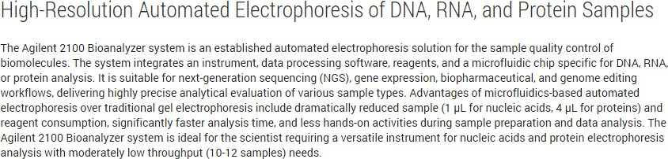
Bioanalyzer Automated Electrophoresis for Sample Quality Control | Agilent

Available Bioanalyzer Assays

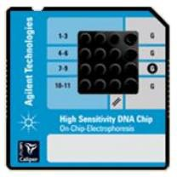
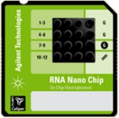
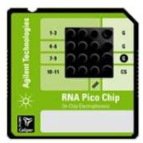
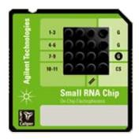

 | High Sensitivity DNA | RNA Nano | RNA Pico | Small RNA
Volume | 1 uL | 1 uL | 1 uL | 1uL
Size | 50 - 7,000 bp | N/A | N/A | 6 - 150 nt
Concentration | 5 - 1000 pg | 25 - 500 ng | 0.05 - 10 ng | Total RNA: 1 - 100 ng
 |  |  |  | Small RNA: 1 - 20 ng

High Sensitivity DNA
Ladder – A ladder is included with each run. The ladder contains two internal standards (Lower and Upper Markers) to align the ladder data with samples to determine sizing. The concentration of the upper marker is known and used to help determine sample concentration.
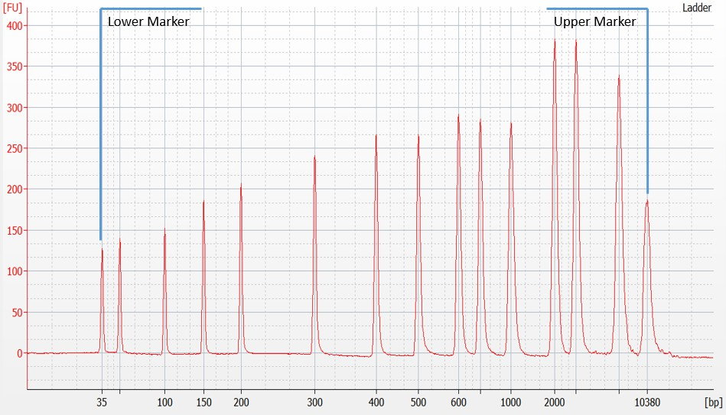
[FU] = Fluorescent Units

High Sensitivity DNA
Example Sample Trace – Lower and upper markers are included with each sample and are used to align the sample with the ladder. A region (Region 1) has been set and is indicated by the vertical blue lines on either side of the library trace. This is manually applied to each sample based on the library profile. This calculates the average size of the library within this region and is used for normalization prior to sequencing.
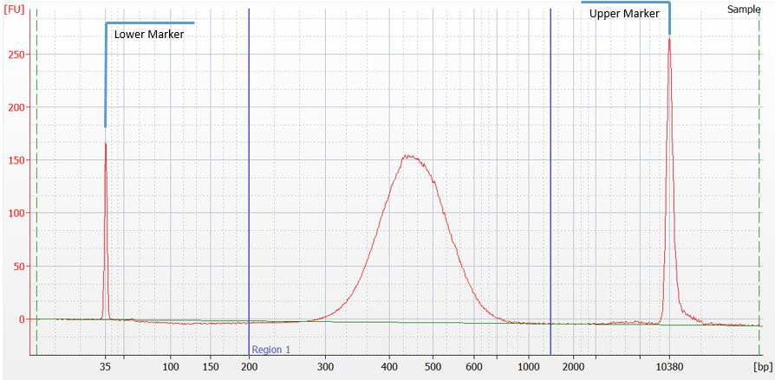
Region 1 *
[FU] = Fluorescent Units

*Region 1 is often placed up to 1500 bp even if the library trace extends beyond this limit. In our experience, library fragments

High Sensitivity DNA
Image 1: Primer Dimer Presence
Image 2: Adapter Dimer Presence
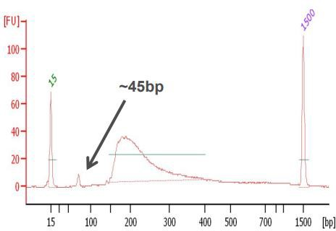
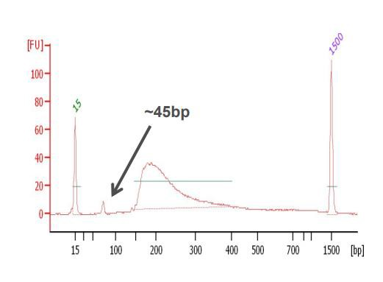
Examples of sample-related Issues that may impact Quality: Presence of peaks prior to the expected library range could be due to primer dimers (Image 1) or adapter dimers (Image 2). Further purification should be performed to remove these peaks prior to next generation sequencing. Large peaks beyond the library trace can indicate Ampure bead carryover (Image 3). Library should be placed on magnet to remove residual beads.

Image 1: Primer Dimer Presence
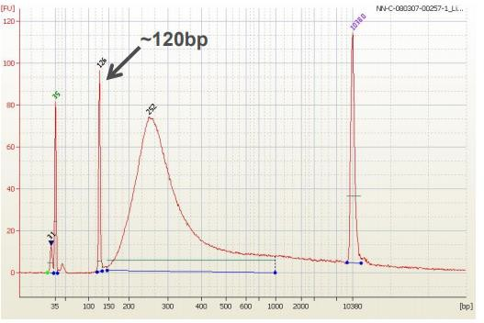
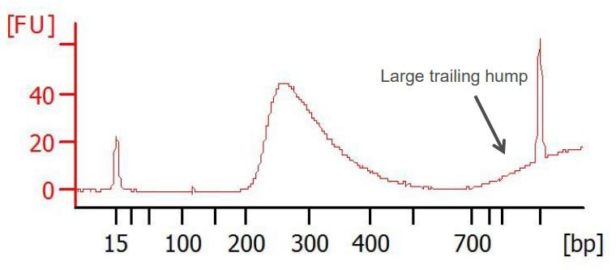
Image 2: Adapter Dimer Presence Image 3: Ampure Bead Presence

High Sensitivity DNA
Examples of Mechanical issues: The presence of an electrical spike (Image 4) or artifact peaks (Image 5) may be caused by the instrument and/or assay buffers, and are not necessarily cause for repeating the QC assay. We address these on a case by case basis to determine if the issue is influencing the instruments ability to call QC parameters.

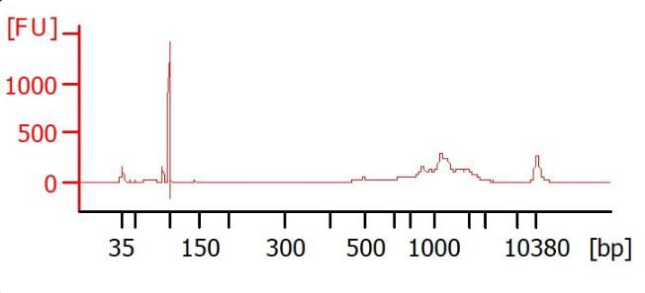
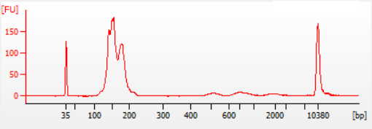
Electrical Spike
Artifact peaks

Image 4: Electrical Spike Image 5: Artifact Peaks

RNA
Ladder – A ladder is included with each run. Below are images of an RNA Nano and RNA Pico Ladder which are a mixture of RNA of known concentrations. The ladder also includes a lower marker used to align the sample with the ladder to determine size and concentration.

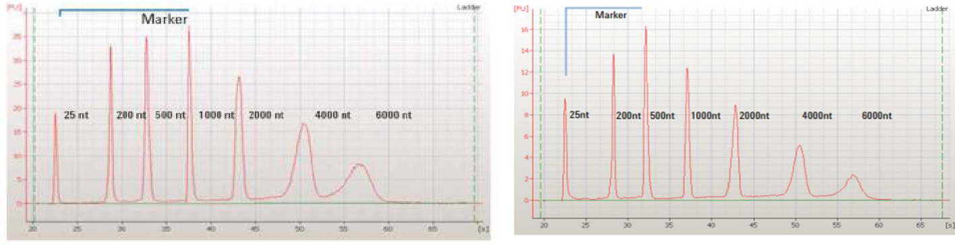
RNA Nano Ladder (Concentration: 150 ng/uL) RNA Pico Ladder (Concentration: 1000 pg/uL)

RNA
Example sample trace from either a Nano or Pico bioanalyzer chip. Both assays incorporate a lower marker with each sample. Quantification and sizing are determined based on the ladder that is included in each run.
There are other factors that may impact the baseline and therefore impact concentration such as contaminants. Baseline impacts such as electrical spikes do not impact quantification/quality metrics.
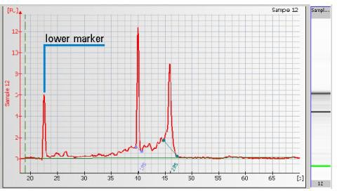
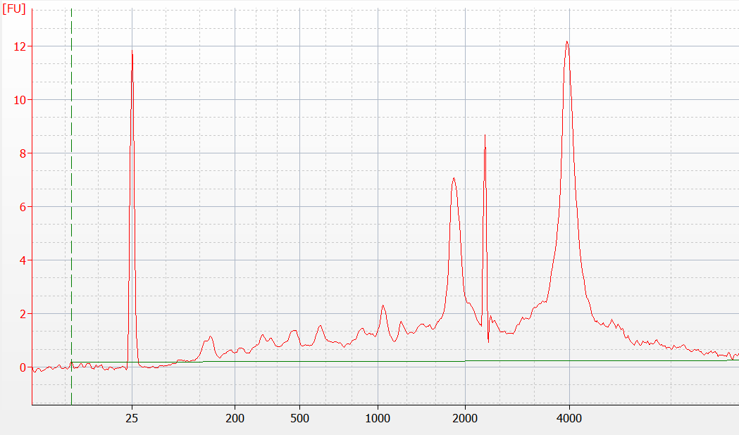
Electrical Spike
[nt]
[FU] = Fluorescent Units

RNA
Both RNA Nano and RNA Pico assays provide a RIN or RNA Integrity Number. The RIN indicates the integrity of the total RNA and is based on a scale from 1 to 10 with 1 being degraded RNA and 10 being intact RNA. To calculate RIN, the entire electropherogram is analyzed with an algorithm that assesses the following regions:
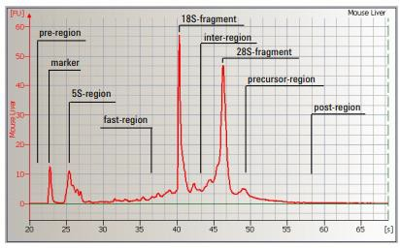
Manually Adapted RIN Values - if there are anomalies that impact the accurate calling of RIN values (such as unexpected signals in 5S region, among other factors), adjustments to the anomaly thresholds allow us to manually adapt RIN values for some samples. Agilent does not guarantee the accuracy of this RIN and recommends
performing a visual inspection of the data. 10

RNA
Lower RIN values can indicate degradation within the sample. Below are examples of varying RIN values and the corresponding traces.

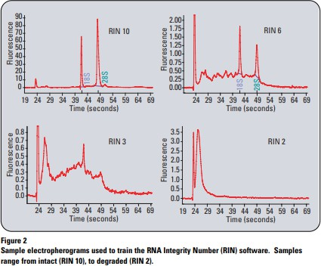
Factors that can impact RNA quality:
- Improper handling during extraction
- Improper RNA storage temperature
- Contaminants
Nanodrop used to help determine contaminant

RIN Bioanalyzer Technical Note 11

RNA
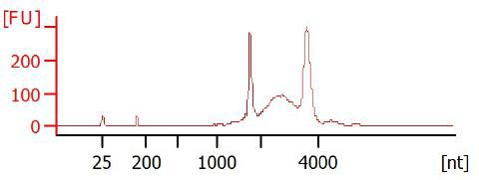
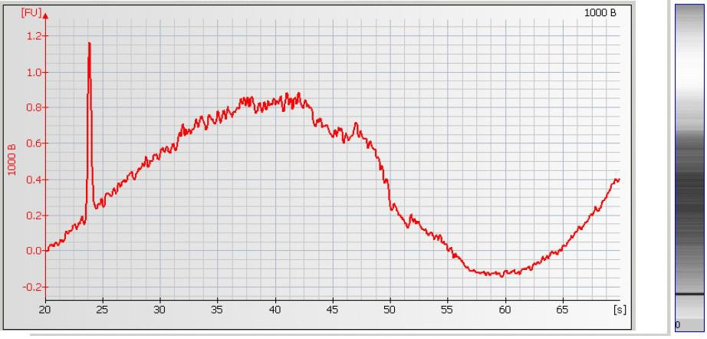
Genomic DNA Contamination – If there are unexpected peaks past the ribosomal peaks or an increase in the inter-region, it is possible your RNA samples are contaminated with genomic DNA. DNase treatment is required before further processing.
Inter-region
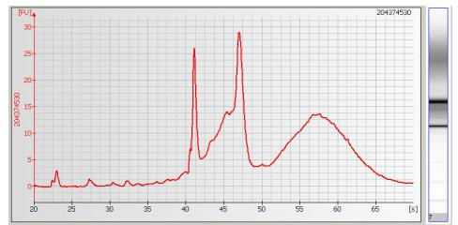

Secondary RNA Structures: Nanodrop is necessary to obtain concentration, 260/280, and 260/230

RNA
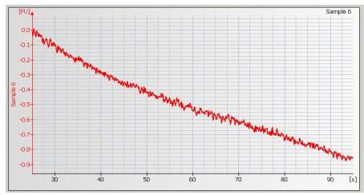
High Salt concentration: The table below shows maximum recommended buffer concentrations, and the image shows an example of the effect high salt concentrations can have on a Bioanalyzer trace.
RNA Pico | RNA Nano | Small RNA
50 mM Tris | 100 mM Tris | 10 mM Tris
15 mM MgCl2 | 15 mM MgCl2
0.1 mM EDTA | 1.0 mM EDTA | 0.1 mM EDTA
50 mM NaCl | 125 mM NaCl

RNA
Prokaryotic Contamination: The presence of 16S and 23S peaks within an RNA profile is an indicator of prokaryotic contamination. We recommend assessing the workflow to identify potential sources of contamination.

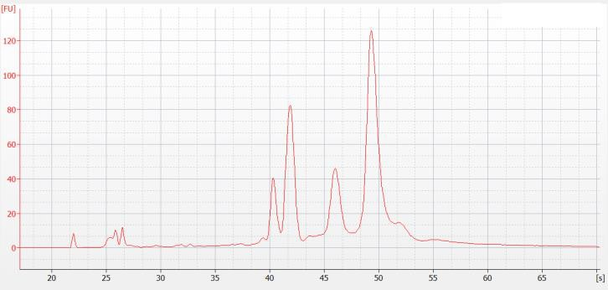
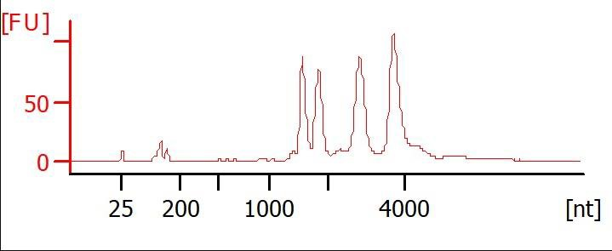

Nanodrop can be used to assess purity
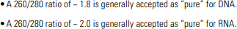
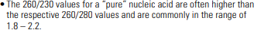
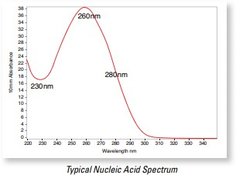
When an absorption spectrum is measured, nucleic acids absorb light with a characteristic peak at 260 nm. Additional measurements at 230 nm (detection of organic substances) and 280 nm (detection of proteins and phenols) will yield a more accurate estimation with respect to sample quality. The ratios of the absorbance values at the wavelengths 260 nm / 280 nm and 260 nm / 230 nm, respectively, provide a clear picture of the purity of a nucleic acid sample

Nanodrop can be used to assess purity

A low A260/A230 ratio may be the result of:
- Carbohydrate carryover (often a problem with plants).
- Residual phenol from nucleic acid extraction.
- Residual guanidine (often used in column based kits).
- Glycogen used for precipitation
A low A260/A280 ratio may be caused by:
- Residual phenol or other reagent associated with the extraction protocol
- A very low concentration (>10 ng/µL) of nucleic acid

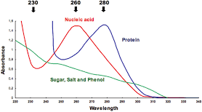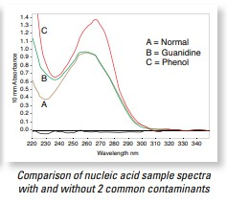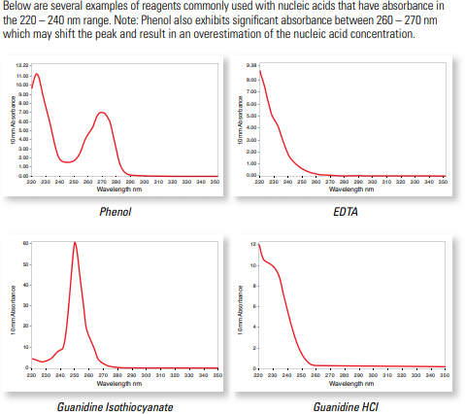

Small RNA
Small RNA – A ladder is included with each run. Below is an image of the Small RNA ladder. A lower marker is included to align the ladder with sample data.
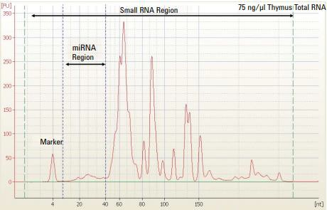
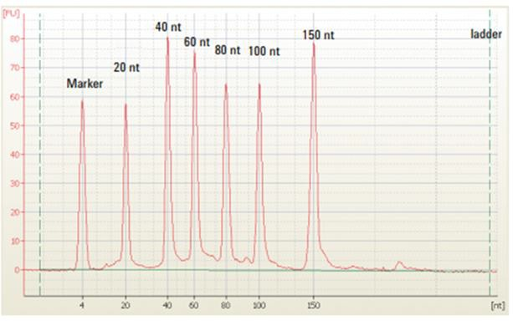
Example Sample Trace - A lower marker is included to align the sample with the ladder data. The Small RNA Region extends from 0 to 150 nt while the micro RNA (miRNA) Region is from 10-40 nt.

Small RNA Ladder


Contact Us

Genomics Research Center
Wilmot Cancer Center
601 Elmwood Ave., Box 704
Rochester, NY 14642
Phone: (585) 275-7250
Website
Email: URGenomics@urmc.Rochester.edu

