
Interpretation of Tapestation Traces

Genomics Research Center

Introduction to Tapestation Assays

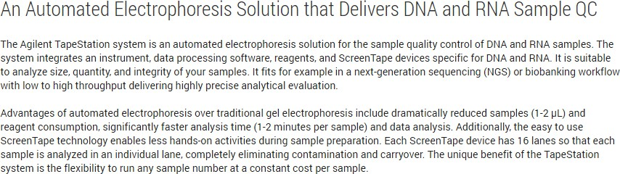
Agilent Tapestation Instrumentation

Available Tapestation Assays

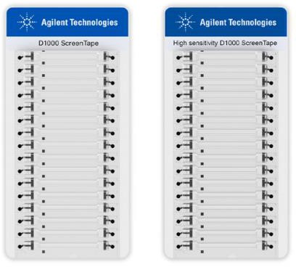
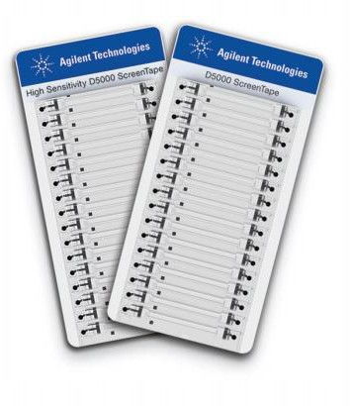
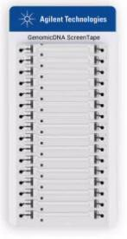

 | D1000 | High Sensitivity D1000 | D5000 | High Sensitivity D5000 | Genomic DNA
Volume | 1 uL | 2 uL | 1 uL | 2 uL | 1 uL
Size Range | 35 - 1,000 bp | 35 - 1,000 bp | 100 - 5,000 bp | 100 - 5,000 bp | 200 to >60,000 bp
Concentration | 0.1 - 50 ng | 0.01 - 1 ng | 0.1 - 50 ng | 0.01 - 1 ng | 10 - 100 ng

The GRC will determine the most appropriate Tapestation assay for your sample type based on:
Expected Size (D1000 vs D5000)

DNA – D1000 + HS D1000

 | D1000 | High Sensitivity D1000
Volume | 1 uL | 2 uL
Size Range | 35 - 1,000 bp | 35 - 1,000 bp
Concentration | 5 - 50 ng | 0.01 - 1 ng

Ladder – A ladder is included with each run. The ladder contains two internal standards (Lower and Upper Markers) to align the ladder data with samples to determine sizing. The concentration of the upper marker is known and used to help determine sample concentration*.

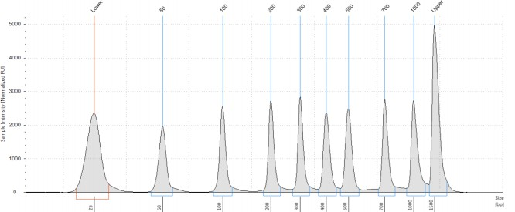
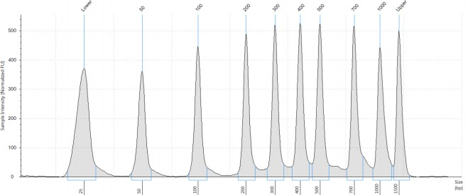
D1000 Ladder HSD1000 Ladder
*The GRC does not use Tapestation to determine concentration. Tapestation is used for quality assessment and

DNA – D1000 + HS D1000

Example Sample Trace – Lower and upper markers are included with each sample and are used to align the sample with the ladder. A region (Region 1) has been set and is indicated by the vertical blue lines on either side of the library trace. This is manually applied to each sample based on the library profile. This calculates the size of the library within this region and is used for normalization prior to sequencing.

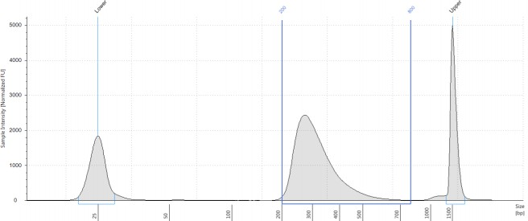
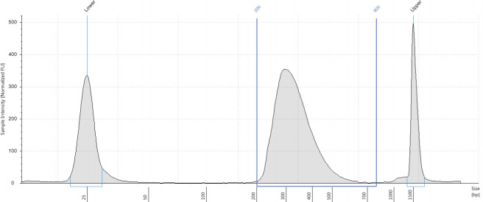
Region 1
Region 1

D1000 Sample Trace HSD1000 Sample Trace

DNA – D5000 + HS D5000

 | D5000 | High Sensitivity D5000
Volume | 1 uL | 2 uL
Size Range | 100 - 5,000 bp | 100 - 5,000 bp
Concentration | 5 - 50 ng | 0.01 - 1 ng
Ladder – A ladder is included with each run. The ladder contains two internal standards (Lower and Upper Markers) to align the ladder data with samples to determine sizing. The concentration of the upper marker is known and used to help determine sample concentration*.

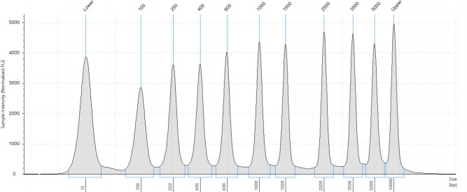
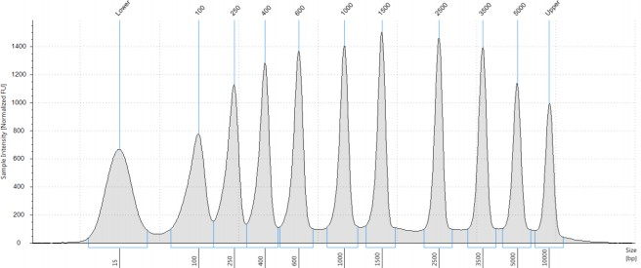
D5000 Ladder HSD5000 Ladder

*The GRC does not use Tapestation to determine concentration. Tapestation is used for quality assessment and

DNA – D5000 + HS D5000

Example Sample Trace – Lower and upper markers are included with each sample and are used to align the sample with the ladder. A region (Region 1) has been set and is indicated by the vertical blue lines on either side of the library trace. This is manually applied to each sample based on the library profile. This calculates the size of the library within this region and is used for normalization prior to sequencing.
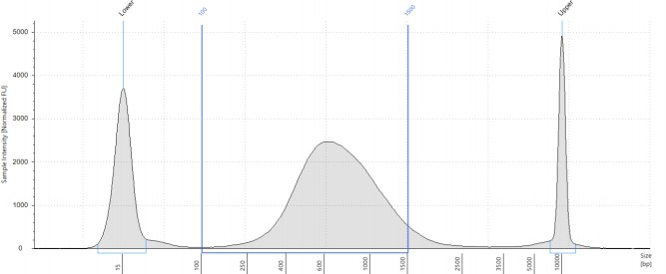
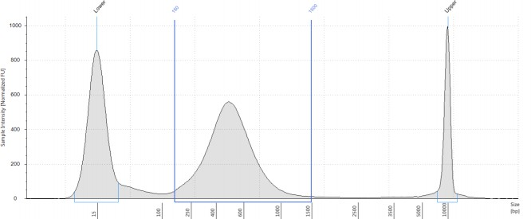
Region 1*
Region 1

D5000 Sample Trace HSD5000 Sample Trace

*Region 1 is often placed up to 1500 bp even if the library trace extends beyond this limit. In our experience, library fragments larger than 1500 bp do not cluster well and are not considered when determining library size for sequencing normalization.

Unexpected Library Peaks
If peaks are present outside the expected library range, it could be due to primer dimers or adapter dimers. Further purification should be performed to remove these peaks prior to next generation sequencing.

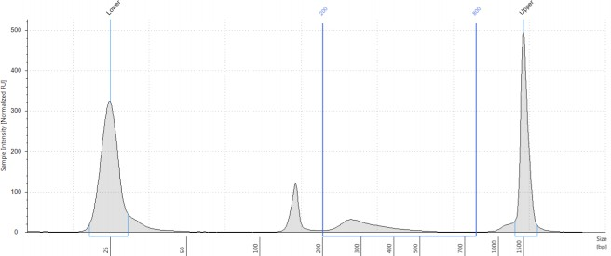
Adapter
Dimer

High Sensitivity Genomic DNA

Ladder – A ladder is included with each run. The ladder contains a lower marker (LM) to align the ladder data with samples to determine sizing, concentration, and DIN (DNA Integrity Number)

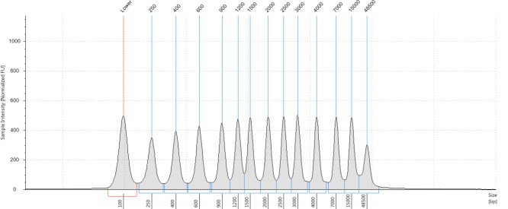

Example Sample Trace – Below is an example of a genomic DNA sample. A Lower Marker (LM) is included with each sample to align to the ladder data.
DIN: DNA Integrity Number: Used to assess genomic DNA degradation.
DIN is on a scale of 1-10 with 1 indicating severe degradation.

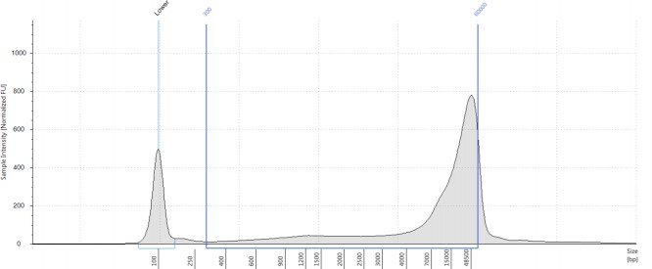
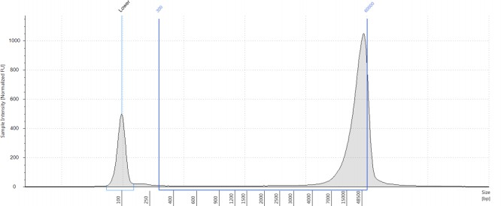
DIN: 7.4 DIN: 9.2

*Tapestation software does not allow a region beyond 60,000 bp. The Tapestation is not used for quantification


Contact Us

Genomics Research Center
Wilmot Cancer Center
601 Elmwood Ave., Box 704
Rochester, NY 14642
Phone: (585) 275-7250
Website
Email: URGenomics@urmc.Rochester.edu

