N E W Y O R K R N A S Y M P O S I U M I N

T H E F I N G E R L A K E S
OCT 14-15, 2024

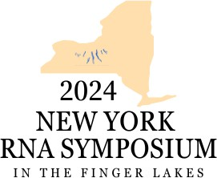

Contact: FingerLakesRNA@urmc.rochester.edu

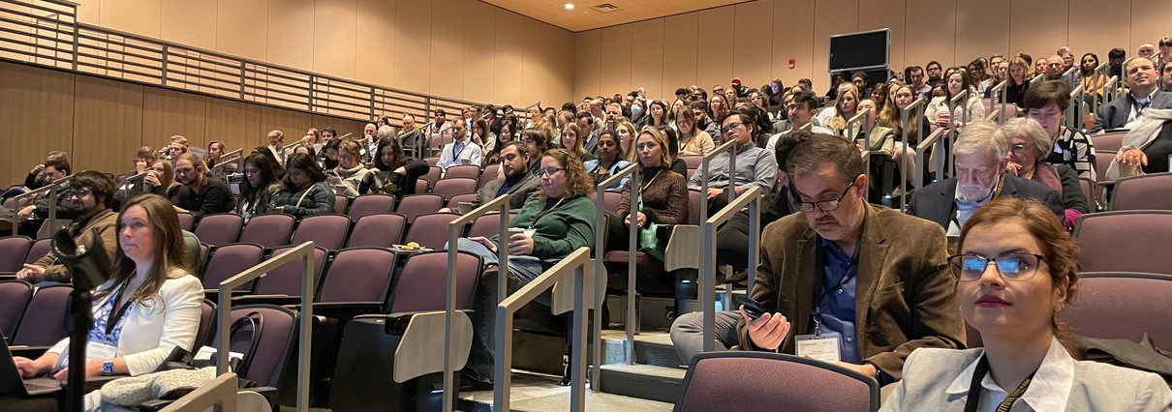
KEYNOTE SPEAKERS
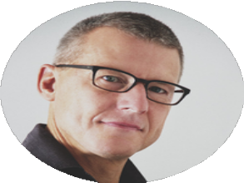
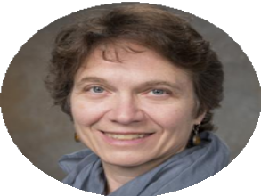
Eckhard Jankowsky VP RNA Science Moderna

Karla Neugebauer
Director, Yale Center for RNA Science & Medicine
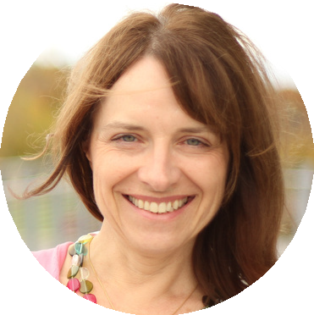
Yale School of Medicine

Sally Temple
Co-Founder & Scientific Director
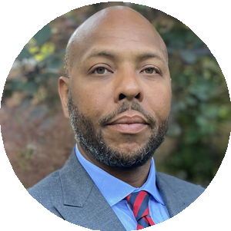
Neural Stem Cell Institute

Blanton Tolbert
VP Science Leadership and Culture at HHMI
University of Pennsylvania

FACULTY SPEAKERS

Mitchell R. O’Connell
Assistant Professor, Department of Biochemistry and Biophysics
University of Rochester Medical Center

Kathleen A. McDonough
Director, Division of Infectious Disease
Department of Health, Wadsworth Center
Professor, School of Public Health, Department of Biomedical Sciences
The RNA Institute at the University at Albany

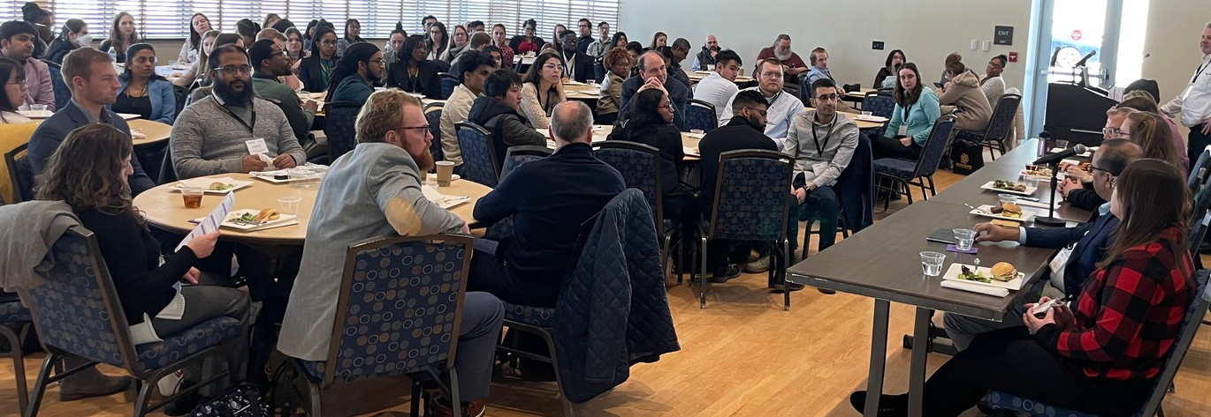
HIGHLIGHTS OF THE SYMPOSIUM

Keynote Seminars
01
02
03
Four leading experts in the field of RNA research will share their groundbreaking research

Selected Talks
15-minute talks will be selected from submitted abstracts

Lightning Talks
Selected abstracts will be given a short-form talk for one minute during this session

04
05
06

Poster Session
A wide range of RNA research topics will be on display from the participants, providing opportunities for interaction and collaboration

Networking Lunch
A time to foster networking and engaging with a diverse group of participants

Award Ceremony
The best talks and posters will be recognized during this session at the end of day 2

2024
NEW YORK
RNA SYMPOSIUM
I N T H E F I N G E R L A K E S

2024 NY RNA SYMPOSIUM IN THE FINGER LAKES
When: Oct 14 & 15, 2024
Where: Hotel Canandaigua, 205 Lakeshore Dr., Canandaigua, NY 14424

This year’s symposium is trainee-focused, with a networking lunch, a trainee gathering the day before the formal meeting starts (to be held on Oct 13th), poster and talk awards, and opportunities for trainees to interact with senior scientists and industry partners.
Keynote Seminars Eckhard Jankowsky, PhD (Moderna)
Karla Neugebauer, PhD (Yale School of Medicine)
Sally Temple, PhD (Neural Stem Cell Institute)
Blanton Tolbert, PhD (UPenn; HHMI)
Faculty Talks Mitch O’Connell, PhD (URMC)
Kathleen McDonough, PhD (UAlbany)
Selected Talks Poster Session Lightning Talks Networking Sessions Award Ceremony

Registration Now Open
Registration Link: tinyurl.com/2bm92vhs

Trainees (students/postdocs) Faculty/ PI (Academia) Industry Professionals
$100 / $150 after 9/13

$400 / $600 after 9/13

$1,000 / $1,500 after 9/13

Abstract Deadline: Friday, September 13th
Attendees who plan to submit an abstract for a poster and/or talk, must register and submit their abstracts by Friday, September 13th. The hotel blocks reserved for this event will also be released after this date.

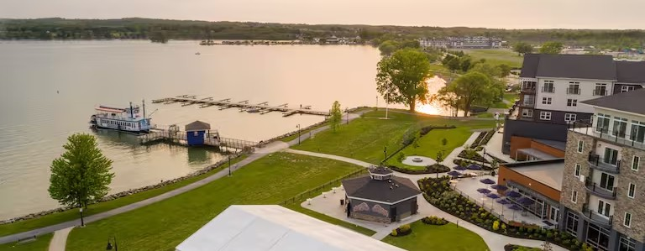


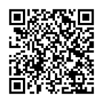
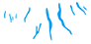
Hosted by
University of Rochester, Center for RNA Biology The RNA Institute, University at Albany
Website: tinyurl.com/2domsdso
Email: FingerLakesRNA@urmc.rochester.edu Social: #2024FingerLakesRNA

SPONSORSHIP PACKAGE
The New York RNA Symposium in the Finger Lakes brings together participants from all stages of research to present their recent findings and development in their RNA-related research.

Sponsorship package levels are given below. Reach out to FingerLakesRNA@urmc.rochester.edu for a customizable package appropriate to the sponsor organization.





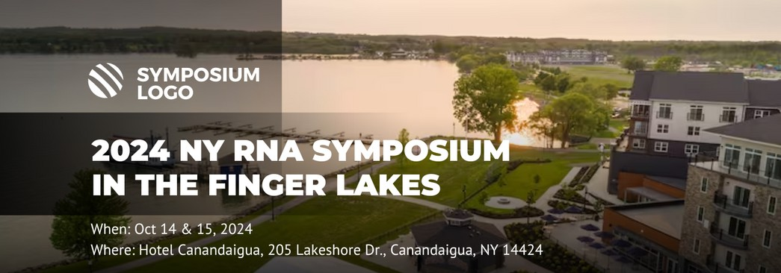
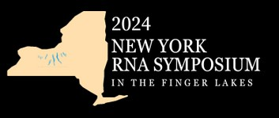
$10K

$5K

$2K

$$

rRNA Package
Abstract or advertisement inclusion in the symposium program 3-minute talk or video presentation during the session
4 Free registrations
Slide displayed in-between sessions Expo table at the symposium
Logo in symposium program

mRNA Package
Abstract or advertisement inclusion in the symposium program Display product slide or advertisement during the symposium 2 Free registrations
Expo table at the symposium Logo in symposium program

tRNA Package
1 Free registration
Expo table at the symposium Logo in symposium program

miRNA Package
Customizable package
Promotional materials displayed on expo tables

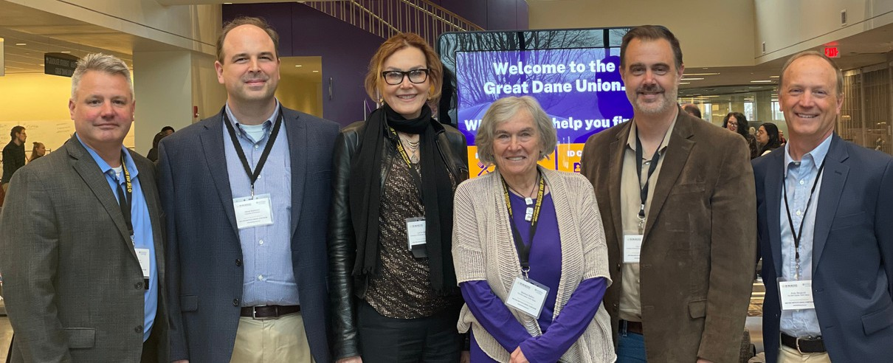

2024 Symposium Organizers
Lynne E. Maquat, PhD

Andy Berglund, PhD

Director, Center for RNA Biology, University of Rochester
David H. Mathews, MD, PhD
Associate Director, Center for RNA Biology, University of Rochester
Eric J. Wagner, PhD
Associate Director, Center for RNA Biology, University of Rochester
Elizabeth (Liz) Raymonda
Administrator, Center for RNA Biology, University of Rochester
Dragony Fu, PhD
Member, Center for RNA Biology, University of Rochester
Elizabeth (Beth) J. Grayhack, PhD
Member, Center for RNA Biology, University of Rochester
Eric M. Phizicky, PhD
Member, Center for RNA Biology, University of Rochester
Director, The RNA Institute, UAlbany
Thomas Begley, PhD
Associate Director, The RNA Institute, UAlbany
Marlene Belfort, PhD
Senior Advisor, The RNA Institute, UAlbany
Sangeetha Selvam, PhD
Science Communications Specialist, The RNA Institute, UAlbany
The NY RNA Symposium in the Finger Lakes aims to bring together esteemed RNA researchers and emerging scholars in a dynamic gathering to showcase cutting-edge RNA research and innovation.

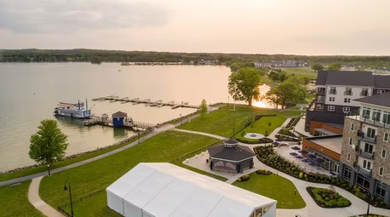
Symposium Venue

2024 NY RNA Symposium in the Finger Lakes
Hotel Canandaigua, a Tapestry by Hilton 205 Lakeshore Dr., Canandaigua, NY 14424
October 14-15, 2024

Hosted by
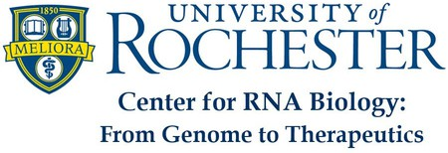

FingerLakesRNA@urmc.rochester.edu

