When composing a new message in from: https://mail.urmc.rochester.edu
If you click on the little plus sign on the right of page you can easily search for Users and add them to your email.

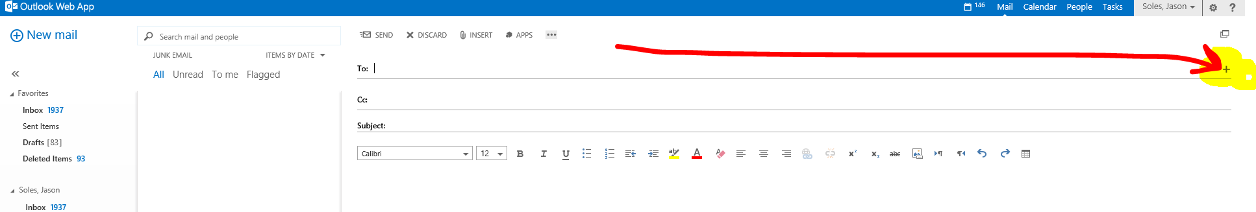

Once you find the person you are lookng for… just hit the plus sign next to their name and click OK.
Make sure you grab the NEW URMC.ROCHESTER.EDU ADDRESS
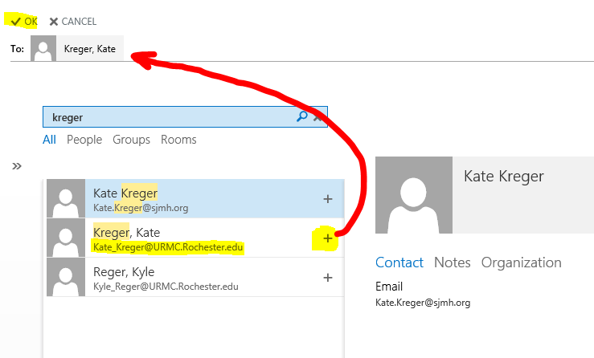

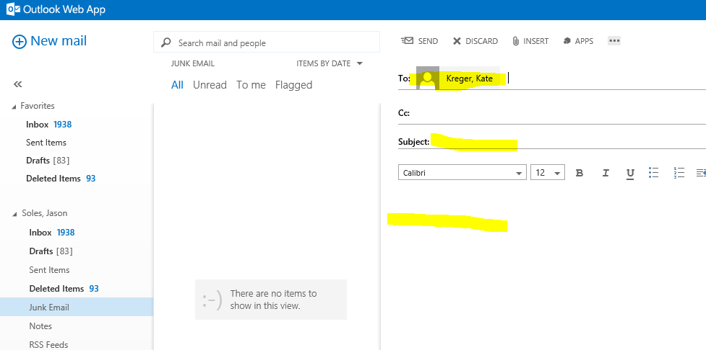

Adding/Searching for Recipients in OUTLOOK DESKTOP
Make sure your from email is correct; only if you have multiple setup
Click to, Search by lastname or Firstname
Make sure you are selecting the right user, and click their name

