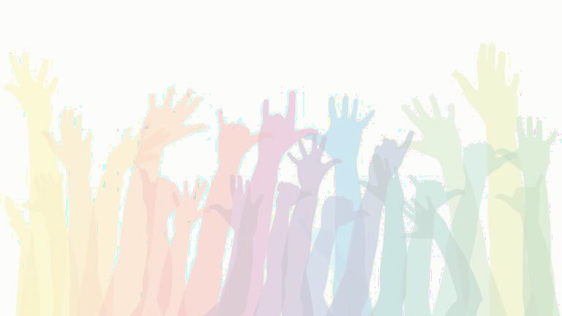
Supporting & Affirming Gender Identity and Sexuality Development

Presented by Leona Oakes, PhD Skirboll Family Autism Conference 11/5/2021

Outline

- A framework for discussion: The Genderbread Person
- The importance of terms
- Brief review of current research
- How we support health identity development
- Local resources

COI Disclosure
- I have no conflicts of interest (COI) to disclose

Allyship Disclosure
- I am learning, too, and am very open to feedback

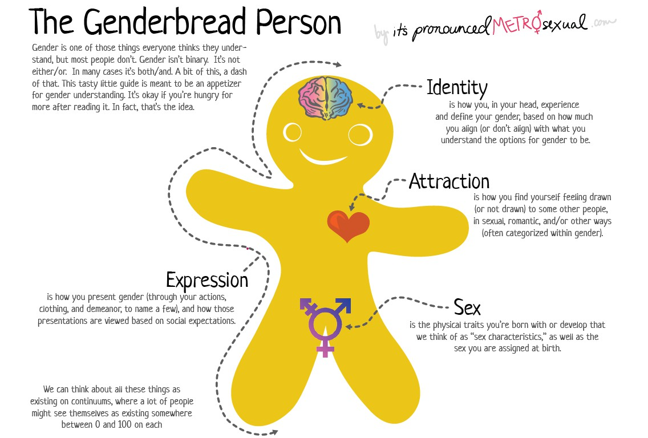

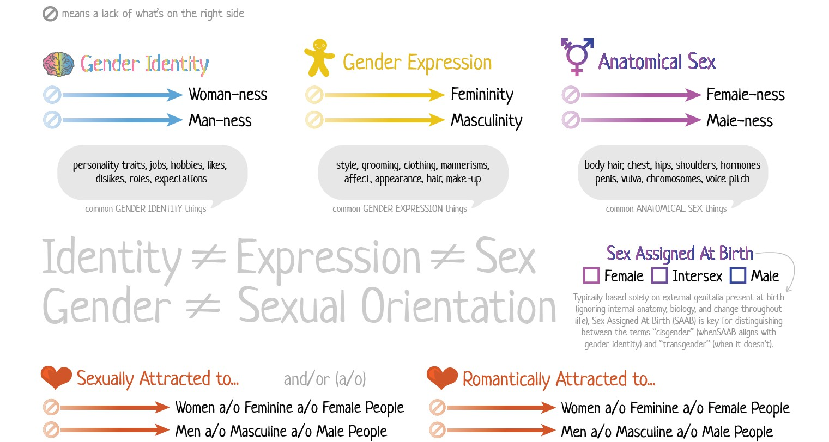

Terms to know/ use/ share

Cis(gender): Describes people whose gender identify  corresponds to their sex assigned at birth | Gender diverse/ trans*: umbrella term for folks with different gender identities | Nonbinary:  used by people who do not identify with the binary of male/female
AFAB:  Assigned female at birth  AMAB:  Assigned male at birth | Transgender: umbrella term for anyone whose sex assigned at birth and gender identity do not correspond in the expected way | Gender fluid:  An identity best described as a dynamic mix of male and female; may always identify as a mix, or may vary day by day

Terms to know/ use/ share

Heterosexual/ straight: Experiencing attraction solely to some members of a different gender | Gay:  experiencing attraction solely to some members of the same gender | Bisexual:  A person who experiences attraction to people of their own and gender and another gender
Asexual:  Experiencing little or not sexual attraction to others and/ or a lack of interest in sexual relationships | Lesbian:  Women who are primarily attracted to other women | LGBTQ+:  an umbrella term to describe individuals who don’t identify as straight and/or cisgender

Current research findings
- Recent surveys have estimated 6-23% of gender diverse people are autistic
- In a 2018 study
  - 6.5% of autistic adolescents identified as trans
  - 11.4% of autistic adults identified as trans
    - Compared to 3-5% of the general population
  - Higher scores on measures of autism traits were associated with a higher likelihood of gender diversity

Current research findings cont…

2018 study
  - 30% of autistic people identified as heterosexual
    - Compared to 70% of neurotypical peers

2017 study
  - 4.7% of men and 14.9% of women on the spectrum reported sexual attraction to neither men nor women
    - compared to 1.1% and 1.6% of neurotypical peers

2021 survey
  - Autistic adults less likely to report sexual activity & heterosexuality
  - Autistic adults more likely to report asexuality or “other” sexuality
  - Autistic males more likely to report being bisexual than TD peers
  - Autistic females more likely to report being lesbian than TD peers

Why is gender and sexuality diversity so common in ASD folks?
We really DO NOT know – we don’t know why it exists in neurotypical folks either
- Autistic people feel less pressure and influence from social norms so they may present their internal selves more authentically
- Autistic folks are more likely to conclude a more open sexuality based on one encounter or experience
- Prenatal testosterone exposure? Findings are mixed! “Makes sense” for trans autistic adults AFAB, but not for those AMAB

How we support healthy identity development
- Start talking about gender and sexuality diversity when people are young
  - Embrace inclusive language
  - Use and teach common terms

- Important to fight disability shadowing. Having a developmental disability DOES NOT mean lacking sexuality

Specific supports around gender identity
- Professionals that work in gender clinics and with LGBTQ+ communities should get familiar with autism
  - This ensures EQUITY of access → many trans folks on the spectrum reported delays in gender-affirming treatments
- Professionals that work with autistic adolescents and adults must get comfortable talking about gender identity and sexuality
- Autistic folks in the process of transitioning will need more frank conversation about social cues and gender expression depending on how feminine or masculine they want their presentation to fall and what (if) they want people to assume their gender

Unique challenges of intersectionality
- Still developing our understanding of what autism looks like in women and girls → need to expand that to understanding how it presents in gender diverse individuals
  - Many associated features and behaviors may be in common due to shared experiences, but these must be separated from actual diagnostic traits
- Sensory experiences and sensitivities have a significant impact on the sexual and relationship experiences of autistic adults
  - Communication is KEY

Acceptance and affirmation saves lives
- Denial of any aspect of their intersectional identity puts adolescents and young adults at significant risk of mental health issues
  - Many have difficulty fitting into LGBTQ+ spaces because of members’ stereotyped understanding of autism
  - Many individuals on the spectrum were not believed by family members and professionals because they assumed they were confused and lacked insight, or because the issue was brought up “all of a sudden”
- Special care must be taken to reduce feelings of isolation – help them find their people!

Resources for learning more about gender identity and sexuality/ sex education
- https://www.itspronouncedmetrosexual.com/ creator of the genderbread person: https://www.genderbread.org/, Defining LGBTQ+ and so much more!
- https://www.scarleteen.com/ “Sex ed for the real world”
- Sex Ed for Self-Advocates: https://researchautism.org/sex-ed-guide/
- https://Queerability.tumblr.com “And LGBTQ and disability rights advocacy organization”
- https://wrongplanet.net/ A web community designed for neurodiverse individuals and the people who support them
- Provider toolkit: https://autisticadvocacy.org/wp-content/uploads/2015/12/realtalk-toolkit-v2.pdf

Resources continued:
Local LGBTQ+ supports
- https://outalliance.org/
- Trillium health support groups https://www.trilliumhealth.org/patient-and-community-services/support-groups
- Rochester LGBTQ+ together https://www.facebook.com/RocLGBTQTogether/
- Golisano Children’s Hospital – Gender Health Services https://www.urmc.rochester.edu/childrens-hospital/adolescent/gender-health-services.aspx
- Art Connect at Spotted Rabbit Studio (providers have lots of disability experience though group is LGBTQ+ focused) https://spottedrabbitstudio.com/art-connect/

Research cited:
- George, R., & Stokes, M. A. (2018). Gender identity and sexual orientation in autism spectrum disorder. Autism, 22(8), 970–982. https://doi.org/10.1177/1362361317714587
- Glidden, D., Bouman, W. P., Jones, B. A., & Arcelus, J. (2016). Gender Dysphoria and Autism Spectrum Disorder: A Systematic Review of the Literature. Sexual Medicine Reviews, 4(1), 3–
14. https://doi.org/10.1016/j.sxmr.2015.10.003
- Gray, S., Kirby, A. V., & Graham Holmes, L. (2021). Autistic Narratives of Sensory Features, Sexuality, and Relationships. Autism in Adulthood, 3(3), 238–246. https://doi.org/10.1089/aut.2020.0049
- Hillier, A., Gallop, N., Mendes, E., Tellez, D., Buckingham, A., Nizami, A., & OToole, D. (2019). LGBTQ + and autism spectrum disorder: Experiences and challenges. International Journal of Transgenderism, 21(1), 98–110. https://doi.org/10.1080/15532739.2019.1594484
- Warrier, V., Greenberg, D. M., Weir, E., Buckingham, C., Smith, P., Lai, M. C., … Baron-Cohen, S. (2020). Elevated rates of autism, other neurodevelopmental and psychiatric diagnoses, and autistic traits in transgender and gender-diverse individuals. Nature Communications, 11(1), 1–12. https://doi.org/10.1038/s41467-020-17794-1
- Weir, E., Allison, C., & Baron-Cohen, S. (2021). The sexual health, orientation, and activity of autistic adolescents and adults. Autism Research, (December 2020), 1–13. https://doi.org/10.1002/aur.2604

Let’s discuss!

