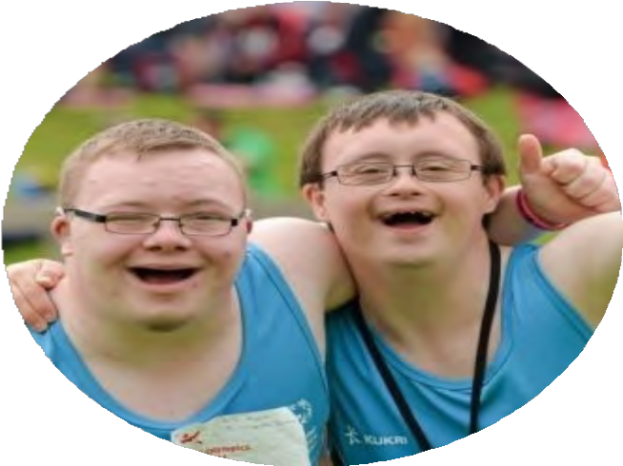
TEAM TRAINER
TOOLKIT
A partnership between the University of Rochester and Special Olympics New York

WELCOME

Inside this toolkit you will find valuable resources that will assist you in improving health outcomes for people with Intellectual and Developmental Disabilities. This toolkit will serve as a template for AADMD student chapters to initiate and implement a successful Team Trainer Program with their state and local Special Olympic teams.

TABLE OF CONTENTS
Welcome

Program Description


Program Accomplishments What We Learned Toolkit Goals Communication Tips Documentation Tips from Trainers

PROGRAM DESCRIPTION
Collaboration
Proposed collaboration built on the Healthy Athletes program which provides free health screenings to SO athletes

Partnership Partnership: University of Rochester AADMD Student
Chapter/UCEDD &
Special Olympics NY
Screenings
Promotes Health Prevention Screenings
TEAM TRAINER PROGRAM



Health Improvement
Enhance athlete’s performance and improve the overall health of athletes
T E A M T R A I N E R T O O L K I T 0 2

THE DATA
TRAINERS RECRUITED

ACTIVITIES
- Promoted health service utilization
- Infused health into SO training and competition
- Trainer attended 3
practices and 1 competition, and provided wellness activities to 1 team.
4. 2 students presented posters at AADMD Annual meetings in Houston, Seattle

IN SUMMARY
Student AADMD
Chapters partner with the state and local Special Olympic teams to improve
health outcomes for athletes on the team.
13
TEAM
TRAINERS

75%
OF TEAM TRAINERS

65%
OF ATHLETES

65%
OF COACHES
Trainers reported growth in appreciation of IDD health challenges, understanding of challenges of health promotion for people with IDD and methods for improving wellness, and comfort with communicating with individuals with IDD around health and health promotion.

SHOWED GREATER UNDERSTANDING
of the health needs of people with IDD based on pre/post test data from Team Trainers.

TRAINER AS AN ASSET
Athletes indicated the Trainer as an asset to them and 72% of athletes reported positively regarding the model.

COACHES' FEEDBACK
Coaches indicated greater awareness of athletes’ health needs. They also reported the Trainer as asset; 3 of 5 coaches responded positively

T E A M T R A I N E R T O O L K I T 0 3


WHAT WE LEARNED
The Special Olympics wants to replicate the Team Trainer
Program, but they lack the people power & student groups to do so.

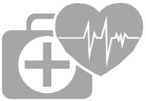
As members of AADMD we have the people power to maintain this project and improve health outcomes for individuals impacted by IDD.

Our program's success comes from dedicated students who wanted to effect change personally and professionally.


Over the course of the program we achieved and surpassed our goals with minimal problems.

T E A M T R A I N E R T O O L K I T 0 4



TOOLKIT GOALS
The key to building a successful Team Trainer Program is to have the right tools!!! Inside this toolkit, you will find valuable resources that helped us build a successful Team Trainer Program with Special Olympic New York. The goal of this toolkit is to package what we learned from the Team Trainer Project and make it available to American Academy Developmental Medicine & Dentistry student chapters.


Through this toolkit we hope to:
- Increase interaction between AADMD student chapters and Special Olympic networks at the local and state level.
- Provide AADMD student chapters with the resources necessary to implement and initiate sustainable partnerships with their local and state Special Olympic Networks.
- Disseminate information at AADMD annual conference.
- Provide a template for replication.

The Team Trainer Toolkit will guide AADMD student chapters on how to initiate and implement a sustainable partnership with their state and local Special Olympic teams.

T E A M T R A I N E R T O O L K I T 0 5

HOW DO YOU DO IT?
C O M M U N I C A T I O N 

Communication was key to our success and it will be to yours too! Knowing who to talk to, what to talk to them about and how to put it all together equals success.

TIPS FOR COMMUNICATION
Who should you talk to?
- Your AADMD Student Chapter
- Local and State Special Olympic Officers
- Coaches
- Athletes
- Us! (Tips from Trainers, pg. 10)


T E A M T R A I N E R T O O L K I T 0 6

HOW DO YOU DO IT?

STUDENT CHAPTER

SAMPLE SCRIPT

Presenting this idea to your local AADMD student chapter is your first point of contact. Some students may have heard of the Team Trainer Program but others may have not.

Hi, at today's meeting we're going to talk about the Team Trainer Program. The Team Trainer Program was built to support the Healthy Athletes (HA) program of the Special Olympics. The HA program provides free health screening to athletes to encourage health promotion at Special Olympic events. As many of you may know, individuals with developmental disabilities often cannot access healthcare, or fail to get proper health screenings from their providers. The Team Trainer project connects AADMD students with Special Olympic teams to promote overall health by establishing healthy goals that may enhance athlete’s performance.

Connect with your local Special Olympics network!
CLICK HERE!
SPECIAL OLYMPICS

SAMPLE SCRIPT

Find your state! Then give them a call!
Hello,
My name is , I'm from the AADMD Student Chapter at the University of
. We would like to speak with someone about starting a Team Trainer program with the Special Olympic teams in this area.

T E A M T R A I N E R T O O L K I T 0 7

COACHES
A major component that contributes to the success of this program is to get the team coach on board! It is very important that you let the team coach know that you are here to be a resource to the team, to improve not only the athletic ability of the team, but the overall health of the athletes on the team.

TIPS
Let the coach know:
You are here to add medical expertise to the team.
You are not here to cause interruption, but to add value to the athletic experience.
It is our plan to create goals that are healthy for the entire team. And, to assist you in getting your athletes to healthy athlete screenings at Special Olympic events.

ATHLETES
The goal of the Team Trainer Program is to improve health outcomes for athletes with IDD. Your job as the team trainer is to set achievable goals with your team that encourage healthy behaviors such as:
Increasing steps Increasing water-intake Increasing fruits & veggies
Examples of motivators to achieve goals:
Water bottles Weight goals
Visual aids for athletes to choose from to assist in achieving their goals
Pedometers/Fitbits Healthy Snacks
Weighing athletes in a private setting if they prefer
Actually training with the athletes, let them know you’re in this with them

T E A M T R A I N E R T O O L K I T 0 8

HOW DO YOU DO IT?
D O C U M E N T A T I O N

Documents needed for the Team Trainer program are:
- Pre/Post Surveys for Coaches and Athletes
- Proof of athletic screenings
- Completed tracking forms reporting goals met/unmet
- Attendance/Participation in healthy athletes screenings
- Contact Information Sheets
- Communication Sheets for provider follow-up
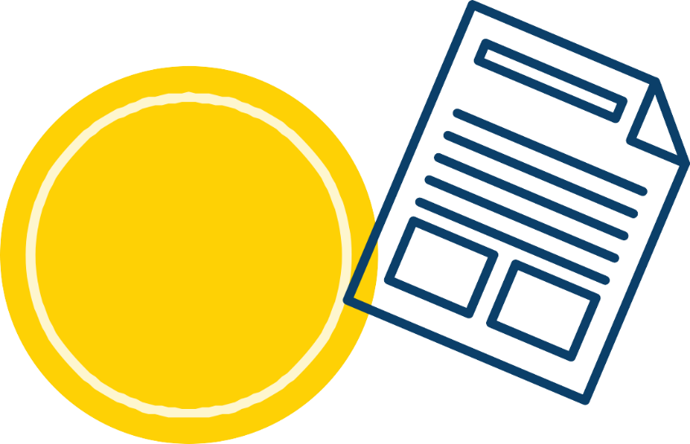
For
sample documents
CLICK HERE

T E A M T R A I N E R T O O L K I T 0 9

TIPSFROM
TRAINERS

WEIGHING ATHLETES
- Consider a digital scale / a scale that would weigh more than 250 lbs.
- Bringing a wooden board to line under the scale would be nice if you are outdoors.
- Weighing athletes in private

GETTING TO KNOW THE TRAINER
- Team trainers should provide an introduction form with a photo that can be sent to the coaches prior to the team trainers’ visit so that the athletes can become familiarized with the idea of a stranger coming to visit and explaining what the agenda for the visit is (dental/nutrition, etc.).
- Ask the coach to send a list of names with photos of the athletes that they all probably have on record with a small brief intro to each one then if would help the team trainers as well. This can be a very brief form.


TEAM GOALS
- Keep in mind these are team goals not individual goals.
- We can have individual goals that contribute to the success of the team goals.
T E A M T R A I N E R T O O L K I T 1 0


1TH
�THANKS
HADE POSSIBLE BY

The WITH Foundation, The American Academy of Developmental Medicine and Dentistry (AADMD), Special Olympics New York, & the Strong Center tor Developmental Disabilities (SCDD).

