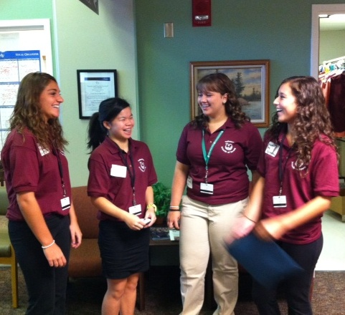 ****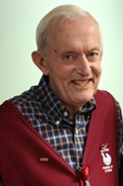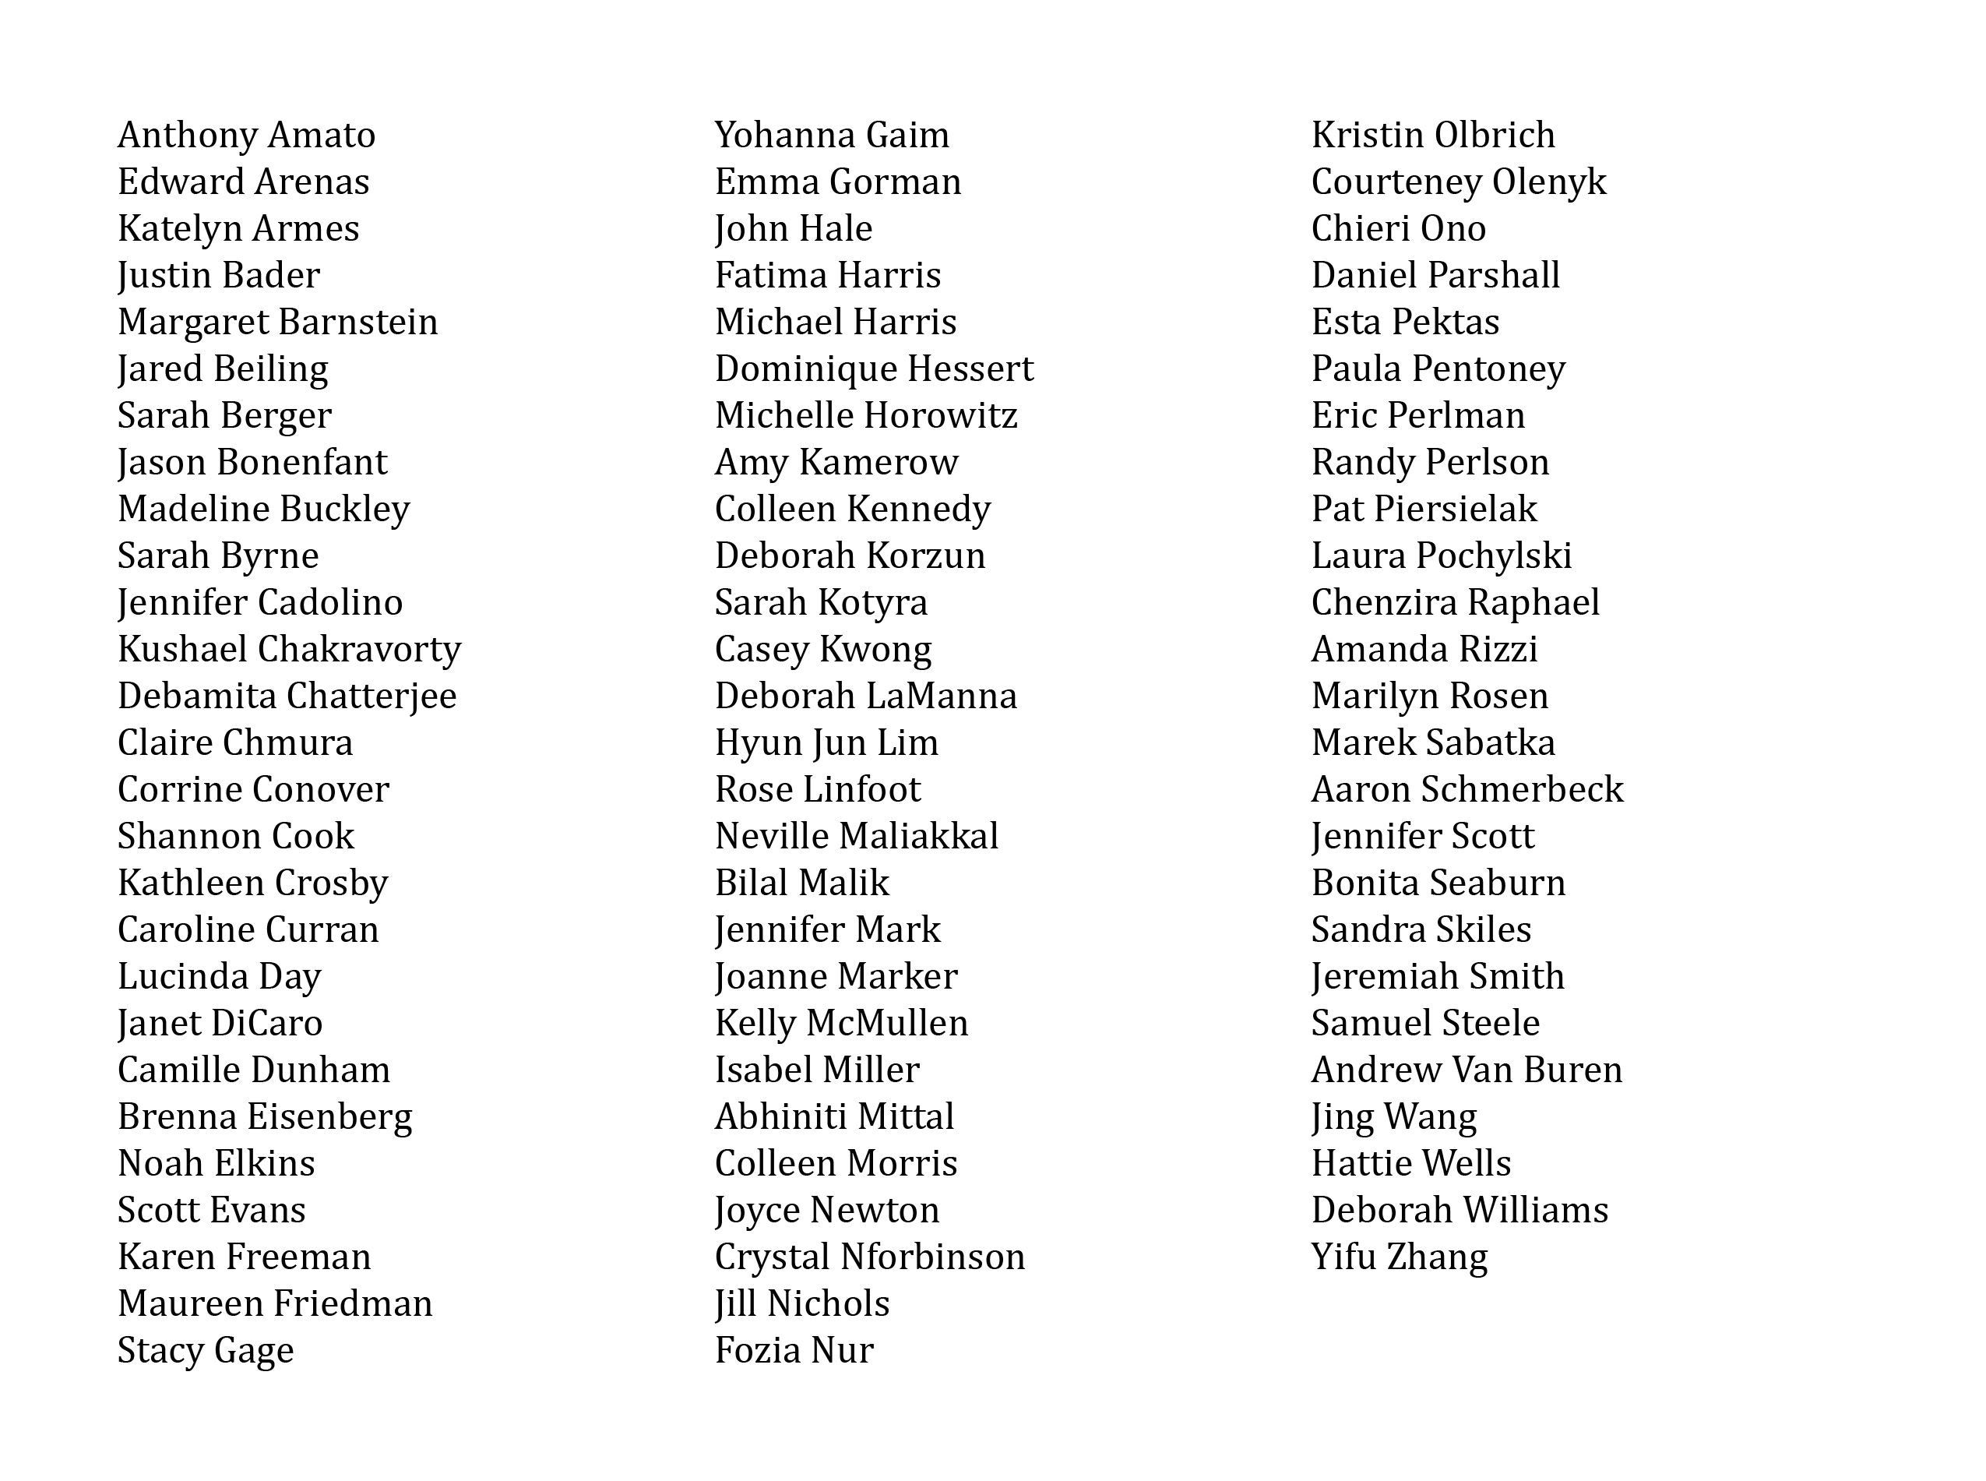 DonateLife Logo RGB

*Every day.*

*Every year.*

*Every gift you make to Friends of Strong helps support patient- and family-centered care initiatives here at Strong. Since 1975, Friends of Strong has given more than $15 million to departments and programs throughout UR Medicine’s Strong Memorial Hospital.*

**Friends of Strong Celebrates National Volunteer Week!**

Hello Friends of Strong Volunteers!

National Volunteer Week is April 7th-13th and we would like to take this opportunity to thank each of you for your commitment and dedication to UR Medicine and Strong Memorial Hospital.

          Last year there were over 1,300 of you …. and you donated over 135,000 hours of your time!  Those are incredible statistics, but even more important is the fact that you chose to give your precious time to the patients and families we serve here at Strong Memorial Hospital, or at one of our many offsite clinic locations. As the UR medicine practices continue to grow, you’re right there with us helping to create volunteer programs in new places, and carrying on the legacy of highly coveted long term positions.

          We value you, our volunteers every day, but we especially want to recognize you during National Volunteer Week.

          With gratitude for all that you do,

          Sandy Arbasak, Director

**2019 High School Summer Program**

This year’s High School Summer Program will be 8 weeks beginning on Monday July 8th and ending on Sunday, September 1st. Students volunteering for this program will be expected to volunteer for a 3 – 4 hour shift once a week.  Students must be at least 14 years old by July 1, 2019 in order to participate.

          There will be a variety of volunteer activities offered and the activities are chosen on a first come, first served basis.  We will begin taking phone calls at (585) 275-2420 from interested students on Tuesday, April 30th beginning at 8:30 am until all of the slots are filled.  The program fills up very quickly, often on the first day of scheduling, so please be sure to continue to call even if the line is busy on that day.

          Thank you for your support of the Friends of Strong High School Summer Program. We look forward to another successful year of skilled and enthusiastic junior volunteers!

*Continued on page 2*

**April**

**2019**

A newsletter for volunteers of Strong Memorial Hospital

Editor

Susan A. Sullivan

friendsofstrong@  
urmc.rochester.edu

585-275-2420

**Bud Wesley Honored**

**Going Strong: Bud Wesley Recognized for Decades of Service to Patients and Families**

Long-time Friends of Strong volunteer Bud Wesley recognized with a 2019 Health Care Volunteer Achievement Award. Only a few weeks shy of an early retirement, Bud Wesley found himself in an ICU waiting room with no one to talk to. His mother was a patient and he found comradery with the families of other patients who were on the same floor—many of which shared the sentiment that they wished there were hospital staff that could be there to help them navigate their circumstances and pass the time.

It was then that Bud decided to fulfil those very wishes. Not having any firm plans of what to do with his newly earned time, he soon became a Friends of Strong Memorial Hospital volunteer, offering just the services he and those other families had wished were available while they were sitting in the waiting room.

Today, at 76 years young, Bud discharges patients in the mornings, after which he brings a coffee cart up to the Intensive Care units to provide comfort to families who find themselves in difficult circumstances.

Just about every Wednesday and Thursday for the past 24 years, he’s been traveling from his home in Bristol to provide an open ear to patients and families who just need someone to talk with, as well as passing out fresh hot coffee, tea, snacks and other comfort items.

“It’s a real blessing to be able to make things a little easier for families who are especially under stress or facing hard things,” he says. “I guess I maybe have that grandfatherly thing. Sometimes it’s just to listen, sometimes it’s a shoulder to cry on, and sometimes it’s to break up family feuds!”

Bud understands the patient perspective and provides a level of reassurance that’s unique from that of clinical staff. “Bud’s service provides a personal touch in what can be a very busy environment for patients and their families,” says Sandy Arbasak, director of Friends of Strong. “His positive, humble demeanor makes him a favorite of patients and staff alike.”

His dedication to comforting patients and their families is unmatched. Bud is quite possibly Strong’s most devoted unsung hero—volunteering more than 15,000 hours at Strong since 1995. And he’s also served as a firefighter and volunteers with his hometown fire department!

Throughout the years, Bud continues to be a fixture within our Adult Intensive Care Units,” says Mike Apostolakos, M.D., chief medical officer and vice president of the University of Rochester Medical Center. “I’ve witnessed his caring and comforting support to our patients and their families first-hand on countless occasions and, without a doubt, Bud’s regular visits with coffee and treats to the families of our most critically ill patients is invaluable.”

**Gala Wine Tasting**

Thanks to Century Liquor and Wines and generous financial and in-kind donations from local businesses, the 28th Annual Gala Wine Tasting held on February 8th at Monroe Golf Club was a wonderful event enjoyed by over 150 guests.

Along with over 100 wines and champagnes to taste, guests enjoyed delicious hors d’oeuvres and desserts. Bids were placed on a variety of silent auction items and many tickets sold in our sweepstakes. Also several large theme packages were auctioned live. All proceeds raised benefit patient care at Strong.

Save the date for next year! The 29th Annual Gala Wine Tasting will take place on Friday, February 7, 2020 at Monroe Golf Club.

**Run/Walk to Benefit Transplant**

Join us for our 18th annual Rochester River Run/Walk 5K—run, walk, or build a team and collect pledges to help patients who are awaiting or recovering from organ transplant surgery.

The River Run takes place along a scenic, park-lined portion of the Genesee River and is certified by USA Track & Field (#NY15140KL).

**Sunday, April 7, 10:00 a.m.**  
Genesee Valley Park (Round House)  
99 Elmwood Ave.  
*Register at* [*riverrun.urmc.edu*](https://runsignup.com/Race/NY/Rochester/RochesterRiverRunWalk5K)

Money raised goes directly toward the Transplant Patient Fund, which provides transplant patients (heart, liver, kidney, and pancreas) with financial assistance before and after surgery, to help cover medication costs, lodging, and other patient care expenses.

**Whose Friends Are They Anyway: An Improv Comedy Night**

Join Friends of Strong on Friday, May 3 at 8 p.m. at Comedy at the Carlson for an evening of comedy with local improv troupe “Nuts and Bolts,” along with special guest emcee, Nikki Rudd, cohost of News10NBC Today, as we raise the roof and raise funds to help support patient- and family-centered care at Strong Memorial Hospital. Tickets are $20, to purchase go to [bit.ly/FOSCOMEDY](https://tickets.vendini.com/ticket-software.html?e=8cbe0e4f8357ba5acfa6bd15b93329df&t=tix&vqitq=345879a8-48dd-4ce3-a01a-eb1fda4d2512&vqitp=3f599d39-9a96-4651-b9d1-a2947a98a329&vqitts=1552591773&vqitc=vendini&vqite=itl&vqitrt=Safetynet&vqith=f717f5db315daa07599be7a1b78b8b71)

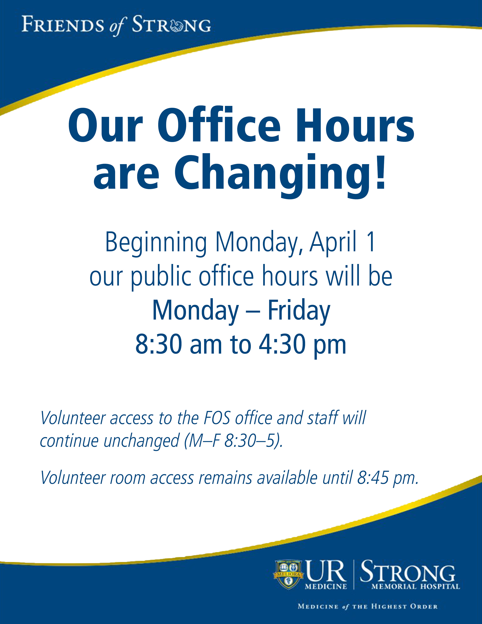

**Please note: Friends of Strong’s office has a new front door.**

**The door is closed but unlocked during public office hours.**



**Donations**

***Friends of Strong***

Debra Mattle

***In Memory of Ersilia LePore***

David and Joan Moore

***In Memory of Robert Sanderson***

Linda Grocki-Bareham