Please follow exit signs in the Hospital Garage. If you exit at:
Jackson Drive turn RIGHT onto Jackson Drive, then turn RIGHT onto Elmwood,
then RIGHT onto East Drive, and then a final RIGHT into Patient Discharge.

East Drive turn RIGHT onto East Drive, then RIGHT into Patient Discharge.

South Drive turn RIGHT into Patient Discharge.

ELMWOOD AVE.

Emergency
JACKSON DR

Eastman Dental

GOLD
EAST DR.

Jackson Drive Exit
Hospital Parking Garage

East Drive Exit

South Drive Exit

RED

Patient Discharge

Patient Discharge
SILVER

Cancer Ctr. Elevators

GREEN
GCH
Elevators 1st floor access

Golisano Children’s Hospital Tower

Wilmot Cancer Center
EAST DR.


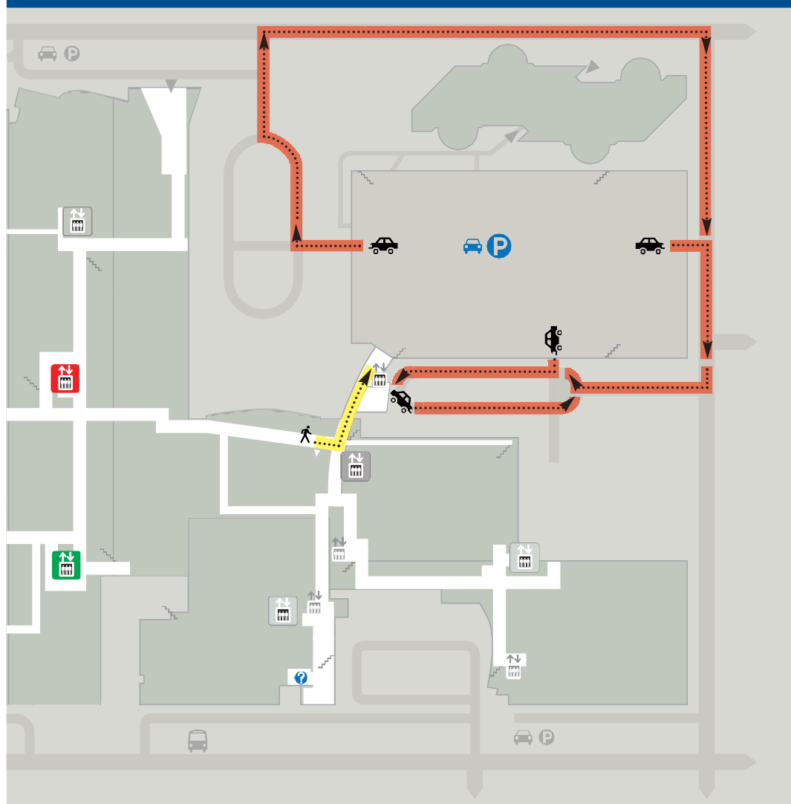

Patient Discharge Directions to patient pick-up

bus
CRITTENDEN BLVD.

