
Assisting Patients and families of Strong Memorial Hospital, Golisano Children’s Hospital and Highland Hospital

Hotel and Lodging Services Making your stay as comfortable as possible

Welcome
We would like your stay in Rochester to be as pleasant as possible. Please call the hotel directly and let them know you are a patient or family member of a patient at Strong Memorial Hospital, Golisano Children’s Hospital or Highland Hospital.
The hotels listed are in order of approximate distance to Strong Memorial Hospital or Highland Hospital. The approximate distance between Strong Memorial Hospital and Highland Hospital is 1.5 miles.
* Reservations for these hotels can be made directly though Strong Hotel & Lodging Services from Monday through Friday 8am- 4pm at (585) 275-7581. During any other time, please call the hotel directly.
If you have any questions, please contact URMC hotel and lodging services at (585) 275-7581.
Strong Memorial Hospital 601 Elmwood Avenue Rochester, NY 14642

Golisano Children’s Hospital
601 Elmwood Avenue Rochester, NY 14642

Highland Hospital
1000 South Avenue Rochester, NY 14620

Special Rate Lodging
University of Rochester Medicine has contracted with the following locations to offer you a significantly reduced rate. To arrange your stay, please contact the University of Rochester Medicine Hotel and Lodging Program at (585) 275-7581 so that we may assist you.

Budget Rate
*RIT Inn & Conference Center
5257 West Henrietta Rd. Henrietta NY 14467 (585) 359-1800
- Approximately 6-9 miles from either hospital (shuttle service available)

*Marriott Courtyard at Brighton
33 Corporate Woods Rochester NY 14623 (585) 292-1000
- Approximately 2-9 miles from either hospital (shuttle service available)

*Hampton Inn Rochester – Irondequoit
1323 E. Ridge Rd. Rochester NY 14621
(585) 339-3500
- Approximately 10 miles from either hospital

Holiday Inn Express- University Area
717 E. Henrietta Rd. Rochester NY 14623 (585) 272-7800
- Approximately 2-5 miles from either hospital

Spark by Hilton
797 E. Henrietta Rd. Rochester NY 14623 (585) 427-0131
- Approximately 2-5 miles from either hospital

Best Western Rochester Marketplace Inn
940 Jefferson Rd. Rochester NY 14623
(585) 427-0131
- Approximately 3-6 miles from either hospital

Clarion Pointe Rochester Monroe Ave.
2729 Monroe Ave. Rochester NY 14618
(585) 376-5502
- Approximately 4-7 miles from either hospital

*EverHome Suites Extended Stay
500 Bellwood Drive Rochester, NY 14606
(585) 649-1814
- Approximately 7-8 miles from either hospital

Extended Stay America – Greece
600 Center Pl Dr. Rochester NY 14615
(585) 663-5558
- Approximately 10-13 miles from either hospital
Moderate Rate
*Staybridge Suites
1000 Genesee St. Rochester NY 14611
(585) 527-9110
- Approximately 1-4 miles from either hospital

Hampton Inn & Suites Rochester – Henrietta
280 Clay Rd. Rochester NY 14623
(585) 475-1510
- Approximately 4-7 miles from either hospital

Doubletree by Hilton Rochester
1111 Jefferson Rd. Rochester NY 14623
(585) 475-8500
- Approximately 4-7 miles from either hospital

Comfort Suites
2085 Hylan Dr. Rochester NY 14623
(585) 487-8500
- Approximately 6-9 miles from either hospital

Homewood Suites
2095 Hylan Dr. Rochester NY 14623
(585) 334-9150
- Approximately 6-9 miles from either hospital

Home 2 Suites by Hilton - Greece
400 Bellwood Dr. Rochester NY 14606
(585) 432-9150
- Approximately 8-11 miles from either hospital

Holiday Inn Express NE - Irondequoit
2200 N. Goodman St. Rochester NY 14609
(585) 342-0430
- Approximately 10-13 miles from either hospital

Hilton Garden Inn – Pittsford
800 Pittsford Victor Rd. Pittsford NY 14534
(585) 248-9000
- Approximately 11-14 miles from either hospital

Wood Spring Suites – Greece
145 Bellwood Dr. Rochester NY 14606
(585) 437-6003
- Approximately 8-11 miles from either hospital

Premium Rate

Hilton Garden Inn – College Town
30 Celebration Dr. Rochester NY 14620
(585) 424-4404
- Approximately 1-4 miles from either hospital

Hyatt Regency Rochester
125 E Main St. Rochester NY 14604
(585) 564-1234
- Approximately 3-6 miles from either hospital

Residence Inn - Henrietta
1300 Jefferson Rd. Rochester NY 14615
(585) 272-8850
- Approximately 5-8 miles from either hospital

Rochester Airport Marriott
1890 West Ridge Rd. Rochester NY 14615
(585) 225-6880
- Approximately 8-11 miles from either hospital

The Renaissance Del Monte Lodge
41 N Main St. Pittsford NY 14534
(585) 381-9900
- Approximately 9-12 miles from either hospital

Woodcliff Hotel & Spa
199 Woodcliff Dr. Fairport NY 14450
(800) 365-3065
- Approximately 13-16 miles from either hospital

Special Accommodations Offered
To stay at one of the locations listed below:
Social Work referral is needed
Please contact your social worker to help make these arrangements.
B. Thomas Golisano Hope Lodge Hospitality House
1120 South Goodman St., Rochester, NY 14620
(585) 224-4951, 224-4952
www.cancer.org/hopelodge
- For Cancer patients and their families
- Approximately 1-3 miles from either hospital

Ronald McDonald
*House Within the Hospital*
601 Elmwood Avenue, Rochester, NY
(585) 276-5437
www.ronaldshouse.com
- For pediatric intensive care unit patients and their families

Harbor House
89 Rossiter Road, Rochester, NY 14620
(585) 473-1779
www.harborhouseofrochester.org
- Long-term housing for patients and their families
- Less than 1 mile from either hospital

Ronald McDonald House
333 Westmoreland Drive, Rochester, NY 14620
(585) 442-KIDS
www.ronaldshouse.com
- For pediatric patients and their families
- Less than 1 mile from either hospital
Locations
Highland Hospital
1000 South Avenue
Rochester, NY 14620
(585)473-2200

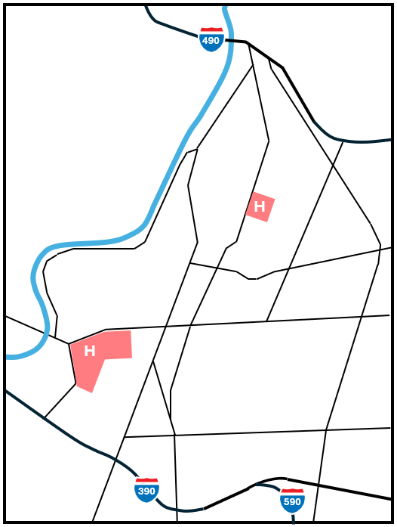

S Goodman St
South Ave

Elmwood Ave
S Clinton Rd
West Henrietta Rd

Westfall Rd

Golisano Children’s Hospital
601 Elmwood Avenue
Rochester, NY 14642
(585) 275-2821

Strong Memorial Hospital
601 Elmwood Avenue
Rochester, NY 14642
(585) 275-2100

