The DAISY Award

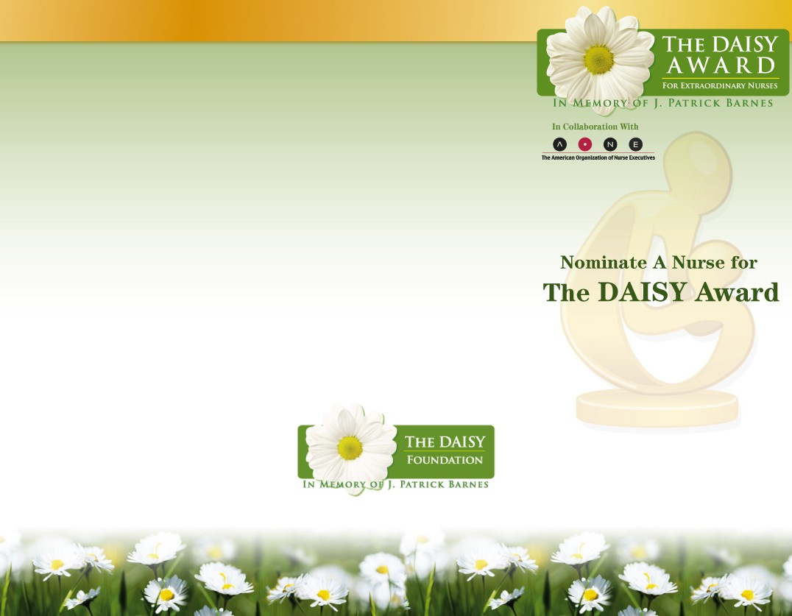
About The DAISY Foundation
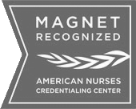
The DAISY Foundation was established in 2000 by the family of J. Patrick Barnes who died of complications of the auto-immune disease Idiopathic Thrombocytopenia Purpura (ITP) at the age of 33. (DAISY is an acronym for diseases attacking the immune system.) During Pat’s 8 week hospitalization, his family was awestruck by the care and compassion his nurses provided not only to Pat but to everyone in his family. So one of the goals they set in creating a Foundation in Pat’s memory was to recognize extraordinary nurses everywhere who make an enormous difference in the lives of so many people by the super-human work they do everyday.

What is The DAISY Award?
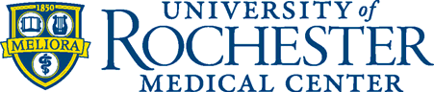
The DAISY Award is a nationwide program that rewards and celebrates the extraordinary clinical skill and compassionate care given by nurses everyday. Strong Memorial Hospital is proud to be a DAISY Award Hospital Partner, recognizing one of our nurses with this special honor every quarter.

To find out more about the program, including the growing list of Hospital Partners, please go to www.DAISYfoundation.org.

DAISY Award honorees personify Strong Memorial Hospital’s remarkable patient experience. These nurses consistently demonstrate excellence through their clinical expertise and extraordinary compassionate care, and they are recognized as outstanding role models in our nursing community.

The DAISY Award for Extraordinary Nurses NOMINATION FORM

Each DAISY Award Honoree will be recognized at a public ceremony in her/his unit and will receive: a beautiful certificate, a DAISY Award
I would like to nominate
from the
Please describe a situation involving the nurse you are nominating that clearly demonstrates he/she meets the criteria for The DAISY Award

pin, and a hand-carved stone sculpture entitled unit/department (Additional pages may be attached if necessary):


“A Healer’s Touch.” Additionally, everyone in the unit/area will celebrate with cinnamon rolls – a favorite of Patrick’s during his illness. The Barnes Family asks that whenever and wherever nurses smell that wonderful cinnamon aroma, they stop for a moment and think about how special they are.

How To Nominate An Extraordinary Nurse
Patients, visitors, nurses, physicians, employees may nominate a deserving nurse by filling out this form and submitting it to either:

Strong Memorial Hospital
Center for Nursing Professional Development Box 619-21
601 Elmwood Avenue
Rochester, NY 14642

Or email your nomination form to Nurse_Award@urmc.rochester.edu
Additional nomination forms may be found on the URMC Internet: http://www.urmc.rochester.edu/strong-nursing/daisy-award/
as a deserving recipient of The DAISY Award. This nurse’s clinical skill and especially her/his compassionate care exemplify the kind of nurse that our patients, their families, and our staff recognize as an outstanding role model. She/he consistently meets all of the following criteria:
- Consistently goes above and beyond
- Exemplifies what it means to be a Strong Nurse
- Is calm, communicative and comforting
- Compassionate and a team player
- Excellent clinical assessment skills
- A true patient advocate, dedicated mentor, an insightful educator and a sensitive caregiver
Thank you for taking the time to nominate an extraordinary nurse for this award. Please tell us about yourself, so that we may include you in the celebration of this award should the nurse you nominated is chosen.
Your Name Unit Phone
Email Pager I am (please check one): RN Patient Family/Visitor MD Staff Volunteer
Date of nomination

Manager Acknowledgement
I acknowledge that this nurse is in good standing. Signed:
Title:
Please submit this nomination to Box 619-21. If you have any questions, please contact the Center for Nursing Professional Development at
273-4220.

