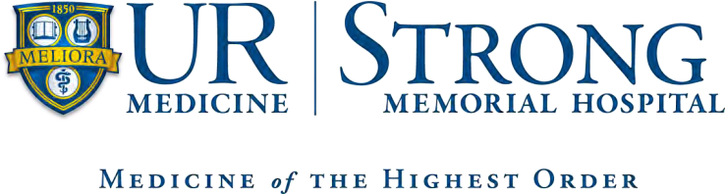
Critical Care Medicine Advanced Practice Provider Fellowship Program Application 2026-2027

Instructions:
- Complete application below
- Statement of Intent- one paragraph statement of your interest in the program
- Include CV, official transcripts, BLS, ACLS, copies of certifications, and licensure
- Three letters of recommendation (one from your program director) sent directly to address provided
- Mail To: University of Rochester
601 Elmwood Ave
Box 619-318
Rochester, NY 14642
- Email PDF copy of application to: vincent_derienzo@URMC.rochester.edu and kari_schenck@URMC.rochester.edu

The APP Fellow MUST meet the following qualifications:
- Nurse Practitioner
  - Master’s degree in nursing (AGACNP)
  - Active New York State licensure as Registered Nurse and Nurse Practitioner in good standing
  - Current national certification as a Nurse Practitioner (upon start of program)
- Physician Assistant
  - Completion of an ARC-PA approved Physician Assistant program
  - Active New York State Physician Assistant licensure in good standing
  - Current national certification as a Registered Physician Assistant (upon start of program)
Applicants for the Critical Care APP Fellow position should demonstrate clinical competence as well as excellent verbal and written communication skills. The APP Fellow should have a passion for Critical Care Medicine and an active desire to learn.

Application Process:
- Complete the on-line job application for Critical Care Medicine – Nurse Practitioner/Physician Assistant Fellow position (Job ID # R267649) located on the Human Resources/Office of Nursing Recruitment website:
https://rochester.wd5.myworkdayjobs.com/UR_Nursing

  - Helpful Hints:
External Candidate – Apply for a position
https://rochester.wd5.myworkdayjobs.com/UR_Nursing

    - In the Browse Jobs page, enter the Job Title you want to search for.
    - Select the Job Position you are interested in applying for.
    - Select the Apply button in the top menu bar.
    - Fill in the fields for Experience, Education, Certifications, and Languages as they apply to your position.
    - Attach and upload your Resume/Cover Letter.
    - Click the Submit Button to submit the application.
    - Click on the My Applications link to see your application ¹ .

Internal Candidate – How to apply for a position online

Quick Reference Card (QRC) available for internal candidates on how to apply for a position in Workday. Here are the steps outlined in the QRC:

- From the Workday Home Page, select the Menu. https://www.rochester.edu/adminfinance/urfinancials/workday-login/
- Select Jobs Hub.
- Optionally, expand the navigation pane by selecting the arrow and vertical bar icon.
- In the Jobs Hub navigation pane, select Browse Jobs.
- Optionally, search for jobs by title or apply filters such as Primary Location, Hiring Manager, Job Family, Job Profile, and Time Type.
- Select the flashcard or View Job to see job information.
- To apply, select Apply.
- Optionally, if you would like recruiters to reach out to you about your application, select Save for Later.

For each section in the internal application, enter information as desired. You can add or remove information as needed.

- Please send the following vincent_derienzo@URMC.rochester.edu and kari_schenck@URMC.rochester.edu
  - Current Resume or Curriculum Vitae
  - Official academic transcript to date
  - Submit 3 professional references:
    - Request a confidential recommendation from a Nurse Practitioner/Physician Assistant/ Physician clinical preceptor during your academic program.
    - Request a confidential recommendation from a faculty member from your academic program.
  - Letter of Interest:
    - Provide a letter of interest which reflects your interest in the Critical Care APP Fellowship program, your passion for Critical Care Medicine, and how this opportunity will impact your future as an Critical Care Medicine APP. Please also comment on why you think this program will be a good fit for you.
Applications for consideration for the 2026-2027 Fellowship program are due by March 1st, 2026.
Candidates will be contacted in mid-March to arrange for an interview. Return complete application to:
  - Vincent DeRienzo, PA-C and Kari Schenck, PA-C
- Mail to:
Strong Memorial Hospital 601 Elmwood Avenue
Box 619-26
Rochester, NY 14642

Please e-mail Vincent DeRienzo and Kari Schenck at vincent_derienzo@URMC.rochester.edu and kari_schenck@URMC.rochester.edu, with any questions or concerns about this application and the application process.

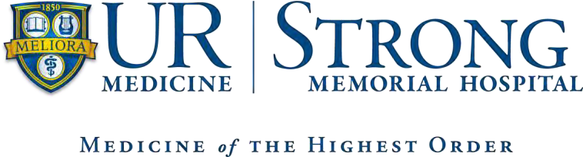
Critical Care Medicine Advanced Practice Provider Fellowship Program
Reference Form

Nurse Practitioner/Physician Assistant Program: Date:
(name of applicant) has applied for a position in the Critical Care Medicine APP Fellowship Program at Strong Memorial Hospital in Rochester, NY.
We would appreciate your evaluation of this applicant’s general ability and professional proficiency in academic and clinical practice. We would like to know what you consider the applicant’s strengths and weaknesses to be. You can be assured that all information will be treated confidentially.
Please be advised that all recommendations are to be completed confidentially and recommender should be provided an envelope to enclose their recommendation which must have a signature across the seal of the envelope and can be submitted with the application.

I hereby authorize the release of my academic/clinical record to Strong Memorial Hospital Critical Care Medicine.
Applicant Signature: Applicant Printed Name:
****************************************************************************************** The above APP was a student in your academic/clinical setting during what period of time?

In comparison with the other students in the class, how would your rank this student academically?
Upper 10% ( ) Upper 25% ( ) Middle ( ) Lower 25% ( ) Lower 10% ( ) N/A ( )
In comparison with the other students you have worked with clinically, how would you rank this student clinically?
Upper 10% ( ) Upper 25% ( ) Middle ( ) Lower 25% ( ) Lower 10% ( ) N/A ( )

Please Rate the Applicant on the Following:

 | Above Average | Average | Below Average
Critical Thinking Skills
Organizational Skills
Leadership Potential
Flexibility/Adapts to Change
Professional Attitude
Clinical Competence
Appropriately selects and interprets diagnostic testing findings
Medical Decision Making Process
Demonstrates therapeutic
communication with patients & families
Demonstrates professional
communication with other professionals
Works in a collaborative fashion with health care team
Appropriate documentation
Procedural skills
Appearance/Grooming
Attendance/Punctuality
Overall Recommendation

Please include a statement about the applicant’s strengths/weaknesses and whether you feel this applicant will be a good fit for our Critical Care APP Fellowship program. Please feel free to provide any additional comments.
Recommender Signature: Recommender Title: Date:
Contact Information:

