Policy for Animal Carcass Storage
UCAR approved February 18, 2026

Animal carcasses must be stored according to one of three procedures:

- Animal carcasses dosed with hazardous substances (biohazards, chemicals and radioisotopes) must be handled, stored and disposed of following practices determined by Environmental Health & Safety (EH&S).

- Nonhazardous animal carcasses must be placed in tagged vivarium bags and taken to the morgue coolers located in the KMRB, SMD, Annex and Meliora.

- Nonhazardous animal carcasses must be bagged, tagged and placed in a secondary leak proof, “Animal Carcass”-labeled container (e.g., Tupperware™ tub) IF stored in a laboratory freezer. The freezer may also be used for reagents and other experimental compounds but not diet. If the laboratory freezer is dedicated to nonhazardous animal carcass storage, the door must be labeled “Animal Carcasses” and only a tagged* leak proof bag is required to contain the carcasses.

Research labs requesting necropsies should submit a Necropsy Request Form and place the bagged, tagged carcass in the bin or shelf labeled "Save for DCM" inside the KMRB carcass refrigerator or SMD Necropsy cooler in the corridor between the incinerator and necropsy rooms. DO NOT freeze carcasses intended for necropsy. All primates must be submitted for necropsy by completing a necropsy request form using the web link above.

All nonhazardous animal carcasses must be bagged, tagged and promptly transported to a Vivarium morgue cooler/freezer for subsequent incineration. Final disposition of animal carcasses dosed with hazardous substances must be in compliance with EH&S policy.

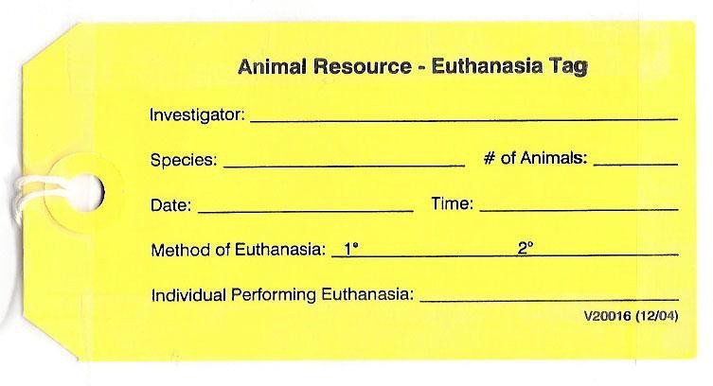
Morgue tags for animals found dead are provided in animal rooms. Euthanasia tags are provided at CO2
euthanasia stations and the Animal Resource Office. Fill out tags completely.

