Nonhuman Primate Food and Water Restriction Policy
Revised 2/18/26

This policy applies to any nonhuman primate that has restricted access to food or water for study-related reasons. Restricted access refers to limiting either the amount of food or water provided or the amount of time the animal has access to food or water.1 Animals may not be both food and water restricted simultaneously.

UCAR accepts the need to regulate access to food or water to motivate primates to participate in behavioral tasks. Alternative methods such as reinforcement with highly preferred rewards should be used whenever possible to eliminate or minimize the need for restriction.1-3 In order to use food or water regulation, investigators must:
- document consideration of alternatives and
- provide a written scientific justification of the need for food or water restriction in the Protocol.

If no acceptable alternatives exist, UCAR requires that:
- the least restrictive schedule that will achieve the scientific objective be used,
- each NHP receives food and water daily at or above the minimum level as outlined below, and
- the health of each NHP undergoing food or water restriction is monitored and documented as outlined below.

INTERVENTION CRITERIA
Normal Appearance
and
BCS of 2.5 or more (Adult) BCS of 2.0 or more (Subadult) and
Stable, consistent weight (Adult) Normal growth (Subadult)
NO INTERVENTION
Abnormal Appearance
or
Abnormal Behavior
or
BCS of 2.5 or less (Adult) BCS of 2.0 or less (Subadult) or
10% weight loss or more from baseline (Adult) Failure to maintain or gain weight (Subadult)
Consult with a DCM veterinarian

- Veterinary evaluation
- Increased monitoring/weighing
- Potential temporary increase in water/food amounts
- Potential temporary removal from water/food scheduling

DETERMINATION OF BODY CONDITION SCORE and BASELINE BODY WEIGHT

Baseline body weight is established during ad libitum food and water access, prior to starting food or water restriction, when the animal is at a healthy body condition score (BCS)4-5 of 2.5-3

(see BCS chart below). Ad libitum access to food and water means that food and water are freely available to the animal without condition at all times. The baseline body weight is used to calculate minimum daily requirements at the start of food or water restriction and to determine monitoring and reporting cutoffs in the event the animal loses weight. DCM veterinary staff in conjunction with the researcher may establish a new baseline body weight at each semiannual health assessment or at any other point if the animal’s weight changes.

Adult NHPs (Macaques ≥8 years old, Marmosets ≥1.5 years old)
All adult NHPs at the University should be maintained at a lean to optimal BCS4 of 2.5-3 as monitored by research and veterinary staff. Minimum food or water requirements must be calculated using the baseline body weight described above.

Subadult NHPs (Macaques <8 years old, Marmosets <1.5 years old)
The monthly average body weight of a growing, immature NHP must increase as they age. Growth trends and minimum food or water requirements must be determined at the beginning of each month using the individual animal’s mean body weight from the
previous month. The mean body weight calculated for the current month may not be below the previous month. If the mean monthly weight has decreased, the higher mean body weight must be used to calculate minimum food and water amounts. Investigators working with young animals should specifically address in their Protocol their expectation for any retardation of growth rate and adult size. While UCAR accepts that some stunting may occur, young animals are still expected to grow and maintain a BCS4 above 2.0.

MINIMUM DAILY REQUIREMENTS

An NHP should only be restricted to the level that is required for acceptable participation in the laboratory. Behavioral tasks should be adjusted to ensure they are not too complex for the age or ability of the animal. Animals should be allowed to earn food or fluids to satiety during each work period and provided with opportunities to complete learned tasks with less restriction. Non- working day water or food provisioning should generally provide animals with 1.5-3 times more than the daily working minimum.1,3 When the animal will not participate in laboratory activities for a sustained period (a week or longer), the animal should be transitioned back to ad libitum food or water. Transitions between water restriction and ad libitum water is best accomplished over a several day period.¹

Water Restriction
UCAR requires that each NHP either earns or is supplemented to no less than 20ml/kg/day of the baseline body weight, as determined above. In general, NHPs maintain a stable hydration state at this level of restriction.6 Up to 20% of the minimum daily water requirements may be provided in the form of fruits and vegetables, allowing for the use of these items as positive reinforcers or enrichment. The Investigator must calculate the water content of any fruits or vegetables used to meet an animal’s daily minimum water requirement and record this value on the Water Restriction Log. Water equivalents can be found in Bowes and Church’s Food Value of Portions Commonly Used.7

Food Restriction
In general, the total caloric intake of a food-regulated animal is 50-70% of that associated with ad libitum feeding.3 Therefore, food-restricted animals must be given at least 50% of their ad lib intake daily. Average ad lib intake should be determined by quantifying and documenting the animal’s daily food consumption over at least 1 week of ad libitum food and

water. Alternative methods of calculating minimum daily requirements (e.g. kcal/kg/day) may be used if described in the approved protocol.

MONITORING AND DOCUMENTATION REQUIREMENTS

Animals undergoing food or water restriction must be monitored to ensure that they remain healthy. This is done by daily assessment of general condition, at least weekly assessment and documentation of body weight, and routine semiannual veterinary exams.

A UCAR-approved Food Restriction Log or Water Restriction Log must be maintained in the animal housing room for each animal on food or water restriction. Total amounts of food or water that the animal earned or was given in the cage must be recorded in the Food or Water Restriction Log daily. Food or water restricted NHPs should be weighed as often as possible, but no less than every 7 days, and this weight must be recorded in the Food or Water Restriction Log. The baseline weight as defined above must be recorded on each page. It is preferred by DCM and UCAR that each NHP has its own log sheet.

DCM will assess normal baseline parameters (e.g. weight, BCS, ad lib consumption, bloodwork, urinalysis) for each NHP on a food or water restriction protocol during a routine semiannual exam or other scheduled exam prior to initiation of food or water restriction. Routine semiannual veterinary exams include assessment of overall health, BCS and body weight trends. Blood parameters (serum osmolality, electrolytes, protein, BUN, creatinine and hematocrit) are measured at least annually for all NHPs on food or water restriction protocols. Based on exam findings, a DCM veterinarian may, in consultation with the Investigator, prescribe an adjustment to the minimum daily food or water requirement or baseline body weight.

REPORTING REQUIREMENTS

The following observations must be immediately reported to DCM:
- Adult NHP that has lost 10% or more of baseline body weight or has a BCS <2.5
- Subadult NHP that fails to maintain or gain weight or has a BCS <2.0
- Any animal displaying abnormal appearance or behavior.

DCM veterinarians will evaluate reported animals and may perform additional diagnostics (e.g. bloodwork, urinalysis) to determine the animal’s clinical health and appropriateness of the current level of food or water restriction. These assessments will also take into consideration normal growth trends and the animal’s laboratory performance. As a result of this evaluation, the veterinarian may require the NHP be transitioned to ad libitum food or water, prescribe some higher daily requirement for the animal, require increased monitoring or weighing frequency, or determine that the animal’s condition is acceptable.

TRANSITIONING TO AND FROM FOOD OR WATER RESTRICTION

A transition period of 2-3 days must be provided when an NHP is introduced to or removed from food or water restriction. The transition period minimizes stress by allowing gradual acclimation of the animal to the restricted schedule.8 To assess an individual animal’s

response to restriction, UCAR recommends a two-week transition period under veterinary oversight the first time an individual animal is introduced to food or water restriction.
Assessments during this period should include daily measurement of body weight and weekly screening tests (bloodwork, urinalysis). UCAR requires animals to be transitioned to ad lib food and water and be maintained ad libitum for at least one week before being changed from food restriction to water restriction, or vice versa.

Food- or water-restricted animals may initially consume large volumes of food or water when returned to an ad lib schedule. The transition period helps prevent such overconsumption, which may result in water intoxication and cerebral edema or gastric upset and bloat. The greater the level of restriction, the longer the transition period should be. DCM should be consulted immediately if an NHP displays any abnormal behavior, vomiting or diarrhea, incoordination, or collapse during the transition period.

PROVISIONING OF FOOD AND WATER BEFORE AND AFTER SURGERY OR GENERAL ANESTHESIA

UCAR requires that all NHPs undergoing a surgical procedure under general anesthesia be transitioned to ad lib water and food by the day prior to the procedure. Fasting prior to surgery should be limited to the least amount of time required (generally 6 to 16 hours). The animal must be maintained on ad lib food and water for at least one week following a major invasive surgery or as long as drugs requiring free access to food and water for appropriate metabolism (i.e. NSAIDs, certain antibiotics) are administered, whichever is longer.

UCAR recognizes that urgent situations may arise in which an animal must undergo general anesthesia before they can be transitioned to ad lib food or water. In these cases, DCM should be consulted and the procedures carried out with veterinary approval and/or supervision.

EXEMPTIONS

In general, all investigators must comply with this policy. Exemptions to the requirements of this policy may be approved only with appropriate scientific justification in the protocol, with the consultation and approval of DCM veterinarians, and must be approved by the committee. It is up to the veterinarians to determine whether individual animals are healthy enough for exemptions and what increased monitoring or other conditions will be required during the exemption.

Any exemption to the daily water provision for training/testing purposes (i.e., not medical), must be the least restrictive possible, and only for a finite period of time, and stated in the protocol. The period of increased restriction should be for the shortest possible time and no longer than 2 consecutive weeks with breaks on the weekends. Prior to beginning any retrictions greater than 20ml/kg/day, the PI must consult the DCM Veterinarians, and DCM animal behaviorist to determine if alternative motivational modalities can accomplish the desired motivational effect. If alternative reinforcement is determined to be not successful, and only then, can the lab proceed with incrementally reducing the daily water provision (e.g., 19ml-10ml/kg/day) to the point where the animal is motivated to perform the task. Under no circumstance will the lower limit be less than 10 ml/kg/day. If at any time the DCM veterinarians determine that the animal is not appropriately hydrated, and the health of the animal is compromised, the water provision must be returned to at least the 20ml/kg/day.

*UCAR voted that a veterinarian may provide an exemption to weekly weighing of water/food scheduled macaques under specific conditions which may include: novel training equipment within the cage, housing in primate play places and when the macaque is provided with more than the minimum amount of food and/or water as described by this policy. This provision will be done on a case by case basis and with the oversight of the veterinarians.

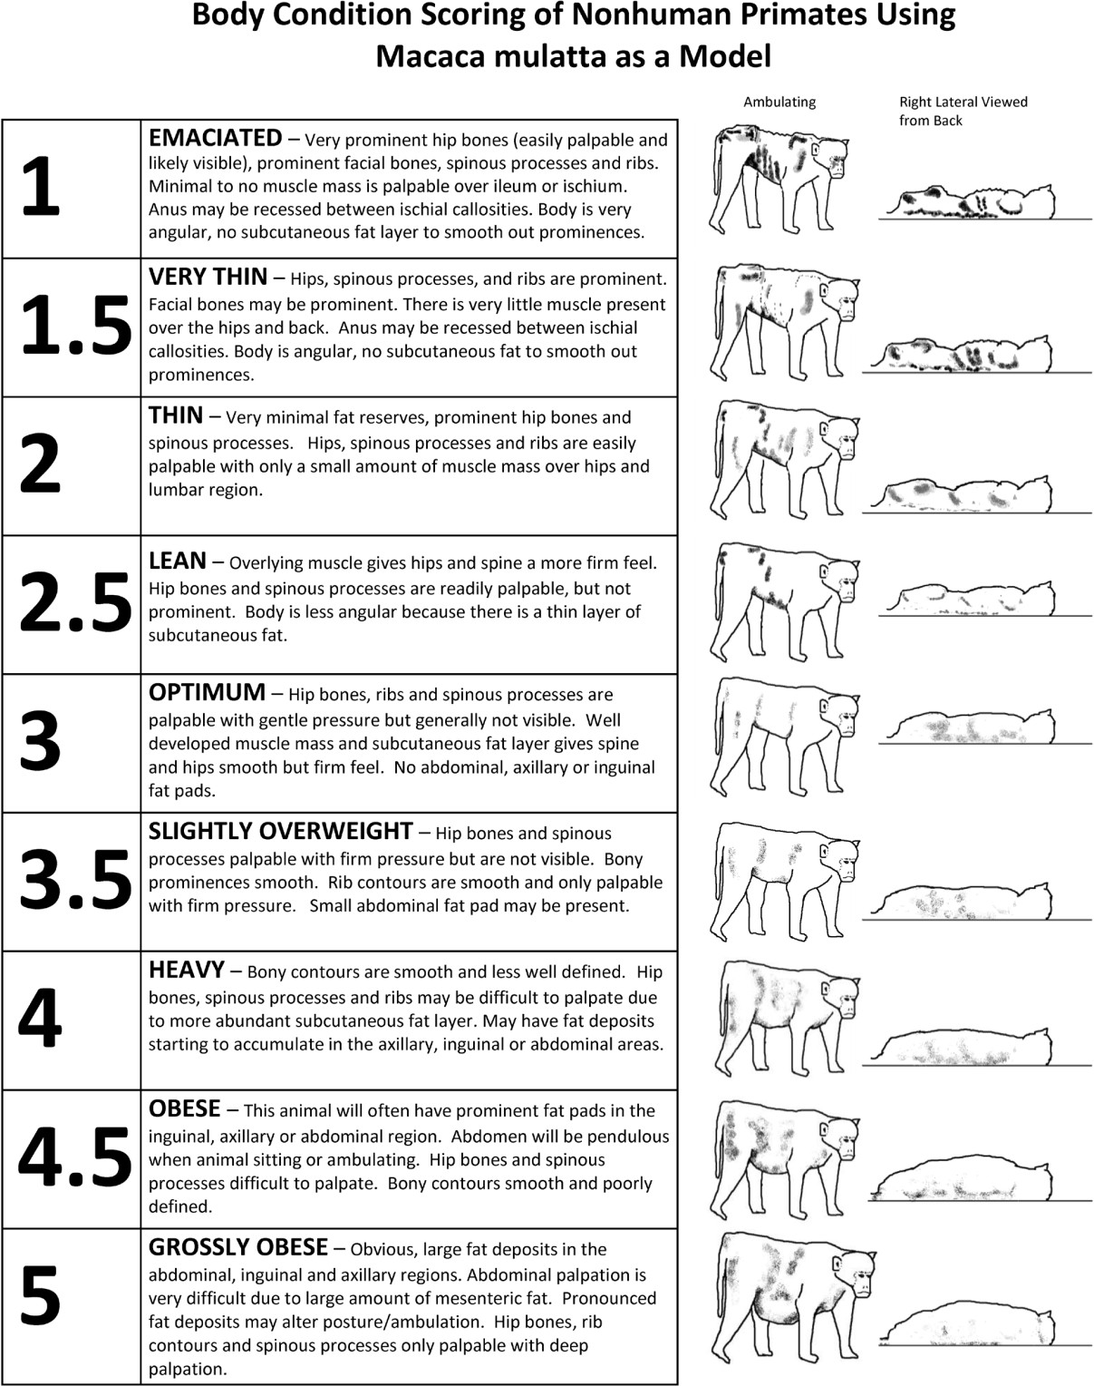

Clingerman KJ, Summers L. 2005. Development of a body condition scoring system for nonhuman primates using Macaca mulatta as a model. Lab Anim 34(5):31-37.

REFERENCES

- Association of Primate Veterinarians Food Restriction Guidelines for Nonhuman Primates in Biomedical Research. 2022. J Am Assoc Lab Anim Sci 61(5): 397-402.

- Institute for Laboratory Animal Research. 2011. Guide for the care and use of laboratory animals, 8th ed. Washington (DC): National Academies Press.

- Institute for Laboratory Animal Research. 2003. Guidelines for the care and use of mammals in neuroscience and behavioral research. National Academies Press: Washington DC. http://grants.nih.gov/grants/olaw/National_Academies_Guidelines_for_use_and_care.pdf

- Clingerman KJ, Summers L. 2005. Development of a body condition scoring system for nonhuman primates using Macaca mulatta as a model. Lab Anim 34(5):31-37.

- Clingerman KJ, Summers L. 2012. Validation of a body condition scoring system in rhesus macaques (Macaca mulatta): inter- and intrarater variability. J Am Assoc Lab Anim Sci 51(1):31-36.

- Yamada H, Louie K, Glimcher PW. 2010. Controlled Water Intake: A Method for Objectively Evaluating Thirst and Hydration State in Monkeys by the Measurement of Blood Osmolality. J Neurosci Methods 191(1): 83-89.

- Bowes and Church’s Food Value of Portions Commonly Used, 18th edition. 2005. Pennington JAT and Douglass JS, ed., Lippincott, Williams and Wilkins: Philadelphia.

- Toth LA, Gardiner TW. 2000. Food and water restriction protocols: physiological and behavioral considerations. Contemp Top 39(5):9-17.

