POLICY ON ASEPTIC RECOVERY SURGERY ON RODENTS AND BIRDS
Adopted by the University Committee on Animal Resources – Update and Approved 8-16-23

The ILAR Guide for the Care and Use of Laboratory Animals states that “In general, unless an exception is specifically justified as an essential component of the research protocol and approved by the IACUC, aseptic surgery should be conducted in dedicated facilities or spaces. When determining the appropriate site for conducting a surgical procedure (either a dedicated operating room/suite or an area that simply provides separation from other activities), the choice may depend on species, the nature of the procedure (major, minor or emergency), and the potential for physical impairment or postoperative complications, such as infection” ⁽¹⁾. As required by the United States Public Health Service (PHS), United States Department of Agriculture (USDA) and the University Committee on Animal Resources (UCAR), all vertebrate animal-use protocols, regardless of the funding source, must comply with the guidelines stated in the Guide and Animal Welfare regulations.

“Tips-only” Surgical Technique for Non-regulated Species
The “tips-only” surgery technique is a modified approach to rodent surgery that is especially useful for serial surgeries. This technique allows the surgeon to wear non-sterile exam gloves because it relies on the surgeon’s ability to only use the sterile tips of the instruments for all surgical manipulations without touching the animal. While the “tips only” technique does not strictly meet the Guide’s requirements specific to use of sterile gloves, NIH has supported this approach for rodent aseptic recovery surgery. Investigators must identify the intent to use the “tips only” technique in the protocol. The “tips only” approach requires attention to detail and must executed in accordance with this policy.

For USDA-regulated rodents (e.g. hamsters, gerbils, spiny mice, degus, guinea pigs, mole rats and voles), a new set of sterile surgical gloves and sterile instruments must be used for each animal. The “tips-only” surgery technique is not applicable to these species.

Surgical Requirements for Non-regulated Species
Investigators who feel that their vertebrate animal experiments require exceptions to the guidelines should contact UCAR for assistance. Otherwise, investigators will be expected to follow:

- Surgery must be conducted on a clean, uncluttered lab bench or table surface. Wipe the surface with a disinfectant before and after use and/or cover with a clean drape.

- Remove hair or feathers from the surgical site with clippers or a depilatory cream or by plucking. Depilatory cream should not contact the skin for longer than 30 seconds to avoid chemical burns. Repeated applications may be applied if needed. Dry gauze should be used to remove depilatory cream after the 30 second contact time followed by copious rinsing of the surgical site and furred margins to remove any remaining residue.

- Disinfect the surgical site with at least a two-minute total contact time using the following two-step process:
  - Remove gross contamination using a surgical scrub at the surgical site (chlorhexidine or povidone iodine scrub).
  - Treat the surgical site with 70% ethyl alcohol to remove scrub detergent
  - A final skin prep may be done using povidone iodine solution or chlorhexidine solution ⁽²⁾.

4. Apply bland ophthalmic ointment to eyes to prevent corneal drying.

5. A sterile drape is required to avoid sterile instruments, sterile gloves or exposed viscera from coming in contact with unprepped areas. Press’n Seal Cling film can be used as sterile drape material for up to 28 days after the box has been opened. Before each use, discard the first 25 centimeters of the roll as this is where the greatest contamination may occur (see figure 2). The drape may then be cut aseptically by the surgeon, or non-aseptically if the edges that were touched with nonsterile gloves are outside the sterile work area. In the reference section, there are YouTube clips demonstrating the draping techniques.

6. Place the animal on a covered warming device (e.g. circulating warm water blanket, warm water bottle, slide warmer or chemical hand warmer) to prevent hypothermia. The use of electrical heating pads is prohibited due to the potential for thermal burns. See the UCAR Policy on Supplemental Heating Devices for more information.

All instruments must be sterilized for both standard and “tips only” aseptic technique, but the method of choice may vary depending upon the surgical instruments or devices used. Acceptable sterilization techniques include autoclaving using steam under pressure or cold sterilization. Approved cold sterilization methods include: soaking instruments in 2.5-3.5% glutaraldehyde (e.g. Cidex Plus for 10 hrs. at 20-25° C) or 7.5% hydrogen peroxide (e.g. Sporox Sterilizing and Disinfection Solution for 6 hours at 20° C) according to manufacturer’s instructions and safe work practices. ⁽³⁾

To monitor sterilization equipment, appropriate indicators must be used to verify that surgical instruments and other materials are sterilized. Investigators must use an indicator strip in each pack to be sterilized. The strip should be placed in a location considered to be the hardest for the sterilant to reach. Indicator tape must be placed on the pack surface. Contact DCM for more information about these methods.

The date of sterilization must be indicated on the outside of the pack. Sterilized packs have a 6-month shelf life as long as the packaging does not become wet or damaged. Just placed the reference at the bottom of the policy). Packs that become damaged, wet, or that are 6 months past the sterilization date must be rewrapped and re-sterilized prior to use.

7. The surgeon must wear a face mask, bonnet, sterile gloves and a clean lab coat. A sterile gown is recommended but not required as part of the surgeon’s attire.

8. The surgeon must wash his/her hands prior to donning surgical gloves. It is preferred that the surgeon use an antiseptic surgical scrub preparation and then aseptically put on sterile gloves. If working alone, the surgeon should have the animal anesthetized and positioned and have the first layer of the double-wrapped instrument pack or any individually wrapped items opened before donning sterile gloves. A sterile field must be prepared on which to place instruments.
- Use of the tips only technique (for non-USDA-regulated rodents) does not require the use of sterile gloves; however, the surgeon must at minimum wash hands with soap or should surgically scrub his or her hands prior to use of exam gloves. The tips only technique allows the surgeon to anesthetize and position the animal between surgeries.
9. Surgery performed on multiple rodents and birds in a series presents special challenges. After the first surgery, the sterilized instruments may be sanitized in a sterile tray containing 70 – 90% ethyl or isopropyl alcohol ⁽⁴⁾ for a minimum contact time of 2 minutes ⁽⁵⁾. This method may be used for no more than a total of five rodents ⁽⁵⁾. The alcohol must be replaced when contaminated with blood or other body fluids. Alternatively, a glass bead sterilizer can be used. It is important to remove any gross debris prior to placement of instruments in the sterilizer and to allow the instruments to cool sufficiently prior to reuse.

Sterile gloves should be changed between surgeries if the surgeon touches nonsterile surfaces. Alternatively, surgeons may wipe their sterile gloves for 30 seconds with sterile gauze pads soaked in 70 – 90% ethyl or isopropyl alcohol ⁽⁵⁾ or spray 0.5% peroxide disinfectant solution (ie, Rescue) on gloved hands and rub hands together until the solution dries ^{(ref#)}.

Reynolds Wrap aluminum foil or Press n’Seal may also be used as a sterile barrier on non-sterile surfaces such as isoflurane vaporizer knobs and stereotaxic equipment to minimize contact of the sterile surgeon with non-sterile surfaces during solo surgery procedures. See Figure 3 for more information.

- TIPS ONLY (for non-USDA regulated species) – Only handle instruments by the handles, and do not allow the tips of instruments to touch non-sterile surfaces. Sutures, catheters, and other sterile materials to be used in the surgery must only be handled with the instrument tips. Tissues must only be touched with instrument tips.
    - Instrument tips must be sanitized between surgeries utilizing the same techniques described in #9 for standard aseptic technique.
    - Exam gloves must be changed or disinfected as described in #9 between surgeries.

10. Monitoring of anesthesia in rodents and birds may be accomplished by observation of color, respiratory rate and pattern, body temperature and observation for the loss of pedal and palpebral reflexes. More sophisticated methods of patient monitoring include EKG and heart rate, pulse oximetry, blood pressure measurements, blood gas measurements, etc.

11. Two-layer closure is required for procedures that penetrate the abdominal or thoracic cavities. The body wall must be closed with absorbable suture material in a simple interrupted pattern, unless otherwise justified in the protocol. Skin closure methods include surgical glue, staples, wound clips, and suture in exposed or subcuticular patterns. The most appropriate closure method depends on the surgical procedure. The closure materials and method must be described in the UCAR-approved protocol. Avoid using braided non-absorbable material (silk) to close skin or muscle as it has the tendency to wick bacteria into skin and muscle causing an inflammatory response. Absorbable sutures placed in a subcuticular pattern to close the skin need not be removed postoperatively since they are buried under the skin. All other skin sutures or staples must be removed seven to fourteen days after surgery.

- When using the tips only technique, it is important to only handle suture with the tips of the surgical instruments. Ensure that the field is draped appropriately to avoid suture ends coming in contact with non-sterile surfaces.

12. Rodents and birds should be recovered from anesthesia in a warmed environment. Warm fluids may be administered subcutaneously to improve postoperative hydration and enhance recovery (rats: 5 – 10 mls LRS or 0.9% NaCl, mice: 0.5-1.5 mls LRS or 0.9% NaCl, birds: 0.5 ml of 50% PlasmaLyte/50% D5W or LRS 10-15 ml/kg). Antibiotics should not be given routinely after surgery unless justified in the protocol.

Post procedural or anesthetized animals may not be left unattended or returned to housing until their righting reflex has returned and they are ambulatory with pink mucous membranes and stable respirations.

13. Systemic analgesics must be given to all species experiencing recovery surgical procedures. Analgesics must be administered prior to the surgical manipulation and must continue for 72 hours from the first pre-surgical administration of analgesic for major invasive surgery, or longer if the animal demonstrates continued signs of pain. Upon request, DCM will dispense Buprenorphine SR to labs for pre-emptive analgesic administration. This drug provides analgesia for up to 72 hours. Buprenorphine HCl is given pre-emptively then every 4 hours in mice and rats. The decision to discontinue analgesic therapy should be made based on the observation that the animal does not appear painful at the end of the previous dosing interval (when the next analgesic treatment is due).

Analgesics must be given at the dosing frequency stated in the UCAR protocol. In the event that the analgesic described in the UCAR protocol is unavailable, please contact a DCM veterinarian so they may provide a satisfactory substitute and oversight of the change in analgesic therapy.
Multimodal analgesia is the standard of care for all laboratory animals including rodents for certain procedures such as major invasive surgeries. Multimodal analgesia harnesses the synergistic effect of two or more different analgesics that target different components of the pain pathway. For rodents, examples include NSAIDs, opioids and local anesthetics ⁽¹⁵⁾.
Non-pharmacologic interventions such as warm, comfortable recovery conditions, highly palatable food and timely wound maintenance should be implemented in addition to analgesic regimens as an element of perioperative and post-operative care ⁽¹⁾.

14. All rodents and birds must be observed at least daily for 3 days post-surgery for signs of pain or distress. Surgery day counts as day zero. Surgeons must use the green “Be Gentle-Post-Op” cage cards (Figure 1) to identify post-surgical animals in the vivarium. The cards must contain all information (PI name, procedure, date, observations, analgesics, etc). Entries should be initialed by the person who made the observation and/or administered the analgesics. Date and time of entry must be recorded chronologically and with a specific time (i.e., 8 am; 12 pm or use military time). If an investigator has scientifically justified that analgesics cannot be used pre and post-operatively, it should be noted on the green post-op cards. If animals are removed from a study prior to the 72 hours of analgesic administration/observation, it should be indicated on the card.
Pain in rodents and birds may be identified by observing the animal’s reluctance to move about, decreased appetite and/or water consumption, weight loss, listlessness, salivation, hunched posture, favoring of the affected body part, piloerection (rodents), ruffled feathers (birds), increased respiration, respiratory sounds (chattering in mice), vocalization with handling and/or self-mutilation. Please review the Sedation/Tranquilization, Anesthesia and Analgesia in Laboratory Animals and Veterinarian-Recommended Formularies or contact a DCM veterinarian (X5-2653) with any concerns regarding the post-operative recovery of any animal.

Remove cards when sutures/wound clips are taken out or when the wound has healed. Keep the completed cards with your lab notes for approximately 1 year.
15. Post-surgical complications and revisions may be corrected by the lab, ONLY after the lab has consulted with
DCM veterinarians about the nature of the complication and the best method to address the issue, and if the lab
staff is qualified to address those issues. UCAR Post-Approval Monitoring, and/or DCM veterinarians may examine
the underlying reason for the surgical complications and suggest retraining and observation of the lab member’s
surgical techniques by UCAR/DCM in order to improve the surgeon’s skills.

Figure 1
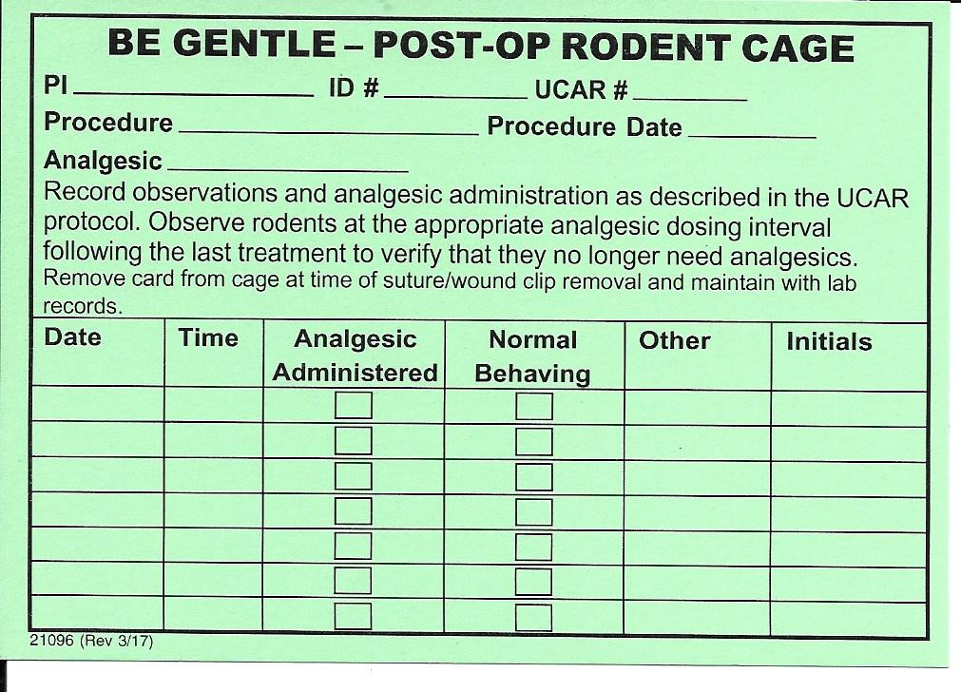

Figure 2.
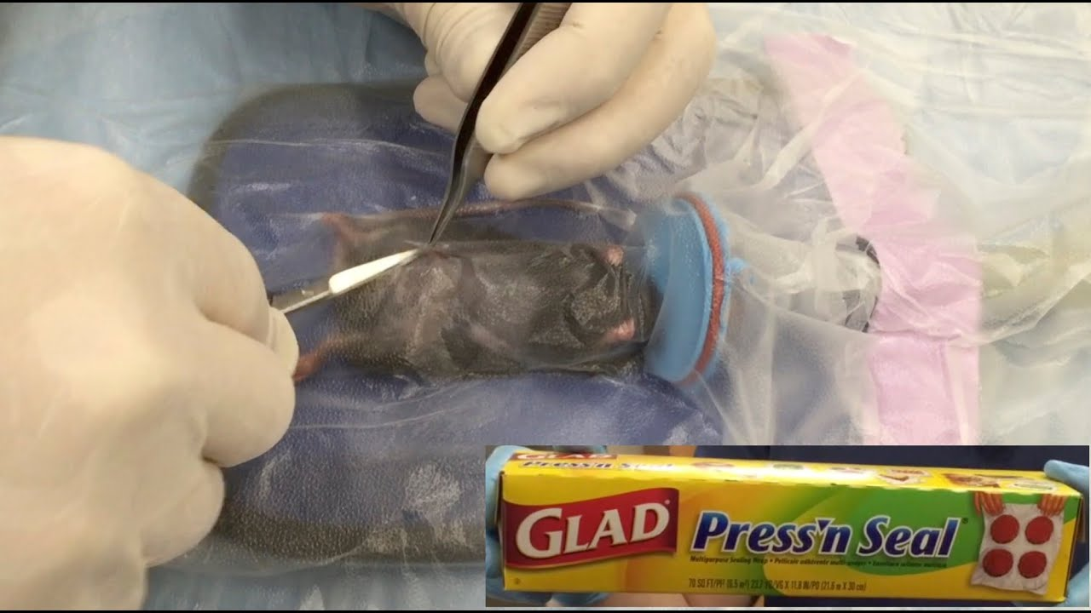

Figure 3: 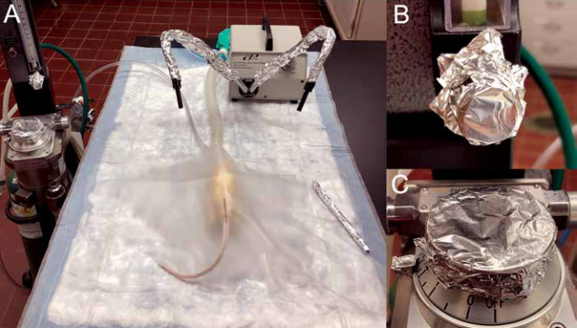

References:

- U.S. Dept. of Health and Human Services, Public Health Service, National Institutes of Health, (2010) Guide for the Care and Use of Laboratory Animals. Washington D.C.: National Academy Press.

- AAALAC, From AAALAC’s Perspective…Using Alcohol as a Disinfectant. AAALAC Connection Newsletter. 2001 Winter/Spring. http://www.aaalac.org/connection_4wsp2001.htm.

- U.S. Food and Drug Administration, (March 2009) FDA-Cleared Sterilants and High Level Disinfectants with General Claims for Processing Reusable Medical and Dental Devices. http://www.fda.gov/MedicalDevices/DeviceRegulationandGuidance/ReprocessingofReusableMedicalDevices/ucm437347.htm

- Block S.S., (1983) Disinfection, Sterilization and Preservation, 3^{rd.} Ed, Philadelphia: Lea & Febiger.

- Keen, J., The Efficacy of 70% Isopropyl Alcohol Soaking on Aerobic Bacterial Decontamination of Surgical Instruments and Gloves in Serial Mouse Laparotomies, accepted May 2010 for publication in J Am Assoc Lab Anim Sci

- National Institutes of Health. Guidelines for Survival Rodent Surgery. http://oacu.od.nih.gov/ARAC/documents/Rodent_Surgery.pdf

- AAALAC, Inc. Guidelines for the Assessment and Management of Pain in Rodents and Rabbits. http://www.aclam.org/Content/files/files/Public/Active/position_pain-rodent-rabbit.pdf

- Emmer, Kathryn M., et al. "Evaluation of the Sterility of Press'n Seal Cling Film for Use in Rodent Surgery." Journal of the American Association for Laboratory Animal Science 58.2 (2019): 235-239.

- http://research.utsa.edu/research-funding/laboratory-animal-resources-center/training/

- “Draping the Table & Animal for Rodent Surgery with Press’n Seal with Non-Sterile Gloves” https://youtu.be/vgl3nn4DOlE

- “Removing a Surgical Drape Sheet from a New/Unopened Press’n Seal Box” https://www.youtube.com/watch?v=2jeHX25tegA

- “Removing a Drape Piece from an Already Opened Press’n Seal Box” https://www.youtube.com/watch?v=3WEgxlfXh74

- “Cutting Press’n Seal Surgical Drape Over the Animal” https://youtu.be/09nMBxINra4

- Nolan, Katherine E. et al. “Evaluation of the Sterility of Reynolds Wrap Aluminum Foil for Use During Rodent Surgery”. Journal of the American Association for Laboratory Animal Science 60.1 (2021): 85-90.

- “Veterinary Guideline: Rodent Anesthesia and Analgesia” Office of Research, The Ohio State University. https://research.osu.edu/research-responsibilities-and-compliance/animal-care-and-use/animal-care-and-use-policies-and-2.

- National Institutes of Health “Study of the deadlines for the use after sterilization of hot-sealable bags and sheaths]” https://pubmed.ncbi.nlm.nih.gov/29478716/

- National Institutes of Health “[Reevaluating the shelf life of sterilized packaged items via a risk-analysis study]” https://pubmed.ncbi.nlm.nih.gov/32037027/

