University of Rochester Committee on Animal Resources
Mouse and Rat Tumor Burden Scoring Policy
Revised – 12/20/23

PURPOSE: To establish guidelines for tumor burden scoring to be used in mice and rats that develop tumors. While legitimate exceptions to these guidelines are recognized, they must be followed unless a scientifically based exemption is approved by UCAR. These guidelines will allow URMC Principal Investigators, laboratory staff and URMC animal care staff to objectively evaluate the health and welfare of animals carrying spontaneous or experimentally-induced tumors and allow for the alleviation of pain and distress associated with these tumors by intervention, including humane euthanasia.

DEFINITIONS:

- BCS = Body Condition Score on a scale from 1 to 5. (see figures 1 and 2)
- Moribund = Condition in which death is imminent characterized by recumbency, hypothermia and/or lack of response.

RESPONSIBILITY: Principal investigators and their designated laboratory personnel, with the assistance and advice of the DCM veterinary staff, have the responsibility for the health and welfare of their experimental animals. It is expected that investigators working with tumor models will perform continuous and comprehensive health assessments of test subjects documented and available for review by DCM. Mice or rats that exceed standard endpoints as outlined in this policy must be removed from study promptly. Justification to exceed these endpoints must be approved in advance by UCAR.

For animals exhibiting clinical signs (e.g. rough coat, hunched posture, declining BCS, diarrhea, jaundice, etc.) that do not yet meet the removal criteria listed below, UCAR recommends consultation with DCM veterinarians to identify interventions that may enable animals to reach predetermined experimental endpoints.

REMOVAL CRITERIA:
- Cumulative tumor burden ≥20mm (mice) and ≥40mm (rats)
- BCS <2
- Any ulceration or excoriation
- Moribund
- Respiratory distress
- Tumor interfering with normal movement
- Inability to access food or water

REFERENCES:
- Morton and Griffiths (1985), Veterinary Record 116: 431-43
- Dr. Liang Xu and Dr. Marc Lippman permitted the use of their previously described tumor burden scoring system standard operating procedure.
- Wallace J, Humane endpoints in cancer research. ILAR 41: 79-84, 2000.
- University of Michigan Tumor Scoring Policy
- Emory University Tumor Scoring Policy
- University of Texas San Antonio Scoring and Endpoints Policy
- Ullman-Culleré M and Foltz C. Body condition scoring: a rapid and accurate method for assessing health status in mice. Laboratory Animal Science 49 (3): 319-323
- Hickman D and Swan M. Use of Body Condition Score Technique to Assess Health Status in Rat Model of Polycystic Kidney Disease. JAALAS 49(2): 155-159.
Figure 1: Mouse Body Condition Scoring (BCS) Guide Taken from M Ullman-Cullere Laboratory Animal Science, 1999.
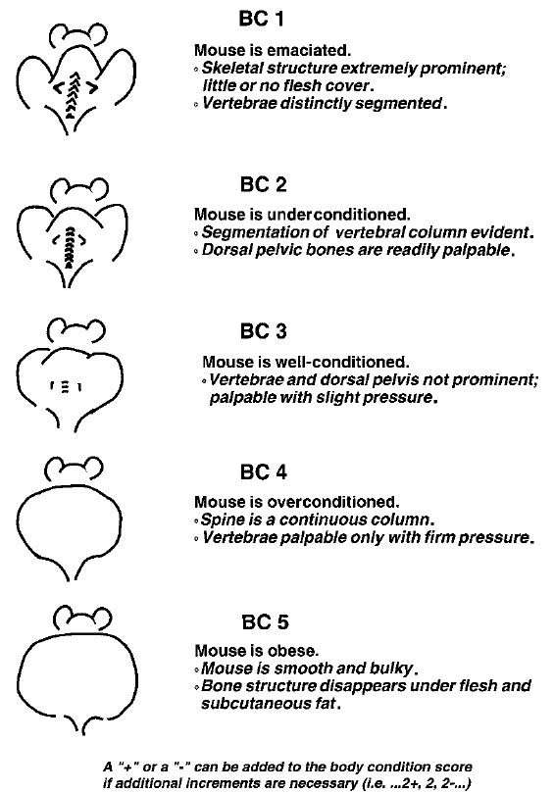

Figure 2: Rat Body Condition Scoring (BCS) Guide Taken from Hickman & Swan, JAALAS, 2010.

