
PATIENT INSTRUCTIONS FOR STOOL COLLECTION
O&P (parasites) – orange vial, C&S (bacteria) – yellow vial, C. difficile and leukocytes- sterile container

- Collect Specimen In a Clean Dry Container.  - Use an insert (toilet hat) for toilet OR  - Clean dry wide mouth container  - Bed pan  - Wastebasket lined with plastic bag DO NOT collect from toilet  DO NOT urinate on specimen DO NOT collect directly in vial  Specimen must be soft or liquid for C. difficile | 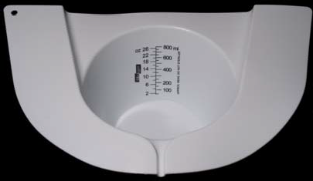
 |  | Toilet Hat
- Transfer Specimen Into Vial(s) and/or Sterile Container
  - Using plastic spoon or wooden stick for each vial or container transfer specimen
  - Fill to red line for Parasite and Bacterial exams
  - Mix vial with spoon or stick
  - Recap vial making sure cap is on tightly
  - Shake the vial until contents are well mixed
- Fill Out Information on Collection Vial-REQUIRED
  - Full name (first and last)
  - Date of birth
  - Date and time specimen was collected
  - Collect no more than one sample per day for each test
  - Samples lacking complete labeling will not be tested
Refrigerate container with blue cap (C. difficile) if transport to collection station is delayed more than 1 hour. Specimen is stable for up to 3 days if refrigerated. Fecal leukocytes (WBC’s) require immediate delivery back to the collection station for prompt delivery to the laboratory.
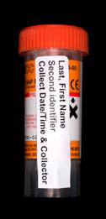
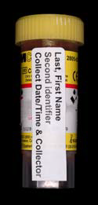
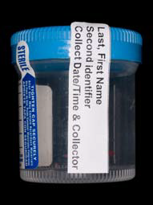
Parasite (O&P) SAF Vial
Bacterial (C&S) Carey Blair Vial
Sterile Container

Stable room temp | Stable room temp | REFRIGERATE
Deliver to lab within 72 hours | Deliver to lab within 72 hours | C. difficle-deliver within 72 hours
after collection | after collection | Leukocytes deliver within 1 hour
4/2008 |  | after collection

