Fixing On-page Sliders

- Open Kentico 11 and navigate to the page you want to fix
- Open the slider widget on the page and copy the list item HTML
- Open the same page in Kentico 13
- Delete the slider that’s currently on the page and add a new one
- In the Content area, click Edit and view the source in the editor
- Paste the HTML from Kentico 11
- REMOVE ALL COMMENTS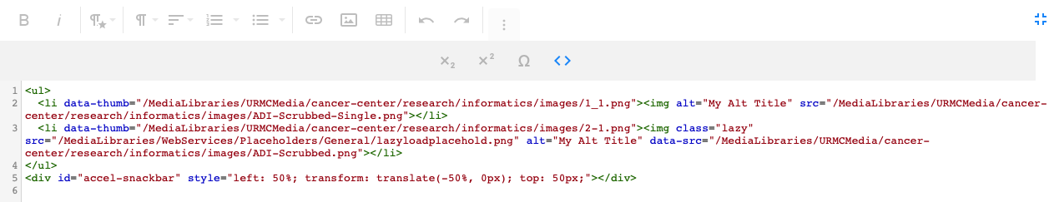
- Exit source mode and click the Apply and Save icon

- Setup the new slider like this
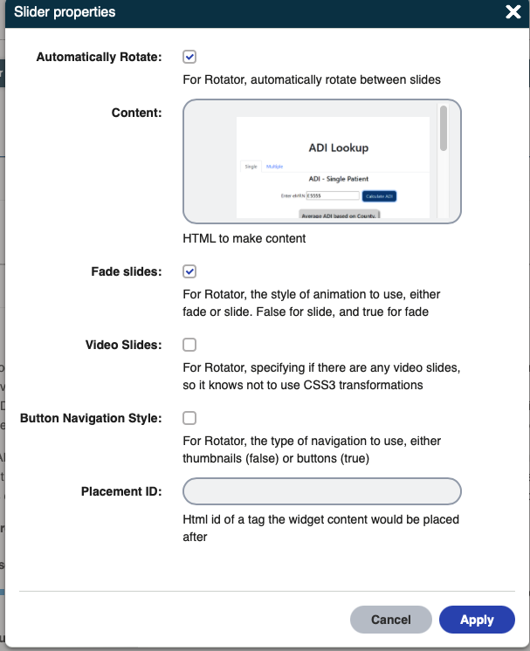
- Click Apply to add the slider to the page
In a Rich Text area (can be in an existing RT area), add the following CSS. This CSS fixes some minor styling on the buttons and ensures the buttons display on mobile.
<style type="text/css">
.slides {
width: 100%; max-width: 500px; margin: auto
}

ol.flex-control-thumbs li {
width: 6%
}

@media screen and (min-width: 1px) and (max-width: 640px) {
ol.flex-control-thumbs li {
width: 12%
}
body:not(.EditMode):not(#m_bodyElem) main .slider-widget.flexslider .flex-direction-nav a.flex-next,
body:not(.EditMode):not(#m_bodyElem) main .slider-widget.flexslider .flex-direction-nav a.flex-prev,
body:not(.EditMode):not(#m_bodyElem) main .slider-widget.flexslider ol {
display: block !important
}
}

</style>
- Exit source view and save the page.

WCI Informatics Page Only

For WCI Informatics content, you will also need to fix the centered text. This seems to be a bug on our end. They added styles to center the H1 on the page (Ugh!) and it looks like it’s applying to all text on the page. To fix this, all blocks on text need to be surrounded by this:
<div style="text-align: left !important;">
HTML here

</div>

