
MEDICINE
HEALTH
Sponsorship Information

EXECUTIVE SPONSOR $1,875
- Two foursomes for golf
- Recognition during introduction at event
- Recognition on thank you board at event
- Logo on pre-tournament advertising, event website and social media
- Opportunity to put brochure, flyer, or other information or item in golfer swag bags
- Large hole sponsor sign with logo

GOLD SPONSOR $625
- One foursome for golf
- Recognition on thank you board at event
- Company name on event website
- Small hole sponsor sign

CORPORATE SPONSOR $1,250
- One foursome for golf
- Recognition during introduction at event
- Recognition on thank you board at event
- Logo on pre-tournament advertising, event website and social media
- Opportunity to put brochure, flyer, or other information in golfer swag bags
- Large hole sponsor sign with logo

FOURSOME $400
- One foursome for golf
- Hotdogs at the turn
- Dinner
- 18 holes of golf with cart

CART SPONSOR $5,000 (1 AVAILABLE)
- Company logo mounted on the inside of each of the golf carts
- Company logo on large sign outside clubhouse
- Recognition during opening and closing remarks, and on thank you board at event
- Company logo on event website, pre and post event advertising
- Large logo sign outside clubhouse

FOOD SPONSOR $2,000 (2 AVAILABLE)
- Large banner with company logo displayed prominently at dinner
- Recognition during opening and closing remarks, on thank you board at event
- Company logo on event website, pre and post event advertising
- Large logo hole sign outside clubhouse

PRIZE SPONSOR $1,000 (4AVAILABLE)
- Small banner with company logo in prize area during registration and dinner
- Sign with company logo at hole where your contest is being held
- Recognition during opening and closing remarks, on thank you board at event
- Company name on event website, pre and post event advertising

LARGE HOLE SPONSOR ($250)
- Recognition on thank you board at event
- Company name on event website
- Large hole sign with company logo

SMALL HOLE SPONSOR ($100)
- Recognition on thank you board at event
- Company name on event website
- Hole sign with company name

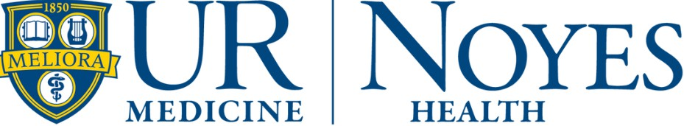

2025 Chip in Fore Noyes Sponsorship Form
□ Executive Sponsor ($1,875) □ Cart Sponsor ($5,000)
□ Corporate Sponsor ($1,250) □ Food Sponsor ($2,000)
□ Gold Sponsor ($625) □ Prize Hole Sponsor ($1,000)
□ Foursome ($300) □ Hole Sponsor - Large ($250)
□ Hole Sponsor - Small ($100)
Other Donation Amount

Business Name Business Address Contact Name
Contact Phone Number Contact Email


Payment is due by July 8 unless other arrangements are made in advance. Checks can be mailed to: Noyes Health Auxiliary,
111 Clara Barton St., Dansville, NY 14437

