Citrix Installation Instructions for MacOS
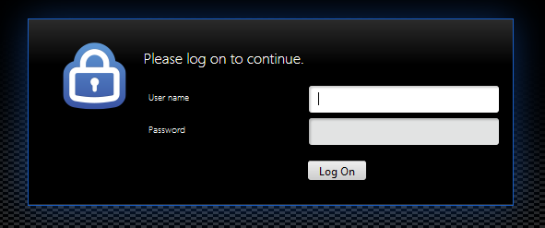
- Sign into https://myapps.urmc.rochester.edu/ with your URMC AD username and password, then verify with Duo.
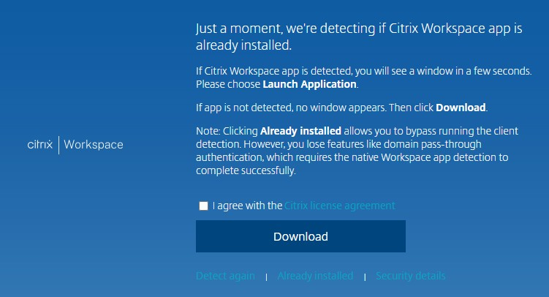
- Once presented with the download option, click the box for the Citrix License Agreement, then click ‘Download’.

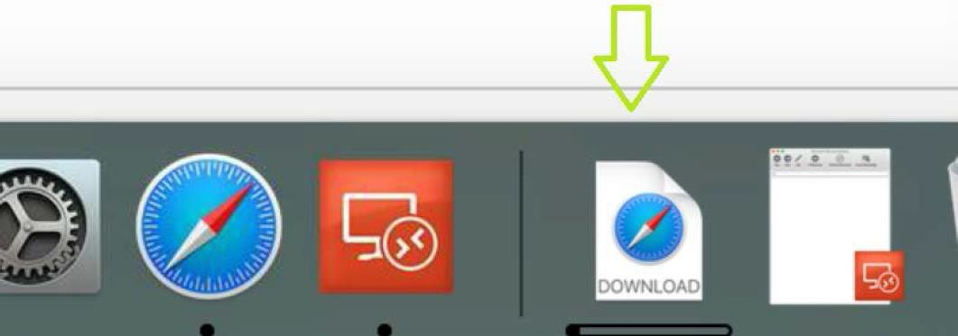
- Once the download is complete, open the installer file.
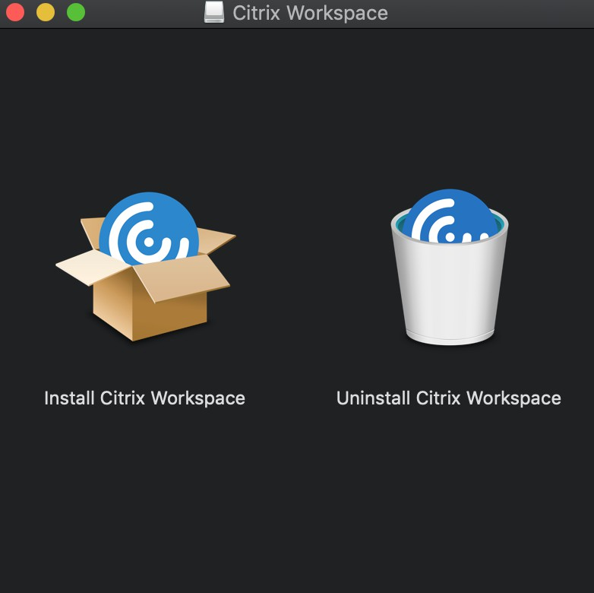
- Click on the “Install Citrix Workspace” option:

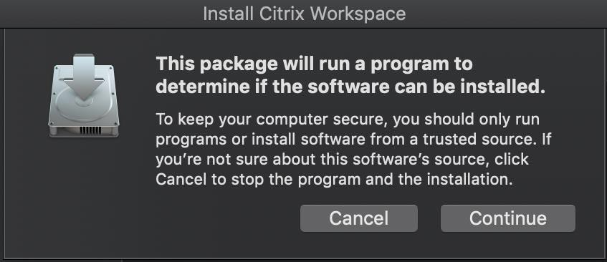
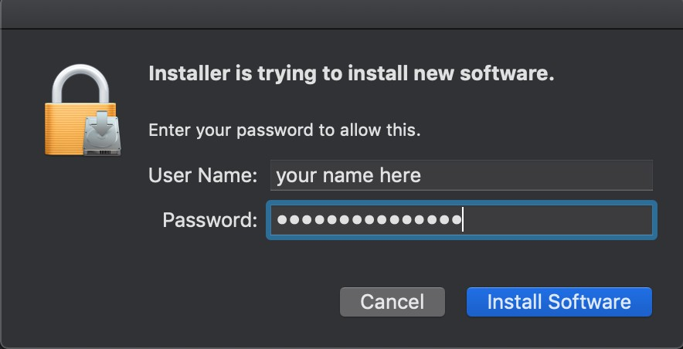
- Click Continue on the prompt to determine if the software can be installed, and enter your Mac password if prompted, then click “Install Software”.

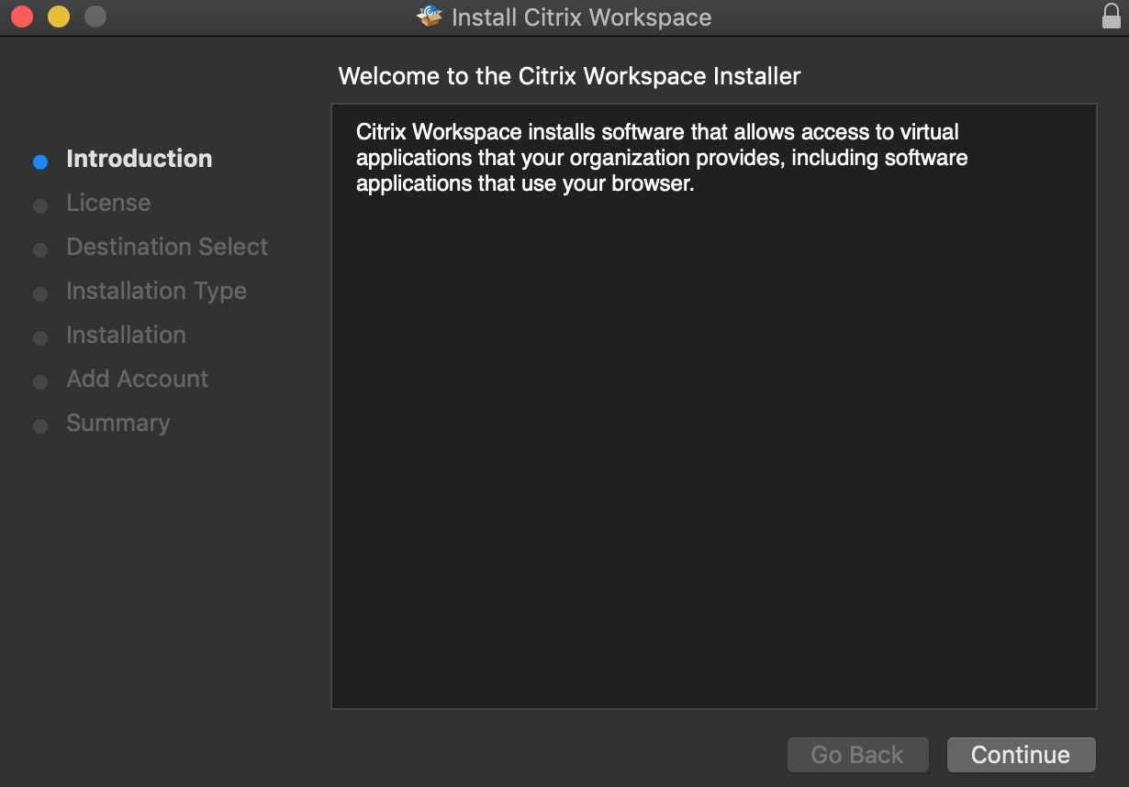
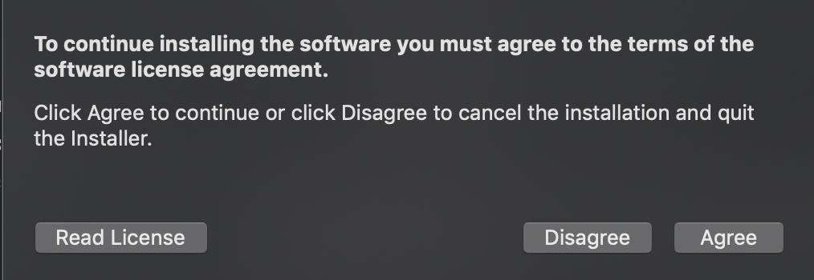
- Click Continue until you are prompted to accept the license agreement.

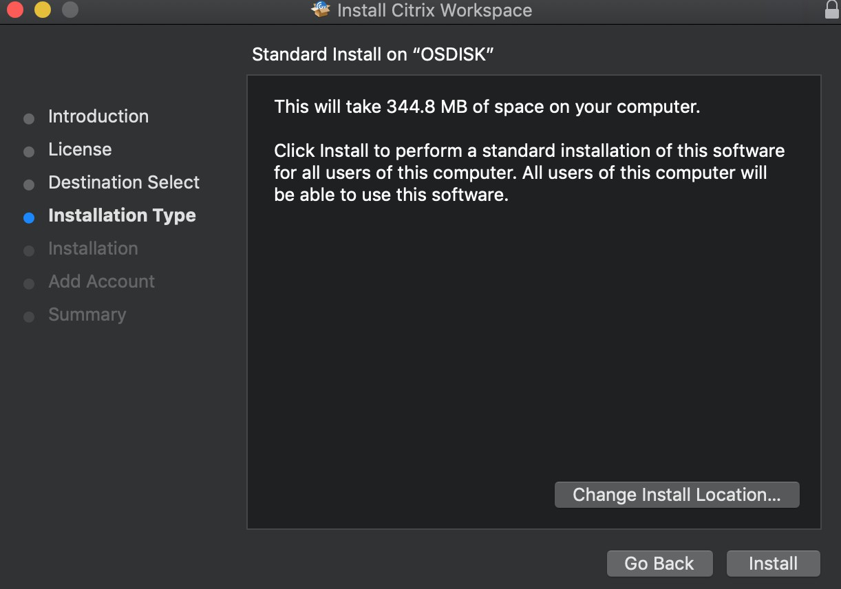
- Click Install when prompted:
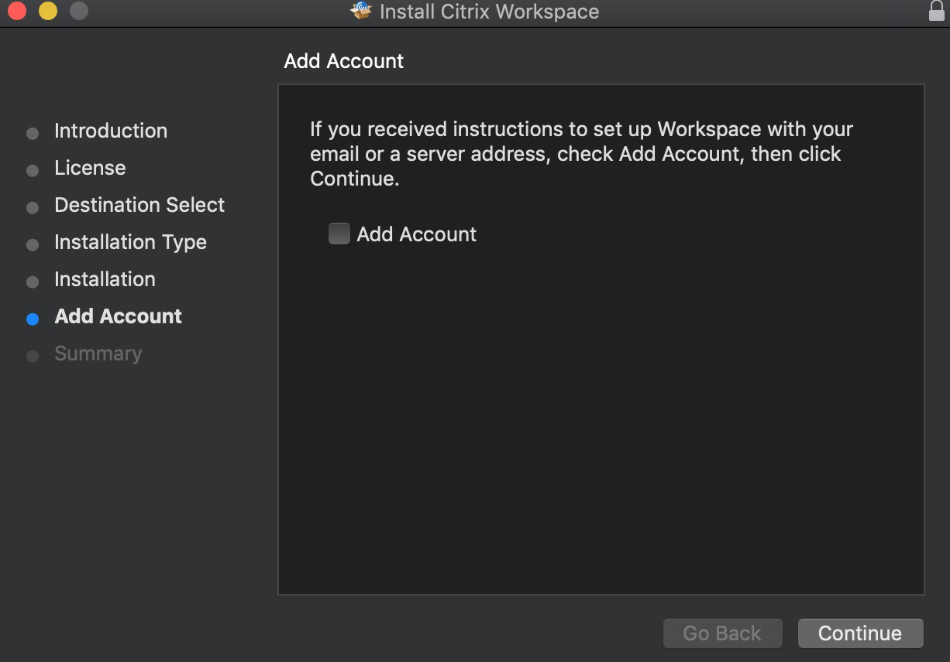
- Once installation is complete, it will ask to add an account. Do Not check the box to add account, only hit Continue.

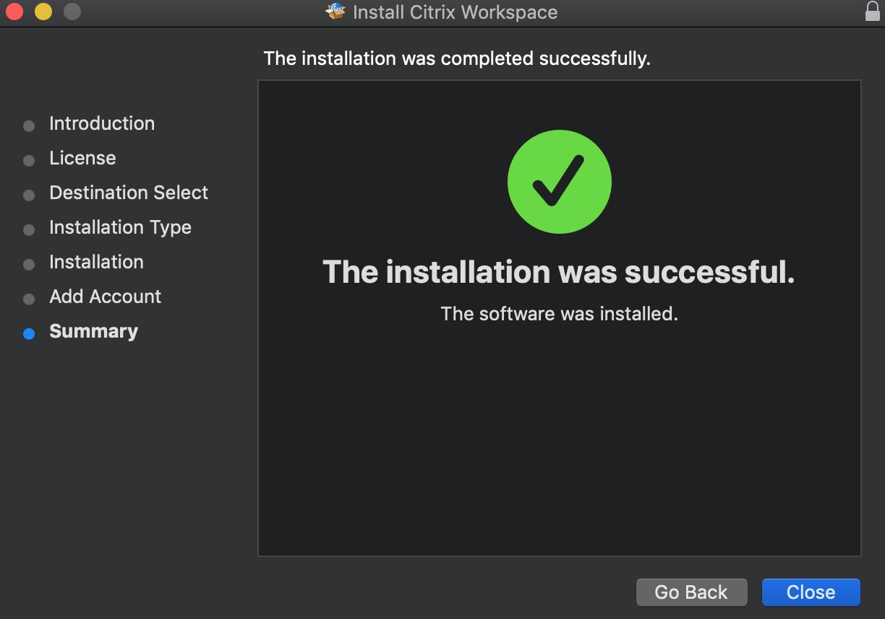
- Click Close once Citrix indicates installation was successful.
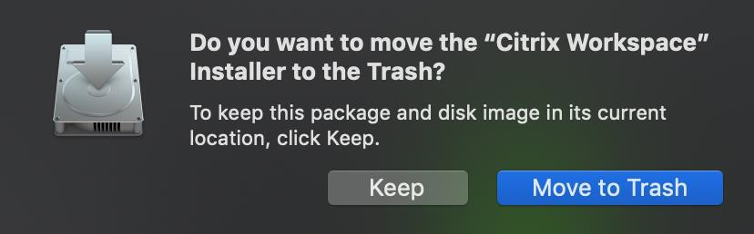
- Once installation is complete, you can get rid of the installer file by clicking “Move to Trash”.

