Heart Transplant Nutrition

Nutritional Needs for Wound Healing
The months following surgery are a critical time for recovery. Adequate intake of protein, calories, fluids and other nutrients are important for wound healing.
Any questions or concerns you may have please contact your Registered Dietitian:
Bethany Barney, RD, CCTD
(585) 276-5815

Long Term Nutritional Changes
Over the course of several months, your blood work and body can change as you recover from surgery. New medications and their side-effects can impact your nutritional needs.
These include:
- Increased risk for foodborne illness
- Changes in blood potassium, calcium, phosphorus, and magnesium levels
- Increased risk of developing heart disease
- Increased blood sugars as a result of steroids
- Weight gain.

A healthy diet and routine exercise can improve some of these side effects.

Protein
Your body requires more protein to heal after surgery. Incorporate at least one 3-ounce portion from the list below at every meal.

Protein Source | Recommended Serving
Poultry: chicken and turkey | 3 ounces*** (~22 grams)
Pork: tenderloin, chop, roast | 3 ounces (~22 grams)
Fish: salmon, tuna, tilapia, haddock | 3 ounces (~22 grams)
Beef: 90-95% lean ground, top round, or sirloin | 3 ounces (~22 grams)
Dairy | 1 cup skim or low fat milk (8 grams)  ½ cup cottage cheese (15 grams)  2-3 ounces cheese (7 grams/ounce)  ¾ cup Greek yogurt (12-15 grams)
Eggs or Egg Substitutes | 1 egg or 1/3 cup (7 grams)
Beans and Legumes | ½ cup (~8 grams)
Soy Products | 1 cup soy milk (8 grams)  ½ cup tofu or soybeans (10 grams)  Processed soy/ meat alternatives

*** A three-ounce portion is about the size of your palm or a deck of cards

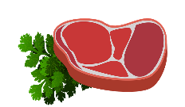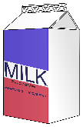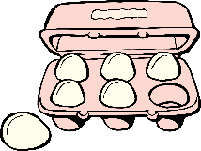

Food Safety
- Check and follow expiration dates.
- Wash produce well before eating.
- Never prepare raw meat on the same surface as other foods.
- Separate raw meat, poultry, seafood, and eggs from other foods in your grocery shopping cart, grocery bags, and in your refrigerator.
- Wash your hands thoroughly before and after handling food
- Do not eat raw meat and fish and raw or undercooked eggs.
- Milk and milk products should be pasteurized. Ciders and juices should also be pasteurized.
- Cook meat properly. Follow package directions for appropriate cooking temperatures. The USDA recommends cooking deli meet (ex: microwave 10-15 seconds).
- Reheat leftovers to a uniform temperature of 165° F (74° C).
- Do not leave food out for more than 2 hours or 1 hour in weather that has temperatures above 90° F (32° C). Keep hot food hot and cold food cold while serving items.
- Do not thaw meat on the counter. Thaw meat in the refrigerator or in the microwave (cook immediately after thawing in the microwave).
- Be aware of safe drinking water, especially while traveling or camping. Well water should be avoided.
- If you would like more information, ask your nutritionist for the USDA/ FDA Food Safety guidelines for transplant patients or go to their website; foodsafety.gov.



Nutrients to Monitor and Limit

Sodium
- Limit highly processed foods, as these contain large amounts of sodium. These include canned soups, canned and processed meats/cheeses, boxed/convenience foods, packaged snack items
- Limit intake of high sodium condiments and sauces
- Read food labels to identify sodium content. Limit sodium intake to 2000 mg per day

Potassium
Potassium levels can become elevated after transplant due to your new transplant medications. In general, avoid consuming multiple high potassium foods on the same day.

Vegetables | Fruits | Other
Potato/ Sweet Potato | Banana/Plantains | Chocolate Candy/ Chocolate Milk/ Cocoa
Tomato Sauce/Soups | Melons | Salt Substitutes
Dark Leafy Greens | All Dried Fruits  Ex: raisins | Coconut/ Coconut Milk
Brussels Sprouts | Avocado
Winter Squash | Oranges
Vegetable Juices | Tropical fruits  (mango and papaya)
Root Vegetables (parsnips, beets) | Prune Juice

(Serving size: ½ cup (4 oz.) or 1 small)

High Blood Sugar
If you have pre-existing diabetes or develop high blood sugars (hyperglycemia) after transplant, you will need to avoid sugary foods and beverages until your blood sugars improve.
- These foods include- candy, table sugar, honey, syrup, jelly, Jell-O, popsicles, cake, pie, cookies, pastries, ice cream, sherbet, soda and other sweetened beverages.
- Look for 100% whole wheat/whole grains and at least 3 gm fiber/serving when looking at food labels.
- Aim for well balanced meals, containing a blend of complex carbohydrates, protein and heart healthy fats.
- Limit Added Sugars (found on the Nutrition Facts Label)
- It may help to eat consistent meals throughout the day – it is not recommended to skip meals. By eating a regular breakfast, lunch, and dinner consisting of whole grains, fruits (not fruit juice), vegetables, and protein, you can help keep your blood sugar stable.

Food and Drug Interactions
- Avoid Grapefruit and grapefruit juice, and fruits in the grapefruit family (such as pomelos), as it interacts with your transplant medications risking rejection of your organ.
- Avoid pomegranate and pomegranate juice
- Avoid herbal remedies and dietary supplements.
- Limit herbal teas to 1 cup a day. Avoid “detox” teas.
- Unless directed by your transplant team, avoid excessive use of vitamins.
- Consult your pharmacists for specific medicine questions.

Weight Management
There are multiple factors that can contribute to weight gain after transplant. Below are some tips to prevent weight gain as well as promote weight loss.
- Follow the “My Plate” method for meal planning which emphasizes vegetables, lean protein, and healthy carbohydrates. Be aware of portion sizes.
- Try a calorie counting app for a few days to monitor intake and learn where extra calories are coming from.
- Limit calorie containing beverages.
- Try the “20-Minute Rule”: if you are bored or have a desire to have a second helping at meals, find a distraction instead. If your mind wanders back to food, consider having a healthy snack like vegetables, lean protein, or a portion controlled carbohydrate (ex 1 cup popcorn, ½ cup or piece of fruit).
- Minimize snacking on highly processed foods like chips, cookies, and cakes as they’re higher in fat, sugar, and calories.

Physical activity is an important part of weight management. Exercise has been found to reduce feelings of hunger and can make you feel more energized.
- Make inactive hobbies active activities. Ride a stationary bike while reading or watching TV or try lifting weights during commercial breaks.
- Aim for at least 150 minutes of exercise weekly. Can be split up into 20 minutes most days of the week.
- Add in strength or resistance training (once medically cleared). Boosting muscle mass burns more calories at rest than fat does.

The Plate Divide

- Make half of your plate non-starchy vegetables.
- Choose a variety of different colored vegetables and fruits.
- Add a serving of fruit to breakfast by adding it to yogurt, oatmeal, or just by itself!
- Include vegetables in casserole and pasta dishes
- Choose fruit instead of cakes, cookies, or pies for dessert.
- Choose fish and lean meats like poultry without the skin, 90% or better lean ground beef, and meats labeled "loin" or “round”.
- Avoid fried and breaded meats, poultry with the skin, and processed meats that are higher in fat.
- Try beans, legumes, tofu, and other meat alternatives at meals.

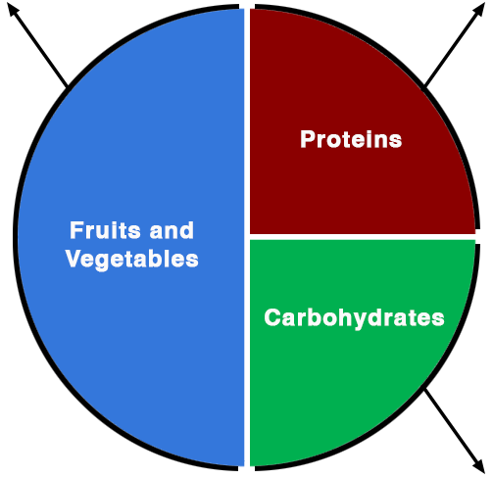
Healthy Fats

- Choose healthy fats like olive oil, nuts and seeds avocado, and fatty fish (salmon) more often.
- Limit fats that are high in saturated fat like fried foods, cookies and cakes, butter, cheese, and fatty meats.

- Make half or more of your grains whole by choosing brown rice, whole wheat bread and pasta, oatmeal, quinoa, and other grains.
- Limit the portion of carbohydrates to about ¼ of the plate.
- Reserve treats like cookies, cakes, and pies for special occasions, as they are high in sugar and fat.

Fluids
- Drink water at meals and throughout the day to stay hydrated.
- Limit sugar sweetened beverages like soda, sweet teas, and lemonade to reduce calories.
- Drink a glass of water before a meal to promote feelings of fullness sooner.

