Citrix Installation Instructions for Windows
- Download the installer file: https://www.citrix.com/downloads/workspace-app/windows/workspace-app-for-windows-latest.html? srsltid=AfmBOopFrr6tP6gxG7Jsxw5ImniaCGdFxBJ5g1Jw 8jeED0j8J2yKIavH
Compatible with Windows 11, 10 as well as Windows Server 2025, 2022, 2019.
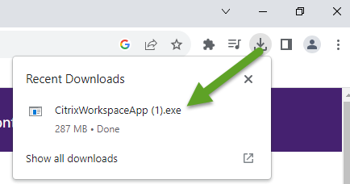
- Open the downloaded file from your Downloads folder, or from your browser:

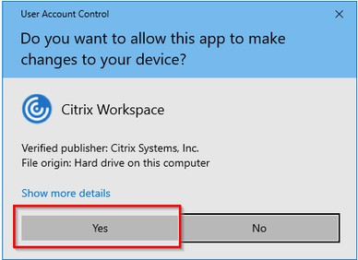
- Approve the Windows prompt to “Allow this app to make changes to your device”.

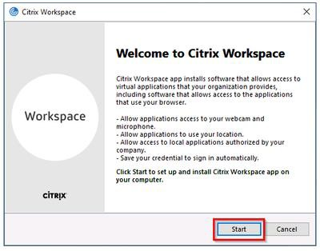
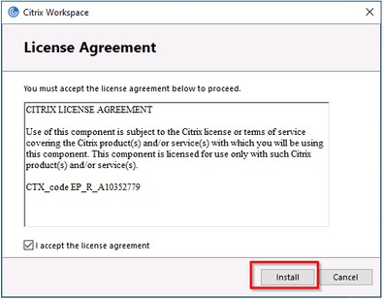
- Start the installation and accept the License Agreement:

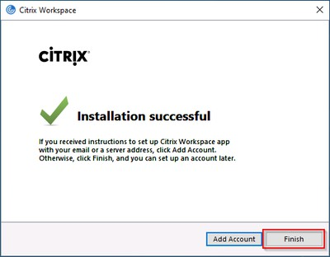
- When the installation is completed, do not click Add Account. Click Finish:

- Click the Citrix Applications button from the Remote Access Portal (https://remote.urmc.edu)
- Sign in with your URMC AD username and Password.
- Verify your identity with Duo two factor.
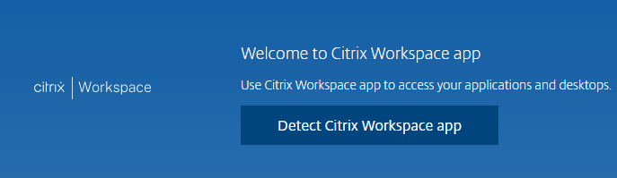
- Select “Detect Citrix Workspace App”.

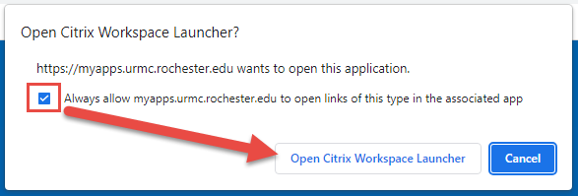
- Check “Always Allow” then click “Open Citrix Workspace Launcher”.
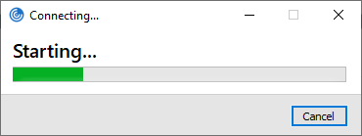

- Click an app to launch.

