Medications After Transplant
Medications play an important role after transplant. Some of them will be taken for the rest of your life to prevent your body from rejecting your new heart and to treat or prevent other medication conditions.

- ALWAYS take your medications as directed
- Never stop or start a medication or change your dose without approval from your transplant coordinator
- If you miss a dose of medication let your transplant coordinator know

Before leaving the hospital, you should know:
- The names of your medications
- How they look
- The dose of each medication
- What each medication is used for
- Possible side effects

Medications to Prevent Rejection
Also called immunosuppressants or anti-rejection medications, these are a group of medications that will keep your new heart from being rejected as a foreign object by your body’s natural immune system. They are ESSENTIAL to keep your new heart healthy.

You will take THREE medications to prevent rejection:
- Prograf (Tacrolimus)
- Prednisone (Deltasone) – *this will be tapered off at approximately 6 -12 months
- Cellcept (Mycophenolate)

Medications to Prevent Infection
These are a group of medications that help to prevent infections in your body. They are given because while taking anti-rejection medications your immune system will not be able to fight off infection as well.

You will take THREE medications to prevent infection:
- Bactrim - This medications helps prevent bacterial infections
- Acyclovir or Ganciclovir – This medication helps prevent viral infection
- Diflucan – This medication helps prevent fungal infections

Other Routine Medications

High Blood Pressure Medications
Some of your anti-rejection medications can cause high blood pressure as a side effect. The transplant team will determine if you need a medication for high blood pressure.

High Blood Sugar Medications
The medications you take to prevent rejection can also cause high blood sugar levels. It is not unusual to require one or two doses of long acting insulin each day as well as meal time doses of short acting insulin.

Antacids
These medications are important because many of the medications you take for rejection can cause stomach irritation, especially prednisone.

Vitamins and Supplements
The medications you take to prevent rejection can cause low magnesium levels. You will be prescribed a magnesium supplement to boost your magnesium levels. Also, prednisone can increase the risk of osteoporosis; therefor you will be prescribed a calcium supplement with vitamin D to promote healthy bones. A daily multivitamin is also commonly prescribed.

Aspirin
Most transplant patients will need to take a baby aspirin each day to promote a healthy heart.

Cholesterol-Lowering Medications
All transplant patients will take a medication to lower cholesterol, which can lower the risk of heart attack and stroke. These medications are also use to help prevent long term rejection.

Anxiety or Depression Medications
The transplant team will help you decide if you would benefit from a medication to treat anxiety or depression. Patients who already take these medications prior to transplant should continue to take them unless otherwise instructed by your transplant team.

You will be provided with a medication sheet after transplant as well as a pill box. It is important to bring these along with all medications to your first several visits with your transplant coordinator. It is VERY important you use the pill box provided to you

Over the Counter Medications

Pain Relievers
You may take Tylenol (acetaminophen) for minor aches and pains. DO NOT TAKE more than 3000 mg of Tylenol per 24 hours.
*DO NOT TAKE IBUPROFEN or NAPROXEN or any other non-steroidal anti-inflammatory medications. These medications can interact with your transplant medications and harm your kidneys.

Allergy/Cold Medications
You may take dextromethorphan for cough or guaifenesin to loosen thick secretions. You may take the following antihistamines for runny or stuffy nose and itchy or watery eyes: loratadine (Claritin), desloratadine (Clarinex), or diphenhydramine (Benadryl).

*DO NOT USE AFRIN NASAL SPRAY. DO NOT USE ANY MEDICATIONS WITH A DECONGETANT, SUCH AS SUDAFED OR PRODUCTS THAT HAVE A “D” ATTACHED TO THE NAME, BECAUSE THEY CAN CAUSE INCREASED BLOOD PRESSURE.

Herbal Medications/ Supplements and Herbal Teas
*DO NOT USE any herbal products or teas, because there may be an interaction between your transplant medications and these products, which may be harmful to yourself and your new heart.

Tips on Filling Your Pill Box

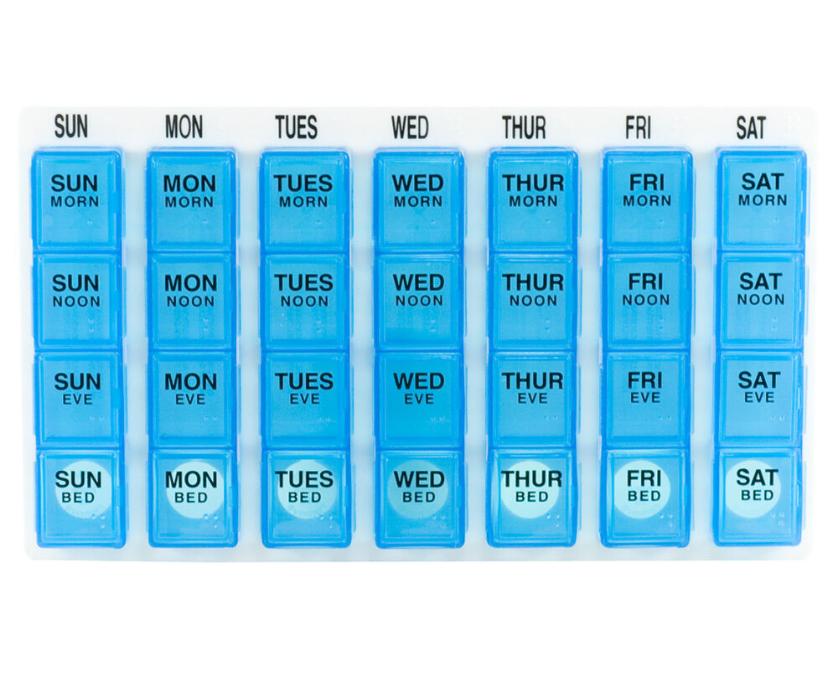
- Refill your pill box on the same day each week.
- Complete in a quiet environment and avoid all interruptions
- Make sure that both you and your support person are capable of filling box (EVEN IF YOU HAVE BEEN INDEPENDENT WITH YOUR MEDICATIONS IN THE PAST)
- Gather all mediations you take
- Have your medication sheet present when filling pill box and follow the order on your sheet
- Check to see if you are going to be out of any medications the next time you refill your pill box. If so, reorder as soon as you can.

