

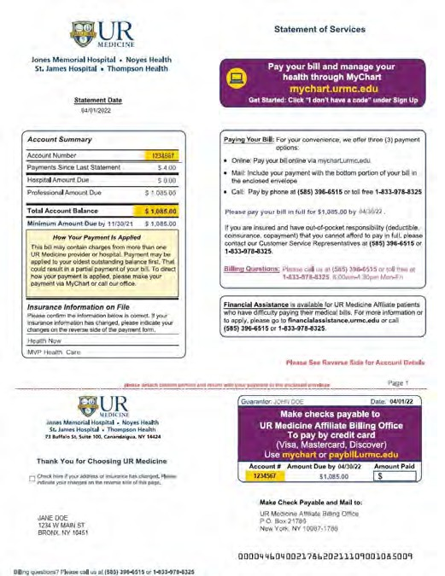

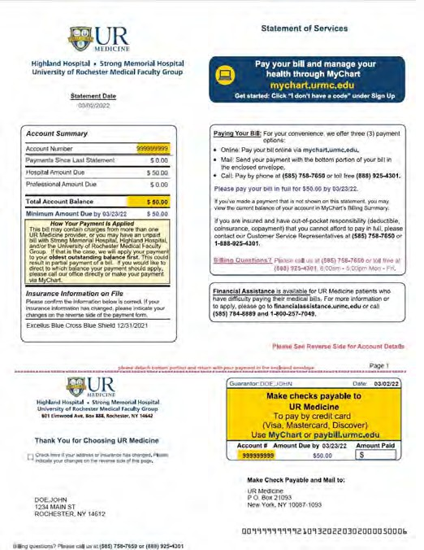

































Statement of Services

UR Medicine Statement for Highland Hospital, Strong Memorial Hospital & University of Rochester Medical Faculty Group Services
UR Medicine Affiliate Statement for Jones Memorial Hospital, Noyes Health, St. James Hospital & Thompson Health Services

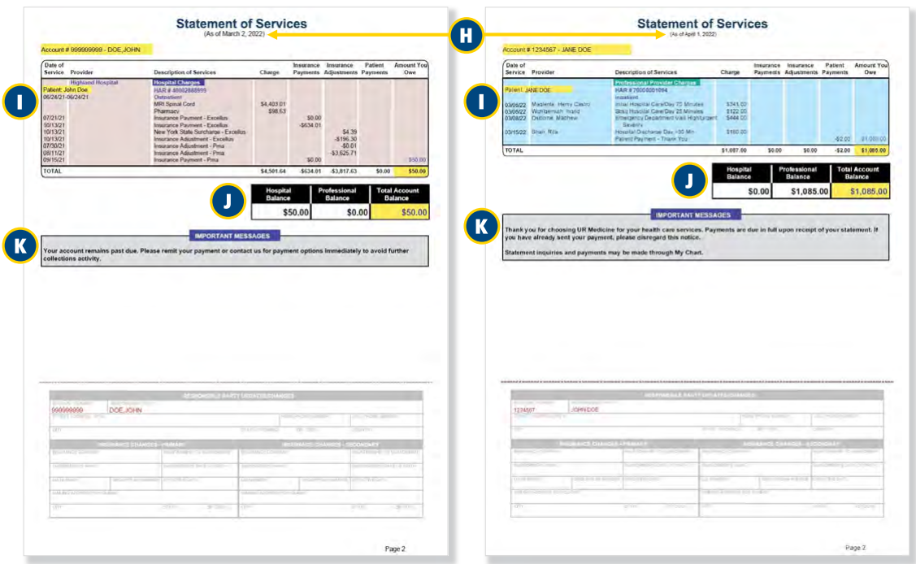


Billing Cycle Date: Your statement may include charges for care/services you received prior to this billing date, as well as older charges that have been processed by insurance and are now your responsibility to pay.


Description of Services: This is the summary of all charges, in detail, as well as payments and insurance adjustments. Your statement includes all charges for care received at the locations shown on that statement, including hospitals, physician practices*, lab and imaging sites and Urgent Care centers.
*Thompson Health Primary Care not included.
Separate Balance Boxes: Your Hospital Balance and Professional Balance are shown separately from the total account balance.

Important Messages: Watch this box for reminders and updates.



paybill.urmc.edu

3/2022

