Infection

The body’s immune system uses a number of defenses to prevent, or get rid of infection. Infections can be caused by a variety of organisms such as bacteria, viruses or fungi.
The anti-rejection medications that keep your body from rejecting your new heart have the unfortunate side effect of compromising your immune system. You may have a reduced ability to fight off infection the way you used to. However, you can minimize infections by preventing exposure to infections, being aware of the symptoms and seeking treatment immediately. You will be MOST susceptible to infections within the first six months after transplant due to the higher dosing of your anti-rejection medications.
Why are infections dangerous in immunocompromised patients?
- The typical symptoms of infection may be absent or less pronounced in patients with weak immune systems.
- Patients with weak immune systems may have trouble clearing infections from their bodies. For example, a viral infection such as the flu may take longer to clear in a patient with a weak immune system compared to a person with a healthy immune system.
What are the signs and symptoms of an infection?
- Fever higher than 100°F (38°C)
- Flu-like symptoms (chills, sweats, aches, headache, or fatigue) or generally feeling “lousy”
- Nausea, vomiting or diarrhea
- Pain, tenderness, redness or swelling of a wound
- Sore throat or pain when swallowing
- Persistent dry or moist cough, sinus drainage, nasal congestion, headaches
- White patches in your mouth or tongue
*It is important to contact your transplant coordinator if you experience any symptoms of infection.

Bacterial Infections
Bacteria are small organisms that can invade the body and cause infections. Bacterial infections are common, but they are not all the same. Anyone can get sick when exposed to bacteria; however, having a weakened immune system puts you at a higher risk of severe bacterial infections.
Bacteria can infect every area of the body and can also spread throughout the blood possibly triggering a potentially life-threatening condition called sepsis. Sepsis occurs when your body has a severe response to an infection.
Generalized symptoms: Fever, chills, and fatigue
Localized symptoms: Pain, redness, swelling or problems with organ function
Causes: You can become exposed to bacteria from other people, the environment or be eating and drinking contaminated food or water.
Diagnosis: The pattern of your symptoms can help your doctor diagnosis your bacterial infection. The location, timing and severity of your symptoms can point to a bacterial infection.
Testing performed to diagnose a bacterial infection:
- Blood tests
- Imaging studies
- Obtaining a urine sample
- Obtaining sample of fluids such as pus or mucous
- Blood cultures
Treatment of bacterial infections:
- Oral antibiotics or IV antibiotics may be required. It is VERY IMPORTANT to complete your entire antibiotic course, even if you feel better after a few days.
- Early diagnosis is key to a quicker recovery.
- Supportive care with fever-reducing medications such as Tylenol, cough suppressants or IV fluids if you are dehydrated
PREVENTION: You will be prescribed BACTRIM after transplant to help prevent bacterial infections. You will remain on this medication for approximately 6-12 months.

Viral Infections
A virus is a small piece of genetic material that looks for a host to live inside and multiply. Unlike bacteria, which can survive on its owns, viruses need a living host to survive.
Viruses can spread via direct transmission, which occurs with close physical contact, sexual intercourse, kissing or by inhaling droplets from an infected person after sneezing or coughing. Viruses can also spread via indirect transmission spread from a mosquito or tick.

Common viral infections:
- Respiratory: Adenovirus (common cold), RSV, Influenza.
- Infections with skin rashes: measles, rubella, varicella (shingles, chicken-pox)
- Sexually transmitted infections: Hepatitis B, herpes, HIV, HPV
CMV (Cytomegalovirus) Infection: CMV is a type of herpes virus. It can affect almost any organ and cause many different symptoms. In the general population, a CMV infection tends to be asymptomatic or is often passed off as a flu-like illness
CMV may cause a more serious illness in an immunosuppressed person, often times resulting in hospitalization.
Symptoms: Fever, chills, diarrhea, muscle aches, fatigue, swollen lymph nodes.
Diagnosing CMV: Blood tests to indicate the presence of the CMV virus, urine or sputum cultures, blood cultures.
Treatment of CMV: Antiviral medications.
Shingles: A viral infection caused due to the reactivation of varicella-zoster virus in nerve roots. This is the virus that causes chicken-pox.
Symptoms: Burning and tingling painful rashes with blisters. Common locations include the chest, flank and face.
The fluid from the blisters can spread the virus to another person. The blisters will gradually crust over and heal, at which point you are no longer contagious. Pain may persist for weeks or longer.
Treatment: There is no cure for shingles however PROMPT treatment with antiviral drugs can speed healing and reduce the risk of complication. Pain medication may be prescribed for pain management.
Prevention: You will be prescribed GANCICLOVIR OR VALGANCICLOVIR after transplant to help prevent VIRAL infections. You will remain on this medication for approximately 3-6 months.

Fungal Infections
Fungi are common in the environment, and people breathe in or come into contact with fungal spores every day without getting sick. However, in people with weakened immune systems, these fungi are more likely to cause infection.
Fungal infections can range from mild to life-threatening. Because of this, it is important to seek treatment as soon as possible to avoid serious infection.

Some types of fungal infections are more common after heart transplant:

Type of fungus | Description | Recommendations
Candidiasis (thrush) | Caused by a yeast/fungus. White patches on inner cheeks, tongue, roof of mouth and throat. | Brush your teeth and floss regularly. Avoid high sugar foods.
Histoplasmosis | An infection caused by breathing in spores of a fungus often found in soil that contains bird or bat droppings. | Avoid gardening/yard work for one year following transplant. After one year always wear gloves when gardening.
Aspergillosis | A mold found indoors and outdoors. Usually affects the respiratory system | Avoid areas with a lot of dust such a construction sites or excavation sites.  Avoid activities that involve close contact to soil.  Avoid home renovations especially in older homes, wet basements, etc.

Cannabis, when used in an inhaled form, can contain fungal pathogens that cause serious and often fatal infections in persons who are immunocompromised
PREVENTION: You will be prescribed DIFLUCAN/fluconazole after transplant to help prevent fungal infections. You will remain on this medication for approximately six months.
TOXOPLASMOSIS: This infection is caused from a parasite. You can become ill with toxoplasmosis by:
- Eating contaminated meat that is raw or undercooked
- Accidental ingestion of the parasite after cleaning a cat’s litter box
- Using utensils or cutting boards after they’ve had contact with contaminated raw meat
- A woman who is newly infected during or just before pregnancy can pass the infection to her unborn child
How can I prevent Toxoplasmosis?
- Cooking all meat to recommended temperatures, do not eat raw oysters, muscles or clams
- Peel or wash fruits and vegetables thoroughly before eating
- Wash cutting boards, dishes, counters, utensils thoroughly after contact with raw meat, seafood or unwashed fruits or vegetables
- Do not participate in cleaning of a cat’s litter box

Infection Prevention
HANDWASHING is the SINGLE most effective way to prevent the spread of infection. Always wash your hands before eating or contact with the eyes or mouth. Always wash your hands after sneezing or blowing your nose and after using the restroom. Ask ALL visitors to wash their hands before visiting.

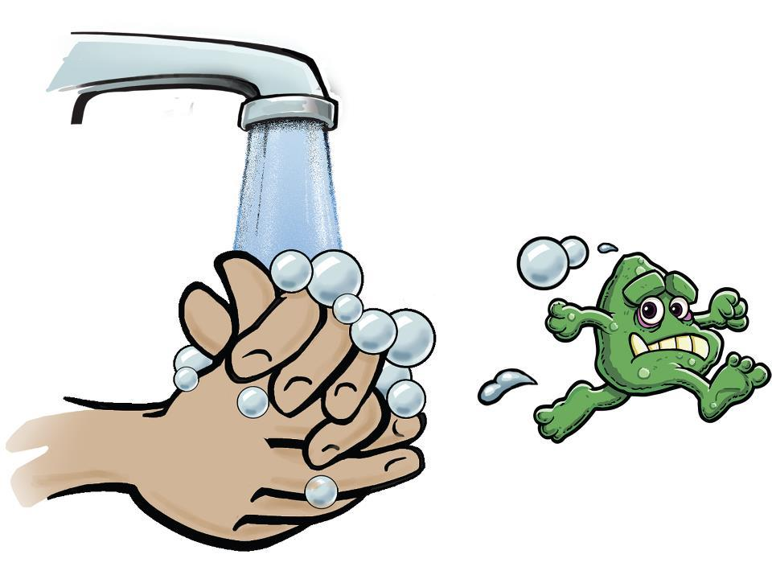

Vaccinations
Keeping up with recommended vaccinations is important in preventing infections that are more dangerous in immunosuppressed individuals.
All patients waiting for a heart transplant should be up to date on their vaccinations prior to listing. These include:
- Diphtheria
- Pertussis
- Hepatitis A and B
- Shingles (recombinant zoster vaccine, Shingrix®)
- Tetanus (every ten years)
- Pneumonia
- Annual flu vaccines (yearly)
- Human papillomavirus (HPV) (if you are younger than 45 years old)
Transplant patients should not receive live virus vaccines as the live virus vaccine may cause an infection in patients with weakened immune systems.

Vaccinations I SHOULD NOT get after my heart transplant:
- Measles/mumps/rubella
- Nasal live attenuated influenza
- Chickenpox (Varivax®)
- Shingles (live zoster vaccine, Zostavax®)
If a family member or other close contact receives a vaccine using a LIVE virus you will need to take precautions.

Summary
Infections are a common complication for transplant patients. Most infections occur during the first 3-6 months following transplant or immediately following treatment of rejection, when immunosuppression is taken in higher doses.
For the first year following transplant please avoid large gatherings as well as avoiding contact with people who are ill.
Please do not become fearful about development of infection. Common sense is the best form of prevention. Early detection and treatment can prevent an infection from becoming more serious. Always remember to call your transplant coordinator if you develop any signs or symptoms of infection.

