

# HM3 Patient and Caregiver Review

**Goal**: Learn the equipment names

**Directions**: Fill in the name of each component

1

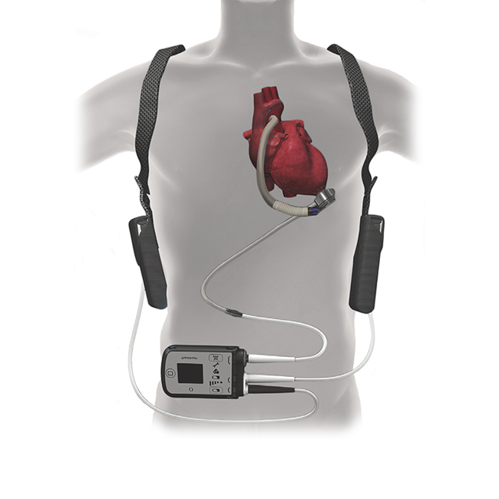

5

2

4

3

**Goal**: Learn the equipment names

**Directions**: Fill in the name of each component

|  |  |
| --- | --- |
|  |  |
|  |  |
|  |  |
|  |  |
|  |  |
|  |  |

**Goal**: Learn the system controller face

**Directions**: Label each **part** on the face of the system controller

3

2

1

4



7

5

6

**Goal**: Learn the system controller face

**Directions**: Label each **alarm light** on the face of the system controller

1

2



7

3

6

4

5

* **Your controller alarms are designed like a traffic light/signal:**

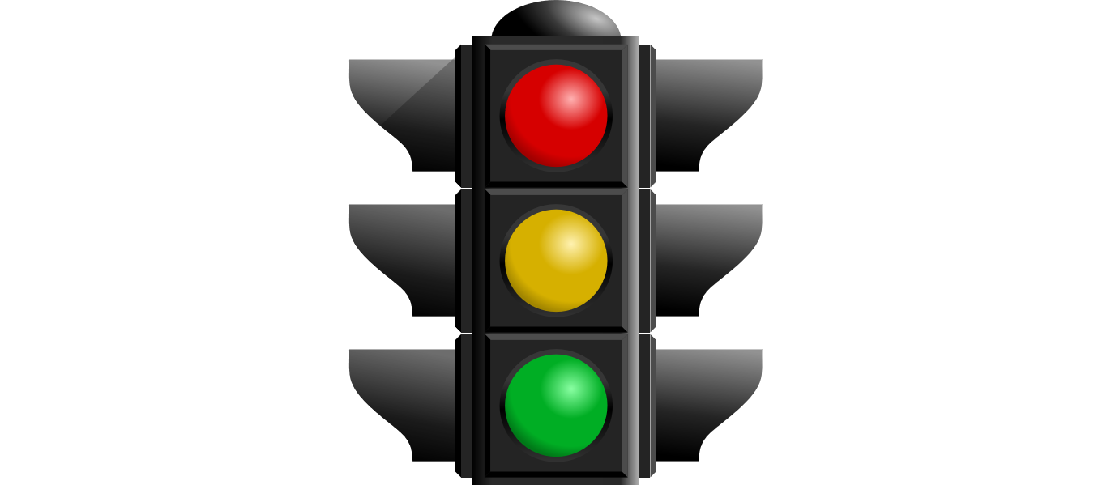

Red: Hazard Alarm – STOP and identify issue. **SOUND:** continuous tone

Yellow: Advisory Alarm – CAUTION, identify issue. **SOUND:** intermittent beep

Green: Good to go! (example: Pump running symbol should always be on [Image result for arrows in circle green](https://www.google.com/url?sa=i&rct=j&q=&esrc=s&source=images&cd=&cad=rja&uact=8&ved=2ahUKEwjytv6Eo-DbAhWxpFkKHWtHAY0QjRx6BAgBEAU&url=https://svn.apache.org/repos/asf/openoffice/symphony/trunk/main/extras/source/gallery/arrows/&psig=AOvVaw1KsHT6jVZqBHl0kdfWaavS&ust=1529516476363634)

**Goal:** Learn the symbols and their meanings on the Mobile Power Unit

**Directions:**  Label the Symbols and below describe their meaning

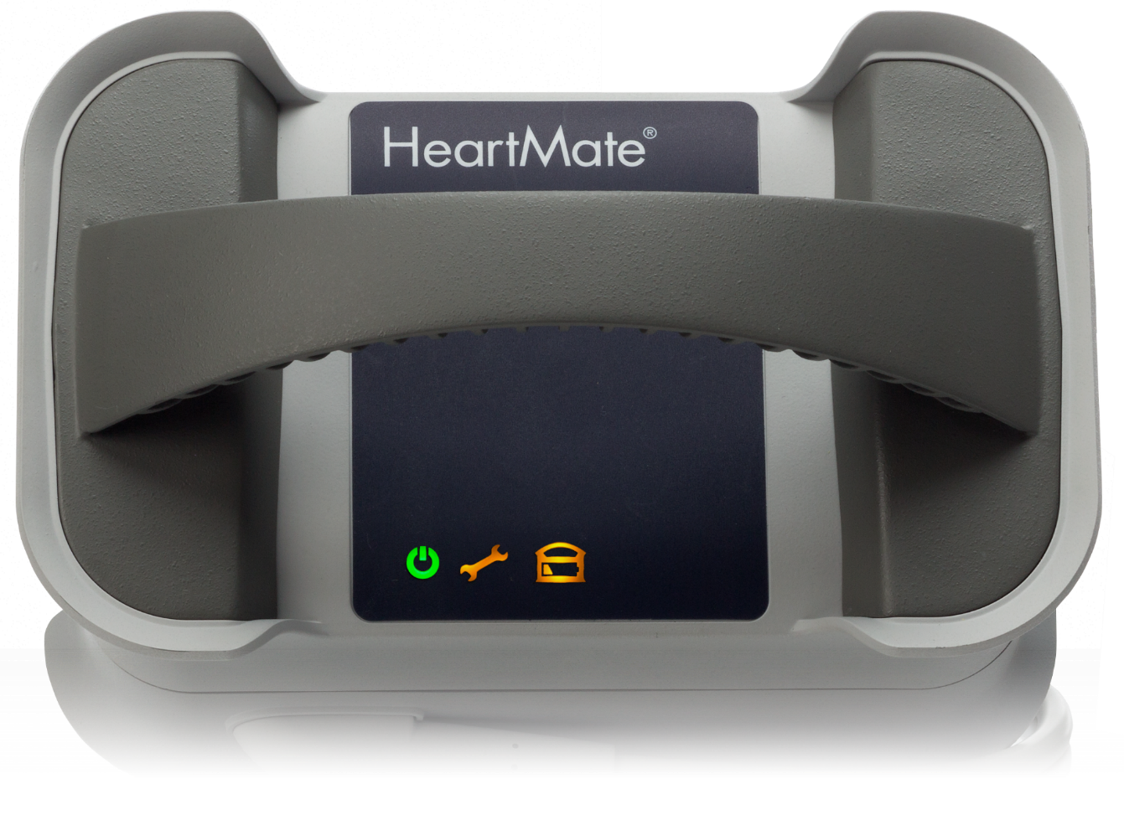

3

2

1

**1:____________________________________________________________________________________________________________________________________________________________________________________________**

**2.____________________________________________________________________________________________________________________________________________________________________________________________**

**3.____________________________________________________________________________________________________________________________________________________________________________________________**

**\*\*Figure 1 and 3 have an audible beeping alarm with the visual light\*\***

Alarm Management

1. If I have a yellow wrench on my controller, I will:
   1. Change my power
   2. Change my controller
   3. Call the VAD clinic
   4. A and C
2. If the power goes out to my home during a storm and I am connected to the MPU, I can expect:
   1. A yellow wrench advisory on the controller
   2. Red heart alarm
   3. Red battery alarm saying “connect power immediately-backup battery”
3. If this occurs, I can expect:
   1. My pump to stop due to loss of power
   2. To hear an intermittent beep from MPU
   3. My pump to continue to run as the controller emergency backup battery would kick in.
4. I could also expect in this scenario to hear from my controller
   1. Continuous tone alarm
   2. Intermittent beep
5. If I were to hear an alarm but it resolved by the time I checked my connections, I should:
   1. Take a deep breath and count my blessings the alarm is gone.
   2. Record my VAD numbers
   3. Press the silence and display button at the same time to review past alarms.
   4. Call the VAD team
   5. B, C, D

|  |  |  |
| --- | --- | --- |
| Please circle TRUE or FALSE for the following statements | True | False |
| I cannot drive until I am off all pain medication and given the okay in clinic. | **True** | **False** |
| I’m at a higher risk for infection if I shower or get my driveline exit site wet | **True** | **False** |
| If my insurance doesn’t cover my dressing supplies then the VAD Coordinators will be able to provide them for me | **True** | **False** |
| I should use the Discharge Binder as a reference | **True** | **False** |
| It is alright for me to go see my favorite concert/sporting event live | **True** | **False** |
| I can still enjoy hunting, fishing, dancing, hiking, golfing, exercising, biking | **True** | **False** |
| I should notify clinic 1 week before traveling out of the area | **True** | **False** |
| It is my responsibility to have my labs checked at least every 2 weeks, more frequently in the beginning. | **True** | **False** |
| If I have increased lightheadedness or weakness I will make the VAD team aware. | **True** | **False** |
| I need a medication refilled, I should page the on-call coordinator immediately even though it is 10 PM. | **True** | **False** |
| I should have my backup controller and batteries with me at all times, even at clinic appointments. | **True** | **False** |
| I am allowed to travel by plane. | **True** | **False** |
| If I am told to increase the Vitamin K in my diet I should eat lots of green leafy vegetables. | **True** | **False** |
| I should continue to have a Primary Care Physician | **True** | **False** |
| It is not my responsibility to know my medications because they have everything in the computer anyway | **True** | **False** |
| If I am more than 20 minutes late to my appointment, I can expect to have my appointment rescheduled. | **True** | **False** |
| If I am going to the emergency room I should bring ALL of my VAD equipment and notify the VAD Team | **True** | **False** |
| My Coumadin dose will be managed by the VAD providers. | **True** | **False** |
| It is ok to disconnect both power leads at the same time because there is an emergency battery. | **True** | **False** |
| I should only use 4 batteries and save the other 4 batteries for an emergency. | **True** | **False** |
| I should change the 3 AA batteries in the MPU every 6 months. | **True** | **False** |
| If I notice a crack in my controller cable I should change the controller and then call the VAD team. | **True** | **False** |
| If the VAD clinic does not call me 24-48hrs after I have blood work, I can assume the bloodwork was ok. | **True** | **False** |
| The VAD clinic will prescribe all of my medications now that I have a VAD. | **True** | **False** |

Equipment Questions

1. How long does it take to fully charge a battery? _____________________
2. When should a self –test be performed? ___________________________________
3. How long does the emergency backup battery in my controller last?______________________________________________________________________________
4. How long does a pair of batteries last for the HM3 LVAD?__________________
5. Does the Mobile Power Unit have an emergency battery that will run the pump in the event of a power outage?__________________________________________
6. How often should I clean my equipment?____________________________________
7. What parts of the equipment require cleaning the metal contacts with an alcohol swab?
   1. Battery clips
   2. Battery charger slots
   3. Batteries
   4. All of the above

General Questions:

1. Where do I find the VAD clinic phone #?________________________________________
2. What is my goal blood pressure?______________________________________________
3. INR is the:
   1. Blood test to monitor the effectiveness of the blood-thinning medication
   2. Blood-thinning medication
4. Coumadin is the:
   1. Blood test to monitor the effectiveness of the blood-thinning medication
   2. Blood-thinning medication
5. What is my INR goal?_______________________________________________________
6. If my INR is higher than my goal, I could be told to:
   1. Eat leafy green vegetables
   2. Take a lower Coumadin dose
   3. Recheck INR
   4. All of the above