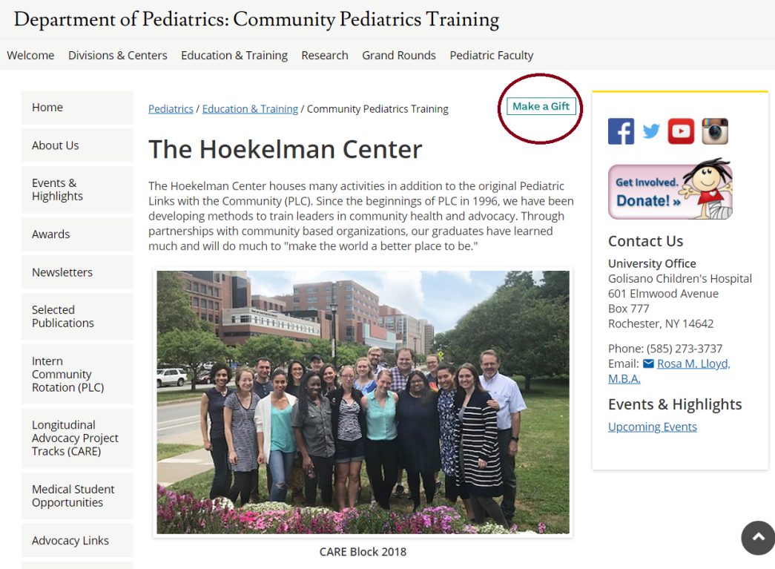

Click “Make a Gift” on our home page.

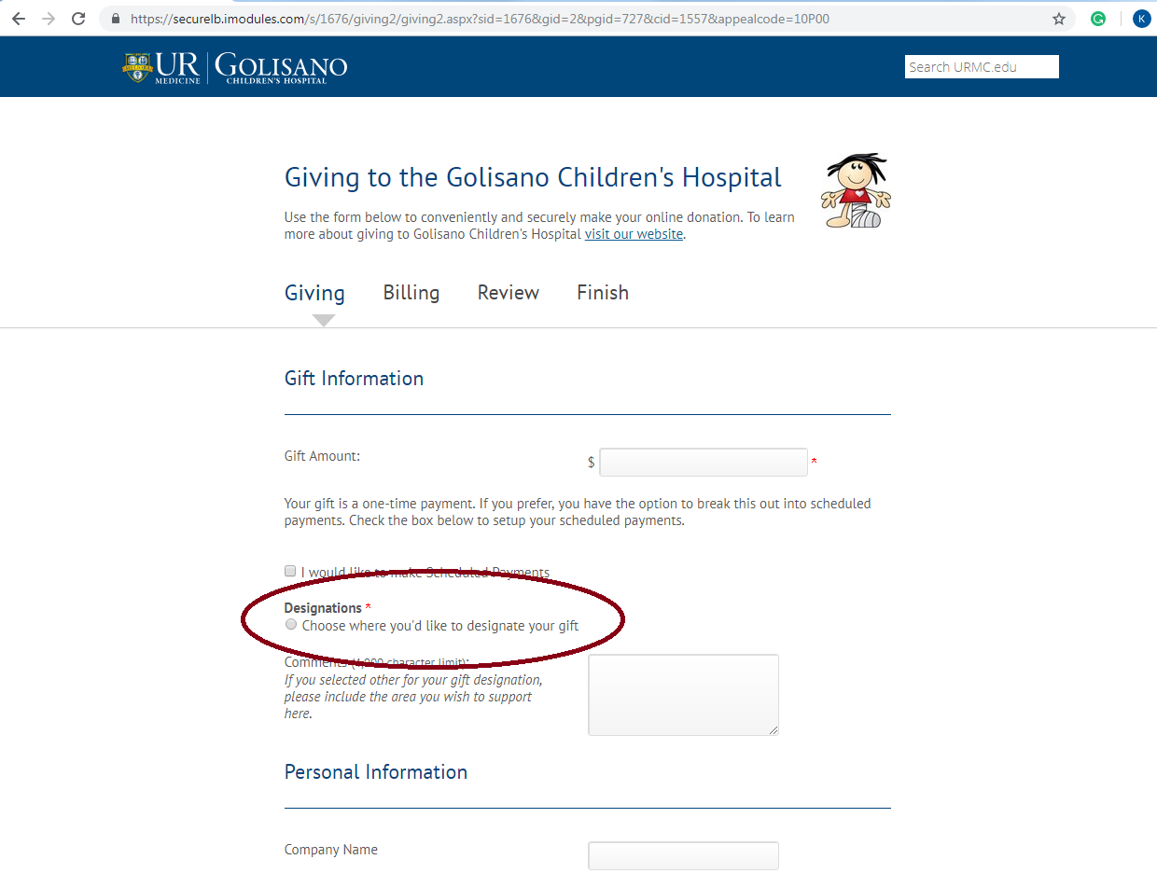

Click “Designations.”

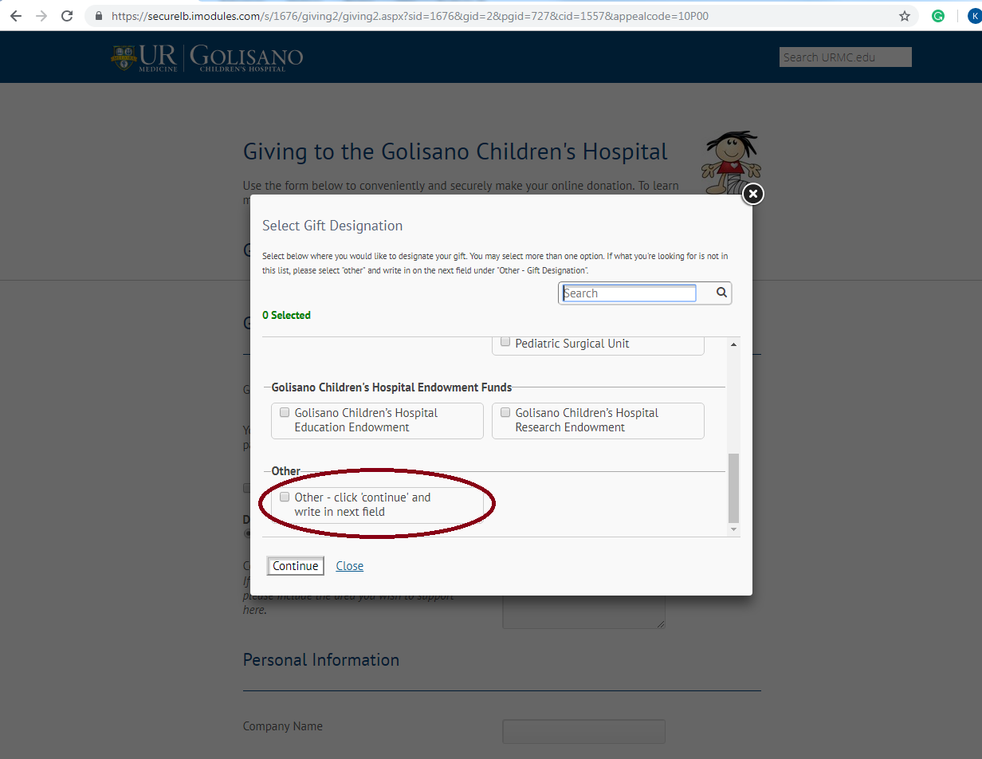

Scroll down the page to select “Other” and press continue.

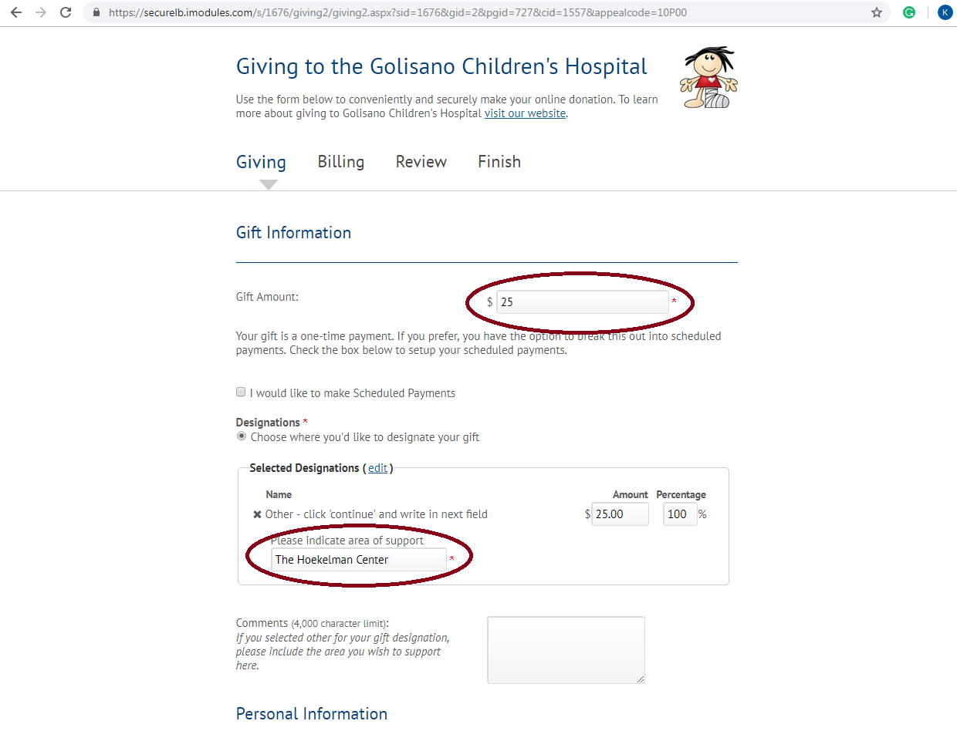

Type in gift amount and then type in “Hoekelman Center” where it asks to indicate your area of support.

Follow the rest of the prompts to enter your personal and billing information. Thank you for your generosity! Let us know if you have any questions.